الجمهورية الجزائرية الديمقراطية الشعبية
وزارة التعليم العالي والبحث العلمي
People’s Democratic Republic of Algeria
Ministry of Higher Education and Scientific Research


École Supérieure de Management – Tlemcen
Graduate School of Management – Tlemcen
Mémoire de fin d'études
Presented in partial fulfillment of the requirements for the Master’s Degree
In: Management of Touristic Establishments
Title:
The Impact of Local Residents’ Behavior on Tourism

Presented by: Adem Draou Supervisor: Mr. Oussama Nabil Bessaid
President of the Jury: Dr. Hellabi Zoubida
Examiner: Dr. Aoufi Fatima
Academic Year: 2024 – 2025
Tlemcen, June 2025

Introduction 1
Research Hypotheses 4
Literature Review 5
Residents’ Behaviour and Social Context 6
Attitudes Towards Tourism and Tourists 7
Host–Tourist Interaction and Intergroup Contact 7
Place Image, Cultural Values, and Identity 7
Negative Impacts and Overtourism 8
Residents’ Empowerment and Participation 8
Research Gaps and Future Directions 9
CHAPTER 1: THE SOCIAL FOUNDATIONS OF RESIDENT BEHAVIOR TOWARD TOURISM 13
2. The Role of Socialization in Behavior Formation 14
3. Cultural Influences on Behavior 14
4. The Impact of Social Norms 14
5. Psychological Perspectives on Human Behavior 15
6. Social Exchange Theory (SET) 15
● 6.1 Foundations of Social Exchange Theory 15
● 6.2 Cost-Benefit Analysis in Relationships 16
● 6.3 Power and Dependence in Social Exchange 16
● 6.4 Types of Social Exchanges 16
● 6.5 Applications of Social Exchange Theory 16
1.2 THE ROLE OF LOCAL RESIDENTS IN TOURISM CONTEXT Error! Bookmark not defined.
1.2.1 Local Residents as Service Providers 18
1.2.2 Cultural Ambassadors: Keeping Traditions Alive 18
1.2.3 Environmental Caretakers: Sustaining Tourism Destinations 19
1.2.4 Strengthening Host–Guest Relationships 19
1.2.5 Factors Shaping Residents’ Attitudes Toward Tourists 20
● 1.2.5.1 Positive Impacts of Tourism 20
○ Economic Gains 20
○ Cultural Exchange 20
● 1.2.5.2 Negative Impacts of Tourism 21
○ Overcrowding and Infrastructure Strain 21
○ Cultural Dilution 21
○ Environmental Harm 22
1.2.6 Types of Local Behavior Toward Tourism 23
● Welcoming Behavior 23
1.2.7 Doxey’s Irritation Index (Irridex) 25
1.3 RESIDENT–TOURIST INTERACTIONS: PATTERNS AND CONSEQUENCES Error! Bookmark not defined.
1.3.1 Recurring Patterns in Resident–Tourist Dynamics 27
● Initial Acceptance and Economic Enthusiasm 27
● Shifts in Perception Over Time 27
● Seasonal Variations in resident-tourist relations 28
● Cultural Exchange vs. Cultural Fatigue 29
1.3.2 Long-Term Effects on Society and Economy 30
● Economic Dependency on Tourism 30
● Social Transformations in Host Communities 30
● Overtourism and Its Consequences 31
● Employment and Income Disparities 32
1.3.3 Examples of Resident Responses to Tourism 32
● Adaptation Strategies by Local Communities 33
● Tourism Fatigue and Resident Backlash 33
● Grassroots Initiatives for Sustainable Tourism 34
● Government and Policy Interventions 34
CHAPTER 2: TOURISM DEVELOPMENT AND ITS SOCIETAL IMPACT 36
2.1 TOURISM AND ITS DEVELOPMENT IN HOST COMMUNITIES Error! Bookmark not defined.
2.1.1 Definition and Importance of Tourism 36
2.1.2 Economic Impact: GDP Contribution and Employment 37
2.1.3 Social and Cultural Significance 38
2.1.4 Types of Tourism and Their Impacts on host communities 39
● Mass Tourism: Economic Gain vs. Overcrowding and Cultural Erosion 39
● Cultural Tourism: Preservation vs. Commodification 40
● Eco-Tourism: Sustainability vs. Greenwashing 41
2.1.5 The Role of Local Populations in Tourism Development 42
● Locals as Key Stakeholders 42
● The Case for Local Involvement 42
● Challenges to Community Participation 43
● Benefits of Inclusive Tourism Policy 44
● Participatory Governance 44
2.2 NEGATIVE CONSEQUENCES OF HOSTILE OR RESISTANT BEHAVIOR Error! Bookmark not defined.
2.2.1 Root Causes of Hostility Toward Tourists 46
➢ From Hostility to Declining Tourist Satisfaction 46
2.2.2 Declining Tourist Satisfaction and the Vicious Cycle 47
2.2.3 Case Examples and Empirical Support 47
2.2.4 Economic and Social Risks of Poor Host–Tourist Relations 48
● Economic Risks 48
● Social Risks 49
● Interdependence of Social and Economic Dimensions 50
2.2.5 Environmental Challenges from Tourism–Resident Conflicts 50
● Overtourism and Environmental Degradation 50
● Resource Depletion and Competition 51
● Resident Well-Being and Environmental Conflict 51
● Accumulated and Delayed Environmental Impacts 52
● Waste Management and Pollution conflict 52
● Community Engagement for Sustainability 52
2.3 THE INFLUENCE OF LOCAL ATTITUDES ON TOURIST EXPERIENCE Error! Bookmark not defined.
2.3.1 Positive Local Attitudes and Tourist Satisfaction 54
2.3.2 Negative Attitudes and Tourist Discontent 54
2.3.3 Participation, Equity, and Their Mediating Role 55
2.3.4 Destination Image and Behavioral Feedback Loops 55
➢ Cultural Mediation and Long-Term Impact 56
Examples of Destinations Affected by Local Behavior 57
1. Barcelona, Spain: Local Resistance and Tourismphobia 57
2. Sevilla, Spain: Moderate Impacts and Community Adaptation 57
3. Kebondalem Kidul, Indonesia: Cultural Preservation Through Local Hospitality 58
1.4 The Relationship Between Local Residents and Tourism 58
1.4.1 Quality of Life and Community Well-being 59
1.4.2 Evolution of Resident Attitudes Over Time 59
1.4.3 Patterns of Engagement and Resistance 59
1.4.4 Governance, Participation, and Empowerment 60
Introduction to the Case Study Error! Bookmark not defined.
“They Treated Me Like Family”: First Impressions Matter 62
Purpose of This Case Study 62
Relevance to the Topic: The Local-Tourist Relationship 62
Why Algiers? 63
Building a Foundation for Better Tourism 63
Description of the Place, Community 64
1. Location and Geographic Context 64
2. Tourism in Algiers: Trends and Attractions 64
3. The People of Algiers: Lifestyles, Economy, and Interaction with Tourists 65
4. Historical and Sociopolitical Context Affecting Tourism 66
4. Presentation of Results 67
4.2. General Attitudes Toward Tourists 69
4.3. Gender-Based Perceptions of Tourism 70
4.4. Age and Attitudes Toward Tourists 70
4.5. Interaction with Tourists 71
4.6. Respect for Local Culture and Traditions 73
4.7. Environmental Impact of Tourism 74
4.8. Changes in Local Traditions 75
4.9. Community Involvement in Tourism 76
5. In-Depth Analysis of Results 78
5.1 Emerging Patterns from the Survey Data 78
5.2 Interpreting the Patterns: Understanding Local Attitudes and Behaviors 79
5.3 Emotional and Cultural Reactions: Between Pride and Distance 80
5.4 Linking Resident Behavior to the Tourism Experience 80

List of Tables
Table 1: Impact of Tourism on Local Communities in Algiers .................................................... …
Table 2: General Attitudes Toward Tourists ....................................................................... …
Table 3: Gender-Based Perceptions of Tourism ................................................................. …
Table 4: Age and Attitudes Toward Tourists .................................................................. …
Table 5: Interaction with Tourists ......................................................................................... …
Table 6: Respect for Local Culture and Traditions .............................................................. …
Table 7: Environmental Impact of Tourism .................................................................... …
Table 8: Changes in Local Traditions ................................................................................. …
Table 9: Community Involvement in Tourism ................................................................. …

List of Figures
Figure No. | Title
Figure 1 | Tourism Development Impacts – Doxey’s Irritation Index (Frontiers in Psychology, Article 684773)
Figure 2 | Map of Algiers
Figure 3 | Chart – Impact of Tourism on Local Communities in Algiers
Figure 4 | Pie Chart – General Attitudes Toward Tourists
Figure 5 | Bar Chart – Gender-Based Perceptions of Tourism
Figure 6 | Bar Chart – Age and Attitudes Toward Tourists
Figure 7 | Pie Chart – Interaction with Tourists
Figure 8 | Pie Chart – Respect for Local Culture and Traditions
Figure 9 | Pie Chart – Environmental Impact of Tourism
Figure 10 | Pie Chart – Changes in Local Traditions
Figure 11 | Pie Chart – Community Involvement in Tourism

dedication
To my beloved family,
Thank you for your endless love, support, and belief in me, even when things got tough.
A special dedication to my lovely nephews and niece Haroun, Baraa, and Ilef your smiles and energy lit up my days and kept my spirit high throughout this journey.
This work is for you all.

Acknowledgments
Alhamdulillah, all praise is due to Allah, who granted me the strength, patience, and guidance to complete this thesis on “The Impacts of Local Residents’ Behavior on Tourism.” His blessings were with me every step of the way, and for that, I am deeply grateful.
I would like to express my sincere gratitude to my supervisor, Mr. Oussama Nabil Bessaid. Thank you for your availability, your constructive feedback, and your constant support throughout this research. Your guidance has been a true source of motivation.
To all the professors of my école supérieure, thank you for the knowledge you have shared, for the challenges that helped me grow, and for the encouragement that pushed me to do better. You have shaped not only my academic journey but also my personal development.
I also extend my appreciation to my classmates and friends who shared this academic experience with me. Your support, discussions, and shared moments made this journey easier and more enjoyable.
Finally, thank you to everyone near or far who contributed in any way, even with a kind word or a smile, to making this work possible.

Abstract
This thesis examines the impact of local communities’ behavior on tourism in Algiers through a case study involving surveys and data analysis. The findings reveal complex patterns in residents’ perceptions and experiences of tourism, characterized by generally supportive yet cautious attitudes. Younger residents tend to show more openness toward tourists, while older groups exhibit more reserved views. Interaction levels vary widely, with those working in tourism-related roles engaging more frequently and positively. Although most residents deny significant cultural or environmental changes due to tourism, subtle shifts are acknowledged by those more exposed. Emotional responses range from civic pride to polite neutrality, reflecting both engagement and emotional distance. The study highlights how local behaviors serve as an influential yet often invisible framework shaping the overall tourism experience in Algiers. It also points to the importance of fostering community involvement to promote sustainable and meaningful tourism development.
Keywords: Local residents' behavior; Tourism in Algiers; Resident-tourist interaction; Tourism development; Social attitudes; Sustainable tourism; Community participation.

الملخص:
تتناول هذه الأطروحة تأثير سلوك المجتمعات المحلية على السياحة في مدينة الجزائر، من خلال دراسة حالة اعتمدت على الاستبيانات وتحليل البيانات. كشفت النتائج عن أنماط معقدة في تصورات السكان المحليين وتجاربهم تجاه السياحة، والتي اتسمت عمومًا بمواقف داعمة لكن حذرة. يميل السكان الأصغر سنًا إلى إظهار مزيد من الانفتاح تجاه السياح، بينما يُبدي كبار السن مواقف أكثر تحفظًا. تتفاوت مستويات التفاعل بشكل كبير، حيث يظهر العاملون في القطاعات المرتبطة بالسياحة سلوكًا أكثر إيجابية وتفاعلًا متكررًا. وعلى الرغم من أن معظم السكان ينكرون وجود تغييرات ثقافية أو بيئية كبيرة ناجمة عن السياحة، فإن البعض الذين تعرضوا بشكل مباشر لها أشاروا إلى تحولات طفيفة. تراوحت الاستجابات العاطفية بين الفخر المدني والحياد المهذب، مما يعكس تفاعلاً وانفصالًا عاطفيًا في آنٍ واحد. تسلط الدراسة الضوء على كيف أن سلوك السكان المحليين يشكل إطارًا غير مرئي لكنه مؤثر في تجربة السائح في الجزائر العاصمة، وتُبرز أهمية إشراك المجتمع في تطوير سياحة مستدامة وذات مغزى.
الكلمات المفتاحية: سلوك السكان المحليين؛ السياحة في الجزائر العاصمة؛ التفاعل بين السكان والسياح؛ تطوير السياحة؛ المواقف الاجتماعية؛ السياحة المستدامة؛ مشاركة المجتمع المحلي.

Introduction
Tourism is often seen as a gateway to cultural exchange, economic development, and global visibility. It brings with it the promise of jobs, infrastructure improvement, and international recognition. However, beyond these measurable outcomes, tourism is deeply human. At its core, tourism is a social process—an interaction between people from different contexts, values, and expectations. In this interaction, the behavior of local residents is not just a background variable; it is a shaping force. The way locals greet, speak to, assist, avoid, or even ignore tourists subtly molds the visitor’s experience and perception of a destination. Yet, while the behavior of tourists has been widely studied, the behavioral patterns of residents—and their impact on tourism—remain relatively underexplored, particularly in North African urban contexts.
In a rapidly globalizing world, tourists are increasingly sensitive to authenticity, atmosphere, and emotional connection. Cities compete not only through attractions and prices, but also through the intangible social climate that visitors experience. In this sense, local residents act as informal ambassadors of place. Their friendliness, openness, helpfulness, or even their indifference can determine whether a tourist feels welcome or alienated. As highlighted in several studies (e.g., Lin, Chen, & Filieri, 2017), residents' perceptions of tourism, their satisfaction with life, and their evaluation of the costs and benefits brought by visitors all influence their willingness to engage in value co-creation. When residents perceive tourism positively, they are more likely to interact meaningfully with visitors, creating experiences that are richer and more authentic.
However, these social dynamics are not uniform across all contexts. In many destinations, especially those with emerging or uneven tourism development, interactions between tourists and locals are irregular and emotionally ambiguous. This is particularly the case in Algiers. As the capital of Algeria, Algiers is not only a political and economic center but also a city of layered identities: French colonial architecture, Mediterranean landscapes, Islamic heritage, and a growing interest in modern tourism all coexist in a dense and diverse urban fabric. Despite Algeria’s enormous tourism potential, including UNESCO heritage sites, mountains, beaches, and desert landscapes, the sector remains underdeveloped compared to neighboring countries like Morocco or Tunisia. This makes Algiers a particularly interesting site for studying the social dimension of tourism.
In this environment, the local population's behavior becomes even more critical. Without a fully structured tourism industry or a strong culture of touristic interaction, the attitudes and actions of everyday residents become the primary lens through which tourists understand the place. A helpful shopkeeper, a curious child, a cold stare in the street — these micro-moments become the foundation of the tourist experience. Yet, how do locals actually perceive tourism? Do they feel involved in it? Do they welcome it, tolerate it, or remain indifferent? And how do these emotions shape their actions?
Despite the importance of these questions, there is limited academic literature that focuses specifically on the Algerian case, or more precisely, on how Algiers residents themselves behave toward tourism and how this behavior impacts the visitor experience. Much of the existing research on tourism in the MENA region emphasizes economic development, destination branding, or cultural preservation. Studies exploring the social interaction between tourists and residents are growing (e.g., Pavluković et al., 2011; Lin et al., 2017), but they tend to focus on countries with high-volume tourism industries. Algeria, with its cautious relationship with international tourism and complex colonial past, offers a unique social landscape that has not been adequately studied through the lens of resident behavior.
This thesis aims to bridge that gap by exploring how local residents in Algiers perceive and interact with tourism, and how their behaviors—whether welcoming, passive, or reserved—ultimately affect the tourism experience in the city.
In light of this context, the central aim of this thesis is to explore how the behaviors and attitudes of Algiers’ residents shape the tourism experience in their city. Rather than focusing on tourist satisfaction alone, this research adopts a resident-centered approach, investigating how local perspectives, emotions, and daily practices influence the dynamics of tourism development. By emphasizing the social interactions between tourists and locals, the study shifts attention away from infrastructure or marketing and toward the everyday human encounters that define the tone of a destination.
Importance of the Study:
This study holds significance on multiple levels. At the academic level, it contributes to the limited literature on resident behavior and its influence on tourism in North African urban contexts, particularly in Algiers—a city with great potential yet underexplored social dynamics. At the practical level, the findings offer valuable insights for policymakers, tourism planners, and local authorities seeking to improve the tourist experience through community engagement. By understanding local attitudes and behaviors, strategies can be designed to foster more inclusive, sustainable, and culturally sensitive tourism development. Additionally, this research empowers local communities by highlighting their role as active agents in shaping destination image and tourist satisfaction.
The guiding research question is as follows:
How do the behaviors and attitudes of residents influence the experience and development of tourism?
To answer this question, the research adopts a case study methodology, focusing specifically on Algiers as a complex urban tourism environment. A mixed-methods approach was chosen, centered around a structured survey distributed to local residents across various districts in the city. The survey included both quantitative and qualitative questions, covering themes such as perceived benefits of tourism, frequency and type of interaction with tourists, cultural attitudes, environmental concerns, and willingness to participate in tourism-related activities.
The case study method is particularly appropriate here, as it allows for a close examination of social and behavioral patterns within a specific and meaningful context. Algiers, with its uneven tourism development and socially diverse population, provides a rich environment for analyzing how residents interpret and react to the presence of tourists. Additionally, using a survey-based approach allows for the identification of statistical trends while still capturing the nuances of individual perspectives.
The structure of this thesis reflects a progression from theoretical grounding to empirical analysis. Following this introduction, the Literature Review presents key definitions and scholarly discussions related to resident behavior, tourism development, and tourist-resident interaction. It also highlights research gaps and sets the foundation for the study. The section on Problematique and Hypotheses defines the core research problem and introduces the hypotheses derived from the theoretical framework.
Chapter 1, as part of the theoretical section (Partie Théorique), develops the main theories supporting the research — particularly social exchange theory and the concept of value co-creation between residents and tourists. Chapter 2 continues the theoretical discussion, focusing on how these frameworks apply specifically to the Algerian context, with particular attention to Algiers and its socio-cultural landscape.
Chapter 3 constitutes the practical part (Partie Pratique) of the thesis. It presents the research methodology, data collection process, and results of the fieldwork conducted through resident surveys in Algiers. This chapter includes both the statistical presentation of results and a detailed analysis of the findings in relation to the hypotheses. The thesis concludes with a general reflection on the implications of the study, its limitations, and recommendations for future tourism planning and research.
Through this research, the aim is not only to better understand the social dynamics of tourism in Algiers, but also to highlight the crucial role that residents play in shaping the identity, atmosphere, and sustainability of their city as a destination. In a time when destinations are increasingly evaluated through the lens of lived experience, understanding the subtle power of local behavior is not just relevant — it is essential.

Research Hypotheses
This study aims to explore how the behavior and attitudes of local residents in Algiers influence the tourism experience within the city. Based on the theoretical framework of social exchange theory (Blau, 1964) and supported by prior studies on resident-tourist value co-creation (Lin, Chen, & Filieri, 2017), the following hypotheses have been developed to guide the empirical investigation:

(H0)
The more residents perceive tourism as beneficial, the more likely they are to adopt positive behavior toward tourists.
This hypothesis is grounded in the assumption that when residents recognize the economic, cultural, or social advantages of tourism (such as employment opportunities, improved infrastructure, cultural exchange, or civic pride), they will be more inclined to engage positively with visitors. Such behaviors may include helpfulness, friendliness, openness, or a willingness to participate in tourism-related activities.
(H1)
The perception of negative impacts from tourism is associated with more passive, distant, or negative attitudes toward tourists.
This hypothesis proposes that when residents identify negative effects of tourism—such as environmental degradation, cultural erosion, overcrowding, or rising living costs—they may respond with emotional or behavioral distancing. This could manifest as reduced interaction, indifference, or subtle forms of rejection, which in turn may impact the overall tourist experience.
These hypotheses will be tested through the analysis of survey data collected from residents across different districts in Algiers. The variables measured include perceived benefits and drawbacks of tourism, general attitudes toward tourists, frequency of interaction, and willingness to participate in tourism initiatives. By analyzing the relationships between these variables, the study seeks to determine whether resident perceptions meaningfully predict behavior, and how that behavior influences tourism outcomes.

Previous studies
The role of local residents in shaping tourism experiences has received increasing scholarly attention, particularly in relation to attitudes, interaction patterns, and behavioral outcomes. Several studies underscore the complexity of resident-tourist dynamics and how these can influence tourism development both positively and negatively.
Shen, Yang, and Geng (2022) proposed a useful distinction between attitudes toward tourism (ATT) and toward tourists (ATTT), showing that residents’ support for tourism development is more closely tied to their perception of tourism as a system rather than their emotional feelings toward individual tourists. Their study, conducted in Huangshan, China, also revealed the mediating effects of host–tourist interaction and place image, highlighting that quality social interaction and place identity are essential in shaping pro-tourism behavior.
Pavluković et al. (2011) examined the interaction between tourists and residents, particularly in regions experiencing seasonal tourism. They found that during peak tourist periods, residents often experience discomfort due to crowding and loss of local access, leading to ambivalent or even negative attitudes toward tourists. However, off-season periods, characterized by fewer visitors and economic slowdowns, reveal a contrasting dependency dynamic where residents become more welcoming, albeit pragmatically.
Linderová, Scholz, and Almeida (2021) utilized Doxey’s Irritation Index to trace how resident attitudes evolve over time as tourism intensifies. Their findings in Czech towns highlighted the shift from euphoria to irritation and even antagonism when tourism's perceived costs—such as congestion or cultural erosion—outweighed the benefits. Yet, their work also noted that inclusion and equity in tourism development can moderate negative perceptions.
Host–tourist interaction quality also plays a central role. Eusébio et al. (2018) and Joo et al. (2018) emphasized, through the lens of intergroup contact theory, that repeated, meaningful engagement reduces prejudice and enhances solidarity. Luo et al. (2015) extended this by arguing that the quality of interaction is more influential than the frequency, especially in destinations receiving budget travelers.
Govender, Maziriri, and Chuchu (2021) contributed to destination image theory by showing that resident behavior has a stronger influence on tourist satisfaction than infrastructure or marketing. Their findings suggest that tourists are more likely to return or recommend destinations where locals are perceived as warm and respectful.
Finally, Hidayat et al. (2023) presented a compelling case from Kebondalem Kidul, Indonesia, where strong cultural hospitality and resident participation led to high tourist satisfaction and positive word-of-mouth. The study shows that integrating residents into cultural tourism not only enriches visitor experiences but also strengthens local identity and community pride.

Residents’ Behaviour and Social Context
Understanding local residents’ behaviour requires situating it within broader social, cultural, and moral frameworks. Rahma and Wantini (2024) argue from an Islamic psychological and educational standpoint that behaviour is inherently shaped by a matrix of internal (emotions, cognition, morality) and external (societal expectations, religious doctrine, family norms) factors. Their model emphasizes that individual behaviours are not merely reactive but are constructed through long-term habituation and value systems. Such insights are critical to tourism research, particularly in culturally conservative or religiously influenced communities, where resident behaviour toward outsiders may be deeply rooted in perceived moral obligations or social etiquette.
However, the limitations of this framework lie in its lack of direct empirical linkage to tourism dynamics. While it establishes foundational behavioural concepts, the translation of these ideas into tourism-specific contexts remains underdeveloped. This highlights a methodological gap in culturally embedded psychological models that fail to engage directly with host–guest interactions.

Attitudes Towards Tourism and Tourists
A more tourism-centric model is provided by Shen, Yang, and Geng (2022), who developed a quantitative framework distinguishing between residents’ attitudes toward tourism (ATT) and tourists (ATTT), and their subsequent pro-tourism behaviours (PBI). Their study, conducted in Huangshan, China, found that residents’ support for tourism development was more significantly predicted by their attitudes toward tourism as a system (ATT) than by their emotional feelings toward individual tourists (ATTT). Furthermore, they demonstrated that host–tourist interaction (HTI) and place image (PI) exerted a mediating effect on these attitudes, suggesting that social interaction quality and perception of place identity are central to behavioural outcomes.
This conceptual clarity—differentiating ATT from ATTT—is methodologically robust and addresses a common conflation in earlier literature. However, their study is context-specific, rooted in Chinese cultural traditionality, and hence raises questions about the generalizability of the findings across different sociocultural or political landscapes. Additionally, while Shen et al. provide quantitative strength, their work lacks qualitative depth, leaving unexplored the nuanced narratives of how residents experience and internalize tourism impacts in their daily lives.

Host–Tourist Interaction and Intergroup Contact
Host–tourist interaction has been a recurrent theme in explaining attitudinal shifts in tourism research. Drawing on intergroup contact theory, Eusébio et al. (2018) and Joo et al. (2018) emphasize that repeated, meaningful, and satisfying interactions between residents and tourists can reduce prejudice, foster emotional solidarity, and encourage supportive behaviours. Luo et al. (2015) found that the quality (rather than quantity) of interactions was more predictive of favourable attitudes toward tourists, particularly in communities exposed to backpackers and budget travellers.
These findings align with foundational work by Ward and Berno (2011), who conceptualized HTI as both a psychological and socio-cultural process. Positive interactions can serve as a buffer against cultural tension and economic resentment, particularly in destinations experiencing rapid tourism growth. However, these interactions are often asymmetric and shaped by power relations, which few studies adequately address. For example, few examine how factors such as class, language, and race influence the host’s perception of the tourist, or vice versa.

Place Image, Cultural Values, and Identity
Place image (PI), defined as residents’ cognitive and affective perception of their living environment, plays a key mediating role between tourism development and behavioural intention. Stylidis et al. (2014) showed that residents with a favourable perception of their locale were more likely to support tourism initiatives, especially if tourism was aligned with the community’s self-image and aspirations. Shen et al. (2022) confirmed this link but noted that PI alone did not directly predict pro-tourism behaviour without the mediating effect of attitudes.
The moderating role of cultural values, particularly Chinese Traditionality (CT), is an innovative contribution in the study by Shen et al. (2022). Residents with high CT were more likely to act on positive attitudes toward tourism, indicating that behavioural outcomes are not merely attitudinal but value-driven. Similar mechanisms may operate in Islamic or Indigenous contexts, where cultural preservation and moral integrity influence how tourism is perceived and internalized (Rahma & Wantini, 2024).

Negative Impacts and Overtourism
While much of the literature emphasizes conditions under which residents support tourism, increasing attention has been given to the phenomenon of overtourism and its socio-cultural fallout. Linderová, Scholz, and Almeida (2021) investigated resident attitudes in a Czech rural town and found that while some residents valued economic benefits, others experienced tourism as a source of noise, congestion, and erosion of cultural authenticity. The Doxey Irritation Index (1975), frequently cited in such contexts, outlines a progression from euphoria to antagonism as tourism volume increases, leading to deteriorating resident–tourist relations.
Contemporary adaptations of Doxey’s model also include socio-political dimensions such as displacement, gentrification, and the commodification of culture (Diaz-Parra & Jover, 2021; Závodná, 2020). These concerns are especially salient in heritage cities and small communities, where tourism is often marketed around a perceived “authentic” lifestyle, which may be disrupted or restructured by tourism itself.

Residents’ Empowerment and Participation
Empirical research has emphasized the critical role of community empowerment and participation in sustaining pro-tourism behaviour. Studies by Moghavvemi et al. (2017) and Phuc and Nguyen (2020) argue that emotional solidarity and a sense of inclusion in decision-making processes are key to eliciting long-term resident support. This aligns with broader frameworks of sustainable tourism, which advocate for participatory planning, equitable benefit-sharing, and the protection of local culture.
However, Lo and Janta (2020) caution that without structural support—such as funding, training, and political agency—local residents may become disillusioned or disengaged, particularly when tourism is perceived as extractive rather than collaborative.
Certainly! Here’s a more detailed and thesis-worthy expansion of your Research Gaps and Future Directions section, incorporating depth and nuance while emphasizing the importance of addressing these gaps in future research:

Research Gaps and Future Directions
Despite significant theoretical advancements and a growing body of empirical studies exploring resident attitudes toward tourism, several critical methodological and thematic gaps persist, limiting the comprehensive understanding of the complex dynamics at play. Addressing these gaps offers fertile ground for future research to deepen insights and inform more effective policy and practice in sustainable tourism development.
Longitudinal Studies:
A prominent limitation in the existing literature is the predominance of cross-sectional designs, which capture resident attitudes and perceptions at a single point in time. While such studies provide valuable snapshots, they fail to account for the fluid and evolving nature of attitudes as tourism dynamics shift, particularly in response to factors such as destination development, policy changes, or external shocks (e.g., pandemics or economic crises). Longitudinal research that systematically tracks changes in residents’ attitudes over extended periods would illuminate causal relationships, adaptation processes, and potential tipping points in local sentiment. These insights are essential for understanding the sustainability of tourism development and designing interventions that can preemptively address emerging conflicts or support positive host-guest relationships.
Qualitative Depth and Contextual Nuance:
The bulk of current research relies heavily on quantitative methodologies, such as surveys and structural equation modeling, to identify patterns and correlations in resident attitudes. However, such approaches often lack the nuanced, contextualized understanding that qualitative methods can provide. Narrative inquiry, ethnographic studies, and participatory action research hold considerable promise in uncovering the lived experiences, emotions, and cultural meanings underpinning residents’ perceptions. These approaches can reveal subtle power dynamics, identity negotiations, and the symbolic significance of tourism beyond what numerical data alone can convey. By integrating qualitative depth, future research can capture the diversity of local voices and foster a more holistic and empathetic comprehension of community-tourism interactions.
Comparative Cross-Cultural Analysis:
Another notable gap is the limited engagement with comparative cross-cultural studies. Resident attitudes toward tourism are invariably shaped by cultural values, historical legacies, economic contexts, and governance structures. Without systematic comparisons across different cultural and geographic settings, it is difficult to discern which findings are universally applicable and which are context-specific. Expanding research to include diverse cultural contexts would enhance theoretical robustness, challenge ethnocentric assumptions, and support the development of culturally sensitive tourism policies. Moreover, comparative studies could elucidate how globalization and localization processes interact to shape resident-tourist relations differently across destinations.
Digital and Media Influences:
In an increasingly digitized world, social media platforms and digital media representations have emerged as powerful forces shaping public perceptions and attitudes toward tourism. Yet, this dimension remains surprisingly under-explored in resident attitude research. Future studies need to examine how exposure to curated images, travel blogs, influencer content, and online narratives influence local residents’ perceptions of tourists, destination identity, and community image. Understanding these digital dynamics is crucial for managing destination branding, mitigating potential misrepresentations, and fostering authentic dialogues between residents and visitors in virtual spaces as well as physical ones.
Reciprocal Perception and Interaction Dynamics:
Most existing research tends to focus unilaterally on how residents perceive tourists, often neglecting the reciprocal dimension: how tourists perceive and interpret locals, and how these mutual perceptions co-construct the quality and nature of interactions. Investigating this bidirectional flow of perception can offer a richer understanding of intercultural communication, social boundary negotiations, and potential areas of conflict or cooperation. Future research could employ dyadic or multi-stakeholder approaches to capture these complex interactional dynamics, thus advancing both theoretical knowledge and practical strategies for enhancing positive host-guest relationships.
By addressing these methodological and thematic gaps, future research can move beyond static and fragmented understandings of resident attitudes, offering more dynamic, culturally nuanced, and interactionally rich insights. Such progress is vital for fostering more inclusive, adaptive, and sustainable tourism development that honors the diverse experiences and voices of local communities worldwide.
In conclusion, residents’ behaviours and attitudes toward tourism are mediated by a range of psychological, cultural, and contextual factors. Support for tourism is strongest when it aligns with local values, identity, and provides tangible benefits. However, in the absence of cultural sensitivity, meaningful interaction, and participatory governance, tourism risks becoming a source of resentment and social conflict. Future research should aim to integrate behavioural theory, longitudinal analysis, and narrative depth to offer a more holistic understanding of the host–guest dynamic in tourism contexts.
Purpose of the Research

The aim of this research is to investigate the impact of local residents’ behavior on tourism development, with a focus on how residents’ attitudes, actions, and levels of hospitality influence tourist perceptions and experiences. Understanding this dynamic is vital, as the success and sustainability of many tourist destinations depend not only on infrastructure and marketing strategies but also on the local population’s engagement with and response to visitors.

This study seeks to explore whether and how behaviors such as friendliness, helpfulness, tolerance, and cultural openness shape the image of a destination and affect tourists’ satisfaction, return intentions, and word-of-mouth recommendations. The relationship between tourists and residents is increasingly recognized as a fundamental component of tourism sustainability, especially in destinations where cultural or social friction can arise from increased visitor numbers.

This research also addresses the concept of community-based tourism and the role of residents as informal ambassadors of their locality. By examining their behaviors and attitudes, the study contributes to broader discussions on tourism-resident coexistence, place identity, and destination image formation. A case study approach, supported by a structured survey, was used to collect data and analyze the perceptions of tourists regarding their interactions with local residents.

Limitations of the Research

Despite the relevance and potential contributions of this study, several limitations were encountered during the research process, which may affect the generalizability and depth of the findings.

1. Difficulty in Obtaining Data

One of the main challenges was the difficulty in obtaining accurate and comprehensive data. Many tourism-related institutions and local authorities were either reluctant or unable to share detailed information regarding tourist flows, resident feedback, or economic impact metrics. This limitation reduced the ability to contextualize the survey data within broader local trends and limited the scope for secondary data analysis.

2. Time Constraints

The research was conducted under a tight academic timeline, which limited the extent of data collection and analysis. Longitudinal studies or seasonal comparisons—important in tourism research due to seasonal fluctuations in visitor behavior—were not possible. As a result, the data represent a snapshot in time rather than a comprehensive, time-sensitive analysis.

3. Small Sample Size

Due to the constraints mentioned above, particularly time and access to respondents, the sample size of the survey was relatively small. While efforts were made to ensure diversity in the sample, the findings cannot be fully generalized to the entire population of tourists or residents. The limited sample also restricts the statistical significance of some results and calls for cautious interpretation of patterns and correlations.

4. Language Barriers

Another significant challenge was the language barrier between the researcher and some potential survey participants, particularly local residents who primarily speak French. To maximize clarity and consistency, the survey was conducted in English, which may have limited participation from non-English-speaking residents and introduced a potential response bias. While English is widely understood among tourists, it may have excluded valuable insights from local participants who are less proficient in the language.

These limitations highlight the need for further research that incorporates larger and more diverse samples, multilingual instruments, and extended timelines. Nevertheless, the insights generated through this thesis provide a useful foundation for understanding how local behavior can shape tourism experiences and offer a starting point for more expansive future studies.

CHAPTER 1: THE SOCIAL FOUNDATIONS OF RESIDENT BEHAVIOR TOWARD TOURISM
Tourism does not occur in isolation; it is embedded within the social fabric of host communities. As such, the behavior of local residents toward tourism is shaped by a variety of social factors that go beyond individual preferences or economic incentives. These include shared cultural values, historical experiences with outsiders, levels of community cohesion, and perceptions of social equity. Understanding these underlying social dynamics is essential to interpreting how residents respond to tourism development and to visitors themselves.

This chapter aims to explore the social foundations that influence resident attitudes and behaviors within tourism contexts. By examining how individuals function within their social environments, how they perceive their roles as community members, and how they interact with tourists, we gain deeper insights into the complexity of local responses to tourism. These insights are not only academically valuable but also critical for policymakers, planners, and tourism developers seeking to foster more harmonious and sustainable tourism-community relations.

Ultimately, the goal of this chapter is to move beyond surface-level assumptions and provide a more nuanced understanding of the resident perspective grounded in the social realities that shape their everyday experiences.
section 1: human behavior in a social context
1. Introduction
Human behavior is basically every action, reaction and interaction exhibited by individuals as a response to internal or external stimuli, so rooted in behaviorism the human behavior is known as a learned response to environmental factors and definitely not predetermined biologically or innate rather; it is shaped through conditioning and social influences. Human behavior is observable and can be studied which makes it the key focus of sociology and other social sciences.
Human behavior at its core consists both social and individual dimensions we see at the individual level that it includes cognitive processes, emotional responses, the actions influenced by the personality, motivation or past experiences while on the social level human behavior is guided by norms, culture and interpersonal relationships, making it a dynamic process that varies according to societies and their historical context and thats why we see that it exists on a spectrum; certain behaviors are common and accepted while the others are considered unusual and deviant, again, thats because socials structures play a crucial role in shaping and regulating these behaviors through authority, persuasion and cultural expectations. Human behavior is an interplay between these social factors and other factors (psychological and biological), its not even a direct reflection of consciousness but rather a complex phenomenon. Only humans among all creatures have the ability to go against their instinct to display socially desirable actions even when it contradicts internal thoughts. Understanding this complexity allows for deeper insight into relationships and social functioning.
Social interactions are shaped by a complex interplay of individual cognition, cultural norms, and environmental influences. In this regard, human behavior is not solely determined by intrinsic personality traits but is also significantly influenced by the surrounding social structures.

2. The Role of Socialization in Behavior Formation
Socialization is a fundamental process in human development, where individuals learn and internalize societal norms, values, and roles. According to Bandura’s social learning theory, behavior is acquired through observation, imitation, and reinforcement (Bandura, 1977). Children, for example, develop social skills by mirroring adults and peers, gradually assimilating into their cultural environment.
Socialization occurs through several agents:
- Family: The primary agent of socialization, where fundamental moral values and behaviors are instilled from an early age.
- Education: Schools play a critical role in shaping cognitive and behavioral development by enforcing discipline, cooperation, and problem-solving skills.
- Peers: Interaction with peer groups reinforces social norms and fosters identity formation.
- Media: Exposure to media content influences perceptions, attitudes, and behaviors, often shaping societal trends and cultural shifts.

3. Cultural Influences on Behavior
Culture plays a pivotal role in determining acceptable behavior within a society. Hofstede’s cultural dimensions theory (Hofstede, 1980) suggests that values such as individualism vs. collectivism, power distance, and uncertainty avoidance significantly impact behavioral tendencies. For instance, in collectivist societies, conformity and group harmony are prioritized, while individualistic cultures emphasize personal achievement and autonomy.

4. The Impact of Social Norms
Social norms are unwritten rules that govern behavior within a community. They dictate how individuals should act in various contexts and can be categorized into:
- Descriptive Norms: Behaviors commonly exhibited by people in a given situation.
- Injunctive Norms: Behaviors that are perceived as socially acceptable or unacceptable.
Norm violations often result in social sanctions, reinforcing adherence to expected behaviors. For instance, in professional settings, punctuality and formal attire are normative expectations that influence workplace interactions and organizational culture.

5. Psychological Perspectives on Human Behavior
Several psychological theories provide insights into human behavior in social contexts:
- Cognitive Dissonance Theory (Festinger, 1957): Suggests that individuals experience psychological discomfort when their actions contradict their beliefs, prompting behavioral adjustments.
- Theory of Planned Behavior (Ajzen, 1991): Explains that behavioral intentions are influenced by attitudes, subjective norms, and perceived behavioral control.
- Self-Determination Theory (Deci & Ryan, 1985): Highlights the importance of autonomy, competence, and relatedness in shaping motivation and behavior.
Human behavior in social contexts is a dynamic interplay of cognitive processes, cultural influences, and environmental factors. Understanding these determinants can enhance social cohesion, foster positive interpersonal relationships, and facilitate effective policy-making in diverse societies. Future research should explore the impact of globalization and digital communication on evolving social behaviors, providing deeper insights into the adaptation of human interactions in modern societies.

6. Social Exchange Theory (SET)
Social Exchange Theory (SET) explains human interactions as cost-benefit analyses where individuals assess whether a relationship provides more rewards than costs. Rooted in utilitarianism and behaviorism, the theory suggests that people engage in social exchanges expecting to maximize benefits while minimizing losses.
Developed by George Homans (1961), Peter Blau (1964), and Richard Emerson (1972), SET has become a key framework in social psychology, sociology, and economics, influencing studies on relationships, workplace dynamics, and social structures.

6.1 Foundations of Social Exchange Theory
SET is based on the idea that human interactions resemble economic transactions, where individuals continuously weigh the rewards (benefits) and costs (effort, risk, emotional strain, or financial loss) of their relationships. Homans (1961) defined social exchange as an interaction involving tangible or intangible rewards, reinforced by repeated exchanges. Blau (1964) expanded this idea by introducing the social structures that emerge from exchanges, emphasizing that relationships are often governed by mutual expectations rather than formal agreements.

6.2 Cost-Benefit Analysis in Relationships
One of the core aspects of SET is that individuals evaluate their relationships based on what they receive versus what they give. Rewards can include emotional support, companionship, financial stability, or career opportunities, while costs involve time investment, effort, or even emotional distress. When rewards exceed costs, individuals are likely to maintain the relationship; however, when costs outweigh benefits, they may withdraw.
Homans (1974) also introduced the concept of distributive justice, arguing that perceived unfairness in exchanges leads to dissatisfaction. If someone feels they are giving more than they receive, they may experience resentment or frustration, whereas over-benefited individuals may feel guilt or pressure to reciprocate.

6.3 Power and Dependence in Social Exchange
Another critical component of SET is power dynamics, as explored by Emerson (1972). He argued that power is linked to dependence—the more a person depends on another for resources, emotional support, or validation, the less power they have in the relationship. Unequal exchanges can result in manipulation, coercion, or social inequality, which is why individuals often seek to balance dependency by diversifying their sources of rewards.

6.4 Types of Social Exchanges
SET identifies two primary types of exchanges:
- Reciprocal Exchanges – Unspoken, informal exchanges based on mutual trust and long-term expectations (e.g., friendships, romantic relationships).
- Negotiated Exchanges – Formal agreements where both parties define expectations and terms (e.g., business contracts, employment relationships).
The difference between these two types explains why some relationships develop naturally, while others require explicit agreements to function smoothly.

6.5 Applications of Social Exchange Theory
SET applies to various aspects of life, including personal relationships, workplace dynamics, and digital interactions.
- In the workplace, employees expect fair compensation, recognition, and career growth in exchange for their effort. If rewards are perceived as insufficient, employees may disengage or leave.
- In social relationships, individuals assess their partners' contributions in terms of emotional support, companionship, and reliability. When an imbalance occurs, relationships often become strained.
- In digital interactions, users engage in social media based on perceived rewards such as likes, validation, or networking opportunities.

Social Exchange Theory remains a powerful framework for understanding human behavior in various contexts. Whether in friendships, business relationships, or social networks, people engage in interactions driven by the desire to maximize benefits and minimize losses. By recognizing the role of fairness, reciprocity, and power dynamics, SET provides insight into why relationships succeed, fail, or change over time.(Cook & Rice, 2006).

Section 2: THE ROLE OF LOCAL RESIDENTS BEHAVIOR IN A TOURISM CONTEXT
Local residents play an essential role in shaping the tourism experience, influencing visitor satisfaction, and contributing to the sustainability of their communities. Their involvement extends beyond direct service provision to include cultural representation and environmental stewardship. Understanding their contributions helps create a more immersive and responsible tourism industry. (This is supported by Huber & Gross, 2020, who highlight that local residents contribute both actively and passively to tourism experiences.)
1. The role of local residents in tourism

1.1 Local Residents as Service Providers
One of the most visible roles of local residents in tourism is their participation as service providers. From hotel staff and tour guides to restaurant workers and shop owners, these individuals directly interact with tourists, shaping their overall experience. Quality service, hospitality, and local knowledge are key factors that can make or break a visitor’s impression of a destination. (Huber & Gross, 2020, found that residents working in tourism services actively contribute to guest experiences, with many recognizing their role in ensuring high-quality service.)
Even those not directly employed in the tourism sector contribute through casual interactions, offering directions, recommendations, or insights into local life. These interactions, whether professional or informal, play a crucial role in how tourists perceive a destination. (The study in Garmisch-Partenkirchen revealed that residents, even those in non-tourism professions, influence visitor experiences through daily encounters and local knowledge sharing.)

1.2 Cultural Ambassadors: Keeping Traditions Alive
Beyond service, local residents act as cultural ambassadors, preserving and sharing their traditions with visitors. Festivals, historical storytelling, traditional attire, and craftsmanship add authenticity to a destination, allowing tourists to engage with the local way of life. (Huber & Gross, 2020, emphasize that cultural events and traditions significantly contribute to tourist satisfaction, reinforcing a destination’s unique identity.)
Cultural events provide an immersive experience, offering visitors a chance to participate rather than just observe. However, the challenge lies in maintaining the integrity of these traditions in the face of commercialization. Balancing tourism demands with cultural preservation is essential to prevent heritage from being diluted or overly commodified. (The study found that while locals recognize tourism’s economic benefits, they express concerns about maintaining cultural authenticity, particularly in long-standing traditions such as music festivals and traditional attire.)

1.3 Environmental Caretakers: Sustaining Tourism Destinations
Tourism heavily relies on the natural and cultural landscapes of a destination, and local residents often take on the role of environmental caretakers. Whether through organized conservation efforts or individual eco-friendly practices, they contribute to preserving their surroundings. (Huber & Gross, 2020, note that residents in Garmisch-Partenkirchen actively support sustainable tourism through conservation and education about local ecology.)
Sustainable tourism initiatives, such as waste management programs, wildlife conservation, and responsible land use, depend on the cooperation of locals. By promoting eco-friendly behaviors among visitors and advocating for responsible tourism policies, residents help ensure that their communities remain attractive and habitable for future generations. (Findings from the study show that residents involved in environmental associations play a crucial role in educating tourists about sustainable practices and protecting local ecosystems.)

1.4 Strengthening Host–Guest Relationships
Despite their crucial role, local residents sometimes face challenges in engaging with tourists. Cultural differences, short-term stays, and overcrowding can create barriers to meaningful interactions. Additionally, economic disparities between locals and visitors may lead to tensions. (Huber & Gross, 2020, found that factors such as language barriers, differing cultural expectations, and short-stay tourism reduce the depth of host-guest interactions.)
However, fostering positive host-guest relationships through community-led tourism initiatives, fair economic distribution, and cultural exchange programs can bridge these gaps. Training programs and awareness campaigns can empower locals to embrace their roles in tourism while ensuring that visitors respect local customs and traditions. (The study suggests that local engagement in tourism planning, as well as policies supporting inclusive interactions, can enhance mutual understanding and visitor satisfaction.)

Local residents are the backbone of a meaningful and sustainable tourism experience. As service providers, they shape visitor interactions; as cultural ambassadors, they preserve and share their heritage; and as environmental caretakers, they ensure the longevity of their surroundings. Recognizing and supporting their role in tourism development leads to richer, more authentic experiences for travelers while fostering long-term benefits for host communities. (Huber & Gross, 2020, conclude that a collaborative approach between residents, tourism authorities, and visitors leads to a more inclusive and sustainable tourism industry.)
By involving residents in tourism planning and decision-making, destinations can create a more inclusive, sustainable, and culturally respectful tourism industry. (The study highlights that resident participation in tourism development strengthens destination identity and fosters long-term economic and social benefits.)

2. Factors Shaping Residents’ Attitudes Toward Tourists
Tourism is widely recognized as a significant driver of economic growth and cultural exchange. However, its impact on host communities can be both positive and negative, influencing residents’ attitudes toward tourists and tourism development. Understanding these attitudes is crucial for sustainable tourism planning, as residents' support or opposition directly affects the long-term viability of the tourism industry. This section explores the factors shaping residents’ attitudes toward tourists, focusing on the economic benefits, cultural exchange, and challenges such as overcrowding, cultural dilution, and environmental harm.

Positive Impacts of Tourism

Economic Gains
One of the primary reasons residents may support tourism is the economic benefits it brings. Tourism generates employment, stimulates local businesses, and improves infrastructure, all of which contribute to a higher standard of living.
- Employment Opportunities: The tourism sector creates jobs in various fields, including hospitality, transportation, retail, and entertainment. Increased employment opportunities reduce local unemployment rates and improve income levels.
- Improved Public Services and Infrastructure: Revenue generated from tourism, including taxes and government funding, often leads to improved public facilities such as roads, healthcare, and education.
- Attracting Investment: Tourism encourages both local and foreign investments in hotels, restaurants, and recreational services, further boosting the local economy.
- Diversification of the Local Economy: In many regions, tourism serves as an economic buffer, reducing dependency on a single industry such as agriculture or manufacturing.
- Growth of Small Businesses: Tourism supports the expansion of local enterprises, including souvenir shops, guided tour services, and cultural event organizations, allowing local entrepreneurs to thrive.(Al-Gahuri, 2014, p. 160)

Cultural Exchange
Beyond economic benefits, tourism fosters cultural interactions that can enrich local communities.
- Increased Awareness and Appreciation: Exposure to different cultures helps residents gain a broader perspective and appreciation for diversity.
- Preservation of Traditions: The demand for cultural experiences encourages communities to preserve and showcase their traditions, including festivals, handicrafts, and traditional performances.
- Language and Skill Development: Interaction with tourists often leads to increased interest in learning new languages and adopting new skills, particularly in service and communication sectors.
- Revitalization of Heritage Sites: Increased tourist interest often results in government and private-sector investments in the preservation and restoration of historical and cultural sites.
- Interpersonal Relations: Tourism provides residents with opportunities to engage with people from different backgrounds, fostering greater mutual understanding and tolerance. (Al-Gahuri, 2014, p. 162)

Negative Impacts of Tourism
Despite its advantages, tourism can also pose several challenges to host communities, influencing residents' perceptions negatively.

Overcrowding and Infrastructure Strain
Rapid tourism growth often leads to overpopulation in popular destinations, putting pressure on local resources and infrastructure.
- Traffic Congestion and Overuse of Public Spaces: Increased tourist numbers lead to overcrowding in streets, markets, and recreational sites, reducing the quality of life for residents.
- Increased Cost of Living: The influx of tourists often results in rising property prices and cost of goods, making daily life more expensive for residents.
- Strain on Public Services: Hospitals, transportation, and waste management systems may become overwhelmed by the growing demand, leading to inefficiencies.
- Housing Market Disruptions: Short-term rental markets driven by tourism can reduce the availability of affordable housing for residents, pushing up rental prices.
- Altered Community Dynamics: In some cases, an excessive focus on tourism can shift the priorities of local governance and businesses away from resident needs to cater exclusively to visitors.(Al-Gahuri, 2014, p. 161)

Cultural Dilution
Tourism introduces new cultural elements that may influence or replace traditional practices, leading to concerns about cultural authenticity.
- Loss of Traditional Identity: Some communities experience a shift in cultural values as younger generations adopt foreign customs, leading to the erosion of indigenous traditions.
- Commercialization of Culture: The demand for tourist-friendly cultural experiences can lead to the commodification of local traditions, altering their authenticity.
- Social Tensions: Differences in behavior and customs between tourists and residents can sometimes lead to misunderstandings and social conflicts.
- Religious and Moral Conflicts: In more conservative societies, exposure to different cultural norms and behaviors from tourists can create moral and ethical dilemmas, sometimes leading to resistance from local communities.
- Exploitation of Cultural Elements: Unregulated tourism may lead to the inappropriate use of traditional attire, religious practices, or sacred spaces purely for entertainment purposes, stripping them of their original significance.(Al-Gahuri, 2014, p. 162)

Environmental Harm
Unregulated tourism development often contributes to environmental degradation, further affecting residents’ perceptions.
- Deforestation and Habitat Destruction: Construction of hotels, resorts, and other tourist facilities can lead to deforestation and displacement of local wildlife.
- Increased Waste and Pollution: Tourists generate large amounts of waste, including plastic pollution, and contribute to air and water pollution.
- Depletion of Natural Resources: Increased demand for water, energy, and other resources can strain local supplies, negatively impacting residents.
- Damage to Ecosystems: Activities such as snorkeling, off-road driving, and hiking in protected areas can cause long-term harm to delicate ecosystems.
- Uncontrolled Urban Expansion: The rapid development of tourist infrastructure can disrupt ecological balance, leading to soil erosion, water shortages, and loss of green spaces. (Al-Gahuri, 2014, p. 161)

Residents’ attitudes toward tourists are shaped by a complex interplay of economic, social, and environmental factors. While tourism brings economic growth and cultural enrichment, it also presents challenges such as overcrowding, cultural shifts, and ecological degradation. Sustainable tourism planning must consider these factors to maximize benefits while mitigating adverse effects. Engaging local communities in tourism planning and decision-making can help create a more balanced and positive relationship between residents and tourists, ensuring long-term sustainability for the industry. Ultimately, the key to successful tourism development lies in balancing economic aspirations with cultural preservation and environmental stewardship.

3. Types of Local Behavior Toward Tourism
Local communities exhibit a range of behaviors toward tourism, influenced by economic, cultural, and environmental factors. These behaviors can be categorized into three primary types: welcoming, neutral, and resistant. Understanding these variations is essential for policymakers and tourism planners to foster sustainable tourism development that aligns with local interests and mitigates conflicts. The categorization of local behavior toward tourism is often analyzed using models such as Doxey’s Irritation Index, which helps assess the evolving attitudes of communities as tourism grows in their region (Setiawan et al., 2020, p. 335). Additionally, factors such as historical experiences with tourism, governmental policies, and the level of community involvement in tourism decision-making play a significant role in shaping local responses.

Welcoming Behavior
Welcoming communities are those that actively support and engage with tourism. These communities often recognize the economic benefits tourism brings, including job creation, infrastructure development, and cultural exchange. Welcoming behavior is commonly observed in regions where tourism has significantly contributed to economic stability and social development.
- Support for Tourism Growth: Residents in welcoming communities view tourism as a vital economic driver. They engage in tourism-related businesses, such as hospitality, guiding services, and handicrafts, contributing to local economic development (Setiawan et al., 2020, p. 336). Many small business owners rely on tourism as their primary source of income, and local governments often invest in tourism infrastructure to enhance visitor experiences and boost economic growth.
- Cultural Exchange and Preservation: In areas where tourism fosters cultural appreciation, local communities are more inclined to preserve traditions and showcase their heritage through festivals and performances. This not only enhances the visitor experience but also instills pride among locals (Setiawan et al., 2020, p. 337). In some cases, tourism has led to the revival of nearly forgotten traditions, with younger generations showing increased interest in learning about and participating in cultural practices.
- Participation in Tourism Planning: Some communities actively participate in tourism decision-making processes, ensuring that tourism development aligns with their values and needs. This proactive involvement fosters a sense of ownership and long-term sustainability (Setiawan et al., 2020, p. 338). Governments and local tourism boards often collaborate with residents to create policies that protect local interests while promoting tourism growth.
- Increased Social Interaction: Welcoming communities often experience higher levels of engagement with tourists, leading to greater cross-cultural understanding. Residents may form personal connections with visitors, broadening their perspectives and creating a more inclusive community (Setiawan et al., 2020, p. 338).
- Neutral Behavior
Neutral communities display an indifferent stance toward tourism. They neither oppose nor actively support tourism development, often because they do not perceive direct benefits or harms from the industry. This type of behavior is most common in areas where tourism plays a minor role in the local economy or does not significantly impact residents’ daily lives.
- Limited Economic Impact: In some regions, tourism may not significantly influence the local economy, leading to indifference among residents. They do not rely on tourism for employment or income, resulting in minimal engagement with visitors (Setiawan et al., 2020, p. 339). These communities may have alternative economic drivers, such as agriculture or industry, which overshadow tourism’s role.
- Cultural Detachment: Some communities may not see tourism as a means of cultural preservation or exchange. They may continue their traditional lifestyles without altering them for tourist appeal (Setiawan et al., 2020, p. 340). In such cases, locals may interact with tourists in a transactional manner rather than actively engaging in cultural exchange.
- Passive Observation: Residents with neutral behavior may acknowledge the presence of tourists but do not actively interact with them. Their daily routines remain largely unaffected by the tourism industry (Setiawan et al., 2020, p. 341). They may benefit indirectly from tourism-related improvements, such as better roads or public services, but remain largely disengaged from tourism activities.
- Lack of Policy Influence: In many neutral communities, local residents may have little to no influence over tourism policies. This lack of involvement can further contribute to their passive stance toward tourism, as they do not feel directly impacted by tourism planning and development (Setiawan et al., 2020, p. 341).

- Resistant Behavior
Resistance to tourism occurs when communities perceive negative impacts such as environmental degradation, cultural dilution, and rising living costs. In extreme cases, resistance manifests as protests and demands for stricter regulations. These communities often feel that the disadvantages of tourism outweigh its benefits, leading to opposition to further development.
- Economic Displacement and Rising Costs: Some locals may experience increased costs of living due to tourism-driven inflation in housing and essential goods. This can lead to frustration and opposition to further tourism development (Setiawan et al., 2020, p. 342). For instance, in some highly touristic areas, property prices and rent increase significantly, making it difficult for residents to afford housing.
- Cultural and Social Conflicts: In cases where tourism is perceived to erode traditional values or introduce behaviors that conflict with local norms, resistance emerges. Communities may implement restrictions on certain tourist activities or demand greater cultural sensitivity from visitors (Setiawan et al., 2020, p. 343). Some locals may feel that their cultural identity is being commodified for tourist entertainment rather than preserved authentically.
- Environmental Concerns and Protests: Over-tourism can lead to environmental degradation, depletion of resources, and pollution. When tourism development disrupts local ecosystems, communities often resist by advocating for conservation measures and legal restrictions (Setiawan et al., 2020, p. 344). In many regions, overuse of natural resources for tourism purposes has led to water shortages, deforestation, and loss of biodiversity, prompting local protests and activism.
- Tourism Fatigue: In communities that experience high volumes of tourists, residents may become overwhelmed by the constant influx of visitors. This phenomenon, known as tourism fatigue, can lead to hostility toward tourists and a decline in the overall quality of life for locals (Setiawan et al., 2020, p. 344). Many communities have responded by imposing limits on visitor numbers or implementing stricter regulations on tourist activities.
Local behavior toward tourism varies based on perceived economic, social, and environmental impacts. While some communities actively welcome tourism due to its benefits, others remain neutral due to a lack of direct influence, and some resist due to its perceived negative consequences. Recognizing and addressing these different responses is crucial for sustainable tourism planning. By involving local communities in decision-making processes and ensuring equitable benefits, tourism can develop in a way that minimizes conflicts and maximizes positive outcomes (Setiawan et al., 2020, p. 345). Additionally, governments and tourism developers must consider the long-term effects of tourism on local populations to prevent economic inequalities, cultural erosion, and environmental harm. A balanced approach that includes responsible tourism policies, community engagement, and sustainable development initiatives can create a more harmonious relationship between tourists and local residents.

4. Doxey’s Irritation Index (Irridex)
- 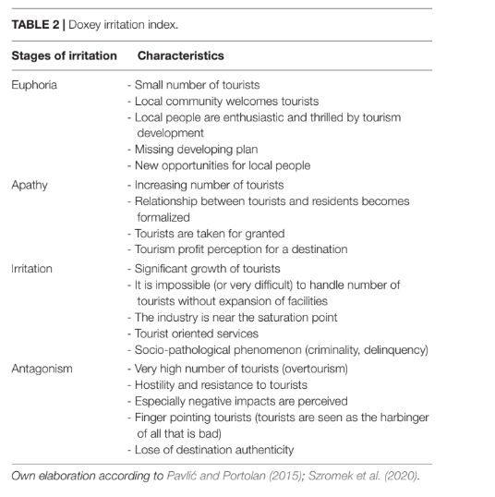
tourism development impacts. Frontiers in Psychology, 12, Article 684773. https://doi.org/10.3389/fpsyg.2021.684773

Section 3: RESIDENT–TOURIST INTERACTIONS: PATTERNS AND CONSEQUENCES

1. Recurring Patterns in Resident–Tourist Dynamics
Tourism exerts a profound influence on local communities, shaping their economic, social, and cultural dynamics over time. Resident-tourist interactions evolve through distinct patterns influenced by economic opportunities, cultural exchanges, and environmental factors. While some communities thrive on tourism, embracing the financial and social benefits it brings, others experience growing resentment and fatigue as the number of visitors increases. This section examines the recurring patterns in resident-tourist dynamics, focusing on the phases of initial acceptance, shifts in perception over time, seasonal variations, and the delicate balance between cultural exchange and cultural fatigue.

Initial Acceptance and Economic Enthusiasm
In the early stages of tourism development, local communities often display a welcoming attitude toward visitors. This enthusiasm is primarily driven by the economic benefits that tourism promises, including increased job opportunities, infrastructure improvements, and economic diversification (Pavluković et al., 2011). As businesses flourish and local economies grow, residents are likely to view tourists as valuable contributors to their financial well-being. Tourism frequently serves as a catalyst for regional development, particularly in areas where alternative economic opportunities are limited (Lin, Chen, & Filieri, 2017).
The initial acceptance phase aligns with the early stages of Doxey’s Irritation Index, where communities experience euphoria due to the perceived positive impact of tourism. In this phase, government initiatives and local business investments often align to support tourism growth, creating an optimistic outlook for both policymakers and residents (Schubert & Schamel, 2020). This enthusiasm is particularly pronounced in destinations where tourism infrastructure is underdeveloped, as the influx of visitors is seen as a gateway to modernization and progress (Hoogendoorn & Hammett, 2021).
However, the sustainability of economic enthusiasm depends on how benefits are distributed within the community. In cases where local businesses and workers directly profit from tourism, residents maintain a positive perception of visitors. Conversely, when multinational corporations and external investors dominate the tourism sector, local communities may feel excluded from the financial gains, leading to early signs of dissatisfaction (Lin et al., 2017). The shift from local ownership to corporate control often results in economic leakage, where profits generated from tourism leave the local economy instead of being reinvested into the community (Schubert & Schamel, 2020).

Shifts in Perception Over Time
As tourism continues to grow, resident perceptions often transition from enthusiasm to ambivalence or even opposition. This shift is typically driven by an imbalance between economic benefits and the social costs associated with increased tourism activity. Research suggests that when the negative impacts—such as overcrowding, inflation, and environmental degradation—outweigh the benefits, residents develop a more critical view of tourism (Pavluković et al., 2011).
The progression from acceptance to frustration follows a predictable pattern. Initially, tourism is viewed as a vehicle for economic prosperity, but as visitor numbers rise, residents may begin to perceive tourists as disruptive to their daily lives. Public spaces become congested, local traditions are commercialized, and essential services—such as healthcare, transportation, and housing—become strained due to increased demand from tourists (Lin et al., 2017). As these inconveniences accumulate, frustration grows, leading to reduced support for tourism expansion (Hoogendoorn & Hammett, 2021).
This shift in perception is particularly evident in urban areas that experience overtourism. Cities such as Barcelona and Venice, where tourism saturation has disrupted local life, have witnessed increasing resistance from residents in the form of protests and policy demands aimed at regulating visitor numbers (Schubert & Schamel, 2020). As tensions rise, communities that once embraced tourism may seek to impose restrictions, such as limiting short-term rentals, increasing tourist taxes, or implementing visitor caps to manage the adverse effects of tourism (Lin et al., 2017).

Seasonal Variations in resident-tourist relations
Tourism is inherently seasonal in many destinations, leading to fluctuations in resident attitudes throughout the year. During peak seasons, the surge of tourists can overwhelm local infrastructure, creating congestion, noise pollution, and resource depletion (Pavluković et al., 2011). These pressures often lead to increased frustration among residents, as their quality of life deteriorates due to overcrowding and heightened demand for goods and services. In extreme cases, residents may develop avoidance behaviors, steering clear of tourist hotspots during high seasons to minimize disruptions in their daily lives (Hoogendoorn & Hammett, 2021).
Conversely, during off-peak seasons, local businesses may struggle due to reduced tourist activity, leading to economic instability. This cyclical nature of tourism can create a paradox where residents simultaneously appreciate and resent tourism, depending on the time of year (Lin et al., 2017). In regions heavily dependent on seasonal tourism, employment patterns mirror these fluctuations, with workers facing job insecurity during off-seasons. This instability further complicates resident attitudes, as individuals may be reliant on tourism for income while also experiencing the negative consequences of its seasonal impact (Schubert & Schamel, 2020).
Governments and tourism boards often attempt to address seasonal imbalances by promoting sustainable tourism strategies that distribute visitor numbers more evenly throughout the year. Initiatives such as diversified attractions, off-season marketing campaigns, and infrastructure improvements aim to mitigate the extreme fluctuations in resident-tourist relations (Lin et al., 2017). However, the effectiveness of these measures varies depending on local policies and the willingness of businesses to adapt to a more balanced tourism model.

Cultural Exchange vs. Cultural Fatigue
One of the most significant aspects of resident-tourist dynamics is the interplay between cultural exchange and cultural fatigue. Tourism brings opportunities for cross-cultural interactions, allowing residents and visitors to engage in meaningful exchanges that foster mutual understanding and appreciation (Pavluković et al., 2011). In many cases, these interactions contribute to a greater sense of cultural pride, as residents share their traditions, language, and history with visitors (Lin et al., 2017).
However, when tourism becomes excessive, cultural fatigue can set in, leading to resentment and resistance. Cultural fatigue occurs when residents feel overwhelmed by continuous exposure to tourists, particularly when interactions are superficial or transactional rather than meaningful (Schubert & Schamel, 2020). In destinations where tourism dominates local identity, residents may experience a loss of cultural authenticity, as traditions and customs are altered to cater to tourist expectations rather than being preserved for intrinsic cultural value (Hoogendoorn & Hammett, 2021).
This commodification of culture can create an identity crisis within host communities. As businesses tailor their offerings to suit tourist preferences, aspects of local culture may be diluted or commercialized to maximize visitor appeal. Lin et al. (2017) argue that this shift can lead to a disconnect between residents and their cultural heritage, as local traditions evolve into staged performances designed for tourist consumption rather than genuine expressions of community identity.
To counteract cultural fatigue, some destinations implement strategies to balance tourism development with cultural preservation. Community-led tourism initiatives, policies that limit mass tourism in sensitive cultural areas, and educational programs promoting responsible tourism behavior are among the approaches used to ensure that cultural exchange remains beneficial rather than exploitative (Schubert & Schamel, 2020). The effectiveness of these efforts depends on the level of resident involvement and the commitment of policymakers to prioritize cultural integrity alongside economic interests.

The patterns in resident-tourist dynamics reveal the complex relationship between economic benefits, social changes, and cultural preservation. While tourism can bring prosperity and cross-cultural connections, it also presents challenges that communities must navigate to maintain a sustainable and balanced approach to tourism development. Understanding these recurring patterns allows for better policy decisions, ensuring that tourism remains a force for positive change rather than a source of tension and division.

2. Long-Term Effects on Society and Economy
Tourism, as a major economic driver in many regions, has profound long-term effects on both society and the economy. While it provides significant benefits such as employment, infrastructure development, and economic diversification, it also poses serious challenges, including economic dependency, social transformation, overtourism, and employment disparities. These long-term consequences shape the sustainability of tourism and its impact on host communities, making it crucial to assess both the benefits and drawbacks of prolonged tourism reliance.

Economic Dependency on Tourism
One of the most significant long-term effects of tourism is economic dependency. Many regions that experience tourism growth become heavily reliant on visitor spending as their primary source of income. While tourism can drive local economies, overreliance on a single industry makes communities vulnerable to external shocks such as political instability, economic recessions, natural disasters, and pandemics (Schubert & Schamel, 2020). The COVID-19 pandemic, for instance, demonstrated the fragility of tourism-dependent economies, as travel restrictions led to widespread job losses and economic stagnation in many popular destinations (Lin, Chen, & Filieri, 2017).
Economic dependency also affects the structure of local economies. Instead of fostering diverse economic activities, tourism often dominates investment, drawing resources away from other industries such as agriculture, manufacturing, or technology. As a result, communities become economically specialized in tourism-related services, leaving them exposed to fluctuations in visitor demand (Schubert & Schamel, 2020). This phenomenon, known as "tourism monoculture," can create a precarious economic environment where financial stability is directly tied to unpredictable tourism patterns.
Additionally, the financial benefits of tourism are not always evenly distributed within host communities. Large-scale tourism developments often favor corporate investors and international hotel chains, leading to economic leakage, where profits generated by tourism do not remain in the local economy (Lin et al., 2017). This imbalance can result in wealth concentration among a small elite while the broader local population experiences stagnant wages and limited economic mobility.

Social Transformations in Host Communities
The long-term social effects of tourism extend beyond economic factors, influencing local culture, community cohesion, and quality of life. The influx of visitors often alters traditional lifestyles and customs, sometimes leading to shifts in societal values and behaviors (Hoogendoorn & Hammett, 2021). In some cases, tourism fosters cultural pride and encourages the preservation of heritage sites and traditions. However, in many instances, it contributes to the commercialization and commodification of culture, where local customs are modified or staged to cater to tourist expectations rather than being preserved for intrinsic cultural value (Lin et al., 2017).
Gentrification is another major social consequence of long-term tourism growth. As demand for short-term rentals and luxury accommodations increases, property values rise, making housing less affordable for local residents (Schubert & Schamel, 2020). This displacement often forces long-term residents to relocate to less desirable areas, leading to a loss of community identity and social cohesion. Cities such as Barcelona and Venice have experienced significant social changes due to mass tourism, with local populations decreasing as residential neighborhoods are converted into tourist-oriented districts (Lin et al., 2017).
Furthermore, tourism can lead to shifts in employment structures within communities. Traditional industries may decline as local workers move into tourism-related jobs, which, while abundant, often provide low wages and seasonal employment. This shift can contribute to economic polarization, where a segment of the population benefits from tourism-related wealth, while others struggle with job insecurity and rising living costs (Schubert & Schamel, 2020).

Overtourism and Its Consequences
Overtourism occurs when the number of visitors exceeds the carrying capacity of a destination, leading to significant environmental, infrastructural, and social strain. Popular tourist destinations often struggle with overcrowding, pollution, increased waste production, and the deterioration of natural and historical sites (Schubert & Schamel, 2020). As more tourists visit a location, the pressure on local infrastructure—such as roads, public transportation, and sanitation systems—becomes unsustainable, reducing the quality of life for both residents and visitors (Lin et al., 2017).
The environmental consequences of overtourism can be particularly severe. Natural attractions, such as beaches, forests, and national parks, suffer from habitat destruction, water shortages, and soil erosion due to excessive foot traffic and irresponsible tourist behavior (Hoogendoorn & Hammett, 2021). In destinations like Thailand’s Maya Bay, authorities were forced to close the area to tourists in an effort to restore damaged coral reefs and marine ecosystems that had been degraded by years of uncontrolled tourism (Schubert & Schamel, 2020).
Socially, overtourism can generate hostility between residents and visitors. As tourist numbers increase, residents may feel alienated in their own communities, leading to resistance movements and calls for stricter regulations on tourism growth (Lin et al., 2017). This phenomenon has been observed in cities such as Amsterdam, where local protests have demanded measures to curb excessive tourism and protect resident quality of life (Hoogendoorn & Hammett, 2021).

Employment and Income Disparities
While tourism generates employment, the quality of jobs it provides is a critical issue. Many tourism-related jobs are characterized by low wages, temporary contracts, and a lack of job security (Schubert & Schamel, 2020). Workers in the hospitality and service industries often face poor working conditions, including long hours, unstable income, and limited access to social benefits such as healthcare and retirement plans (Lin et al., 2017).
Income disparities within tourism-dependent economies are also a major concern. While business owners, property investors, and large hotel chains accumulate significant wealth, frontline tourism workers—such as hotel staff, tour guides, and restaurant employees—frequently struggle to make a living wage (Hoogendoorn & Hammett, 2021). This inequality is exacerbated in regions where tourism revenue is not reinvested into community development but instead extracted by external investors (Schubert & Schamel, 2020).
Moreover, gender and racial disparities in tourism employment further deepen economic inequalities. Women and marginalized groups are often concentrated in the lowest-paying and most precarious tourism jobs, with limited opportunities for career advancement (Lin et al., 2017). This systemic inequality highlights the need for labor protections and policies that ensure fair wages and working conditions in tourism industries.
The long-term effects of tourism on society and the economy are complex and multifaceted. While tourism can drive economic growth and cultural exchange, it also creates vulnerabilities related to economic dependency, social transformation, overtourism, and employment disparities. Sustainable tourism development requires careful planning and regulation to mitigate these negative impacts and ensure that the benefits of tourism are equitably distributed among host communities. Policymakers must balance economic incentives with social and environmental considerations to foster a tourism industry that supports both residents and visitors in a sustainable manner.

3. Examples of Resident Responses to Tourism
Tourism has a profound impact on local communities, prompting various responses from residents as they navigate the benefits and challenges associated with visitor influx. These responses range from adaptation and acceptance to resistance and advocacy for sustainable tourism practices. While some communities integrate tourism into their daily lives, others express concerns over economic, social, and environmental pressures. This section explores key resident responses, including adaptation strategies, tourism fatigue and backlash, grassroots sustainability initiatives, and government interventions.

Adaptation Strategies by Local Communities
Residents often employ adaptation strategies to accommodate the presence of tourists while maintaining their quality of life. These strategies may include behavioral adjustments, economic participation, or selective engagement with tourism activities. In many cases, locals modify their routines to avoid overcrowded tourist hotspots, adjusting their shopping habits, commuting times, and use of public spaces. This form of passive adaptation allows residents to coexist with tourists while minimizing disruptions to their daily lives.
Economic adaptation is another common response, as locals capitalize on tourism by opening small businesses, providing accommodations, or offering cultural experiences. Many residents shift toward entrepreneurial activities that cater to visitors, such as guiding tours, selling handcrafted goods, or operating restaurants. This economic engagement not only fosters financial stability but also facilitates positive resident-tourist interactions, fostering cultural exchange and mutual understanding.
Additionally, some communities adopt a more structured approach to adaptation by implementing resident-driven tourism management strategies. These may include organizing local events to engage both residents and tourists, establishing designated tourist zones, or promoting off-peak tourism to reduce congestion. Such strategies help integrate tourism into community life in a way that benefits both visitors and locals.

Tourism Fatigue and Resident Backlash
Despite the economic advantages of tourism, prolonged exposure to large tourist numbers can lead to tourism fatigue, where residents experience frustration, inconvenience, and resentment. This phenomenon is particularly evident in areas experiencing overtourism, where the local population struggles with issues such as overcrowding, rising living costs, environmental degradation, and the commercialization of their cultural heritage.
Tourism fatigue often manifests through social tension, with residents expressing dissatisfaction in various ways. Common signs of backlash include public complaints, anti-tourism slogans, and increased social media discourse highlighting the negative effects of tourism. In more extreme cases, frustration escalates into active protests, public demonstrations, or calls for stricter tourism regulations. Resident backlash is often fueled by concerns over housing shortages caused by short-term rentals, noise pollution from tourist activities, and the loss of community identity due to mass tourism.
As tourism fatigue intensifies, communities may adopt measures to reclaim their spaces, including petitions for policy changes, community-driven awareness campaigns, and restrictive zoning laws to control the spread of tourism-related businesses. Such efforts reflect a growing demand for balance between tourism growth and resident well-being.

Grassroots Initiatives for Sustainable Tourism
In response to the challenges posed by tourism, many communities engage in grassroots initiatives aimed at promoting sustainable tourism practices. These initiatives are often led by local organizations, residents’ associations, and environmental advocacy groups seeking to mitigate the negative effects of tourism while preserving the cultural and ecological integrity of their surroundings.
One common approach is the promotion of responsible tourism behavior among visitors. Residents participate in awareness campaigns encouraging tourists to respect local customs, reduce waste, and support local businesses. Social media platforms and community websites serve as key tools for educating visitors about ethical tourism practices and fostering a culture of respect between residents and tourists.
Environmental conservation efforts also play a crucial role in grassroots sustainable tourism initiatives. Many communities organize beach clean-ups, wildlife protection programs, and responsible hiking initiatives to minimize tourism-related environmental harm. Additionally, local businesses may collaborate with sustainability organizations to implement eco-friendly policies, such as banning single-use plastics, promoting carbon-neutral tourism activities, and encouraging visitors to engage in low-impact travel experiences.
Beyond environmental efforts, grassroots initiatives often advocate for policy changes that prioritize resident interests. Community-led discussions, town hall meetings, and local advocacy campaigns serve as platforms for residents to voice concerns and propose solutions that align tourism growth with long-term community sustainability.

Government and Policy Interventions
Recognizing the complexities of resident-tourist dynamics, governments at various levels implement policy interventions to manage tourism’s impact on local communities. These policies range from regulatory measures aimed at controlling tourist numbers to initiatives designed to distribute tourism benefits more equitably.
One common government response is the introduction of tourism taxes, designed to generate revenue for infrastructure maintenance, environmental conservation, and community support programs. These taxes, often applied to accommodations, attractions, or transportation services, help offset the costs associated with tourism and ensure that residents benefit from visitor expenditures.
Governments also regulate short-term rental markets to address housing affordability concerns. Policies such as rental caps, licensing requirements, and zoning restrictions aim to prevent an oversaturation of tourist accommodations that displace long-term residents. By managing the balance between tourism and housing availability, these regulations help protect local communities from gentrification and housing shortages.
In addition to financial and housing policies, governments implement sustainable tourism strategies to mitigate environmental and cultural degradation. These may include restricting access to sensitive ecological sites, enforcing noise control measures, and investing in public infrastructure improvements to accommodate both residents and tourists more effectively.
Finally, collaborative governance models encourage resident participation in tourism planning and decision-making. By involving local communities in policy discussions, governments can create tourism strategies that align with resident needs and ensure that tourism remains a sustainable and mutually beneficial industry.

Resident responses to tourism vary widely depending on the scale and impact of visitor presence. While some communities adapt by integrating tourism into their economic and social structures, others experience fatigue and resistance due to excessive tourist numbers. Grassroots initiatives play a crucial role in promoting sustainable tourism, advocating for responsible visitor behavior, and pushing for policy changes. Meanwhile, government interventions provide regulatory frameworks to balance tourism growth with resident well-being. By understanding these responses, stakeholders in the tourism industry can work toward more sustainable and inclusive tourism models that respect both local communities and visitor experiences.

CHAPTER 2: TOURISM DEVELOPMENT AND ITS SOCIETAL IMPACT
Tourism is often celebrated for its potential to generate economic growth, create employment, and foster cultural exchange. However, its development within host communities also brings a wide array of societal implications both constructive and detrimental. As tourism expands and reshapes local environments, it inevitably affects the social fabric of communities, influencing how residents perceive themselves, their surroundings, and their interactions with outsiders.

This chapter explores the multifaceted societal impacts of tourism development, emphasizing how local communities experience, adapt to, or resist these changes. It critically examines the intersection between tourism growth and community well-being, drawing attention to the significance of local perceptions and social responses. Whether through increased opportunities or emerging tensions, tourism development becomes a transformative force that alters not just economies but also identities, values, and daily life.

Understanding these societal dimensions is crucial for fostering more equitable and sustainable tourism practices. Acknowledging the lived experiences of residents enables tourism stakeholders to address underlying sources of discontent and to design interventions that are more inclusive and socially responsible. This chapter contributes to that understanding by analyzing how tourism development shapes, and is shaped by, the people who live where it occurs.

Section 1: TOURISM AND ITS DEVELOPMENT IN HOST COMMUNITIES

1. Definition and Importance of Tourism
Tourism is a multifaceted and dynamic global activity that involves the temporary movement of people to destinations outside their usual environment, along with the consumption of goods and services in those places. It has evolved from being a leisure activity for a privileged few into a major global phenomenon affecting nearly every country and community. The definition of tourism has been explored and expanded upon by many scholars and institutions to reflect its changing nature and scope. The United Nations World Tourism Organization (UNWTO) defines tourism as “the activities of persons traveling to and staying in places outside their usual environment for not more than one consecutive year for leisure, business and other purposes” (Goeldner & Ritchie, n.d.). This definition, which has gained international acceptance, reflects a consensus that tourism includes both domestic and international travel, with wide-ranging implications for economies, cultures, and the environment.
Historically, the concept of tourism has developed in response to evolving social, economic, and technological conditions. According to Camilleri (2018), tourism involves voluntary travel outside of one’s regular environment and often includes activities chosen by individuals for recreational or professional reasons. Earlier interpretations, such as those discussed by Hall (2008), Holloway and Taylor (2006), and Jafari (2002), also emphasized the role of the destination in distinguishing tourism from other types of human mobility. The 1963 United Nations Conference on International Travel and Tourism defined visitors broadly, dividing them into tourists (staying more than 24 hours) and excursionists (staying less than 24 hours), with a focus on international movement. However, later frameworks, such as that from the Tourism Society (cited in Cooper, 2008), expanded this definition to include domestic tourism, day-trips, and short excursions, thereby acknowledging that tourism is not confined to international borders but exists within nations as well.
Tourism is now widely understood not merely as a collection of activities or an industry, but as a powerful force with economic, cultural, environmental, and social dimensions. As Camilleri (2018) explains, tourism involves the interaction between demand (visitors) and supply (destinations and services), creating a network of relationships and exchanges. The significance of tourism lies in its ability to stimulate regional development, create employment opportunities, and foster international cooperation and understanding. Moreover, tourism has become a critical component of globalization, facilitating the movement of people, ideas, and values across borders (Camilleri, 2018; Goeldner & Ritchie, n.d.).
In the thesis by Ghalia (2016), tourism is described as a short-term movement of people that contributes to a broader exchange of goods, services, and ideas, playing an increasingly central role in global economic systems. This is consistent with Mathieson and Wall’s (1982) perspective, which highlights the impact of domestic travel on the national balance of payments and the circulation of economic benefits within local economies. Yuksel (2004) also emphasized the dual nature of tourism domestic and international and the importance of distinguishing between these categories when evaluating tourism’s role in national development strategies.

2. Economic Impact: GDP Contribution and Employment
Tourism is one of the most significant contributors to the global economy. It directly and indirectly supports employment and generates income through related sectors such as hospitality, transportation, and retail. Ghalia (2016) outlines how the tourism sector stimulates both direct and indirect employment across a wide range of industries, underscoring the sector’s capacity to act as a multiplier in economic terms. The economic ripple effect created by tourism means that the benefits of a single tourist's spending often extend beyond the immediate services they consume.
According to Camilleri (2018), the tourism industry not only brings in foreign exchange but also attracts investment in public infrastructure such as roads, airports, sanitation, and public utilities. In many developing countries, tourism is one of the few viable sectors capable of generating foreign exchange earnings, creating employment, and fostering entrepreneurship. It is particularly important in regions where traditional sectors such as agriculture or manufacturing have declined or are insufficiently diversified. The versatility of tourism allows for both formal and informal employment opportunities, often serving as an entry point into the workforce, especially for youth and women.
However, the benefits of tourism are not without their drawbacks. Ghalia (2016) warns of the dangers associated with over-dependence on tourism, particularly in small economies where it becomes a dominant sector. In such cases, the economic structure may become distorted, leading to what is known as Dutch Disease—where booming sectors crowd out traditional industries, leading to a loss of competitiveness in agriculture and manufacturing. Moreover, the seasonal nature of tourism, as discussed by Fabry (2014), means that employment and income from tourism are often unstable and concentrated in certain months of the year. During off-peak periods or the “inter-saison,” economic activity may shrink, businesses may close temporarily, and workers may face layoffs or reduced hours.
Seasonality is particularly pronounced in coastal, rural, or mountainous regions that are specialized for either summer or winter tourism. In these areas, entire economies may hinge on peak tourist flows. Conversely, urban tourism tends to be less affected by seasonality due to the variety of available activities (Fabry, 2014). However, even in cities, significant fluctuations can still occur based on global events, crises, or changing travel patterns. Thus, while tourism can serve as an economic lifeline, it also introduces volatility and risk that must be managed through diversification and strategic planning.

3. Social and Cultural Significance
Beyond its economic contributions, tourism is a major social force that reshapes communities and societies. It facilitates intercultural exchange, promotes mutual understanding, and can foster global awareness. By drawing attention to unique cultural practices, heritage sites, and local traditions, tourism can encourage their preservation and elevate their value within and outside the community. As Kefalaki and Papanikos (2008) argue, cultural tourism in particular enables communities to take pride in their identity and to monetize aspects of their culture in ways that support conservation and development.
The presence of tourists can revitalize traditional crafts, music, dance, and rituals by providing both an audience and a revenue stream. This can lead to a revalorization of local identity and a renewed sense of purpose, especially in areas facing economic stagnation or cultural erosion. Tourism can also support language preservation, as heritage tourism often draws attention to indigenous and minority languages that are otherwise at risk of disappearing.
However, there are significant risks associated with the cultural commodification that tourism often brings. As Korstanje et al. (2016) note, tourism can lead to the reconfiguration of cultural practices into staged performances designed to meet the expectations of outsiders. This transformation may strip rituals and traditions of their original context and meaning, reducing them to entertainment and, in some cases, distorting their symbolic value. Furthermore, when tourism development is led by external actors, local voices may be marginalized, and the community may lose control over how its culture is represented and interpreted.
Additionally, the influx of tourists can strain local infrastructure and create tensions between visitors and residents. Overcrowding, rising prices, and changing social norms can lead to resentment, especially if the perceived benefits of tourism are not evenly distributed. In extreme cases, tourism may contribute to the displacement of local populations, gentrification, or the prioritization of tourist needs over those of residents.
Historically, these tensions have grown as tourism has expanded in scope and scale. As Goeldner and Ritchie (n.d.) point out, the rise of mass tourism in the 1960s and 1970s introduced new challenges, including the management of large tourist flows, the preservation of environmental and cultural assets, and the mitigation of social disruption. While tourism has existed for centuries, its explosive growth in the post–World War II era has necessitated more deliberate planning and policy-making to balance its benefits and costs.

4. Types of Tourism and Their Impacts on host communities
In analyzing the impacts of different forms of tourism on host communities, it is critical to not only rely on theoretical discussions but also draw on empirical research. This section integrates findings from Musinguzi’s (2011) doctoral thesis and Muganda, Sirima, and Ezra’s (2013) grassroots case study in Tanzania, alongside other scholarly literature, to offer a comprehensive and extended analysis. These works provide detailed insights into how tourism—depending on its form and policy context—can influence the economic, cultural, and environmental landscapes of host communities.

Mass Tourism: Economic Gain vs. Overcrowding and Cultural Erosion
Mass tourism is characterized by the large-scale movement of tourists, typically to well-developed destinations with standardized amenities and package deals. Economically, mass tourism contributes significantly to local incomes and job creation (Tureac & Turtureanu, 2008). It supports a wide range of businesses and encourages investment in infrastructure, such as roads, airports, and sanitation systems.
In the context of South Africa, Musinguzi (2011) found that while residents in Alldays and Musina acknowledged the potential of tourism to alleviate poverty, the actual benefits were minimal and unevenly distributed. Mass tourism projects were often managed by external stakeholders, and community members expressed concern over the "unbalanced ownership of businesses" and lack of tourism revenue-sharing mechanisms (Musinguzi, 2011, p. 180). This highlights a structural flaw common in mass tourism: economic gains are not always equitably shared with the local population, particularly in historically marginalized communities.
Despite its economic promises, mass tourism often leads to negative externalities. Host communities may experience overcrowding, environmental degradation, and a decline in quality of life. Moreover, the social carrying capacity of destinations may be exceeded, leading to tensions between residents and visitors. Cultural erosion is another concern, as traditional ways of life may be abandoned or altered to cater to the preferences of mass-market tourists (Ghalia, 2016, p. 32). This phenomenon was echoed in Musinguzi’s (2011) work, where residents observed a shift in community values and social structures in response to tourism's demands—particularly when tourism planning excluded local input.
Muganda et al. (2013) also identified a widespread rejection of top-down tourism models in Tanzania. Locals voiced their dissatisfaction with being sidelined in policy and decision-making, resulting in forms of tourism that did not align with their values or priorities. This marginalization contributes to a loss of cultural autonomy, where communities are expected to perform sanitized versions of their culture for tourist consumption, leading to what many view as cultural dilution or mimicry.

Cultural Tourism: Preservation vs. Commodification
Cultural tourism focuses on the exploration and appreciation of a destination’s cultural heritage, including architecture, arts, rituals, and cuisine. This form of tourism has the potential to support cultural preservation by generating revenue for conservation projects and fostering pride in local identity (Kefalaki & Papanikos, 2008). When implemented sensitively, it encourages community engagement and the transmission of traditional knowledge.
However, cultural tourism is also prone to the risk of commodification. Cultural practices may be transformed into performances devoid of their original context or meaning, as communities adapt to the demands of tourists. As Korstanje et al. (2016) explain, the increased visibility of certain cultural traits can lead to their simplification, distortion, or exploitation, particularly when tourism development is led by external actors with minimal local participation.
Muganda et al. (2013) highlighted the tension between cultural preservation and commodification in Barabarani village. While cultural tourism provided income opportunities, residents expressed concerns about the exploitation of their traditions without corresponding benefits or recognition. Importantly, their study revealed that locals wanted greater control over how their culture was represented and marketed to tourists. They emphasized the need for policies that allow them to safeguard cultural integrity while still leveraging tourism for economic empowerment.
Musinguzi (2011) similarly found that in South African communities, cultural tourism initiatives often benefited private operators more than local artists, performers, and heritage custodians. Without community involvement in tourism planning and heritage interpretation, cultural resources became commodities rather than living expressions of identity. These findings underline the necessity of participatory governance in tourism development, particularly in initiatives involving cultural heritage.

Eco-Tourism: Sustainability vs. Greenwashing
Eco-tourism is defined as responsible travel to natural areas that conserves the environment and supports the well-being of local people. It emerged as a response to the negative impacts of mass tourism and is often associated with sustainability, conservation, and education. Ghalia (2016) notes that eco-tourism provides an opportunity for host communities to benefit from their natural assets while avoiding the environmental degradation typical of large-scale tourism operations.
However, eco-tourism is not immune to criticism. The concept is sometimes misused in marketing—referred to as “greenwashing”—where conventional tourism operations are branded as eco-friendly without adopting substantive environmental or social practices (Korstanje et al., 2016). Moreover, poorly regulated eco-tourism can disrupt local ecosystems and traditional land use, especially when profits are not equitably shared with local populations.
Musinguzi (2011) illustrated these dynamics through his research in communities adjacent to the Mapungubwe National Park. While the park was a major draw for eco-tourists, the benefits to nearby communities were minimal. Locals were often restricted from accessing natural resources they had traditionally relied upon, such as firewood and grazing land, leading to conflicts and resentment. The imposition of conservation rules without community consultation contributed to the perception that eco-tourism was a form of enclosure rather than empowerment.
Additionally, residents reported that employment opportunities in eco-tourism projects were limited and often filled by outsiders (Musinguzi, 2011, p. 155). This undermined the principle of local benefit and highlighted the disconnect between eco-tourism ideals and realities on the ground.
Muganda et al. (2013) reinforced these findings by showing that grassroots involvement in eco-tourism planning is crucial for sustainability. Community members in Tanzania expressed the desire to be involved in decision-making processes to protect their environment in culturally appropriate ways. Their rejection of centralized governance reflected a broader call for participatory conservation models that acknowledge local knowledge and rights.

Tourism holds tremendous potential for the development of host communities through economic stimulation, social engagement, and cultural revitalization. Nonetheless, the nature and impact of tourism depend greatly on the type of tourism promoted and the policies guiding its implementation. Mass tourism brings immediate financial benefits but can lead to long-term socio-cultural and environmental challenges. Cultural and eco-tourism offer more sustainable alternatives but require genuine community involvement and transparent governance to avoid exploitation.
Ultimately, sustainable tourism development should prioritize the interests of host communities, promote equitable benefit-sharing, and safeguard the cultural and environmental integrity of destinations.

5. The Role of Local Populations in Tourism Development
Tourism has evolved into a vital sector for economic and socio-cultural development globally. Its influence extends far beyond recreation, shaping national economies, urban planning, employment patterns, and cultural landscapes. As tourism expands, so does the recognition of the essential role played by local populations in shaping sustainable tourism practices. Local communities are no longer viewed as passive beneficiaries or obstacles to development but as critical stakeholders whose involvement can significantly influence the success or failure of tourism initiatives. Their inclusion in policymaking processes is not only a matter of equity and fairness but also a pragmatic and strategic approach to ensuring long-term sustainability, social cohesion, and local ownership of development efforts.

Locals as Key Stakeholders
The term "stakeholder" refers to any group or individual that is either affected by or can affect the outcomes of a policy or development initiative. In the context of tourism development, stakeholders include a broad range of actors: governments, private investors, tourists, non-governmental organizations, and, most significantly, the local populations who reside in the destinations where tourism activities take place. These residents experience tourism’s effects most directly and consistently.
According to Muganda, Sirima, and Ezra (2013), local communities are not only affected by tourism development, but they also have a moral and practical right to influence the policies that shape that development. Their dual role as both impacted parties and potential contributors to planning makes them unique among tourism stakeholders. The authors underscore that treating locals as stakeholders must go beyond rhetoric; it must translate into active participation and influence in planning, decision-making, and implementation. Their views, needs, and aspirations should be incorporated at every stage of tourism policy development.
The recognition of locals as legitimate stakeholders has contributed to a shift toward participatory approaches in tourism development. This shift emphasizes not only the inclusion of local populations in dialogues but also values their cultural knowledge, practical experience, and long-term interest in the health of their environment and economy.

The Case for Local Involvement
The involvement of local communities in tourism policy is crucial for several interconnected reasons.
First, their participation ensures that tourism development is culturally appropriate and socially acceptable. As the primary custodians of their cultural heritage, locals hold deep knowledge of traditions, values, and practices that are often central to the tourist experience. When they are included in decision-making processes, tourism initiatives are more likely to respect these cultural assets rather than exploit or distort them. Without this involvement, development can lead to cultural misrepresentation, where traditions are repackaged solely for tourist consumption, sometimes to the detriment of community identity and cohesion.
Second, local participation enhances community acceptance of tourism projects and minimizes potential resistance. Tourism development, particularly in areas with limited infrastructure or historical marginalization, can lead to tensions if residents feel excluded or ignored. Musinguzi (2011) found that in the communities bordering Mapungubwe National Park in South Africa, residents expressed both hope and frustration—hope that tourism could improve their lives, and frustration at their lack of meaningful involvement in planning processes. This gap between policy intention and local engagement often leads to mismatches between what tourism delivers and what the community actually needs or values.
Third, community involvement contributes to economic empowerment. When properly supported, tourism can generate employment, income, and entrepreneurial opportunities. However, this is only achievable if locals are adequately trained, supported, and included in the value chain. Without this, the economic benefits of tourism are often absorbed by external investors or intermediaries, resulting in what is known as economic leakage. Muganda et al. (2013) observed this phenomenon in Tanzania, where many tourism operations were managed by outsiders, and local residents remained on the periphery—employed in low-wage jobs but unable to access ownership or decision-making roles. By contrast, when locals are involved early and meaningfully, they are better positioned to capture economic benefits and reinvest them in their communities.

Challenges to Community Participation
Despite widespread acknowledgement of its importance, community participation in tourism development often remains limited due to deep-rooted structural barriers.
One of the primary challenges is the persistence of top-down governance models. Muganda et al. (2013) found that in Tanzania, centralized decision-making processes continued to dominate tourism planning. Local communities were rarely consulted during the formulation of tourism policies and strategies. As a result, development initiatives often overlooked local priorities, which bred resentment and decreased community support for tourism projects. This disconnect also reduced the potential effectiveness of tourism as a development tool, as policies failed to reflect ground realities.
Another major barrier is the lack of capacity within many local communities. As Musinguzi (2011) highlighted in his research, a significant portion of residents living near tourism zones in South Africa lacked the education, technical skills, or institutional support to engage effectively in tourism. This deficiency was often a legacy of historical exclusion and socio-economic inequality. Without targeted capacity-building programs, communities remain unprepared to participate in or benefit from tourism, despite being directly affected by it.
Additionally, local involvement is sometimes limited to symbolic or superficial forms. Community consultations may be held as formalities, without actual influence on outcomes. In practice, this means that while locals are technically "involved," their contributions are not integrated into final decisions. This tokenistic participation does little to empower communities or improve tourism sustainability. As observed by Muganda et al. (2013), true participation must be both inclusive and influential—giving people not just a seat at the table, but a voice that is heard and acted upon.

Benefits of Inclusive Tourism Policy
When local populations are genuinely engaged in the tourism policymaking process, the results are substantially improved in terms of sustainability, equity, and effectiveness. Community participation enhances transparency in decision-making and creates a feedback loop that allows for continuous monitoring and adaptation.
Musinguzi (2011) developed a comprehensive monitoring framework that incorporates both external indicators—like infrastructure and revenue distribution—and internal perspectives—such as local knowledge, satisfaction, and cultural priorities. This kind of dual-approach underscores the importance of treating communities not only as beneficiaries but also as evaluators and co-managers of tourism outcomes.
Muganda et al. (2013) also reported that Tanzanian locals wanted to be involved at the earliest stages of policy formulation, not after decisions had already been made. Their experience showed that when locals are empowered from the start, tourism projects are more likely to reflect community needs, address existing inequalities, and distribute benefits more fairly. Moreover, participation acts as a safeguard against corruption and mismanagement by increasing transparency and building local accountability mechanisms.

Participatory Governance
Creating a participatory tourism model requires more than good intentions. It demands legal, structural, and cultural changes within tourism governance. Muganda et al. (2013) argue that effective participation involves the creation of institutions that support dialogue, build trust, and allocate real authority to community representatives. Local councils, tourism boards, and planning committees must include community members not just for appearance but for genuine policy influence.
Moreover, empowerment must be both procedural—through laws and systems that require local consultation—and substantive, by giving communities access to the training, funding, and platforms they need to engage meaningfully. As shown in Musinguzi’s (2011) work, technical skills, tourism literacy, and organizational support are essential for locals to move from observers to active participants in tourism development.
Ultimately, participatory governance is not merely a tool for inclusion—it is a foundation for building a tourism industry that is equitable, resilient, and truly sustainable. Local populations, when empowered, offer the insight, oversight, and innovation needed to ensure that tourism serves people as well as profit.
The role of local populations in tourism development is central to achieving sustainable, equitable, and effective tourism outcomes. As key stakeholders, locals bring cultural insights, vested interest, and practical knowledge that can enhance the design and implementation of tourism policies. However, their role remains underutilized due to persistent barriers such as top-down governance, capacity constraints, and lack of political will.
To harness the full potential of tourism as a tool for development, governments and planners must prioritize inclusive policymaking and genuine community engagement. This shift not only addresses issues of justice and empowerment but also strengthens the foundation for a resilient and community-driven tourism sector.

Section2: NEGATIVE CONSEQUENCES OF HOSTILE OR RESISTANT BEHAVIOR
Declining Tourist Satisfaction → Bad Reviews → Fewer Visitors
While tourism is often celebrated for its economic and cultural benefits, negative social dynamics between host communities and visitors can lead to significant long-term consequences for destinations. Among the most critical of these is hostile or resistant behavior by locals, which often stems from perceived or real negative impacts of tourism on their daily lives, culture, and environment. When such attitudes intensify, they directly influence tourist satisfaction, often culminating in bad experiences, negative reviews, and ultimately a decline in visitor numbers — triggering a downward spiral in the local tourism economy.

1. Root Causes of Hostility Toward Tourists
Hostility in tourism contexts often emerges when the host community perceives tourism as an external imposition rather than a participatory opportunity. According to Sheikhi, Jafari, and Xiao (2015), hostility can result from the commodification of local culture, social inequalities, and saturation of local resources, all of which alter the sociocultural balance and reduce the quality of life for locals. As tourists often consume services and occupy spaces critical to locals without meaningful engagement or respect for local norms, tension inevitably arises.
Doxey’s Irridex model (1975) provides a useful theoretical lens here: it outlines a progression from euphoria to apathy, irritation, and finally antagonism as tourism intensifies. This antagonism marks the stage where locals may actively or passively express resentment, sometimes even targeting tourists directly with cheating, verbal abuse, or exclusionary behavior (Sheikhi et al., 2015). Dogan (1989) further highlights that this resistance is not always overt; it can also manifest in retreatism, boundary maintenance, or cultural revitalization, all forms of adaptive behavior that, when misaligned with tourism development, can reduce tourists' sense of welcome and safety.

From Hostility to Declining Tourist Satisfaction
When visitors encounter unfriendly or unwelcoming hosts, the perceived hospitality—a core component of the tourism experience—diminishes. Hostile behavior creates discomfort, reduces emotional connection with the destination, and undermines feelings of relaxation or cultural curiosity. As a result, tourists leave with negative perceptions, leading to poor reviews on travel platforms and word-of-mouth deterrence.
Tourists today rely heavily on user-generated content, such as TripAdvisor or Google reviews, when making decisions. A few bad reviews mentioning hostility or safety concerns can have an outsized impact, especially in an industry where trust and perception play crucial roles in destination marketing.
Moreover, once a destination becomes associated with local unfriendliness or tension, reputational damage ensues. As pointed out by Akova and Atsız (2019), destinations that fail to maintain positive host–guest relations risk deteriorating their unique cultural appeal and aesthetic value—two major drivers of heritage and cultural tourism.

2. Declining Tourist Satisfaction and the Vicious Cycle
Reduced tourist satisfaction leads to lower visitation numbers. In tourism-dependent economies, this decline can trigger a domino effect:
- Local businesses suffer from decreased spending.
- Job losses occur, especially in service sectors like hospitality and transport.
- Public services—often maintained through tourism revenue—decline in quality.
- Community resentment intensifies, as the promised economic benefits of tourism no longer materialize.
As Dogan (1989) describes, communities may enter a state of prolonged resistance, especially when they feel exploited by external tourism stakeholders (such as foreign investors or tour operators). This leads to further degradation of the tourism environment, deterring investment and compounding the decline.
The phenomenon also intersects with cultural degradation. When tourism is viewed as a source of disruption rather than pride, locals may abandon or commercialize their traditions. This reduces the authenticity of the tourism experience, which, ironically, is what many cultural tourists seek. Thus, the cycle continues: less authenticity → lower satisfaction → fewer tourists.

3.Case Examples and Empirical Support
Evidence from multiple case studies supports this trajectory. In destinations such as Lamu (Kenya) and Zanzibar (Tanzania), Okech (2010) found that while some locals initially welcomed tourists, over time, perceptions shifted due to overcrowding, moral concerns, and economic marginalization. In extreme cases, such tensions have led to protests, boycotts, and deliberate efforts to restrict tourist access to culturally sensitive areas.
Likewise, Sheikhi et al. (2015) cite examples from the Caribbean, Hawaii, and parts of Greece, where fraud, cheating, and even physical assault on tourists have been documented—manifestations of accumulated frustration and unresolved conflict.

Ultimately, the emergence of hostility in host communities and its ripple effect on tourist satisfaction is not merely a byproduct of cultural differences—it is a reflection of inequitable development and exclusionary planning. As such, addressing these issues requires a proactive, participatory approach to tourism governance.
Stakeholders must ensure that local communities not only benefit materially from tourism but also feel respected, valued, and involved in shaping its future. Without this foundation, destinations risk turning tourism—a potential catalyst for development and intercultural understanding—into a source of tension, degradation, and economic decline.

4. Economic and Social Risks of Poor Host–Tourist Relations
Tourism is often promoted as a powerful vehicle for economic development and cultural exchange. However, the success of tourism heavily depends on the quality of interaction between hosts and tourists. When this relationship is strained, the consequences are not only interpersonal but deeply economic and social. Poor host-tourist relations can create a feedback loop that undermines the sustainability, inclusiveness, and resilience of tourism destinations.

Economic Risks
At the economic level, tourism is often hailed for generating employment, boosting local income, and increasing tax revenue. Nevertheless, the benefits are not always equitably distributed. In many cases, local residents perceive that tourism primarily benefits external investors and large tourism operators, leaving local communities to bear the environmental and social costs. According to the study on Prague, Krakow, and Braga, residents expressed dissatisfaction with how tourism profits were monopolized by outsiders, with little reinvestment into local welfare (Walas et al., 2023). This economic alienation can lead to resentment, withdrawal of community support, and passive resistance to tourism development.
Moreover, when residents feel excluded from the economic gains, they are less likely to engage in tourism-related entrepreneurship or participate in cooperative planning. This hampers the economic diversification of tourism and increases dependency on external actors. The “Economic Impacts of Tourism Industry” report highlights that if local communities do not see tangible improvements in their quality of life, they are more inclined to view tourists as a threat rather than as guests, leading to deteriorating service quality and a decline in repeat visitation (Economic Impacts of Tourism Industry, n.d.).
Additionally, conflicts between residents and tourists can increase public spending. Municipalities may be forced to allocate resources to manage crowding, restore damaged infrastructure, or mitigate environmental degradation caused by tourism—diverting funds from long-term development projects. This financial strain undermines the economic sustainability of tourism and diminishes the destination's ability to attract responsible investments.
Another critical aspect is the potential damage to the destination's image. In today’s digital age, tourists quickly share their experiences online. A negative encounter with unfriendly locals or reports of social tensions can harm a destination’s reputation, discouraging future tourists. This loss of goodwill can lead to a measurable drop in tourism revenue, particularly in destinations where tourism is a primary economic pillar.

Social Risks
Poor host-tourist relations also pose significant social risks. The influx of tourists into small or traditionally cohesive communities often disrupts daily life. Locals may feel that their culture, values, and living spaces are being commodified for external consumption. The “Social Impacts of Tourism Perceived by Host Communities” report points out that residents in several case studies experienced stress due to overcrowding, noise pollution, and the loss of familiar community spaces. This is particularly prevalent in destinations that experience rapid, unplanned tourism growth (Social Impacts of Tourism Perceived by Host Communities, n.d.).
Social tensions often intensify when tourists engage in behavior that is perceived as disrespectful—such as public intoxication, inappropriate clothing, or disregard for local customs. These behaviors create a cultural gap that can evolve into hostility, stereotyping, or even verbal and physical altercations. In the case of Prague, residents in highly touristic neighborhoods reported avoiding their own city centers because of the feeling that they no longer belonged there (Walas et al., 2023). This alienation contributes to a loss of social cohesion and can encourage out-migration, particularly among young residents.
Another social risk is the erosion of cultural authenticity. When tourism becomes the dominant economic activity, there is often a shift toward performing culture in ways that please tourists rather than preserving it for the community’s own continuity. This “staged authenticity” can dilute local traditions and create identity crises among the population. Over time, this weakens intergenerational transmission of culture and contributes to a homogenized cultural landscape that lacks depth and meaning for both residents and tourists.
Furthermore, when poor host-tourist dynamics persist, they can create long-lasting divisions within the community itself. Some residents may benefit from tourism (e.g., those owning businesses), while others feel exploited or marginalized. This internal fragmentation adds another layer of social risk, potentially leading to protests or grassroots movements opposing tourism altogether. As seen in Braga, even small increases in tourism can trigger community resistance when residents feel ignored in planning processes (Walas et al., 2023).

Interdependence of Social and Economic Dimensions
The economic and social risks of poor host-tourist relations are deeply intertwined. Economic exclusion often fuels social discontent, while social unrest discourages tourist arrivals and investor confidence. A breakdown in this delicate balance can send destinations into a cycle of decline, where mistrust, hostility, and disillusionment replace cooperation and shared prosperity.
To address these risks, tourism planning must prioritize inclusive governance, transparent benefit-sharing, and cultural sensitivity training—for both tourists and residents. Empowering communities to co-create tourism narratives and manage visitor flows can restore dignity to local cultures and foster mutual respect. As Walas et al. (2023) argue, sustainable tourism can only be achieved when local residents are not merely passive observers but active stakeholders in tourism development.

5. Environmental Challenges from Tourism–Resident Conflicts
Tourism, while often praised for its economic benefits and capacity to foster cultural exchange, has also been increasingly recognized as a contributor to environmental stress and social conflict. Among the most pressing concerns in this regard are overtourism—the phenomenon of excessive visitor numbers—and the subsequent depletion of natural resources. These issues not only threaten ecological sustainability but also heighten tensions between tourists and residents, often resulting in environmental conflicts that undermine the goals of sustainable tourism development (STD).

Overtourism and Environmental Degradation
Overtourism occurs when the volume of visitors exceeds the environmental or social carrying capacity of a destination. This excessive presence of tourists can trigger a cascade of negative environmental impacts. As noted by Tran (2023), tourism frequently leads to “soil erosion, waste accumulation, water and air pollution,” and endangers biodiversity and cultural landscapes when not properly managed (Tran, 2023, p. 359). A particularly illustrative case is that of the Galapagos Islands, where increased tourism has resulted in overuse of freshwater resources, contamination of local water bodies, and degradation of delicate ecosystems (Tran, 2023, p. 360). These impacts are not isolated but tend to intensify with the rise in visitor numbers, especially in regions that lack resilient infrastructure or strong environmental protections.
Tourist activities—such as hiking, wildlife viewing, and water sports—place direct pressure on natural environments. Construction of resorts, roads, and recreational facilities often comes at the expense of forests, wetlands, or coastal zones, leading to habitat loss and fragmentation. Tran (2023) explains that air travel, vehicular traffic, and hotel energy consumption significantly contribute to greenhouse gas emissions, compounding the broader effects of global climate change (p. 360). These processes threaten not only the biodiversity and ecological integrity of host regions but also their attractiveness as tourism destinations.

Resource Depletion and Competition
In many developing regions, tourism intensifies competition over scarce natural resources, creating visible and often politically charged conflicts between local populations and tourism operators. The strain is especially pronounced in regions where basic services such as water, food, and energy are already limited. Tourism tends to absorb a disproportionate share of these resources due to the high consumption patterns of tourists. According to Tran (2023), “Tourism can put a significant strain on local resources, such as energy, food, and other raw materials, which may already be in short supply” (p. 359). This dynamic not only increases the cost of living for local communities but can also result in direct resource exclusion, where residents lose access to resources essential for their livelihoods.
For instance, in Bali, Indonesia, increased tourism development displaced communities and restricted their access to coastal resources, a vital source of subsistence and income (Tran, 2023, p. 361). These types of conflicts often go beyond the environmental sphere and manifest in social, political, and even ethnic tensions, highlighting the deeply interlinked nature of environmental and socio-economic systems in tourism destinations.

Resident Well-Being and Environmental Conflict
The link between tourism-induced environmental degradation and resident well-being is central to understanding the roots of environmental conflict. Croes, Park, and Bonilla (2024) conducted an empirical study in Colombia, focusing on two contrasting settings: La Candelaria in Bogotá (urban) and La Macarena in Meta (rural). Their research revealed that while residents acknowledge tourism’s economic potential, environmental degradation emerges as a significant concern—particularly in rural areas (Croes et al., 2024, p. 1220). In La Macarena, residents reported environmental impacts such as noise pollution, reduced air quality, and strain on water and waste systems. These adverse conditions eroded their sense of environmental security and well-being.
The study further demonstrates that residents’ emotional and cognitive well-being—expressed as happiness and life satisfaction—are directly influenced by their perceptions of tourism’s environmental consequences. While economic benefits may temporarily boost life satisfaction, long-term exposure to environmental degradation has a corrosive effect on residents' quality of life (Croes et al., 2024, pp. 1221–1222). Residents increasingly view tourism as exploitative when it leads to irreversible environmental change, exacerbates inequalities, or fails to deliver tangible local benefits.

Accumulated and Delayed Environmental Impacts
One of the complexities in managing tourism-related environmental conflicts lies in the delayed nature of many ecological effects. Tran (2023) notes that “some impacts may accumulate gradually over time, leading to long-term and significant changes that may not become apparent until it is too late to reverse them” (p. 360). These include the loss of biodiversity, contamination of water sources, and erosion of coastal zones. Such “slow violence” undermines both ecological resilience and social trust, especially when authorities are perceived as passive or complicit in facilitating unsustainable tourism.
The cumulative nature of environmental degradation also places tourism operators at risk. As Tran (2023) observes, ecosystem degradation often results in “reduced attractiveness of a destination and negative economic impacts on the local tourism industry” (p. 359). This dynamic demonstrates the self-defeating nature of unsustainable tourism development and highlights the urgent need for long-term planning and ecosystem monitoring.

Waste Management and Pollution conflict
Waste generation—particularly solid waste and sewage—is one of the most immediate and visible impacts of mass tourism. In many popular destinations, infrastructure is insufficient to handle the seasonal influx of tourists, leading to uncollected garbage, polluted rivers, and overwhelmed landfills. According to Tran (2023), “tourist destinations with a high concentration of activities and natural attractions often face significant challenges with waste disposal,” which in turn fuels resident dissatisfaction (p. 360). Improper waste management affects not only environmental quality but also public health, contributing to an increasingly adversarial relationship between residents and the tourism industry.
Croes et al. (2024) support these findings by illustrating how waste accumulation in both urban and rural Colombia affects residents' perceptions of tourism. In La Macarena, where public services are underdeveloped, the burden of tourism-related waste disproportionately falls on local populations. The perceived inequality in how environmental costs and economic gains are distributed deepens resident resentment and leads to resistance against further tourism development (p. 1223).

Community Engagement for Sustainability
Addressing the dual challenge of overtourism and resource depletion requires the integration of environmental stewardship with inclusive governance. Tran (2023) outlines a set of conflict management strategies that include “collaborative decision-making, community engagement, environmental impact assessments, and regulatory frameworks” (p. 358). These mechanisms are essential to mitigate conflict, empower local communities, and ensure that environmental sustainability is not sacrificed for short-term profit.
Furthermore, Croes et al. (2024) emphasize the role of perception in shaping resident support for tourism. When locals see that tourism contributes to environmental conservation—such as through eco-tourism, protected areas, or green infrastructure—they are more likely to support its expansion. Conversely, when tourism is seen as extractive and environmentally harmful, support diminishes, regardless of economic gains (pp. 1222–1224).
The environmental challenges posed by overtourism and natural resource depletion are inseparable from the lived experiences of local residents. These challenges are not merely about ecological metrics but are deeply embedded in the social fabric of communities. As the case studies from Colombia and broader global trends show, unsustainable tourism creates conditions for environmental conflict, undermines resident well-being, and ultimately threatens the viability of the tourism industry itself.
Effective responses must move beyond technocratic solutions to embrace participatory, community-driven models that balance ecological conservation with equitable development. Only by addressing the roots of tourism-resident conflict—through environmental justice, inclusive governance, and long-term planning—can destinations hope to achieve truly sustainable tourism.

Section 3: THE INFLUENCE OF LOCAL ATTITUDES ON TOURIST EXPERIENCE
Tourism is not only a transactional relationship between guests and service providers but a socially embedded experience that is highly influenced by the attitudes of local residents. Local communities are not passive bystanders in the tourism process; rather, their perceptions, behaviors, and engagement with visitors play a significant role in shaping the tourist experience. Research increasingly recognizes that welcoming or unwelcoming local attitudes can directly impact tourist satisfaction, destination image, and even the long-term sustainability of tourism. Understanding the central role of local communities, therefore, becomes essential for planning inclusive, authentic, and resilient tourism development.

1. Positive Local Attitudes and Tourist Satisfaction
Local residents who view tourism positively tend to engage more warmly with visitors, and this directly contributes to an enhanced tourist experience. Friendly gestures, willingness to assist, and openness to cultural exchange are often highlighted in tourist feedback as key components of memorable trips. These experiences are emotionally significant, contributing to tourists’ feelings of safety, inclusion, and cultural immersion.
Govender, Maziriri, and Chuchu (2021) found that local attitudes have a statistically significant influence on tourists’ willingness to visit and revisit destinations. Their study, grounded in destination image theory, concluded that attitudes held by local residents toward tourists had a stronger effect on tourist behavior than residents’ general perceptions of tourism. When tourists perceive locals as warm, helpful, and respectful, they associate the destination with hospitality and are more likely to recommend it to others.
In many destinations, especially those that are community-dependent or rural, the interaction between locals and visitors becomes a defining aspect of the travel experience. Linderová, Scholz, and Almeida (2021) assert that a sense of shared identity and mutual respect between tourists and residents fosters more authentic and enriching experiences. When communities understand the benefits of tourism—such as economic gains, cultural preservation, or improved services—they tend to exhibit more positive behaviors toward visitors, reinforcing a cycle of goodwill and tourism growth.

2. Negative Attitudes and Tourist Discontent
On the other hand, negative or indifferent local attitudes can severely damage the tourist experience. Tourists are quick to sense discomfort, exclusion, or even subtle hostility, which may lead to feelings of insecurity, alienation, or regret. This is especially evident in destinations where locals perceive tourism as exploitative, disruptive, or unfairly managed.
Linderová et al. (2021) use Doxey’s Irritation Index to describe how local attitudes evolve as tourism intensifies—starting with euphoria and eventually shifting toward irritation and antagonism when tourism’s negative effects outweigh perceived benefits. In their study in Czechia, residents cited overcrowding, environmental strain, and rising prices as reasons for their growing frustration, particularly when tourism development occurred without adequate local consultation or compensation.
Kariuki (2013), in a study of communities around Lake Nakuru National Park in Kenya, reported that local residents developed negative attitudes toward tourism due to minimal involvement in decision-making, lack of revenue sharing, and increased wildlife-related damages. When benefits are unevenly distributed and locals are treated as outsiders in their own land, resentment builds. This hostility often manifests in passive resistance—such as lack of service quality—or active opposition through vandalism or protest, both of which directly affect the tourist experience.

3. Participation, Equity, and Their Mediating Role
A key factor influencing local attitudes is the extent to which residents feel involved in and benefit from tourism development. According to social exchange theory, people support tourism when they perceive that the benefits outweigh the costs (Govender et al., 2021). This theory has been confirmed across various contexts, indicating that inclusive planning and tangible benefits are critical to maintaining local support.
Kariuki (2013) found that communities with higher involvement in tourism management and more equitable benefit distribution expressed stronger support for tourism and demonstrated more positive attitudes toward tourists. In Lake Nakuru, when locals received employment opportunities or compensation for wildlife-related losses, their perception of tourism improved significantly. Conversely, where participation was minimal and benefits were unclear, hostility increased.
Linderová et al. (2021) emphasize the importance of resident empowerment through tourism, noting that local entrepreneurs who operate guesthouses, sell crafts, or guide tours tend to express pride in their cultural identity and act as informal ambassadors of their community. This not only enhances the tourist experience but strengthens the resilience of the local tourism economy.

4. Destination Image and Behavioral Feedback Loops
Resident attitudes have implications beyond individual interactions—they shape the perceived image of the destination itself. Destination image theory distinguishes between the "projected" image (through marketing) and the "perceived" image (based on actual experience). If local hostility contradicts promotional messaging that portrays the community as welcoming, it undermines destination credibility and visitor trust (Govender et al., 2021).
Tourist-generated content—such as social media posts, reviews, and testimonials—often highlights resident behavior. Positive experiences are widely shared and boost a destination’s reputation, while negative interactions can go viral and discourage future visits. In this way, the attitude of the local population becomes a branding mechanism that either validates or undermines official marketing narratives.
Moreover, as tourists become more socially conscious, the ethical dimensions of travel—such as fairness, local involvement, and cultural respect—play a larger role in destination selection. Linderová et al. (2021) suggest that community sentiment can be both a reflection of, and a response to, tourist behavior. When tourists act respectfully and contribute to local well-being, residents are more likely to respond with warmth and support.

Cultural Mediation and Long-Term Impact
Beyond economic considerations, local attitudes also shape how cultural assets are preserved, presented, or diluted. When residents view tourism as a way to celebrate and share their heritage, they are more likely to invest in authentic cultural experiences—from traditional dances to cuisine and storytelling. However, when culture is commodified or distorted for external consumption, residents may withdraw or even oppose tourism development.
Kariuki (2013) found that communities in Kenya were more supportive of tourism when they saw it as a vehicle for cultural pride and education. However, where tourism marginalized traditional practices or imposed foreign expectations, residents felt disconnected from the process. This disconnect can impact not only the richness of the tourist experience but also the sustainability of local identity.
Education, awareness campaigns, and cultural dialogue can mitigate these risks by aligning tourist behavior with community values. As Linderová et al. (2021) suggest, involving locals in curating their own narratives ensures that tourism becomes a two-way cultural exchange rather than a one-sided spectacle.
Local attitudes are among the most powerful forces shaping the tourist experience. They influence not only moment-to-moment interactions but also long-term perceptions of safety, authenticity, and emotional satisfaction. Whether tourism thrives or fails often depends on the support, engagement, and behavior of resident communities. As such, tourism development must move beyond infrastructure and marketing to prioritize community participation, equitable benefit-sharing, and cultural respect.
Positive local attitudes can enrich the tourist experience, foster loyalty, and generate sustainable economic growth. Conversely, negative attitudes—stemming from exclusion, injustice, or cultural loss—can erode both tourist satisfaction and destination reputation. Ultimately, placing the local population at the center of tourism strategy is not just ethical; it is essential for creating meaningful, reciprocal, and enduring travel experiences.

5. Examples of Destinations Affected by Local Behavior
Local behavior plays a pivotal role in shaping the development and sustainability of tourism destinations. Community reactions—ranging from engagement and hospitality to resistance and protest—have tangible impacts on how destinations are perceived and experienced by tourists. This section discusses examples drawn from empirical research that illustrates how local behavior directly influences tourism outcomes in specific global destinations.

5.1. Barcelona, Spain: Local Resistance and Tourismphobia
Barcelona has emerged as a quintessential example of how local opposition can impact tourism development. Once celebrated for its architecture and Mediterranean lifestyle, the city has increasingly become a site of contestation between residents and the tourism industry. The phenomenon of "tourismphobia" has been particularly visible, with locals protesting overtourism through demonstrations and public messaging such as graffiti, banners, and political activism (Hernandez-Maskivker et al., 2021).
Residents report a host of negative impacts, including housing inflation, gentrification, traffic congestion, and deterioration in quality of life. In a quantitative study of 395 Barcelona residents, social and environmental dimensions of tourism were rated negatively, especially by those living or working downtown (Hernandez-Maskivker et al., 2021). Locals expressed frustration at losing access to public spaces and cultural heritage sites, while also experiencing psychological pressure from overcrowding. This antagonistic local behavior has not only influenced tourism policy but has also shaped the global image of Barcelona, prompting media outlets like CNN to list it among destinations to avoid due to local unrest (Hernandez-Maskivker et al., 2021).

5.2. Sevilla, Spain: Moderate Impacts and Community Adaptation
Sevilla, while also a mature destination in Spain, demonstrates a more nuanced relationship between locals and tourism. Though it faces similar challenges related to housing costs and congestion, local perceptions in Sevilla show a more balanced view. A study involving 252 residents revealed that while concerns exist—especially regarding mobility in the city center and increased prices—residents also recognize tourism's economic contributions, including job creation and city development (Hernandez-Maskivker et al., 2021).
Importantly, residents who lived outside the city center but worked downtown exhibited more optimistic perceptions of tourism. This indicates that proximity to tourist zones may intensify negative feelings, a trend that echoes Butler’s (1980) Tourism Area Life Cycle model as destinations mature and approach stagnation or decline unless managed sustainably. The relative calm in Sevilla suggests that while local behavior can signal discontent, it can also provide valuable feedback for managing tourism in a more sustainable and inclusive way.

5.3. Kebondalem Kidul, Indonesia: Cultural Preservation Through Local Hospitality
In contrast to European urban destinations, Kebondalem Kidul in Central Java, Indonesia, represents a rural and heritage-based tourism model where local behavior revolves around cultural preservation and hospitality. The village is renowned for its traditional dances, culinary arts, and artisanal crafts, all of which are rooted in Javanese culture (Hidayat et al., 2023).
Local culture in Kebondalem Kidul significantly influences the tourist experience, particularly through memorable cultural interactions and community involvement. A quantitative study using structural equation modeling found that local culture had a strong and positive effect on both memorable tourism experiences and the overall destination image. These, in turn, increased the tourists’ intention to recommend the destination to others (Hidayat et al., 2023). Unlike Barcelona, where overtourism led to conflict, Kebondalem Kidul showcases a destination where respectful interaction between tourists and locals enhances satisfaction and supports cultural sustainability.
However, the village has also faced challenges. Tourist numbers declined due to shifting preferences toward modern experiences, highlighting that even in culturally rich environments, local behavior must adapt to evolving expectations (Hidayat et al., 2023). In response, local tourism managers began creatively repackaging cultural experiences to appeal to contemporary tastes while maintaining authenticity. The continued involvement of residents in providing culturally immersive experiences remains key to the village’s tourism strategy.
The examples of Barcelona, Sevilla, and Kebondalem Kidul provide a cross-cultural view of how local behavior affects tourism. In Barcelona, resistance to overtourism has redefined the city’s global image, while in Sevilla, more moderate community responses offer a path for coexistence. Meanwhile, in Kebondalem Kidul, positive local engagement rooted in cultural hospitality plays a central role in shaping tourist satisfaction and loyalty. These cases underline the importance of including local communities in tourism planning and highlight the need for adaptive, culturally sensitive strategies to ensure sustainability and mutual respect between hosts and guests.

6. The Relationship Between Local Residents and Tourism
Tourism development and local residents are inherently interconnected. As outlined in the previous sections—ranging from the foundations of human behavior in social contexts (1.1), to residents' attitudes within the tourism environment (1.2), and finally to the interactional dynamics and long-term social consequences (1.3)—this section concludes the theoretical chapter by synthesizing how tourism and local communities affect each other. Drawing from the three core documents used in this thesis—Huber & Gross (2020), Al-Gahuri (2014), and Kliuchnyk et al. (2023)—this part highlights the dual role residents play as both beneficiaries and stakeholders in tourism, and explains how tourism ultimately shapes community well-being, collective identity, and local governance.

6.1 Quality of Life and Community Well-being
Tourism’s ability to enhance or degrade the quality of life (QoL) for local residents is central to its long-term viability. QoL encompasses both objective improvements—such as infrastructure, job creation, and access to services—and subjective perceptions of satisfaction, identity, and belonging. As Kliuchnyk et al. (2023) argue, rural and small communities that participate in tourism development often report increased economic opportunities, revitalized public services, and strengthened cultural preservation efforts.
However, the distribution of benefits is not always equal. Al-Gahuri (2014) notes that disparities in access to tourism-driven income and rising living costs can intensify class tensions and marginalize lower-income residents. These effects are particularly visible in destinations where tourism grows faster than local governance and infrastructure can accommodate.

6.2 Evolution of Resident Attitudes Over Time
Resident reactions to tourism evolve through a predictable series of stages, as described in Doxey’s Irritation Index (cited in Al-Gahuri, 2014). This four-phase model outlines how:
- Euphoria marks the initial stage, where residents enthusiastically welcome visitors for the economic boost they bring.
- Apathy follows as interactions become more routine and commercialized.
- Irritation sets in when the costs—such as crowding and environmental degradation—begin to outweigh perceived benefits.
- Antagonism is the final phase, characterized by active resistance, protests, and growing hostility toward tourists.
This framework is supported by both Huber & Gross (2020) and Kliuchnyk et al. (2023), who document how unchecked growth in tourism leads to psychological fatigue, rising social tensions, and a decrease in residents' support for tourism policies.

6.3 Patterns of Engagement and Resistance
The relationship between residents and tourism manifests in three main types of behavior:
- Welcoming Behavior: Huber & Gross (2020) emphasize that communities who benefit from job creation and cultural exchange tend to express pride and hospitality toward visitors. Tourism is seen as a way to preserve local identity and improve living standards.
- Neutral Behavior: In areas where tourism has minimal economic impact, residents tend to be indifferent, engaging with tourists in a transactional way or not at all (Kliuchnyk et al., 2023).
- Resistant Behavior: Al-Gahuri (2014) describes how residents may oppose tourism due to inflated housing costs, cultural commodification, or environmental harm. Such opposition can range from passive disapproval to organized protests and legal restrictions.
Resistance is especially strong in places suffering from overtourism, where residents feel their quality of life is being sacrificed for short-term economic gains. Seasonal fluctuations and mass tourism exacerbate this tension, often leading to visible conflict between visitors and locals.

6.4 Governance, Participation, and Empowerment
Local empowerment plays a decisive role in shaping the success and sustainability of tourism. Kliuchnyk et al. (2023) show that when residents are included in tourism planning and decision-making, they tend to perceive tourism more positively and are more likely to support sustainable development strategies.
According to Huber & Gross (2020), inclusive models that invite residents to participate in cultural events, service training, and policy design help reduce misunderstandings between hosts and tourists. Al-Gahuri (2014) further emphasizes that fair economic distribution and respect for cultural values are necessary to prevent alienation.
When local voices are heard and reflected in tourism practices, the result is a stronger destination identity, increased trust in institutions, and a healthier social balance between growth and preservation.

The relationship between local residents and tourism is multi-dimensional and deeply influenced by socio-economic and cultural factors. While tourism has the potential to uplift communities through jobs and revitalization, it also poses risks such as cultural erosion, cost-of-living increases, and resident fatigue. The sustainability of tourism depends largely on the participation of local people, fair benefit-sharing, and careful governance. As highlighted by Huber & Gross (2020), Al-Gahuri (2014), and Kliuchnyk et al. (2023), empowering communities is not just an ethical imperative but a practical necessity for maintaining tourism as a force for good.

Chapter 3: study case about the impact of local residents behavior on tourism in algeirs
Introduction to the Case Study

“They Treated Me Like Family”: First Impressions Matter
In a recent video that went viral on TikTok, a solo female traveler from Europe described her trip to Algeria as “unexpectedly heartwarming.” She explained that, upon arriving in Algiers, she felt nervous due to the country’s under-the-radar tourism status. However, what stood out to her most was not just the architecture, the Mediterranean Sea, or the Casbah’s winding alleys—it was the people. “I was treated like family,” she said. “Strangers helped me with directions, invited me to join their meals, and insisted I feel at home.” Her comment section was flooded with similar stories: visitors recounting spontaneous hospitality, generous shopkeepers, and locals who went out of their way to show kindness.
These testimonials are more than feel-good anecdotes—they reflect a key variable in the tourism experience: the behavior and attitude of the local population. While tourism is often analyzed through the lens of economic growth, policy, or marketing, the human element—how locals interact with tourists—can deeply shape how a destination is perceived and remembered.

1. Purpose of This Case Study
This case study forms an integral part of my Master’s thesis, which explores how the behavior of local residents influences tourism experiences and perceptions. Tourism is a multidimensional sector that goes far beyond sightseeing. It is also about exchange of stories, cultures, and emotions. In this context, tourists’ experiences are not shaped only by landmarks or hotels, but by the people they meet. This study aims to examine how local residents—through their friendliness, curiosity, hospitality, or even indifference can act as facilitators or barriers to tourism development.
The goal is not merely to assess positive or negative behaviors but to understand the nuances: how locals feel about tourism, how they perceive tourists, and how their behaviors are shaped by social, economic, or historical contexts. Through this research, I hope to contribute practical insights for tourism planners and stakeholders who seek to promote sustainable and community-inclusive tourism in Algeria and beyond.

2. Relevance to the Topic: The Local-Tourist Relationship
The topic of this thesis is "The Impacts of Local Residents’ Behavior on Tourism," and the case of Algiers directly illustrates this dynamic. Tourists’ interactions with residents can influence everything from their satisfaction to whether they recommend the destination to others or return in the future. Positive local behaviors—such as offering help, engaging in conversation, or simply being welcoming—are often cited as key reasons for tourists feeling safe and appreciated in unfamiliar surroundings. On the other hand, if tourists encounter apathy, rudeness, or discrimination, the destination risks long-term reputational damage, no matter how attractive its natural or historical assets are.
In Algeria, particularly in Algiers, the role of locals is especially important given the country's relatively recent efforts to grow its international tourism sector. Unlike many countries with established tourism infrastructures and formal hospitality industries, Algeria’s tourist experience is still deeply community-based. This means locals, knowingly or not, are often acting as informal ambassadors of the country.
Moreover, tourists today are increasingly drawn to authenticity—seeking real interactions and cultural immersion rather than generic packages. As such, the emotional and social experiences shaped by resident behavior can significantly impact destination loyalty, social media narratives, and Algeria's global tourism image.

3. Why Algiers?
Algiers, the capital and largest city of Algeria, offers a unique and complex environment to study this topic. The city is not only a cultural and political hub but also a growing tourist destination with a mix of local life and historical intrigue. From the Kasbah, a UNESCO World Heritage Site, to its French colonial architecture, museums, and Mediterranean coastline, Algiers attracts a range of visitors—cultural tourists, history enthusiasts, and increasingly, digital nomads and backpackers.
I chose Algiers for several reasons:
- Tourist Density and Visibility: As the most visited city in the country, Algiers provides frequent and direct opportunities for interaction between locals and tourists.
- Cultural and Social Diversity: The city’s mix of old and new, traditional and modern, conservative and liberal spaces creates a wide range of resident attitudes toward tourism.
- Relevance to National Image: As the capital, Algiers often forms tourists’ first impressions of Algeria. Understanding the resident-tourist relationship here can help improve national tourism strategies.
- Research Accessibility: The availability of respondents who currently live or have lived in Algiers enables a more grounded, local perspective through the administered questionnaire.
The questionnaire responses will reflect first-hand experiences, insights, and attitudes of those familiar with the city. By focusing on these voices, the study ensures that any proposed recommendations are rooted in the lived realities of local people.

Building a Foundation for Better Tourism
In summary, this case study is not just about measuring friendliness—it’s about exploring the depth of social interaction in tourism. How do residents of Algiers view tourists? What kind of behaviors do tourists find meaningful or off-putting? How can Algeria harness the natural hospitality of its people to create a more appealing, inclusive, and sustainable tourism experience?
This research does not aim to idealize or criticize, but rather to observe, understand, and ultimately support better tourism policy through one of its most important yet often overlooked agents: the people who live in the destination itself.

Description of the Place, Community

1. Location and Geographic Context
The case study is situated in Algiers, the capital city of Algeria, located in the northern part of the country along the Mediterranean coastline. With over 3 million inhabitants in the metropolitan area, Algiers is not only the largest urban center in Algeria but also the political, economic, and cultural heart of the nation. It combines a unique blend of Arab, Berber, Ottoman, and French colonial influences, visible in its architecture, urban design, and daily life.
The city is divided into distinct zones—coastal neighborhoods with historical landmarks like the Casbah (a UNESCO World Heritage Site), modern districts such as Hydra and El Madania, and rapidly growing suburban areas. Its port, one of the largest in North Africa, reinforces its historical importance as a gateway for trade and cultural exchange. As highlighted in The City in Algeria: From Statistical Concept to Legal Definition, Algiers has undergone significant urban transformation over the decades, shifting from a colonial administrative hub to a national symbol of independence and identity.

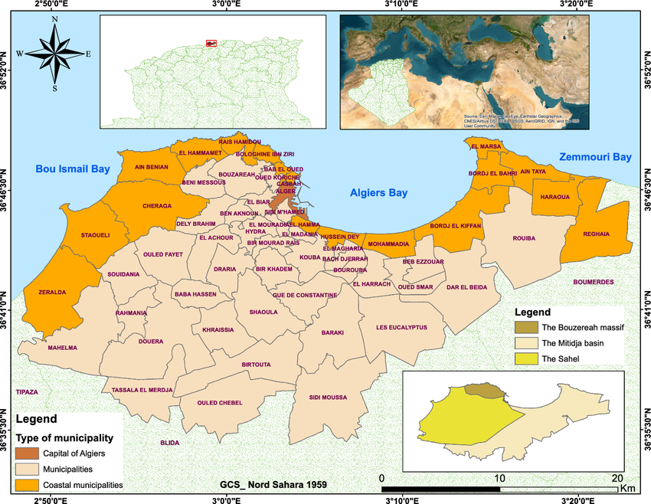
Map of Algiers City: Location and Districts
source: https://www.researchgate.net/figure/Study-area-location-map-Algiers-city_fig1_378461437

2. Tourism in Algiers: Trends and Attractions
Tourism in Algiers is steadily developing, though it remains less saturated than other Mediterranean cities. The city offers a rich array of attractions that appeal to cultural, historical, and religious tourists. Key sites include:
- The Casbah of Algiers: A labyrinthine old city filled with narrow alleys, Ottoman-era mosques, and traditional houses.
- Notre-Dame d'Afrique Basilica: A Catholic church overlooking the sea, symbolizing religious coexistence.
- Martyrs’ Memorial: A monumental structure commemorating those who died during the Algerian War of Independence.
- Botanical Garden of Hamma and Bardo National Museum: Spaces for cultural, scientific, and ecological interest.
While Algeria receives fewer international tourists than neighboring Morocco or Tunisia, those who do visit often describe Algiers as “authentic,” “raw,” and “welcoming.” A growing number of vloggers and social media influencers on platforms like TikTok and YouTube are highlighting the friendliness of locals as a major draw, presenting Algiers as a city that is underestimated but full of soul.
Tourism is not yet a dominant economic driver, but the government has been actively promoting it through national strategies to diversify the economy and reduce dependency on oil and gas. The "Plan Qualité Tourisme Algérie" (Algerian Tourism Quality Plan) aims to enhance infrastructure, encourage local entrepreneurship, and improve tourist services.

3. The People of Algiers: Lifestyles, Economy, and Interaction with Tourists
The population of Algiers is ethnically diverse but primarily Arab-Berber. The majority are Muslim, with a secular-liberal orientation in urban areas and more conservative values in traditional neighborhoods. Daily life is centered around strong family networks, neighborhood identity, and social gatherings in cafés or public spaces. French and Arabic are widely spoken, with French often used in professional and urban contexts.
Economically, Algiers residents work in a mix of public administration, commerce, transportation, education, and informal trades. Unemployment remains high, especially among the youth, contributing to economic migration and a large informal economy. Despite these challenges, locals often maintain a spirit of solidarity, pride, and resilience, especially toward visitors.
Contact with tourists is relatively organic and informal. Because the city lacks a heavy commercialized tourism industry, most interactions happen in daily life—when tourists ask for directions, shop in local souks, or eat in traditional restaurants. This allows for genuine interpersonal encounters, which travelers often describe as deeply memorable.
Interestingly, the fact that Algeria is not yet “over-touristed” is perceived positively by both locals and tourists. Residents generally express curiosity and pride when engaging with foreigners. Anecdotal accounts and social media feedback suggest that many tourists feel "special" or "welcomed as guests, not consumers," a feeling that sets Algiers apart from more commercial destinations.

4. Historical and Sociopolitical Context Affecting Tourism
Algiers carries the complex legacy of colonization and revolution. From 1830 to 1962, it was the center of French colonial power in Algeria. The struggle for independence left deep scars but also a strong sense of national identity. The civil war of the 1990s (often called the “Black Decade”) significantly reduced tourism and created a lingering perception of instability, especially in Western media.
However, over the past two decades, the city has become increasingly secure and modernized. New transport infrastructure (e.g., the Algiers Metro), restored heritage sites, and increased investment in hospitality have improved its capacity to host tourists.
Still, bureaucratic barriers, limited tourism services, and restrictive visa policies continue to affect international visitor numbers. Moreover, some locals express concerns about the potential cultural and environmental impacts of mass tourism. These factors make the relationship between tourism and the local community a highly relevant and sensitive issue—highlighting the need for inclusive, respectful, and sustainable development strategies.
3. Description of the Method & Questionnaire
To examine the impact of tourism on local communities in Algiers, a structured questionnaire was chosen as the primary method of data collection. This decision was informed by both the research objectives and practical considerations. The aim of the study was to capture a broad overview of local perceptions concerning the social, cultural, environmental, and economic effects of tourism. Using a questionnaire allowed for efficient data collection from a diverse and geographically dispersed population in a relatively short timeframe. In contrast, relying solely on interviews would have significantly limited the scope of the research. Interviews, while offering rich qualitative insight, are time-intensive and often require building rapport with participants, scheduling individual sessions, and transcribing large volumes of narrative data. Such an approach, though valuable for in-depth case studies, would not have been practical for this study, which seeks to generalize trends and attitudes across a wider segment of the population.
The standardized nature of a questionnaire offers a high degree of consistency in the questions posed to each participant, thereby reducing interviewer bias and increasing the reliability of the data. In addition, questionnaires can be administered anonymously, which is particularly beneficial when dealing with potentially sensitive issues such as dissatisfaction with tourists, perceived disrespect for local customs, or environmental concerns. Anonymity encourages more honest responses and reduces the likelihood of social desirability bias—where respondents may answer in a way they believe is more socially acceptable rather than reflecting their true opinions.
The questionnaire was distributed both digitally and in person. Online distribution was carried out via social media platforms and email, while physical copies were shared in public areas such as university campuses, cafés, and community centers across different districts of Algiers. This mixed method of distribution ensured accessibility and diversity among respondents. The survey was conducted during the first week of May 2025, a period chosen deliberately to avoid major holidays or tourist events that might skew the data due to abnormal activity levels.
A total of thirty individuals completed the questionnaire. The demographic profile of the participants reflected a relatively young and urban population. Approximately 73% of respondents were aged between 20 and 29, while smaller portions represented the 30–39 and 40+ age groups. In terms of gender, 60% identified as male, 30% as female, and the remaining either preferred not to disclose their gender or left the field blank. Most respondents had lived in Algiers for more than five years, providing a stable basis for evaluating changes and trends related to tourism.
The respondents came from a variety of neighborhoods in and around Algiers, including Dely Ibrahim, Kouba, Bab El Oued, and Beb Ezzouar. Some responses were also recorded from individuals who currently reside outside the city but had lived in Algiers for an extended period in the past. This inclusion allowed for a slightly broader perspective on tourism’s influence, incorporating voices both from within the urban center and from its surrounding communities.
The questionnaire consisted of twenty carefully formulated questions, covering a range of topics relevant to the research objectives. These included basic demographic information, the frequency of tourist presence in different areas, attitudes toward tourism and tourists, perceived benefits and disadvantages of tourism, cultural and environmental changes, and personal interactions with visitors. A combination of question formats was used: multiple-choice options for clear quantitative analysis, Likert-scale questions to assess attitudes and intensity of opinion, and a few open-ended questions to allow for elaboration and contextual insights. The questionnaire was pre-tested with a small pilot group to ensure clarity and coherence before being finalized.
Ethical considerations were also taken into account during the development and distribution of the questionnaire. Participation was voluntary, and respondents were informed of the purpose of the study and assured that their data would be used solely for academic research. No identifying personal information was collected, in order to maintain privacy and comply with standard ethical research practices.
A complete copy of the questionnaire can be found in the appendix of this document. For clarity and reference, a table summarizing the content and focus of each of the twenty questions is provided below.

4. Presentation of Results
This section presents the findings of the survey conducted on the perceived impact of tourism on local communities in Algiers. The data is grouped thematically and supplemented with visual aids to highlight key trends and insights.
Respondents were asked whether they believed tourism is beneficial for the city of Algiers. The majority expressed a generally favorable outlook.
Response | Percentage (%)
Yes, but only in certain aspects | 50.0%
Yes, very beneficial | 43.8%
No, it has more negative effects | 6.2%
table 1: impact of tourism on local communities in Algiers

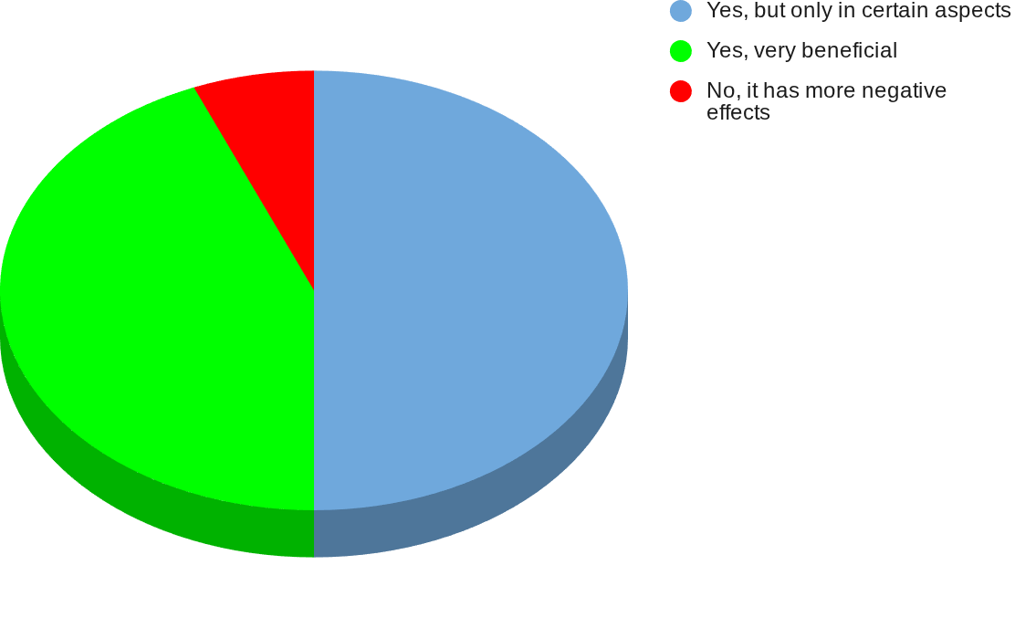

figure 2: impact of tourism on local communities in Algiers
Interpretation:
Approximately 94% of respondents view tourism as beneficial, either fully or partially. This suggests that tourism is widely accepted as a positive force, though many believe its benefits are conditional or limited in scope. Only a small minority (6.2%) perceive tourism as having predominantly negative consequences.

4.2. General Attitudes Toward Tourists
Participants were also asked to describe their overall attitude toward tourists visiting Algiers.
Attitude | Percentage (%)
Positive | 50.0%
Neutral | 37.5%
Very Positive | 12.5%
table 2:general attitudes towards tourists
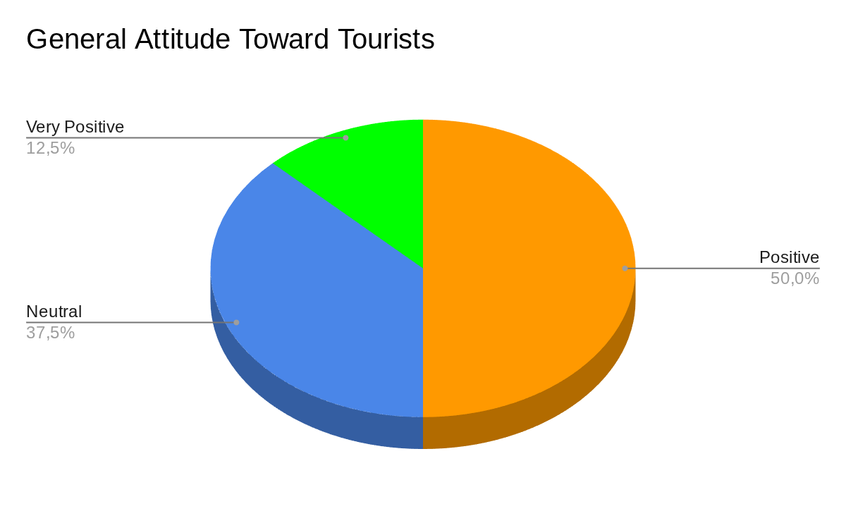
figure 3: general attitudes towards tourists
Interpretation:
Half of the respondents reported a “positive” attitude toward tourists, and another 12.5% held a “very positive” view. A notable portion (37.5%) remained neutral. These results reflect a generally welcoming stance, with only a small fraction showing disinterest or reservation.

4.3. Gender-Based Perceptions of Tourism
A cross-tabulation analysis was conducted to examine whether perceptions of tourism benefits vary by gender.
Gender | No | Yes (some aspects) | Yes (very beneficial)
Female | 6% | 50% | 44%
Male | 7% | 50% | 43%
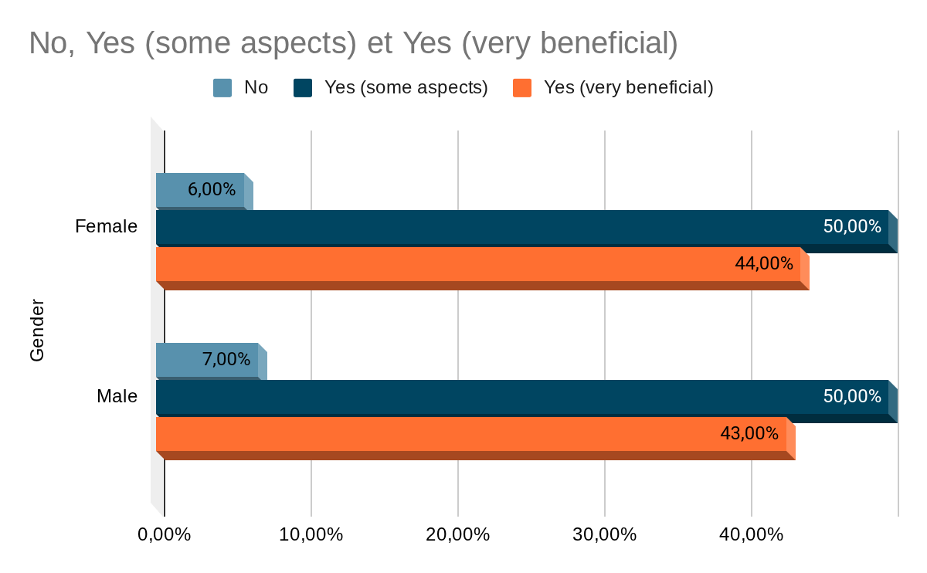
Interpretation:
Responses were consistent across genders. Both male and female participants expressed similar views, with approximately half agreeing that tourism is beneficial “only in certain aspects.” This indicates that gender does not significantly influence opinions on tourism’s overall benefit.

4.4. Age and Attitudes Toward Tourists
The relationship between respondents’ age groups and their attitudes toward tourists was also explored.
Age Group | Neutral | Positive | Very Positive
20–29 | 36% | 59% | 5%
30–39 | 43% | 29% | 29%
40–49 | 100% | 0% | 0%
Under 20 | 0% | 50% | 50%
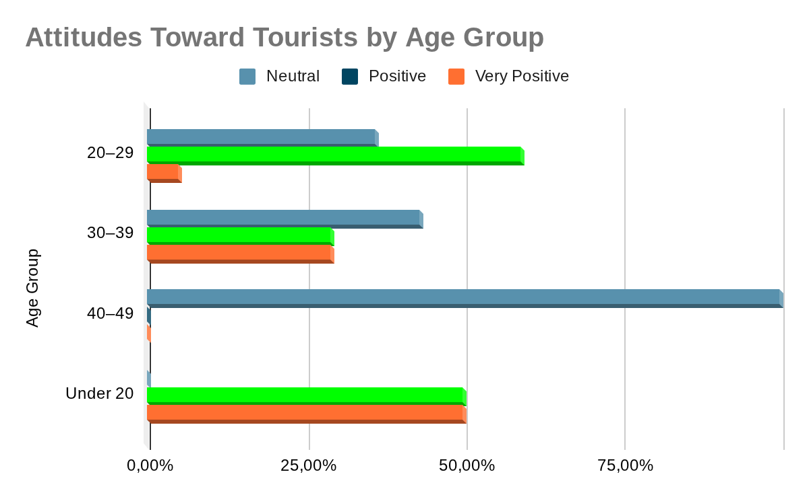
Interpretation:
Younger respondents (especially those under 30) tend to have more positive or very positive attitudes. Those aged 30–39 are more polarized, with a significant number showing high enthusiasm (29%) and others remaining neutral. The only respondent in the 40–49 group was neutral, and while not representative, it may suggest increasing detachment with age.

4.5. Interaction with Tourists
Respondents were asked whether they had interacted with tourists in Algiers, and if so, in what ways. The results indicate a moderate level of interaction.
Interaction with Tourists | Number of Respondents
Yes, frequently | 5
Yes, occasionally | 12
Yes, but only partially | 8
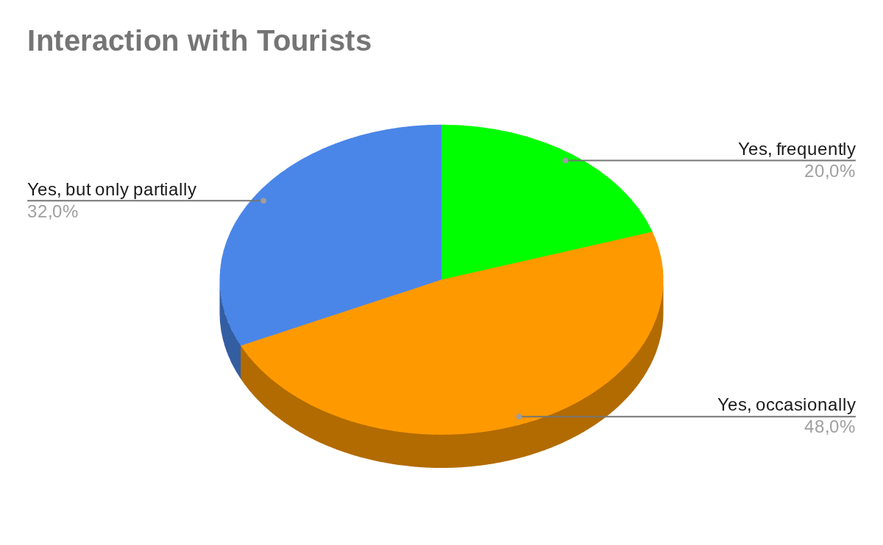
Common Types of Interaction (Qualitative Overview):
- Giving directions
- Casual conversation
- Work-related service (e.g., hotel staff, shop owners)
- Assisting with photos or translation
Interpretation:
Many participants reported casual or occasional interactions with tourists, often providing assistance or answering questions. A smaller group indicated regular contact due to professional responsibilities. This highlights a generally open and helpful approach from the community, even if tourism isn’t deeply embedded in daily life for most.

4.6. Respect for Local Culture and Traditions
Respondents were asked whether they believed tourists respect Algerian culture.
Respect for Culture | Number of Respondents | Percentage
Yes, they show respect | 21 | 67.7%
Yes, but only partially | 5 | 16.1%
I have not noticed | 4 | 12.9%
No, they often show disrespect | 1 | 3.2%
Total | 31 | 100%
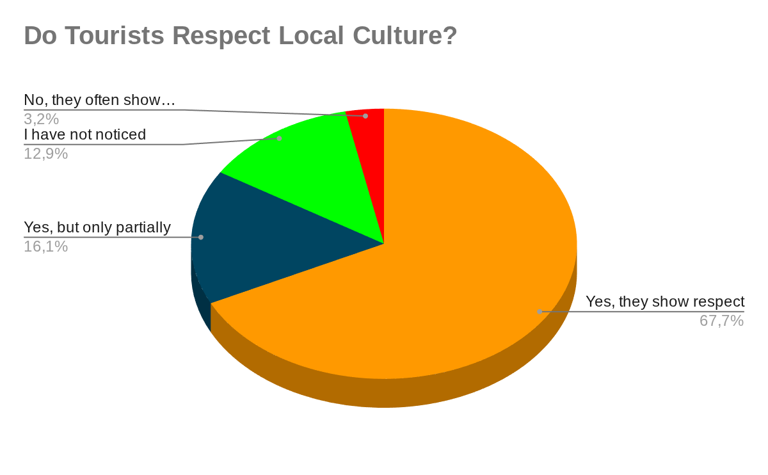
Interpretation:
Most participants felt that tourists were generally respectful of local norms, though some acknowledged only partial observance. A small number noted no respect or had not paid attention to the issue. This suggests that while Algiers residents are tolerant, there is room for improvement in cultural awareness among visitors.

4.7. Environmental Impact of Tourism
Participants were also asked if they had noticed any environmental issues linked to tourism.
Environmental Impact | Number of Respondents | Percentage
No noticeable effect | 20 | 64.5%
Yes, minor issues | 9 | 29.0%
Yes, significant issues | 3 | 9.7%
I am not sure | 3 | 9.7%
Total | 31 | 100%
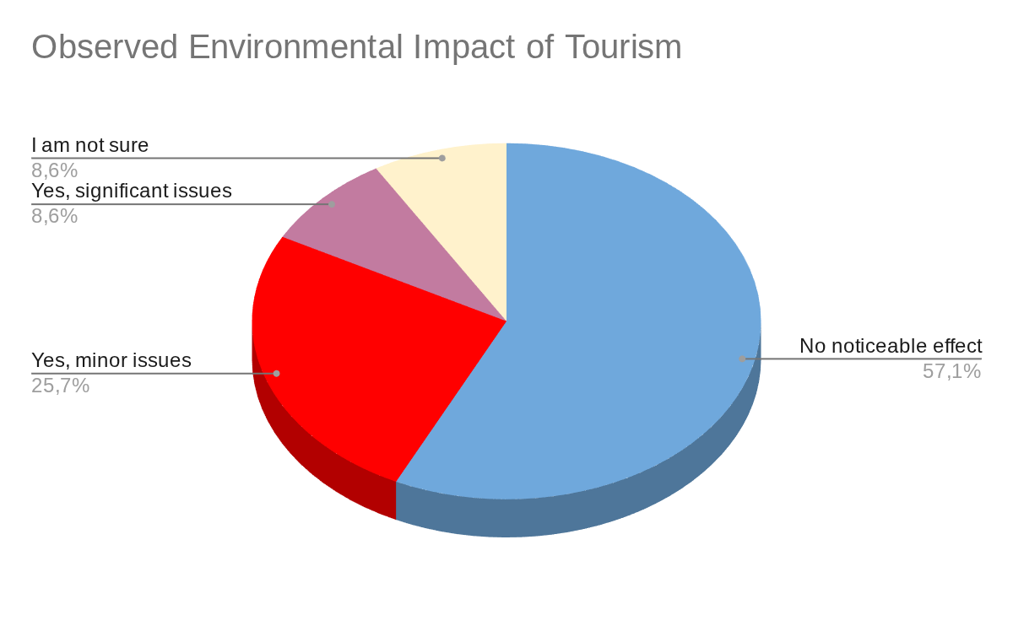
Interpretation:
Most respondents did not perceive any environmental problems caused by tourism. However, some reported minor issues such as litter or congestion in popular tourist spots. A few highlighted significant issues, suggesting a need for improved waste management and regulation in high-traffic areas.

4.8. Changes in Local Traditions
Respondents were asked whether they had noticed any cultural or societal changes due to tourism.
Cultural/Societal Change | Number of Respondents | Percentage
No noticeable changes | 18 | 58.1%
Yes, minor changes | 4 | 12.9%
Yes, significant changes | 3 | 9.7%
I am not sure | 6 | 19.4%
Total | 31 | 100%
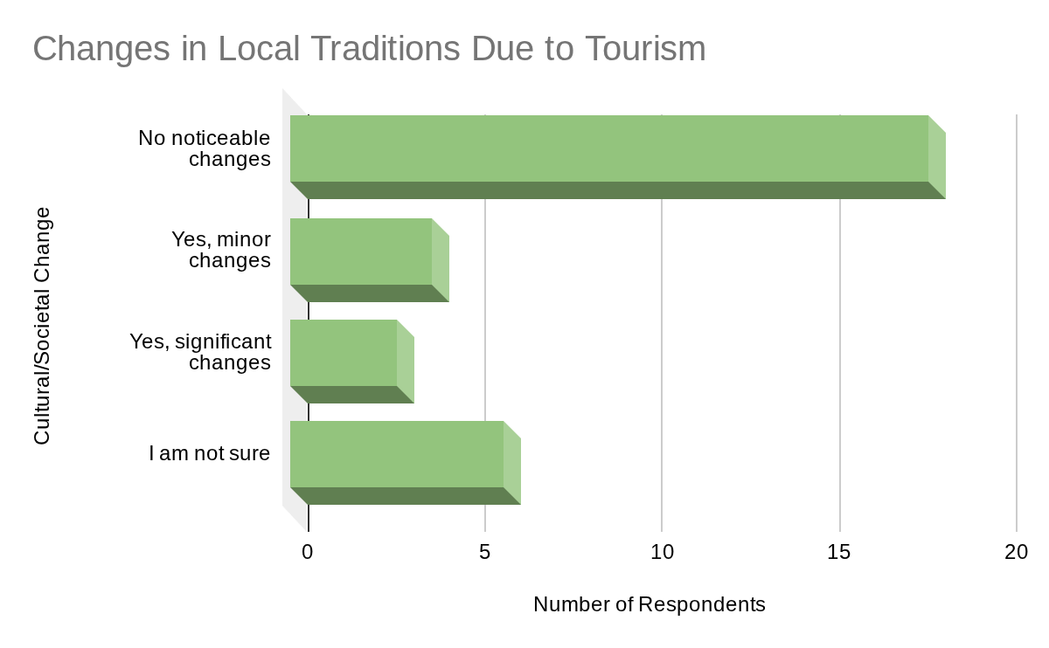
Examples Mentioned:
- Increase in imported habits (e.g., dress, food)
- Influence on youth behavior
- More English/French in signage and speech
Interpretation:
Most participants did not notice major cultural shifts. However, some pointed to subtle social changes, especially among the younger population. These observations reflect a slow but present cultural evolution, possibly driven by the growing exposure to global influences.

4.9. Community Involvement in Tourism
The survey explored whether residents are willing to engage in tourism-related activities.
Willing to Engage in Tourism Activities | Number of Respondents | Percentage
Yes, definitely | 14 | 45.2%
Possibly | 10 | 32.3%
Probably not | 2 | 6.5%
No, not at all | 3 | 9.7%
I am not sure | 2 | 6.5%
Total | 31 | 100%
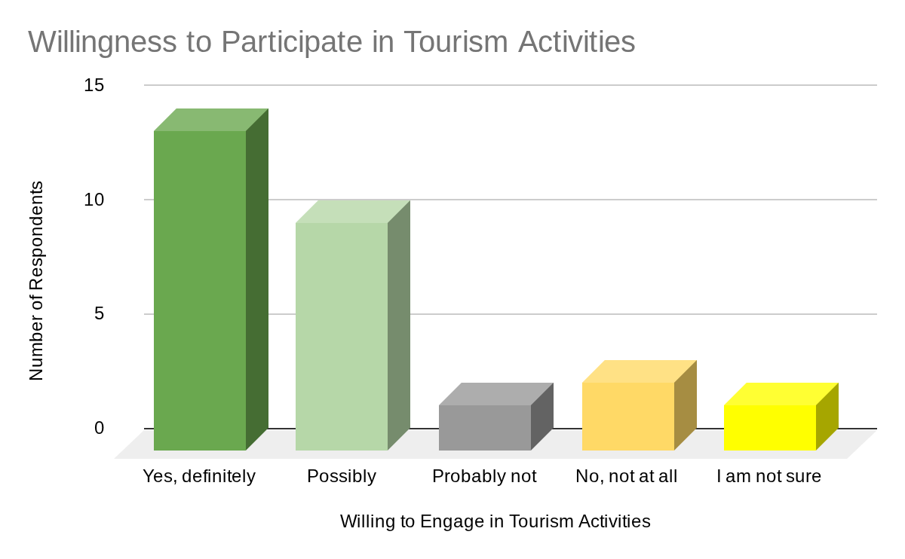
Interpretation:
The data reveals a generally enthusiastic attitude toward participating in tourism-related initiatives. Many respondents, particularly those who have already interacted with tourists, expressed a strong willingness to be involved in future efforts, suggesting an untapped potential for community-based tourism projects.

5. In-Depth Analysis of Results

5.1 Emerging Patterns from the Survey Data
When considered collectively, the survey responses reveal several underlying patterns that provide a deeper understanding of how Algiers’ residents perceive and experience tourism in their city. These patterns are not always immediately visible through numerical summaries alone; rather, they come to light through the subtle repetition of similar sentiments, choices, and behaviors across different demographic groups.
One of the clearest themes is the presence of a generally supportive attitude toward tourism that is nonetheless accompanied by careful qualifications. While residents appear to welcome tourism as a positive force, many of their responses suggest a preference for measured approval rather than unconditional enthusiasm. This cautious tone recurs in questions related to tourism’s benefits, with respondents consistently recognizing its value while also hinting at limitations or unbalanced outcomes.
A second pattern relates to emotional engagement with tourists. Although negativity is notably absent, many responses settle into a space of polite neutrality. The tone is not one of rejection, but of a mild and distant hospitality — as if residents are willing to accommodate tourism, yet remain personally unaffected or uninvolved in any deep way. This emotional distance surfaces repeatedly, especially in responses about personal interaction and cultural perception.
Another thread running through the data is the impact of age on perception. Younger respondents consistently display greater warmth and openness toward tourists and tourism in general, whereas older individuals tend to offer more reserved or neutral evaluations. This generational variation suggests that age plays a meaningful role in shaping not just opinion, but the emotional and cultural proximity people feel toward visitors.
Patterns also emerge around the depth of resident-tourist interaction. Many participants describe their contact with tourists as incidental or circumstantial — a question asked here, a direction given there. For a smaller subset, especially those working in tourism-related roles, interactions are more structured and frequent. These contrasting levels of engagement contribute to a divide between passive awareness and active participation, influencing not only behavior but also broader attitudes toward tourism as a community issue.
Cultural perception is another area where patterns emerge subtly. While many residents believe tourists show respect for Algerian traditions, this respect is often seen as partial or incomplete. There is a quiet expectation that visitors should go beyond surface-level politeness and show a deeper awareness of local customs. The repetition of uncertain or qualified answers in this area points to a population that notices and values cultural behavior, even when tourism is not central to their lives.
In terms of impact, both cultural and environmental, the majority of responses lean toward denial of significant change. Yet, within this apparent consensus, minor disruptions and subtle transformations are occasionally acknowledged — particularly among those more exposed to tourism. These small but consistent references suggest that while large-scale effects may not yet be fully visible or consciously recognized, tourism is gradually weaving itself into the social and physical fabric of the city.
Finally, willingness to engage in tourism-related initiatives varies significantly based on prior experience. Individuals who already interact with tourists — either through work or repeated informal encounters — are much more inclined to express openness to future participation. This indicates that familiarity may play a vital role in fostering local involvement, revealing an opportunity for deeper integration of community voices in tourism development.

5.2 Interpreting the Patterns: Understanding Local Attitudes and Behaviors
Beyond the surface of agreement or neutrality in the survey responses lies a layered social reality — one shaped by generational experiences, geographic exposure, contradictions in self-perception, and the subtle workings of memory. These patterns offer insight not only into what residents think, but how and why they arrive at those perceptions in the first place.
Generational Difference
One of the clearest divides in the data lies between age groups, particularly between younger respondents (under 30) and older ones. Younger participants expressed more open, enthusiastic attitudes toward both tourism and tourists themselves. This generational openness can likely be attributed to the influence of globalization and digital culture. Having grown up with social media, online travel content, and greater cultural exchange, younger residents are more accustomed to diversity in language, dress, and behavior. Their mental landscape is already shaped by a hybridized view of the world — making foreign visitors feel less “foreign.” This adaptability may also reflect economic pragmatism: tourism represents opportunity, and younger people are often more willing to explore new ways of working, networking, or even shaping their identity through global connection.
Location Impact
Geographical context also plays a significant role in shaping resident behavior. Respondents living in areas that regularly attract tourists — such as Bab Ezzouar, Hydra, or central Algiers — were more likely to report frequent interaction and a more welcoming stance. These areas serve as physical points of contact where tourism shifts from abstract concept to lived experience. As such, residents in these spaces may develop more tolerant, strategic, or even performative behaviors toward tourists, especially if tourism is tied to their livelihood. For someone working in a hotel or running a shop, politeness and hospitality are not merely social values — they are professional assets. In contrast, individuals living in more peripheral or quieter districts, where tourism is rare or absent, may lack this strategic engagement and thus express more indifference or uncertainty in their responses.
Contradictions in Perception
A notable tension surfaces in responses where residents describe tourism as “very beneficial,” yet simultaneously claim it has little to no effect on their daily life. This apparent contradiction reveals a psychological and emotional detachment from tourism’s real impact. It suggests that the perceived “benefit” of tourism may be conceptual — rooted in national pride, media narratives, or assumptions about economic growth — rather than grounded in personal experience. This detachment raises critical questions: is tourism merely a symbolic good, something to be applauded from a distance? Or does its absence from daily life reflect a deeper issue — such as unequal distribution of benefits, or a disconnect between policy-level tourism goals and actual community participation?
Selective Memory or Gradual Change?
Another important interpretation lies in the responses to questions about cultural and environmental change. The majority of residents reported “no noticeable change,” a striking consensus given that tourism inevitably carries some level of influence. This collective dismissal could be interpreted in several ways. It might reflect a genuine lack of impact — suggesting that tourism in Algiers is still relatively small-scale or well-managed. But it might also be a sign of selective memory or unawareness. When change is gradual, it often escapes notice. People adapt, forget, or normalize new behaviors over time, especially when these shifts occur incrementally. There may also be a reluctance to acknowledge subtle cultural transformations that challenge traditional values — especially when those changes manifest in the habits of youth, language use, or public spaces. In this sense, the absence of perceived change does not necessarily indicate stability; it may instead reveal a slow-moving evolution that has yet to be consciously registered.

5.3 Emotional and Cultural Reactions: Between Pride and Distance
Beyond data points and patterns, the emotional texture of the responses reveals how residents feel about tourism and its place in their cultural landscape. While the overall tone remains measured and non-confrontational, a closer look exposes a subtle spectrum of reactions — ranging from civic pride to emotional detachment.
Many participants, especially those with experience in tourism-related work, implicitly express a sense of pride in Algiers as a city worthy of international attention. Their willingness to guide, assist, or host tourists suggests an underlying belief in the cultural value of their surroundings and a desire to represent their community positively. This quiet pride is not always stated directly, but it is present in the openness shown through their responses, especially in comments related to interaction and respect for traditions.
At the same time, a contrasting emotional stance surfaces through frequent expressions of uncertainty — phrases like “I’m not sure” or “no noticeable effect” appear repeatedly throughout the dataset. These responses do not reflect hostility, but rather an emotional distance, a passive relationship with tourism that lacks engagement. This neutrality may result from a lack of direct benefit or experience, or from the perception that tourism is something that happens elsewhere, to others. In this emotional space, tourism is neither celebrated nor rejected — it is simply tolerated.
Such distance is telling. It reflects not only a lack of strong opinion but a deeper sense that tourism is not truly embedded in the lived experience of many residents. For them, tourism may be seen as a background phenomenon — a city-wide event that does not touch their personal lives. This emotional neutrality, though not negative, has important implications when considered in the context of community participation.

5.4 Linking Resident Behavior to the Tourism Experience
Ultimately, the purpose of this case study is to understand how the behavior and mindset of local residents shape the tourism experience in Algiers. The survey data — and the patterns and emotions behind it — suggest that resident behavior operates as a kind of soft infrastructure for tourism: invisible but influential.
When residents express welcoming attitudes, even if those are polite rather than enthusiastic, they contribute to a general atmosphere of hospitality. Tourists encountering helpful locals — whether through directions, conversations, or services — are more likely to leave with a positive impression of the place. In this way, even limited but friendly engagement can significantly impact a tourist’s emotional experience and memory of Algiers.
However, passive or indifferent behaviors can also shape the visitor experience — often through absence rather than action. When residents are neutral, reserved, or distant, tourists may struggle to feel immersed in the local culture. This can result in shallow encounters, limited understanding, or reliance on tourist-only zones, cutting off opportunities for deeper cultural exchange. In these moments, the gap between local and visitor becomes more visible, and the experience risks becoming transactional rather than meaningful.
Passivity among residents also raises important questions for tourism management. If a large portion of the population feels unaffected by tourism, they may be less likely to support or participate in tourism planning, preservation efforts, or local initiatives. This can leave tourism development in the hands of a small group — often commercial or institutional actors — and limit the community’s role in shaping how their city is represented and experienced.
Moreover, cultural misunderstandings between tourists and locals can stem not only from tourists’ behavior, but also from the emotional tone of the community itself. When tourists sense disinterest or detachment, they may feel unwelcome or confused. What one resident considers neutrality, a tourist may interpret as coldness or unfriendliness. These moments of misalignment — often subtle and unintended — can shape perceptions on both sides and reinforce cultural gaps.
In short, the behavior of local residents is not simply a reaction to tourism; it is a powerful force in shaping its direction. Whether through active engagement, silent tolerance, or quiet indifference, residents play a central role in defining what kind of experience Algiers offers its visitors — and, in turn, what kind of tourism it invites in the future.

Conclusion
This study gives us a clear picture of how people living in Algiers feel about tourism and how their behavior influences the whole tourism experience. Overall, residents seem pretty open to tourism and recognize its benefits, but they’re not always fully enthusiastic. Instead, their support comes with some caution—they want tourism to bring good things without causing problems or disrespecting their culture.
One interesting thing is how age and where people live affect their views. Younger folks and those in neighborhoods that see more tourists tend to be friendlier and more involved with visitors. Older people or those in quieter areas are a bit more reserved or neutral about tourism. This makes sense because those who meet tourists more often, or work in tourism-related jobs, naturally have a different outlook than those who don’t interact with tourists much.
Emotionally, many residents feel proud that Algiers is a place people want to visit, but at the same time, there’s a sense of distance or neutrality. Tourism isn’t something that deeply touches their daily lives, so while they’re polite and welcoming, they don’t always feel personally connected to it. This mix of pride and detachment shows that tourism is still growing as part of the city’s identity and that there’s room to make it more meaningful for everyone.
The way locals act, whether warm or neutral, really shapes how tourists experience Algiers. Friendly interactions can leave visitors with great memories, but when people seem distant, tourists might feel like they’re just passing through without truly connecting with the city or its culture. This can make tourism feel a bit shallow or transactional instead of rich and immersive.
For tourism to really benefit Algiers and its people, it’s important to involve the community more. When locals feel included and understand tourism’s impact, they’re more likely to support it and help shape how the city welcomes visitors. It’s also key to bridge any cultural gaps between residents and tourists so everyone feels respected and valued.
In the end, the people of Algiers aren’t just bystanders in tourism—they play a big role in creating the city’s tourism story. Encouraging more genuine engagement and making sure tourism helps everyone will make Algiers an even better place to live and visit.

Final Abstract
This thesis investigates the impact of local residents’ behavior on tourism, with a specific focus on Algiers, a major touristic destination in Algeria. The central research question explores how the behaviors and attitudes of residents influence both the tourist experience and the development of tourism in the city. The study is anchored in the management of touristic establishments and is based on two main hypotheses:
- H0: The more residents perceive tourism as beneficial, the more likely they are to adopt positive behavior toward tourists.
- H1: The perception of negative impacts from tourism is associated with more passive, distant, or negative attitudes toward tourists.
To test these hypotheses, a practical study was conducted using a survey of Algiers residents. Participants were asked about their general attitudes toward tourism, perceived benefits and drawbacks, and their personal interactions with tourists. Algiers was chosen as the case study for its cultural significance and increasing exposure to tourism in recent years.
The results confirm both hypotheses. Residents who perceive tourism as economically or culturally beneficial tend to display welcoming, cooperative, and positive behaviors toward tourists. This is particularly true for younger people and those living in neighborhoods with high tourist activity. Conversely, those who associate tourism with negative consequences—such as overcrowding, cultural dilution, or disrespect—are more likely to adopt distant, neutral, or even passive attitudes. This cautious stance is more common among older individuals and residents in less touristy areas.
Although most respondents are not hostile to tourism, many express emotional detachment. Tourism is seen as something external to their daily lives, even when they recognize its importance. Their behavior, whether warm or reserved, has a direct impact on how tourists experience the city—either creating memorable human connections or making visits feel impersonal and transactional.
In conclusion, the study highlights that the local population plays a fundamental role in shaping the image and success of tourism in Algiers. Strengthening community involvement, addressing residents’ concerns, and promoting respectful tourism practices are essential steps toward sustainable tourism development. Residents are not merely passive observers—they are key contributors to the story Algiers tells its visitors.

Critical Insight
While doing this study, I realized something that really stayed with me — people in Algiers aren’t against tourism at all, they’re actually quite open to it. But at the same time, there’s this feeling that tourism is something happening around them, not with them. It’s like they’re okay with visitors being here, even proud of it in a way, but not really emotionally connected to the whole thing. I found that really interesting. Most people are kind and polite, but not super involved — like they’re welcoming, but from a bit of a distance.
Honestly, I think that’s where the gap lies. If we really want tourism in Algiers to work for everyone, then it has to feel more real for the people who actually live here. Locals need to feel like they’re part of it, not just watching it happen. If they feel seen, respected, and included in the process — not just economically, but culturally too — they’ll naturally be more welcoming, not out of duty, but because it makes sense to them.
To me, it’s not just about promoting Algiers better, it’s about making tourism something people here can relate to and feel proud of in a deeper way. When that happens, tourists won’t just see the city — they’ll feel it, through the people. That’s what makes a place memorable.

Advice to Future Researchers
Future researchers should include residents of different ages and from various neighborhoods to get a wide range of views. It’s important to pay attention not only to what people say but also to how they feel about tourism. Adding your own thoughtful reflections can help make the study deeper and give a better understanding of how residents and tourism affect each other.
references:
Prakash, A. (2020). Study of human behaviour formulated in psychology. IOSR Journal of Humanities and Social Science, 25(12-1), 62. https://doi.org/10.9790/0837-2512016264
Rahma, A., & Wantini, W. (2024). Human behavior in social context. Jurnal Impresi Indonesia, 3(6), 411-412. https://rivierapublishing.id/JII/index.php/jii/index
Cook, K. S., & Rice, E. (2014). Social exchange theory. Retrieved from [https://www.researchgate.net/publication/227109881_Social_Exchange_Theory\]
Linderová, I., Scholz, P., & Almeida, N. (2021). Attitudes of local population on tourism development impacts. Frontiers in Psychology, 12, Article 684773. https://doi.org/10.3389/fpsyg.2021.684773
tourism development impacts. Frontiers in Psychology, 12, Article 684773. https://doi.org/10.3389/fpsyg.2021.684773
Huber, D., & Gross, S. (2020). Local residents’ contribution to tourist experiences: A community perspective from Garmisch-Partenkirchen, Germany. Tourism Review. https://www.researchgate.net/publication/352193430_Local_residents'_contribution_to_tourist_experiences_a_community_perspective_from_Garmisch-Partenkirchen_Germany
Hoogendoorn, G., & Hammett, D. (2021). Resident tourists and the local 'other'. Tourism Geographies, 23(5-6), 1021-1039. https://doi.org/10.1080/14616688.2020.1713882
Lin, Z., Chen, Y., & Filieri, R. (2017). Resident-tourist value co-creation: The role of residents’ perceived tourism impacts and life satisfaction. Tourism Management, 61, 436–442. https://doi.org/10.1016/j.tourman.2017.02.013
Pavluković, V., Pejović, L., & Lukić, T. (2011). Interaction between tourists and residents: Influence on tourism development. Polish Sociological Review. Retrieved from https://wEducation.
Ghalia, T. (2016). Essays on tourism and its determinants [Doctoral dissertation, Brunel University London].
Kefalaki, M., & Papanikos, G. T. (Eds.). (2008). Essays on tourism research. Athens Institute for Education and Research.
Korstanje, M. E., Skoll, G., Schroeder, A., Pennington-Gray, L., & Chavez, M. E. (2016). Tourism in a world of risks. Advances in Hospitality and Tourism Research, 4(1), 52–69.
Tureac, C. E., & Turtureanu, A. (2008). Types and forms of tourism. Acta Universitatis Danubius Oeconomica, 4(1), 92–96.
Muganda, M., Sirima, A., & Ezra, P. M. (2013). The role of local communities in tourism development: Grassroots perspectives from Tanzania. Journal of Human Ecology, 41(1), 53–66. https://doi.org/10.1080/09709274.2013.11906553
Musinguzi, D. (2011). The impacts of tourism on local communities: Developing and operationalising a comprehensive monitoring framework (Doctoral dissertation). The Hong Kong Polytechnic University
Dogan, H. Z. (1989). Forms of adjustment: Sociocultural impacts of tourism. Annals of Tourism Research, 16(2), 216–236.
Sheikhi, A., Jafari, J., & Xiao, H. (2015). Hostility, tourism. In J. Jafari & H. Xiao (Eds.), Encyclopedia of Tourism (pp. 1–4). Springer. https://doi.org/10.1007/978-3-319-01669-6_560-1
Akova, O., & Atsız, O. (2019). Sociocultural impacts of tourism development on heritage sites. In The Routledge Handbook of Tourism Impacts: Theoretical and Applied Perspectives. Routledge.
Economic Impacts of Tourism Industry. (n.d.). [PDF file].
Social Impacts of Tourism Perceived by Host Communities. (n.d.). [PDF file].
Walas, B., Szromek, A., Kruczek, Z., & Roncak, M. (2023). Minimizing conflicts between residents and local tourism stakeholders as a way to achieve sustainable tourism in Prague, Krakow and Braga. Tourism Review. https://doi.org/10.1108/TR-04-2023-0210
Croes, R., Park, J.-Y., & Bonilla, J. (2024). Tourism and resident well-being: Balancing economic gains, social dynamics, and environmental challenges across urban and rural divides. Tourism and Hospitality, 5(4), 1217–1235. https://doi.org/10.3390/tourhosp5040068
Tran, D. M. (2023). Managing environmental conflicts for sustainable tourism development. In Earth and Environmental Sciences, Green EME Conference Proceedings (pp. 357–363). Retrieved from https://www.researchgate.net/publication/377186983
Govender, K., Maziriri, E. T., & Chuchu, T. (2021). Perceptions of local tourists, attitudes and willingness to visit local destinations: A destination image case. Business Management Analysis Journal (BMAJ), 4(2), 121–139. https://doi.org/10.24176/bmaj.v4i2.6175
Kariuki, P. N. (2013). Local residents’ attitudes and perceptions towards tourism development: A study of Lake Nakuru National Park and its environs, Kenya [Master’s thesis, Moi University].
Linderová, I., Scholz, P., & Almeida, N. (2021). Attitudes of local population towards the impacts of tourism development: Evidence from Czechia. Frontiers in Psychology, 12, 684773. https://doi.org/10.3389/fpsyg.2021.684773
Hernandez-Maskivker, G., Fornells, A., Teixido-Navarro, F., & Pulido, J. I. (2021). Exploring mass tourism impacts on locals: A comparative analysis between Barcelona and Sevilla. European Journal of Tourism Research, 29, 2908. https://creativecommons.org/licenses/by/4.0/
Hidayat, I. I. N., Wisnalmawati, & Sugandini, D. (2023). Exploring how local cultural influences affect tourist conduct. Asian Journal of Islamic Management, 5(2), 141–154. https://doi.org/10.20885/AJIM.vol5.iss2.art5ww.researchgate.net/publication/261557287
Schubert, S. F., & Schamel, G. (2020). Sustainable tourism development: A dynamic model incorporating resident spillovers. Tourism Economics, 26(6), 1190–1212. https://doi.org/10.1177/1354816620934552
Muler González, V., Galí Espelt, N., & Coromina, L. (2023). Residents' perceptions of tourism: A social exchange theory approach in a small heritage town. Investigaciones Turísticas, 25(5), 45-67. https://doi.org/10.14198/INTURI2023.25.05
Schubert, S. F., & Schamel, G. (2020). Sustainable tourism development: A dynamic model incorporating resident spillovers. Tourism Economics, 26(6), 1190–1212. https://doi.org/10.1177/1354816620934552
Camilleri, M. A. (2018). The tourism industry: An overview. In Travel marketing, tourism economics and the airline product (pp. 3–27). Springer Nature. https://doi.org/10.1007/978-3-319-49849-2_1
Fabry, N. (2014). Saisonnalité : enjeux et stratégies. Gustave Eiffel University. https://doi.org/10.13140/2.1.4011.5844
Ghalia, T. (2016). Tourism, culture and sustainable development: A critical review (Master’s thesis). Université Paris 1 Panthéon-Sorbonne.
Goeldner, C. R., & Ritchie, J. R. B. (n.d.). Tourism: Principles, practices, philosophies (12th ed.). Wiley.
Hall, C. M. (2008). Tourism planning: Policies, processes and relationships. Pearson
Al-Gahuri, A. (2014). Tourism and Cultural Heritage. Cairo: Al-Fikr Press.
Huber, D., & Gross, A. (2020). The impact of residents on tourism experiences: Evidence from Garmisch-Partenkirchen. Tourism and Hospitality Research, 20(1), 34–48.
Kliuchnyk, A., Oliinyk, T., Galunets, N., Borysova-Yaryha, A., & Fedorenko, T. (2023). The impact of tourism on local community development. Economic Affairs, 68(Special Issue), 649–655. https://doi.org/10.46852/0424-2513.2s.2023.4
Chen, N., Hsu, C. H., & Li, X. R. (2018). Feeling superior or deprived? Attitudes and underlying mentalities of residents towards Mainland Chinese tourists. Tourism Management, 66, 94–107. https://doi.org/10.1016/j.tourman.2017.11.007
Diaz-Parra, I., & Jover, J. (2021). Overtourism, place commodification and the consumption of urban space. Tourism Geographies, 23(3), 549–571. https://doi.org/10.1080/14616688.2020.1759124
Fan, D. X., Zhang, H. Q., Jenkins, C. L., & Tavitiyaman, P. (2017). Tourist typology in social contact: An addition to existing theories. Tourism Management, 60, 357–366. https://doi.org/10.1016/j.tourman.2016.12.021
Luo, X., Brown, G., & Huang, S. S. (2015). Host perceptions of backpackers: Examining the influence of intergroup contact. Tourism Management, 50, 292–305. https://doi.org/10.1016/j.tourman.2015.03.009
Moghavvemi, S., Woosnam, K. M., Paramanathan, T., Musa, G., & Hamzah, A. (2017). The effect of residents’ personality, emotional solidarity, and community commitment on support for tourism development. Tourism Management, 63, 242–254. https://doi.org/10.1016/j.tourman.2017.06.021
Phuc, H. N., & Nguyen, H. M. (2020). The importance of collaboration and emotional solidarity in residents’ support for sustainable urban tourism. Journal of Sustainable Tourism, 1–20. https://doi.org/10.1080/09669582.2020.1831520

Annex 1: Survey Questionnaire on the Impact of Tourism on Local Communities in Algiers
Note: This questionnaire was distributed to residents to collect data for the case study on Algiers.

Demographic Information
- What is your age?
  - Under 20
  - 20–29
  - 30–39
  - 40–49
  - 50 or older
- What is your gender?
  - Male
  - Female
  - Prefer not to say
- In which area of Algiers do you live?
- How long have you lived in Algiers?
  - Less than 2 years
  - 2–5 years
  - More than 5 years
  - I do not currently live in Algiers

Tourism Perceptions and Experiences
- Does your area attract tourists on a regular basis?
  - Yes, frequently
  - Yes, occasionally
  - No, rarely
  - No, never
  - I am not sure
- In your opinion, is tourism beneficial for the city of Algiers?
  - Yes, very beneficial
  - Yes, but only in certain aspects
  - No, it has more negative effects
  - I am not sure
- What is your general attitude toward tourists in Algiers?
  - Very positive
  - Positive
  - Neutral
  - Negative
- Does tourism influence your daily life in Algiers?
  - Yes, significantly
  - Not really
  - Not at all
  - I am not sure
- In your opinion, do tourists respect local culture and traditions?
  - Yes, they show respect
  - Yes, but only partially
  - No, they often show disrespect
  - I have not noticed
- Have you ever interacted with tourists in Algiers?
  - Yes, frequently
  - Yes, occasionally
  - No, never
  - I am not sure
- In what ways have you interacted with tourists? (open-ended)
- Would you describe yourself as:
  - Very welcoming
  - Somewhat welcoming
  - Neutral
  - Reserved
- Would you be willing to take part in tourism-related activities (e.g., guiding, hosting, cultural exchange)?
  - Yes, definitely
  - Possibly
  - Probably not
  - No, not at all
- Have you noticed any changes in local traditions as a result of tourism?
  - Yes, significant changes
  - Yes, minor changes
  - No noticeable changes
  - I am not sure
- What kind of changes have you noticed? (open-ended)
- Has tourism in Algiers strengthened or weakened community bonds?
  - It has significantly strengthened
  - It has somewhat strengthened
  - No noticeable effect
  - It has significantly weakened
  - I am not sure
- Have you observed any environmental issues related to tourism?
  - Yes, significant issues
  - Yes, minor issues
  - No noticeable issues
  - I am not sure

