People’s Democratic Republic of Algeria



Ministry of Higher Education and Scientific Research

Superior school of management

Tlemcen

Department of: management and enterprise’s strategies

MEMORY OF END STUDIES

THEME

The application of online marketing strategies:
A study of the effectiveness of various tools In the Algerian territory

Framed by:

Fersaoui Seif el-Islam

Comity of debate:

Mr/Mr. …………………………. grade…………………. President

Mr/Mrs. …………………………grade…………………. Advisor

Mr/Mrs. …………………………grade ………………… Examinator

Academic year: 2018/2019

ملخص

أصبحت الأنترنت جزئا هاما في حياتنا, حيث خلقة هذة الثورة التكنولوجية حاجة جديدة من حاجاتنا المتزايدة و هي الإطلاع على كل جديد يطرح فيها من متابعة أخبار, مشاهدة الفيديوهات و الإفلام إلى التواصل مع الأشخاص أو تلقي الدروس الإلكترونية و غيرها من النشاطات المتنوعة, لدرجة أنه إذا غبت ليوم كامل دون أنترنت ينتابك شعور بتضييعك الكثير من الأخبار الجديدة و التحديثات. حيث غدت الأنترنت ملتقى هام لللأفراد و الشركات, و طورت العلاقة الرابطة بين العملاء و المنتجين أو مزودي الخدمات بشكر كبير و ملحوظ.
لاحظنا خلال دراستنا الفرص و التحديات المتعلقة بالأنترنت في الوقت الحالي. إلا انه إنتابنا شعور بأن أغلب الشركات الجزائرية بعيدة كل البعد عن إستخدامها ظمن مخططاتها سواء في التسويق أو في التواصل مع عملائها. لذا تطرقت في هذه الدراسة لشرح محتوى إستراجيات التسويق عامة و إستراجيات التسويق و التواصل على الأنترنت بشكل خاص و كذلك شرح أغلب الوسائل المتعارفة في وقتنا الحالي و تحليل مساهمتها في تعظيم عائدات الشركات الجزائرية و مدى تأثيرها على المستهلك الجزائري من منظور أحد وكالات التسويق و التواصل الجزائرية.
من خلال إجراء مقابلات مع طاقم الشركة و طرح إستبيان على مواقع التواصل الإجتماعي يهدف إلى محاولة فهم اهمية الإستراجيات التسويق الإلكتروني و وسائلها و مساعدتنا في تحديد أفضل الخيارات في الوقت الحالي التي تتناسب مع خصائص السوق الجزائرية و من أجل إيجاد طرق تساعد شركاتنا المحلية في فهم المستهلك و توطيد العلاقة مهم.
الكلمات الرئيسية :
وسائل الإعلام الإجتماعية, استراتيجية, تسويق الإلكتروني, استراتيجيات التسويق,

ABSTRACT
Nowadays, the internet became an important part in our lives. This technological revolution has added a new needs to our growing ones, we are always looking for news updates, watching videos, communicating with other people, E-learning and many other activities, the internet play a huge role in our daily lives, so much that if you are gone for one day you will feel like you've missed a lot of updates and news The internet has become a major forum for individuals and for companies and the relationship between customers producers or service providers has developed During our study, we noticed the opportunities and the challenges related to the internet at moment but we have a feeling that most Algerian companies are so far from using these plans whether in marketing or in communicating with their clients, therefore in this study I explained the contents of marketing strategies and communication on internet specially and also explained the most common methods used in analyzing the contribution of Algerian companies in glorifying there incomes and it's impact on the consumer Through the interviews with the company's staff and a survey on social media aimed at trying to understand the importance of e- marketing strategies and their tools and helping us to define the best options adapted with the characteristics of the Algerian market and to find ways to find ways to help our local companies understand the importance of consolidation with customers.

Keywords: Digital Marketing, Marketing, Strategic Planning. Market; E-marketing

DEDICATION

This thesis is wholeheartedly dedicated to my beloved parents, who have been my biggest supporters and gave me strength when I thought of giving up, who continually provide their moral, spiritual, emotional, and financial support. To our brothers, sisters, relatives, mentor, friends, and classmates who shared their words of advice and encouragement to finish this thesis.

Acknowledgement

First of all, I would thank Allah for giving me the strength to finish this work.
Foremost, I would like to express my sincere gratitude to my advisor Prof. Amal hssaine for the continuous support of my master thesis, for her patience, motivation, advices, and immense knowledge. Her guidance helped me in all the time of research and writing of this thesis. I could not have imagined having a better advisor and mentor for this study.
Besides my advisor, I would like to thank all the teachers that help me reach this far, for their encouragement. And the precious information and comments they help me with.
My sincere thanks also goes to my colleagues for the help they offered to me during this work. To my brother Abd el Madjid Fersaoui, to the staff of Nilover communication for the time and the opportunities they gave me.

CONTENTS

GENERAL INTRODUCTION

CHAPTER ONE: MARKETING STRATEGY
Section 1: Marketing strategy general
Section 2: Marketing mix theory
Section 3: Market strategies

CHAPTER TWO: ONLINE MARKETING
Section 1: Online marketing
Section 2: Online marketing strategy
Section 3: Online marketing communication
CHAPTER THREE: RESEARCH AND ANALYSIS
Section 1: Presentation of the company
Section 2: presentation of the quantitative research
Section 3: Interview
Section 4: Survey results and analysis
Section 5: Conclusion and recommendations

GENERAL CONCLUSION

General introduction:
the fast evolution of the environment and the technology led to a new era in our life, nowadays a lot more people have a daily access to the internet, the high developed telecommunications technologies -3G, 4G, and sooner The 5G- made using the internet a lot more easier than before, from anywhere at any time and with affordable cost, the world is now connected more than it ever was, this massive change in the environment around us has remarkably affected our lives, people connect every day to know the news updates, exchange information, learn, shop online, and many other activities to do, this may be the main reason why our life style changed a lot. And our consuming habits changed with it.
The use the internet become a worldwide phenomenon and it didn’t affect just our personal life but it also changed the way we do business and promotions, the marketing has reached completely a new scale with the invention of the internet and resulted in the emergence of online marketing, the importance of digitalization and online presence involved companies into tough competition to find and keep the customers attention and in a long- term to win their loyalty and take, this mainly will possible only if they used the right strategies to reach this objectives and if they could find the way to take their relationship with their customers into the next level, with all the huge digital tools available these days, online marketing find it way into the organizations shooting range, with the penetration of online marketing the old traditional marketing we used to know is fading into the dark.
With this huge amount of data firms and organizations has new challenges to accomplish, and a tough competition to face, if they don’t know how to turn the available data onto a useful information that help them understand the customer habits in a better, they will be missing a lot of opportunities in the market. This why marketers and companies should know what strategies to use, when to use, and whom to target, this could be the perfect reflection of the online marketing strategies.
The given study in this thesis focus in understanding the marketing strategy in a general way, the online marketing strategies specifically, the use of the online or the digital marketing tools from the point of view of a professional digital marketing agency and from the Algerian users point of view, which lead us to conclude how this global online marketing affected our local market and to know the right tools and strategies to use and the effectiveness of it.
The scope of the research is narrowed down to the analysis of the internal data obtained from the company. Interviews and questionnaire are the major research methods, selected for gathering supporting information. External view of the author, literature, and other valid sources such articles complement chosen research methods.
Strengths and weaknesses of the digital marketing strategy are shown in the analysis and from the interview I did, some ideas how to fix and improve the situation proposed by the users in the survey I did.
Objectives:
- To identify the relationship between marketing and strategy
- To identify what are the online marketing strategies and their impact on the strategy of the company.
- To determine what are the online marketing tools used by companies to communicate with its consumers or potential customers.

CHAPTER ONE: MARKETING STRATEGY

Introduction:
The study and practice of marketing have broadened considerably, from an emphasis on
marketing as a functional management issue, to a wider focus on the strategic role of
marketing in overall corporate strategy (e.g., Kotler, 2000; Sudharshan, 1995)
The study and practice of marketing have broadened considerably, from an emphasis on
marketing as a functional management issue, to a wider focus on the strategic role of
marketing in overall corporate strategy (e.g., Kotler, 2000; Sudharshan, 1995)
The study and practice of marketing have broadened considerably, from an emphasis on
marketing as a functional management issue, to a wider focus on the strategic role of
marketing in overall corporate strategy (e.g., Kotler, 2000; Sudharshan, 1995)
The study and the practice of marketing has grown considerably, from an emphasis on marketing as a functional management issue, to a wider focus on the strategic role of marketing in overall corporate strategy. This growth of the marketing concept, to include strategic as well as operational decisions, has resulted in an overlap between marketing and strategic management. Managers around the globe are recognizing the increasing importance for the firm to develop marketing strategies to compete effectively in worldwide markets. (Furrer, 2006) p.1
Theodore Levitt a professor of business in Harvard business school said: “that the purpose of all business is to ‘find and keep customers’”. Furthermore, the only way you can achieve this objective is to create a competitive advantage. That is, you must convince buyers (potential customers) that what you have to offer them comes closest to meeting their particular need or want at that point in time. Hopefully, you will be able to provide this advantage consistently, so that eventually the customer will no longer consider other alternatives and will purchase your product out of habit. This loyal behavior is exhibited by people who buy only apple’s products, drive only BMW cars and stay only in “ibis” hotels, creating this blind commitment-without consideration of alternatives to a particular brand, store, person, or idea is the dream of all businesses. It is unlikely to occur, however, without the support of an effective marketing program. In fact, the specific role of marketing is to provide assistance in identifying, satisfying, and retaining customers. (Burnett, 2008)
While the general tasks of marketing are somehow simple, attaching an acceptable definition to the concept has been difficult. A textbook writer once noted, "Marketing is not easy to define. No one has yet been able to formulate a clear, concise definition that finds universal acceptance." Yet a definition of some sort is necessary if we are to layout the boundaries of what is properly to be considered "marketing." How do marketing activities differ from nonmarketing activities? What activities should one refer to as marketing activities? What institutions should one refer to a marketing institution? (Burnett, 2008)
Marketing is advertising to advertising agencies, events to event marketers, a knock on doors to salesmen, direct mail to mail marketers. In other words, to a person with a hammer, everything looks like a nail. in reality, marketing is a way of thinking about business, rather than a bundle of techniques. It's much more than just selling stuff and collecting money. It's the connection between people and products, customers and companies. (Burnett, 2008)
Tracing the evolution of the various definitions of marketing we find many different aspects in explaining the concept of marketing, Dr. (Kotler, 2002) said: “We can distinguish between a social and a managerial definition for marketing. According to a social deﬁnition, marketing is a societal process by which individuals and groups obtain what they need and want through creating, offering, and exchanging products and services of value freely with others. As a managerial definition, marketing has often been described as “the art of selling products.” But Peter Drucker, a leading management theorist, says that “the aim of marketing is to make selling superﬂuous. The aim of marketing is to know and understand the customer so well that the product or service ﬁts him and sells itself. Ideally, marketing should result in a customer who is ready to buy.” (Burnett, 2008)
(Burnett, 2008) explained in his book “core concept of marketing”, that "Marketing is the process of planning and executing the conception. Pricing, promotion, and distribution of ideas, goods, and services to create exchanges that satisfy individual (customer) and organizational objectives.'"

The concept of strategy on the other hand has been adopted from the military and adapted for use in business. Strategy is a term that comes from the Greek strategia, meaning "generalship." In the military, strategy often refers to maneuvering troops into position before the enemy is actually engaged. In this sense, strategy refers to the deployment of troops. Once the enemy has been engaged, attention shifts to tactics. Here, the employment of troops is central. Substitute "resources" for troops and the transfer of the concept to the business world begins to take form. (Nickols, 2015)

In the book “Top Management Strategy”, Benjamin Tregoe and John Zimmerman, of Kepner-Tregoe, Inc., define strategy as "the framework which guides those choices that determine the nature and direction of an organization”. (Nickols, 2015)

Section 1: Marketing strategies:
“Marketing strategy refers to an organization’s integrated pattern of decisions that specify its crucial choices concerning products, markets, marketing activities and marketing resources in the creation, communication and/or delivery of products that offer value to customers in exchanges with the organization and thereby enables the organization to achieve specific objectives” (Varadarajan, 2010)
Marketing strategy is the fundamental goal of increasing sales and achieving a sustainable competitive advantage (Anthony J James [AJ], 2019). Marketing strategy includes all the essential, short-term and long-term actions and activities in the field of marketing that deals with the analysis of the strategic initial situation of a company and the formulation, evaluation and choosing the market-oriented strategies that are related to the goals of the company and its marketing objectives. Market penetration strategy is also known as concentrated growth strategy since a company can thoroughly develop and exploit their knowledge in a specific market. Companies do this so that they can expand their customer base. This is possible through size of purchase, maximum rate of product obsolescence, getting new product users, advertising and offering inducements. (Kasiso, 2017)

We can also say that marketing strategy is a process that can allow firms and companies to the right use of their limited resources on the right opportunities to increase sales; therefore, the performance is measured in the amount of the products produced and the services performed. Consumers need to be contacted again and again to make a vital connection so we can understand what do they want and how they want it.
Product development comes as a result of changes in the client’s preferences. Innovations made on the products or existing product that has been improved. Successful product development strategies are as a result of leveraging three internal elements, technical advantage and experience, marketing savvy, and a better understanding of the customer. (Kasiso, 2017)

Finally, Product diversification; which is corporate strategy aims at entering new market segments. This is the most uncertain section since the business Goes in without any experience in the new market and is also unsure if the product will be successful. Market penetration is vital in market penetration since the business works on convincing current clients to new products that they are not used to. This is a great place to start because these clients already know to add the use of the company’s products and services. Therefore, a relationship that can be expanded has been established earlier. (Kasiso, 2017)
Marketing strategies and sales performance still use the theory of Marketing Mix following the decision-making process. Marketing mix theory help to organize all the aspects of the marketing plan around the habits, desire, and psychology of the target market. (Grönroos, 1994)

Section 2: Marketing mix theory
Marketing is a continually evolving discipline and updates every day, companies find themselves left very much behind the competition if they stand still for too long. One example of this fast evolution is the massive changes done to the basic Marketing mix. Where once there were only 4 Ps to explain the mix, nowadays they’re 7 developed Ps adds a much-needed additional layer of depth to the Marketing Mix. (Professional academy, n.d.)
“Marketers use numerous tools to elicit the desired responses from their target markets. These tools constitute a marketing mix” (Kotler, 2002)
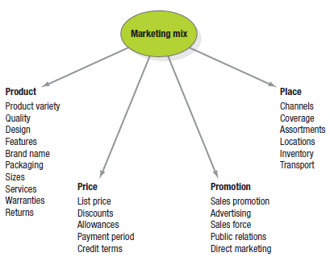

Fig.1.1: The Four P Components of the Marketing Mix

Marketing Mix theory, was brought by the American professor - Jerome McCarthy - back in the sixties. He classiﬁed the tools marketers use to target markets into four broad groups that he called the four Ps of marketing (as shown in Fig1.1). Product, Price, Placement and Promotion, known as the In our days the four Ps are well-known basics of the marketing strategies of traditional and computerized type.
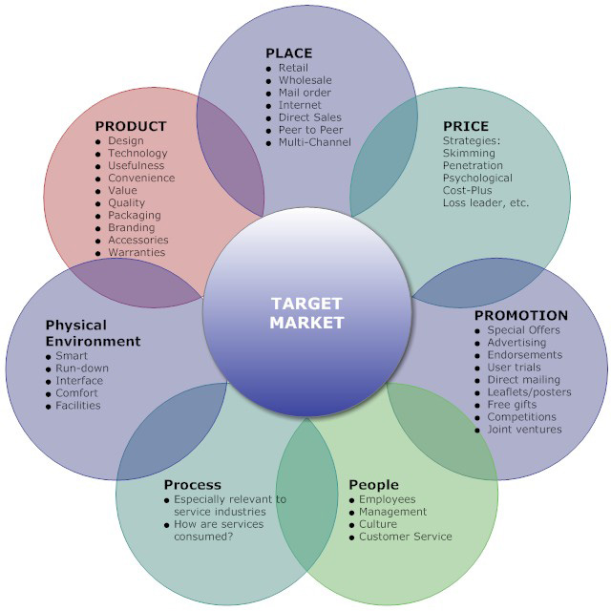
Marketing mix is the combination of different marketing decision variables being used by the firm to market its goods and services. After identifying the market and gathering all the basic data, the next step is to decide which are the tools and the strategy to use, to meet the needs of the customers and the challenge of the competitors. It offers an optimum combination of all marketing Instrumens so that companies can accomplish their objectives like maximizing the profit, and the sales volume, largening the market share, return on investment etc. The basics of the marketing mix are Product, Price, Place, Promotion, then there’s this new three developed elements; people, process, and physical environment. (išoraitė, 2016)

Fig.1.2: The 7 Ps of marketing mix
Source: (marketingmix.co.uk, 2019)

Therefore, while satisfying the needs of consumers, the company makes decisions related to the product, its price, distribution / place and promotion, and the four of the group is considered to be the key marketing mix elements also called.
- Product:
“Product is defined as a physical product or service to the consumer for which he is willing to pay. It includes half of the material goods, such as furniture, clothing and grocery items and intangible products, such as services, which users buy”. (išoraitė, 2016)
Kotler and Armstrong define a product as “anything that can be offered to a market for attention, acquisition, use, or consumption that might satisfy a want or need. Products include more than just tangible objects, such as cars, computers, or cell phones”. (Kotler & Armstrong, Principles of Marketing, 2012)
“Products are a key element in the overall market offering. Marketing-mix planning begins with building an offering that brings value to target customers. This offering becomes the basis on which the company builds profitable customer relationships”. (Kotler & Armstrong, Principles of Marketing, 2012)

- Price:
Price is one of the most important marketing mix items and many scientists consider the price as one of the most important elements of the market, which increases not only profits, but also market share. However, the price is not only one of the key factors in a competitive situation, which directly affects the company's sales and profitability indicators, but also one of the most flexible marketing mix elements, which can quickly adapt to environmental changes. Therefore, it is the price is perceived as the only element of the marketing mix, generating revenue and the most important customer satisfaction and loyalty factor. (išoraitė, 2016)
(Kotler & Armstrong, Principles of Marketing, 2012) defined the price as the amount of money to pay for a product or service, or the value of the exchange help customers receive a product or service for a certain amount. "Thus, the direct cost of the period is the amount of money the buyer has to pay for the product or service that is likely to buy it. "The price may also be defined as a monetary expression of value for the consumer agrees to pay" (išoraitė, 2016)
Place:
Place is as important as the first two elements of the marketing mix theory, that is also called the distribution, which is defined as the process and methods by which products or services reach customers, the right use and the implantation of this element will help customers and users to find and keep purchasing and ordering those products and services from those producers and providers, that mean that this element include all the decisions and actions related to the movement of goods and services from the manufacturer to the consumer. (išoraitė, 2016)
Many companies started to work internationally, without crossing country borders, thanks to the Internet a globalization. All ties to the companies’ locations were destroyed allowing bigger possibilities. Different type of products emerged from bigger market spaces, and individuals as well as companies started to save money on marketing material, which is much simple to produce now. (Stokes 2011, 26.)
- Promotion:
If the product is manufactured keeping the consumer needs in mind, is rightly priced and made available at outlets convenient to them but the consumer is not made aware about its price, features, availability etc., its marketing effort may not be successful. Therefore, promotion is an important ingredient of marketing mix as it refers to a process of informing, persuading and influencing a consumer to make choice of the product to be bought. Promotion is done through means of personal selling, advertising, publicity and sales promotion. It is done mainly with a view to provide information to prospective consumers about the availability, characteristics and uses of a product. It arouses potential consumer’s interest in the product, compare it with competitors’ product and make his choice. The proliferation of print and electronic media has immensely helped the process of promotion. (gupta, 2015)
When Promotion is well organized, customers are aware of companies, brands, the most crucial points, and this information does the job it is expected to.
- People:
The fifth P found its place in the Marketing Mix. It stands for customer importance, storytelling, personalized way of doing business. Thorough research is important to discover whether there are enough people in your target market that is in demand for certain types of products and services.
The company’s employees are also important in marketing because they are the ones who deliver the service. It is important to hire and train the right people to deliver superior service to the clients, whether they run a support desk, customer service, copywriters, programmers…etc. When a business finds people who genuinely believe in the products or services that the particular business creates, it's is highly likely that the employees will perform the best they can. Additionally, they'll be more open to honest feedback about the business and input their own thoughts and passions which can scale and grow the business. This is a secret, “internal” competitive advantage a business can have over other competitors which can inherently affect a business's position in the marketplace. (marketingmix.co.uk, 2019)
It is a well-known fact that customers are expecting personal attention, involvement, and personalization now more, than ever before. It gives the fifth P more value for the businesses, and it will help it to become even stronger in the nearest future. Such changes are leading companies to money and time investments in storytelling. 111111111111111
- Process:
The 6th element in the marketing mix theory is the (Process) and it was referred to the systems used to deliver the product or the service, imagine you walk to any fast-food or a restaurant and you order something and get it delivered hot and well-cooked within 2 minutes, what was the process that allowed you to obtain an efficient service delivery? Your bank sending you a new credit card a day before it expired again this require an efficient process to identify expiry date and renewal, an efficient service that replaces old credit cards will foster consumer loyalty and confidence in the company, all services need to be underpinned by clearly defined and efficient process. This will avoid confusion and promote a consistent service. In other words, processes meant that everybody knows what to do and how to do it. And we cannot ignore the help that the internet and the new technologies (software’s that uses a data base in the internet, mostly to collect data about customers and help to manage and analyze this data) gave us to make this possible and lot easier to manage. (marketingmix.co.uk, 2019)

- Physical evidence:
The last P from the extended marketing mix is the physical evidence (physical Environment) and this is about where the service is being delivered from. It is particularly relevant to retailers operating out of shops. This element of the marketing mix will distinguish a company from its competitors. Physical evidence can be used to charge a premium price for a service and establish a positive experience. Learnmarketing.net (2019) ^{[13]}, For example all hotels provide a bed to sleep on but one of the things affecting the price charged, is the condition of the room (physical evidence) holding the bed. Customers will make judgments about the organization based on the physical evidence. For example, if you walk into a restaurant you expect a clean and friendly environment, if the restaurant is smelly or dirty, customers are likely to walk out. This is before they have even received the service studymoose.com(2016).
In another words this refers to the way your product, service, and everything about your company, appears from the outside. Decisions need to be made about the size, shape, color, material, UPC bar code, and label of the packaging. This should be customer tested and updated when needed. It should fall in line with your other product offerings as well. Packaging involves the visual layout, practical setup, and when needed for products, clear and precise installation instructions. Physical Evidence can also refer to the people within your company and how they dress and act. It can refer to how your office is set up, the professionalism of your staff, nice brochures, how you interact with your customer base, and every single visual element about your company. (masterclassmanagement, 2019)
In some spheres of thinking, there are 8 Ps in the Marketing Mix. The final P is Productivity and Quality. This came from the old Services Marketing Mix and is folded in to the Extended Marketing Mix by some marketers. The 8th P of the Marketing Mix Productivity & Quality - This P asks “is what you’re offering your customer a good deal?” This is less about you as a business improving your own productivity for cost management, and more about how your company passes this onto its customers. (Professional academy, n.d.)

Section 3: Market strategies
Technically speaking, a market is any place where two or more parties can meet to engage in an economic transaction—even those that don't involve legal tender. A market transaction may involve goods, services, information, currency, or any combination of these that pass from one party to another. investopedia.com (2019) ^{[16]}
The market can be viewed from many different perspectives and, consequently, is impossible to define precisely. In order to provide some clarity, we provide a basic definition of a market: A group of potential buyers with needs and wants and the purchasing power to satisfy them. Rather than attempting to cut through the many specialized uses of the term, it is more meaningful to describe several broad characteristics and use this somewhat ambiguous framework as the foundation for a general definition. (Burnett, 2008)
The economist's perspective:
The term 'market' as used by economists has a different meaning from ordinary usage. It does not mean literally the physical place in which commodities are sold or purchased (as in 'village market'), nor does it mean the stages that a commodity passes through between the producer and the consumer (as in marketing channels). Rather it refers in an abstract way to the purchase and sale transactions of a commodity and the formation of its price. Used in this way, the term refers to the countless decisions made by producers of a commodity (the supply side of the market) and consumers of a commodity (the demand side of the market), which taken together determine the price level of the commodity ... the term is detached from any particular geographical coverage. The geographical scope of the term depends on the context in which it is being used. It may refer to the local situation in some part of the rural economy. (soas.ac.uk, n.d.)
The business perspective:
Business people tend to use the term 'market' to describe the groups of individuals or organizations that make up the pool of actual and potential customers for their goods and services. These groups fall into one or more of the following categories: geographic, demographic or socioeconomic, psychographic, behavioral or sectoral. (soas.ac.uk, n.d.)
The New Institutional Economics' perspective:
Markets are a type of 'institution' or mechanism that exists to facilitate exchange, co-ordination and allocation of resources, goods and services between buyers and sellers, between producers, intermediaries and consumers; competitive markets can provide 'efficient' co-ordination by reducing the cost and risk of carrying out transactions, can encourage business development and also help to achieve broader economic objectives. But markets are not always competitive or efficient. Markets as an institution can be imperfect. (soas.ac.uk, n.d.)
After the invention of the internet new type of markets appeared we called virtual markets or online markets like the E-Commerce websites that we know (Amazon – eBay – Jumia … etc) as a result of the revolution of social media this type of markets kept devolving and new shapes of markets has appeared like the Facebook marketplace or the pages specialized in selling products online without third part website or a physical place.

3/ Market Strategy

There are plenty of definitions about marketing strategy, each of it reflect a different perspective; However, Marketing strategy is defined as in a given market area, the proper allocation of resources to support enterprises to win competitive advantage. (Goi, 2009) define marketing strategy as the set of the marketing tools that firms use to pursue their marketing objectives in the target market.
In order to respond to the opportunities and challenges of the marketplace, most organizations involve in their there process a strategic planning, Bennett defined strategic planning as a process that describes the direction an organization will pursue within its chosen environment and guides the allocation of resources and efforts. (Bennett, 1988)
The aim of the development of an organization’s marketing strategy development is to establish, build, defend and maintain its competitive advantage. Managerial judgment is important in coping with environmental ambiguity and uncertainty in strategic marketing.
Marketing strategy can be divided into four ways to research that:
(1) Dual-oriented marketing strategy: using rational and emotional product name, easy to remember, and pricing to take into account the cost of service and quality orientation, psychological factors and competitors‟ prices.
(2) Rational marketing strategy: the use of functional demands of a rational position, consider after-sales service, warranties, delivery and installation attached by the product factors.
(3) Emotional marketing strategy: the emotional appeal to locate, emphasis on physical product shape, color design, the use of emotional product names, and so on memory, attention to product packaging and labeling.
(4) Maintenance marketing strategy: consumers are more concerned about price and quality, it is not suitable to use a lot of marketing techniques, manufacturers can improve product packaging and labeling, give a simple name for remember, consider the quality position and competitor pricing during pricing.
Lin (1993) divides marketing strategy into four parts, that is dual-oriented, rational, emotional and low involvement, different product types with different marketing strategy, so the manufacturer’s marketing strategy can be divided into five parts which is the choice of target market, product strategy, pricing strategy, channel strategy and marketing strategy. He uses a total of 29 questions to measure new product marketing strategy and seven points Likert scale is used to measure. When the industry lacks of competition, the business performance would be better even when companies are not entirely market-driven, the performance will have a more excellent performance. (Gbolagade, Adesola, & Oyewale, 2013)

3.1 Product development Strategies

Kotler and Armstrong (2006) define a product as anything that can be offered to a market for attention, acquisition, use, or consumption that might satisfy a want or need. They further define a consumer product as the product bought by the final consumer for personal consumption. Consumers buy products frequently, with careful planning, and by comparing brands based on price, quality and style. (Gbolagade, Adesola, & Oyewale, 2013)
The product is the core of the marketing mix strategy in which retailers can offer consumers symbolic and experiential attributes to differentiate products from competitors. However, it is also concerned with what the product means to the consumer. Product is about quality, design, features, brand name and sizes. (Jayaraman & Wong , 2008)
regardless of a product being a new innovation, an update of a familiar product or an imitation of a competitor product, it needs careful considerations and planning to make sure suits the customers‟ needs and wants, it should have a significant competitive advantage and should be accepted in the marketplace. Many attributes of a company’s products, including brand name, quality, newness, and complexity, can affect consumer behavior. The physical appearance of the product, packaging, and labeling information can also influence whether consumers notice a product in-store, examine it, and purchase it. One of the key tasks of marketers is to differentiate their products from those of their competitors and create consumer perceptions that the product is worth purchasing. (Kasiso, 2017)
Brand equity reflects consumer’s belief that the brand is looking out for them, will do whatever it takes to make them satisfied, and is responsive to their needs. The ability of a product to perform its functions includes the product’s overall durability, reliability, precision, ease of operation and repair, and other valued attributes. (Jayaraman & Wong , 2008)
  - Pricing Strategies

(Kotler P. , Marketing: an introduction, 2007) defines price as a cost of producing, delivering and promoting the product charged by the organization. Pricing is one of the 4 P’s outlined in the marketing mix strategy of a company. The price of products and services often influences whether consumers will purchase them at all and, if so, which competitive offering is selected.
There’s a significant relationship between price and business performance. The price you set for your product or service plays a large role in its marketability.
Pricing for products or services that are more commonly available in the market is more elastic, meaning that unit sales will go up or down more responsively in response to price changes. (Gbolagade, Adesola, & Oyewale, 2013)
As we said above an acceptable price change is determined by the buyer’s willingness and ability to purchase a product, and the seller’s cost of producing and distributing the product. Price discrimination is a common method used by organizations where products are of different prices depending on the quality, so products of high quality are priced higher than the other products. Stores like Wall-Mart, Amazon, aliexpress … etc, are perceived to charge the lowest prices to attract many consumers based in this fact alone, for some offerings, higher prices may not be always unattractive because so many consumers believe that the products or services with the higher a price are more prestigious or in a higher quality. However, many consumers may buy products more on the basis of the price than other attributes. Among retail stores, the pricing strategy has become the pivotal point as they need to compete in terms of pricing to lure more customers. (Kasiso, 2017)

  - Promotion Strategies

Promotion is defined as sales promotion, advertising, personal selling, public relations and direct marketing (Borden, 1984) describes promotion as part of specific effort to encourage customers to tell others about their services. promotion is the key to the market exchange process that communicates with present and potential stakeholders, and the general public. Every firm or store must cast itself into the role of communicator and promoter. It appears as an issue of how to create an optimal mix of marketing communication tools in order to get a product's message and brand from the producer to the consumer.
Kotler states that Promotions have become a critical factor in the product marketing mix which consists of the specific blend of advertising, personal selling, sales promotion, public relations and direct marketing tools that the company uses to pursue its advertising and marketing objective. (Kotler P. , Marketing: an introduction, 2007)
Advertising, sales promotions, personal selling and publicity can influence what consumers think about products, what emotions they experience in purchasing and using them, and what behaviors they perform, including shopping in particular stores and purchasing specific brands. Since consumers receive so much information from marketers and screen out a good deal of it, it is important for marketers to devise communications that first offer consistent messages about their products and secondly are placed in media that consumers in the target market are likely to use. Marketing communications play a critical role in informing consumers about products and services, including where they can be purchased and in creating favorable images and perceptions. (Jayaraman & Wong , 2008)

  - Place Strategies

The place is the third element of the marketing mix, and it encompasses all decisions and tools which relate to making products and services available to customers. Place strategy calls for effective distribution of products among the marketing channels such as the wholesalers or retailers (barman, 1996).
(Kotler P. &., 2006) define place or distribution as a set of interdependent organizations involved in the process of making a product available for use or consumption by consumers. The place is the way that the customer can obtain a product or receive a service. The dimensions of place are channels, coverage, assortment, location, inventory, and transport.
(Borden, 1984) highlighted that the place has a remarkable effect on business performance. So, and taking place or distribution into considerations may play a major role in influencing consumer motives to buy a product.
A marketer’s strategy for distributing products can influence consumers in several ways. First, products that are convenient to buy in a variety of stores increase the chances of consumers finding and buying them. When consumers are seeking low-involvement products, they are unlikely to engage in an extensive search, so ready availability is important. Second, products sold in exclusive outlets may be perceived by consumers as having a higher quality. In fact, one of the ways marketers create brand equity - that is favorable consumer perceptions of brands - is by selling them in prestigious outlets. Third, offering products by nonstore methods, such as on the Internet or in catalogues, can create the consumer perception that the products are innovative, exclusive, or adapted for specific target markets. (Jayaraman & Wong , 2008)

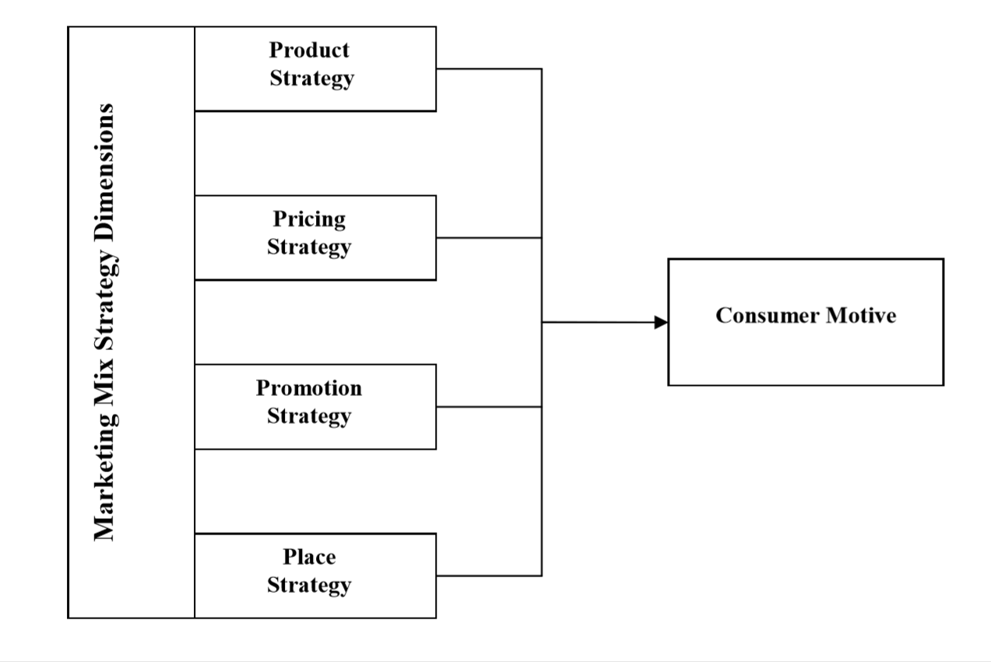

Fig.2: Marketing Mix Strategy Dimensions
Source: Kotler, Philip and Amstrong, Gary (2006). Principles of Marketing. Pearson International Edition, 11th Edition.

CHAPTER TWO: ONLINE MARKETING

Introduction:
The fast evolution of the Internet helped to create new tools for people and businesses, With the arrival of social media, Algerians change the way they communicate with each other’s, it becomes easier to share their thoughts and ideas, and it’s allowed them to use many different ways to achieve that, blogs, images, videos, etc... with a few clicks; and this itself gave another dimension to the usage of the Internet. And many advantages for the users.!!
The history of the Internet started in the United States in the early 1960s. This was the Cold War period when the world was bi-polar: The United States and the Soviet Union were competing in expanding their influence in the world, viewing each other with great caution and suspicion, when they needed to create a network to help them collect more information about their enemies, encrypted, easier to use and faster. (cohen-almagor, 2015)

According to (we’re social, 2018) internet reached 4 billion users in 2018 (Fig.2). And it’s estimated this number will keep increasing in the few next years, well over half of the world’s population is now online, with the latest data showing that nearly a quarter of a billion new users came online for the first time in 2017. Africa has seen the fastest growth rates, with the number of internet users across the continent increasing by more than 20 percent year-on-year. Much of this year’s growth in internet users has been driven by more affordable smartphones and mobile data plans. More than 200 million people got their first mobile device in 2017, and two-thirds of the world’s 7.6 billion inhabitants now have a mobile phone.

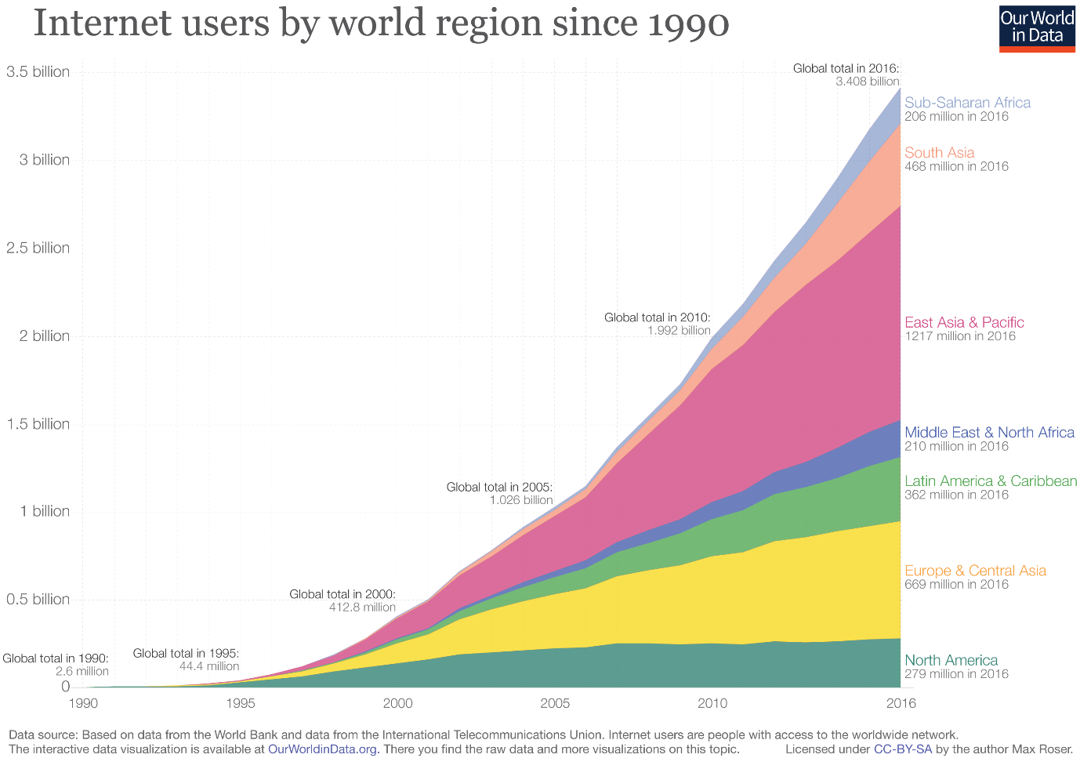

Fig.2: the internet usage growth from 1990 to 2016
Source: our world in data

Section 1: Online marketing
What is online marketing?
Internet can nowadays provide customers with information at any time from any place, that’s why firms companies changed completely the way of advertising their products and they considered the internet a new era in the business world and have to take it very seriously if they wanted to keep or expand their businesses.
(Kotler P. &., 2006): “Online marketing consists of measures and activities to promote products and services and build relationships with customers over the Internet”. Burrett (2008) explained online marketing as a careful targeting of users and getting them to interact with you while they’re minding their own business.
Through our research we found that the most general and complete definition has been articulated by (Chaffey, 2007) he defines online marketing as the Applying of Digital technologies which form online channels (Web, e-mail, databases, plus mobile/wireless ) to contribute to marketing activities aimed at achieving profitable acquisition and retention of customers (within a multi-channel buying process and customer lifecycle) through improving our customer knowledge (of their profiles, behavior, value and loyalty drivers), then delivering integrated targeted communications and online services that match their individual needs". As this relationship concept definition show online marketing revolve around interaction and building relationship with customers, a point which discriminates it from traditional, offline marketing. (Bostanshirin, 2014)
Marketers these days have to face new challenges on the internet when attempting to promote their products and services. But they also have the opportunity to create personalized, relevant communications and content to develop deep relationships with customers based on ongoing interactions, sas.com (2019). And to do that they have to plan and use different strategies and be prepared for every situation. Online marketing is not just about advertising anymore; it is about reaching the right customers, at the right time with the correct information. “What’s the motive,” “What is making the customer buy?” – These questions are essential if we want to know how to reach the right customers. There is no single appropriate and applicable answer for all businesses, but unrepeatable sets of features and obstacles for different industries are always going hand in hand with some popular influencers. The marketing team has to understand and analyze the market, data trends, and previous marketing strategies to face these obstacles.

The evolution of digital marketing:
With every web development, Marketing adopted new tools and strategies that helped her reach to new customers, and interact in a better way with its loyal clients. This improvement is noted by marketers with the evolution from marketing 1.0 to the recent version marketing 3.0.
When Marketing 1.0 was recently started, it was based on the product, since it develops all its strategies around it. It is based on the basic needs of the consumer without taking into account feelings. Its diffusion is by traditional means such as television and radio, so it is not present on the Internet. It should be mentioned that its message is unidirectional because it does not provide feedback to the client and the units of measurement are very few and variable.
Unlike the previous one, Marketing 2.0 is responsible for developing strategies based on the consumer, is responsible for knowing them and satisfying their needs, reaching a specific segmentation of sex and age, as well as highlighting their feelings and the wide capacity for evaluating different products or services. This is why Marketing 2.0 communicates with, in addition to traditional media, interactive media that promote the participation of society and obtaining constant feedback. Here applies communication through social networks.
Marketing 3.0 is based on the values of society, so it seeks to reinforce the integral image of the person and therefore create a better and balanced world, this is why companies start making public that they are socially responsible. It also seeks to improve the environment, retaking green marketing tends in order to reinforce products and campaigns, joining in this trend some of the most important brands around the globe, such as The Coca-Cola Company, McDonald’s or PepsiCo, among others. ektroid.com (2018)

Section 2: Online Marketing Strategy
The internet has perhaps revolutionized everything in our daily life from learning in schools to E-learning, from spending hours from store to another searching for products to online shopping and a lot more stuff to do with just a click of a button. this opened a completely new fields of marketing, evolved different types of strategies. This is where digital marketing became not only television and radio but also the internet and a new era has started called “online marketing”, that it’s full of skillful and convenient promotional tools, actively used nowadays. It even created a highly competitive environment for companies determined to gain web leadership. And this also led to a noticeable change in consumer’s habits, needs and interests even their life style. the globalization made trends become lot more effective than before, that’s why companies could not ignore this big change and the developing in the consumer buying behavior must be a priority to be studied and understood. (sotnikova, 2016)
But this doesn’t mean that any small involvement in the online marketing will lead to success, it is not enough to create couple of accounts in the social media or networking web pages and to update them sometimes. The presence of a company on the Internet does not provide any result if it is not related to the long-term strategies. The accomplishment most company wants can be reached only with a strong and solid online marketing strategy, and this won’t just serve the short-time plans but it will follow the company’s purpose and its long-term objectives, which leads to adding desired value to their customers. First of all, the connection between all the actions and the company’s goals should be questioned, and later - the extent to which company would want to increase sales, profits or awareness, with the help of online marketing, should be defined (sotnikova, 2016)
The internet has radically changed the way that companies design their marketing strategies, while marketing may have been limited in the past to a specific geographical area, the internet has meant that marketing strategies and targeted demographics can be significantly widened since the web network has no known boundaries, at the same mean time the accessibility and the availability plus the easy use of the internet means that your competition has changed as well, before you might have had a limited competitors in your area, but now you’re competing against everyone who uses the web and the internet as a marketing strategy.
The perfect explanation of a “strategy” is to know how to use the resources you have to reach to the potential consumers and convince them the buy your products or use your services, this might be the biggest weakness of your company, that’s why you have to understand what your company is dealing with before starting the online marketing process, and to know how can this affect your brand image reputation in every possible way.
An online marketing plan is a strategic document that takes the current situation of a certain organization to set some midterm goals and to determine the strategy and objectives to achieve them. This document also describes the responsibilities, the time frame and control tools for monitoring. The aims of an online marketing plan include discussing organizations the environment they’re willing to work with. Likewise, it needs to be a roadmap of how to manage the organization’s marketing strategy, so that resources are properly allocated. The plans also help control and evaluate output and tackle any potential deviation from the organization’s expected outcomes. In this line, a marketing plan becomes a flexible document that must be adapted to the situation of the company and that must feed into the results obtained by each of the actions developed, especially in the digital arena. (teresa piñeiro & Xabier , 2016)
Any online marketing strategy need to go through some steps before it starts to work. The strongest the connectivity of the company’s goals to its online marketing plan, the highest chance that it will work as it’s planned to be.
The development of an online marketing plan is similar to a conventional one in its structure, but it also includes some variations at an operational level. In fact, this means not only that some specific strategies and tools are to be developed, but also that the volubility of the digital media and its capacity for immediate measurement force organizations to develop a strategy that can be revised in the short term, as well as the iterative process between action and control. An online marketing plan is a document in line with the company’s strategic plan that sets goals of an activity in the digital environment, as well as the what, how, when, who and why (6 Ws) of Web presence. There are different options regarding the structure of a marketing plan. (teresa piñeiro & Xabier , 2016)
In the online world, loyalty and support for the brand can take the relationship between the clients and the company to the next level and change consumers into prescribers, who follows your entire business news and stay always updated, this cause a noticeable increasing in the scope of the organization’s action, which could lead to an expansion of its customer base. (teresa piñeiro & Xabier , 2016)
One of the most important things any company should be aware of and focus on studying it is customer behavior. It is very necessary to understand how customers act, evaluate and make decisions to develop an effective marketing mix.
To understand customers habits, behaviors and their needs, many measuring tools were created. According to the measuring and analyzing, effective strategies can be designed and used to help achieve companies’ objectives and means. All the details about the customer action or behavior are important and we cannot ignore or not consider it while planning our online marketing strategy. (Stokes 2011), if we can understand the customer, the biggest part of the process is accomplished, but sometimes we found that the number of the customers is huge and they have a very diverse needs and habits. This raises another part of excellent marketing strategy, where not only the consumers are counted, but also classified with their diverse habits and buying behaviors. (sotnikova, 2016)
From all this, we notice that the main part of the online marketing strategy Is the connection between the company and the customers, and if we could understand and communicate with our clients and customers in the right way, this can majorly be the reason to win their loyalty and help to give them more from what they want, and to do that perfectly, we need to really know how to communicate with them? What are the tools we can use to do that? which one will be the ideal to use? And when is the perfect timing to do that?

Section 3: Online marketing communication
Online marketing referrers to as internet marketing meaning it requires live internet connection to work. Online marketing strategy is a subset of digital marketing. Organizations raise their sales turnover, market share and profitability using online marketing strategies
Online Marketing does not stay at one place, but it constantly moves towards innovativeness. As it was already mentioned before, the earliest forms of Internet marketing, which are still valid and even effective, are supplemented by new emerging means. Due to its fickleness, online marketing requires keeping an eye on the changes all the time. For this reason, Internet marketing tools represented in this chapter were selected in accordance with latest tendencies.

2.3.1 Online Marketing Communication’s tools:
2.3.1.1 Email Marketing
Emails now play a big part in everyone’s life especially in the business world as an online communication tool that helps you communicate with your staff, your suppliers and most importantly your customers, using this as an online marketing communication tool help you create a connection between you and your customers in order to make them update and win their loyalty.
The first ever email was sent by Ray Tomlinson in 1971, marked the beginning of a new modern communication era. And quickly emails become the first communication channel in the world (mailchimp, 2019), according to optinmonster at least 91% of people using the internet check their emails on a daily basis. Gary Thuerk, a Marketing Manager at Digital Equipment Corp, sent the first commercial email years later after email was created, where the message reached a list of email addresses. And, Email Marketing was born. There were only a few hundred people on the list, but that was enough for Thuerk to claim the mantle, "Father of Spam." (optinmonster, 2019),
When considering a definition for email marketing, there are a number of ways to define it from the broad to the specific. Essentially, email marketing is the act of sending out emails to customers that contain advertisements or commercial information. This is a was used to attract new customers or make those that one already has loyal to the brand.
In such instable environment, e-mail has been one of the Web tools that have best adapted to change, both in content and in scope and penetration. Therefore, e-mail marketing becomes one of the main tools in a digital strategy. And it considered as one of the highly effective digital marketing strategies. (teresa piñeiro & Xabier , 2016)
The term “spam” refers to those messages we do not want to receive, usually sent though an automatic mass mailing. Although spam can be used on other apps, websites or electronic devices, for example SMS on mobile phones, e-mail is the most important channel for this practice. There’s a fine line between commercial information sent by e-mail and spam emails, (teresa piñeiro & Xabier , 2016) many tech companies are working today in order to minimize the spam emails or at least minimize the complain they get about it.
Features of E-mail:
- One-to-one or one-to-many communications
- Instant communications
- Physical presence of recipient is not required
- Most inexpensive mail services, 24-hours a day and seven days a week
- Encourages informal communications

Advantages of E-mail Marketing

The significant advantage of this tool of online marketing communication is that you can manage your relationship with you customers in an outstanding way, that is why it is used in CRM. On another hand, email marketing is very direct and can be managed to be sent to a specific audience and not to another, also email marketing can be done with the lowest cost possible and which can be well customized, measured and modified.
The strong penetration of e-mail in the current context becomes an important reason to include it any digital strategy, but there are also other important reasons to do so. This is mass technology that instantly reaches everyone and whose use spans devices and screens (desktop, laptop, mobile telephones, tablets, etc.). The system is direct and able to reach targeted individuals. This because an e-mail can be sent multiples addresses, while the content can target different types of customers. (teresa piñeiro & Xabier , 2016)
Disadvantages of E-mail Marketing
Despite the many plus points of this marketing format, starting e-mail marketing process can have some disadvantages: The most important enemy of professionals in the sector are antispam ﬁlters of e-mail managers that identify e-mail marketing as spam, thus to reduce the effectiveness of this filters, the authorization by the end-user to receive ads through mail is required. Such actions are regulated by data protection acts and speciﬁc e-commerce laws. Depending on the country and speciﬁc laws, sending unauthorized messages may result in very high ﬁnes for the companies sending them. This need for prior authorization to include the person on an e-mail database of a particular organization has pushed e-marketing into the group. (teresa piñeiro & Xabier , 2016)

2.3.1.2 Content Marketing
the word “content” in the internet can be used to describe all the information available on the web pages of the companies, blogs, social media channels, chats, whether it is a video, picture or a description, audio, presentations, e-books. As the content is everywhere, especially on the Internet it appeared to be a possible tool of attraction and interaction with the customer and as a result, it gave birth to the Content marketing. Nowadays, Content Marketing is a tool for making a profit through establishment durable customer communication and usage of inspiring and interesting content to attract desired targets.
The Content Marketing Institute offers the following definition:
“Content marketing is a strategic marketing approach focused on creating and distributing valuable, relevant, and consistent content to attract and retain a clearly defined audience and, ultimately, to drive profitable customer action.”
(content marketing institute, 2019)
It’s also a way of communicating with your customers or prospects without directly selling. This is done by creating and publishing interesting and relevant content to targeted audiences. Content can be published for example in the form of blog posts, social media posts, web articles and videos. The purpose of content marketing is to engage people with your brand, the technique of Content marketing delivers high quality relevant and valuable information to prospects and customer with the goal of driving profitable customer action. (Järvelin, 2016 )
Sometimes, when we speak of Content Marketing, one is led to think that it is something new and innovative designed especially for the internet, but history says that is not so. Content Marketing is a success coming from the past, it is something of a practiced craft with a longer history than we might expect. (CMEX, 2014)
Content marketing is not trying to push aggressive sales an it’s not direct way to make revenues or to sell a product, is the opposite of advertising. It’s about engaging consumers with the stuff they really want (CMEX, 2014), The key idea is to help customers understand issues and give helpful information about the services they could choose. It is a way to collect leads without losing your customers’ interest. Sometimes content marketing can be something which is given free upfront for customers, (Paavola, 2017) in a way that serves your brand’s purposes and ideas, rather than just trying to jam your logo into their periphery. It’s reaching the exact consumers you want, instead of a vaguely defined demo. It’s helpfully providing an experience they want, instead of trying to distract them from the one they came for. In short, (CMEX, 2014). Content marketing, in other words, is collecting leads in a way so that customers can seek and get in contact by themselves. (Paavola, 2017) it is the very evolution of advertising itself into something more effective, more efficient. (CMEX, 2014)
Content marketing can be a strong communicator between the company and the customer, which help them produce more relevant content in the future to be able to understand and control customer’s actions. Once communication circle is created it is easier to deliver the information, promote new ideas and perceptions or simply to inspire, because their attention is already received. (sotnikova, 2016)
The Straight communication with the consumers is a big advantage for the company. the experience of consuming or using a service from a company created some emotions and thoughts, and this experience stay in their mind. For the company, customer experience can be used as a source of feedback or development suggestion. If something went wrong and the customer is not happy. The faster you know about it and fix it, the highest chance you get their attention and win their loyalty. (sotnikova, 2016)
blogs were also only about written information, but today's practices showed that blogs are also affected by visualization. More and more pictures appear in the posts every day. (DeMers 2013) The information which contains images is always more memorable, associative and interesting. For example, some online retailer shops such as Aliexpress allowed customers to attach pictures to their comments and reviews that attract more audience to interact with the company and other users. Not just image we can see that many more social media platforms has added the option to share your thoughts using videos, and this can be a lot more helpful when you want to share a specific reaction or an emotion into something you’ve seen. This type of content makes it possible for you to involve your true emotions and share it in better way with others, this can help and guide companies who are trying to interact with new customers online to understand them lot better.
Why are companies using CM?
There are many reasons why firms and companies are using Content marketing to promote their products. these reasons are mostly the same as any other marketing practice case. Every company aims at winning new customers and win the loyalty of the existing ones, in order to increase the sales of its products and services and maximize its profit. All actions within marketing are focused on this very objective. Content marketing is no exception. However, if we assume that generating and maximizing the incomes is the objective, we will easily come to the conclusion that this objective is too obvious and too general. In particular in the context of the budget of the marketing actions, you must be perfectly aware of what the money is spent on and what effect you can expect. Precisely defined objectives will come in handy. The major objectives of the marketers who decide to launch content marketing are as follows: (CMEX, 2014)
- Increasing brand awareness
- Lead generation
- Converting leads into customers
- Building the image as the industry leader
- Customer engagement
- Customer retention
- Website traffic
- Sales

2.3.1.3 Search Engine Optimization:
Nowadays it is hardly possible to imagine a business which has not its own website. But having a well-designed website does not necessary result in an ideal number of visits. In order for this goal to be accomplished another type of online marketing, called SEM و should be adopted. (Bostanshirin, 2014)
Probably everybody heard the mysterious term “SEO”. SEO it is related to one of the most performed actions on the Internet – search. Search Engines help millions of users to find required content or web page by word or group of words (key words). These days alternative Search Engines are emerging all the time, but there are some of them, which are keeping the leading positions and always have a high demand. In 2019 Google, Bing, Yahoo! Search, Ask.com Baidu aol.com are continuing to keep dominance in the sector, where Google has the first place with its more than 1,6 billion monthly users. And 3.6 billion daily searches.
To provide users with the wanted results Search Engines are involving algorithms and programmed indexes of words. According to (Stokes , 2013) «Google says it uses more than 200 different factors in its algorithm to determine relevance and ranking». One search attempt can result on thousands of outcomes related to the given topic. Normally, the most suitable pages appear on the top of search result, allowing getting the best matches of the information. For the user search process does not normally go more difficult than typing the word in the field of Search Engine. (sotnikova, 2016)
We can classify search engines results into two categories, the first category is for organic results they’re considered as the most suitable results march to the searched words. Google search engine usually makes a very accurate results to the search, which explains its popularity among other search engines. The results are appearing on the top of the page as it was already mentioned before. And the more relevant result always goes the first and usually it attracts the attention of the users. (sotnikova, 2016)
The second category called paid results. These results might be not the best or hardly related to the search word, According to Econsultancy’s own Paid Search Best Practice Guide:
“ Paid search marketing affords businesses the opportunity to advertise within the sponsored listings of a search engine or a partner site by paying either each time their ad is clicked (pay per click) or less commonly, when their ad is displayed (CPM or cost per thousand) or when a phone contact is generated, which is ‘pay per call’.”
(Sentance, 2018)
So paid results are basically advertisements, the Web site owners have to pay to make their Web pages display for certain keywords in the top search engine results page, so these listings show up when someone runs a search query containing those keywords. (dummies, 2019)
Many people are searching for information about products and the places they can purchase this products from, many of them are switching to E-shopping because it is even more convenient and easier than going to an actual real stores, when thinking about this we conclude that search engine can be one of the most successful tools for directing the customers interesting in buying some products to a specific web pages in the internet. Trying to influence the buying decision for the people are ready to do so, this way companies must prepare it self to be there one the users start looking for products. (sotnikova, 2016)
The importance of search engine optimization use lies down on the assumption that search engines used as a way of surfing the web. Many marketing techniques have been developed to improve the rank of intended business websites in the search engine results. The purpose of SEO strategies is to help you place your websites among the most ranked website and help you get more traffic using a specific technic (keyword, better discerption. Etc.). So, "Web site owners, webmasters and online marketers want search engines to send traffic to their site. Therefore, they need to make sure that their sites are relevant and important in both the eyes of the search engines and the users." (Stokes , 2013)
Since search engine requires very specific technical knowledge, it is advisable to hire experts in the field to perform website and search engine optimization. Nevertheless, it is important to have an understanding of the basic aim and purpose of website optimization to include it in the company’s digital marketing strategy. (Lokteva, 2015)
Key components of SEO:
Unique, Relevant Site Content: Search engines blend multiple types of content into a search engine results page (SERP) based on the anticipated intent of the user. Therefore, to provide more opportunities for higher rank, it is important for websites to contain a wide variety of unique content (text, pictures, videos, infographics, etc.) that relate to the page subject.
Organized Site Structure A well-planned website with keyword-rich URLs goes a long way in ensuring usability for humans and “findability” for search engines. Using a different key words that describe your business may help finding you easier.

2.3.1.4 Social Media
With this fast-changing environment, even the way we communicate with each other has change. Social media has become one of the most used communication tools in the 21't century, enabling us to express our belief, ideas and manner in an absolute new way. This new way of communication has a noticeably affected corporations, where they have realized that without a using the perfect social media strategy and marketing plan, they have no chance to stand out in this fast-changing digital environment. To guarantee a successful attendance on social media the companies need to take different online marketing strategies into consideration so that they can boost their brand in different aspects. If this can be collective with original ways of consumer interaction the companies have a good chance to take the lead in social media marketing. (Saravanakumar & SuganthaLakshmi, 2012)
«social media is understood as the different forms of online communication used by people to create networks, communities, and collectives to share information, ideas, messages, and other content, such as videos. » (Terrell, 2019)

«Social media refers to internet and mobile-based social networking platforms build on the foundations of web 2.0 that allow users to produce, consume and exchange information, socialize and interact with each other, share opinions and content, it involves building of communities or networks and encourages participation, engagement and content creation. » (Lokteva, 2015)
Social media has been constantly evolving and growing in popularity since its development. According to (we're social, 2019) the number of social media users worldwide in 2019 is 3.484 billion. In a few years, so many websites appeared in the internet, social networking websites sharply transformed human communication, habits, lifestyle and the life itself. (Dr. M. Saravana Kumar, 2012)
social media made the bigger impact on interpersonal communication and amplified the amount of Internet content. social media should be considered by all the businesses, because it helps them larger their market share, to do that so, companies must be able to involve and integrate a social media marketing plan, not only as a way to enhance its communication with its clients, and to advertise its products and services, but also to merge it with it’s long-term objectives. (sotnikova, 2016)
Social media is also transforming the way organizations communicate, mostly all the social media tools available these days are cost-effective when compared to traditional approaches such as email and online advertising. Blog posts and tweets enable businesses to create a connection with your audience, offer immediate feedback or assistance, and promote their products and services. (Trisha Dowerah Baruah, 2012)
« Most social networks show business models based on advertising. If we take for granted that a social network manager is a massive database, with large amounts of qualitative data from its users, using them allows brands for micro segmentation of their advertising actions. » (teresa piñeiro & Xabier , 2016)
a) Facebook
Facebook is one of the most known and recognizable web pages in the world. For a bit more than ten years it grew amazingly big, and, already in 2014, Facebook had 1,3 billion registered users (Facebook 2016.). Facebook was founded on February 4, 2004 by Mark Zuckerberg, as well as Eduardo Saverin, Andrew McCollom, Dustin Moskovitz, and Chris Hughes. Facebook started as a social media site exclusive to Harvard students, although it quickly spread to the rest of the Ivy League, as well as Stanford and MIT. However, after 2006, Facebook was available to anyone claiming to be above the age of 13, regardless of whether or not they had an affiliation with a university. (Terrell, 2019)
Facebook is the king of segmentation. Its advertising platform, Facebook Ads, allows for a delimitation of the target audience of each ad depending on location, age, sex, languages and even interests and behaviors. Facebook is the social network with more data on its users. The basic data ﬁlled in by the user alone in the process of registration on Facebook includes name, e-mail, sex and age of the new user. (teresa piñeiro & Xabier , 2016)
Facebook advertising formats are inserted either on the sidebar on the right-hand side of the platform itself or on the users own timeline (Web and mobile), as well as on the logout page. These adverts must to be identiﬁed as such, while their goal is to foster as much interaction with users as possible. They thus try to increase engagement, lead users to a website or special offers, get more likes on pages, app downloads... etc.
The success of Facebook can be related to its simplicity. The ordinary Internet user does not need to know anything about programming or coding to create a Facebook account. For the first visit of the website, the user does not need to search for the registration forms or bring any documents like a passport. The online registration form appears automatically and does not require anything demanding (basic personal information.); Facebook registration does not ask too personal information and can be accomplished in minutes without any effort.
The possibility to spread and share different forms of content, including text, links and pictures attract businesses to be present on Facebook. It helps companies to integrate better in the informational stream and promote the products without any pressure to the potential customer. Also, Facebook helps companies to start without any charge and need of planning. It directs companies from the very beginning, starting with category selection. These categories are listed as follows: Local Business or Place, Artist, Band or Public Figure, Company, Organization or Institution, Entertainment, Brand or Product, Cause or Community. (Facebook 2016.)
To begin a successful story in Facebook the business should attract the user and gain more followers for its page after the profile was created and the package of first information was added to it. To create traffic and to build recognition, the company can start with already existing customer base through invitation them to follow the company’s page.
As per usual, when the business has loyal customers the word-of-mouth spreads and already subscribed users start to invite their friends, relatives, and other connections to view the page. The company, in turn, does not have to apply any special or outstanding means to track the traffic and users, who started to follow their page. This data is counted and automatically displayed in the upper line of the page, where company name, details and contact information are located.
Not only news and updates can be fast spreading when the company is registered and active on Facebook. The client communication and dialogue can speed up as well. Taking into consideration the fact that people are more limited with the time available and like simplicity in everything, it is wise to consider that some people would prefer to ask questions or leave comments when they are looking through their News Feed, than go the company’s website, log into webmail or make a call.
The number of Facebook users might be the main attractive thing about it as a business platform but one of its biggest advantage is that there’s no need for companies to wait until the customer comes to them and show the interest its brand or activity, the company can go directly to the customer by the selected content intended to attract the users attention. It even allows business to keep the customers and its clients updated about the new stuff they’re doing. to make Facebook advertising work, it very important from the companies to post at least once a week, because many sets of information are appearing every day, and users are simply forgetting or losing interest very quickly.
To obtain more followers the company should have a visible tendency in its publishing as it was stated in the paragraph above. However, it is not wise to talk only about goods or services, while networking through social media. It could be explained by communicating and interactive nature of Facebook. Some other types of content tailored to customer needs should be distributed. As an example, interesting company events, guidance, campaigns, competitions and even stories can be used as relevant and valuable reminders to the subscribers.
It is believed that overall company’s image and perception matters the most; though, it also should be noticed what the brand creates itself. The smallest details can play the biggest.
Facebook also has more business directed services such as Facebook Adverts and Adverts Manager. These means allow business to select a specific audience segmentation and target them, like selecting targeting groups based on gender, age, physical location and many other segmentation methods, after selecting the targeted group, can used what it’s called sponsored ads, they can decide the budget they want to spend and the period the ad has to keep running, which will be set on daily or per campaign basis. To manage campaigns effectively Facebook offers to use its application “Adverts Manager”, which can be accessed even through smartphones and tablets. Which help you control, track every ad and the things related to it. (Facebook 2016.)
b) YouTube
The consumption of online video has seen a rapidly rising trend over the past years, People are recording their everyday lives with mobile phones and uploading the content into the internet. Social media platforms are constantly filled with video material one of the main video sharing platforms is YouTube that was created in February 2005 by Chad Hurley, Steve Chen, and Jawed Karim, who were all early employees of PayPal. The site allows users to upload, watch and share videos from all around the world on its platform. The available content on the platform can range from professional to amateur and the diversity of the videos goes from TV clips to short films and other types of content, such as video blogging, tutorials and Educational videos. YouTube users can comment on and share other content and they can join communities and engage in conversations. YouTube is the second largest search engine in the world and it is transforming the way we discover information on the internet. (Garcia, 2016)
Years ago, YouTube started to grow very fast, it was developed back in 2005. Already in 2014 it had more than 1 billion users. YouTube never stopped developing. With time the ntegration of commercials started to be possible and YouTube Live took place. Since then, YouTube has introduced multiple new features such as YouTube ads, this ad where merged with the videos posted, and YouTube Live. Live online translations appeared together with automatic play and video categories uniting videos according to search results. (sotnikova, 2016)
When we see the massive amount of people using YouTube, it is not very wise if we ignore this marketing tool. Any kind of a company or an organization can include YouTube as an effective online marketing with its strategic planning and marketing process. YouTube proved its efficiency not only as a tool of entertainment and video sharing but also as an effective business introduction and as a promotional platform. With its ranking as one of the most visited web page in the world, it also managed to become a very popular search engine and attract more than 1.8 billion visitors monthly according to (Gilbert, 2018) from business insider.
According to Safko and Brake, “Video is almost always the best medium for communicating with your customers. Being able to share your expressions, inflections and body language builds much greater trust and conveys sincerity to your viewers. Watching someone deliver her or his message is powerful” (Garcia, 2016)
c) Twitter
Over the past ten years the increasing use of social media by businesses has re-defined the way businesses connect and communicate with customers. Twitter is one of the most popular social media platforms, (Twitter statistics, 2018) attracting around 326 million active monthly users, with around 500 million tweets sent per day Twitter users tend to visit the platform more frequently than Facebook users, with 46% being daily visitors and 29% visiting the platform multiple times a day (Duggan & Smith, 2013).
The large audience that can potentially be reached with Twitter makes it a very attractive tool for brands to interact with their customers. Twitter says that its research indicates that users want to hear from organizations on Twitter, as they typically follow five or more brands (Twitter statistics, 2018) many digital marketers believe that Twitter has greater potential than other social networks for delivering sales growth.
For companies striving to have a well-planned online marketing strategy. It was already mentioned previously that profile creation and registration in any social media is not a part to ignore, but to pay extra attention and time. The Twitter account of the company cannot be any exception and should be registered already with the understanding of its purpose. The company's channel should be correlated with its products and image and create the proper impression. That is why the name of the company on Twitter cannot deviate too much from the original one. In case if it is impossible to use the company’s name, brand name can take its place or some minor.
The business should deliver particular ideas and values to the customers even through social media channels, engage viewers to the company’s story and let them see the core in the credible and transparent manner.
The message cannot be too direct or strict, but it rather should initiate an open discussion and encourage friendly atmosphere. Similarly, to the customer involvement positive tone of the message can shrink the distance between audience and company and support long-term customer relationship.
d) Instagram
Another social media channel, which stated its popularity in the worldwide range, is Instagram. It is impossible to say that Instagram is used by all the people, but those who are using Facebook and other social media channels are more likely to register in Instagram under the influence of connections and friends.
Instagram is founded in 2010. It is a mobile application, which allows users to share their photos and videos to their followers According to Instagram (2018), Instagram first started off with providing functions on editing and sharing photos and later on added in the functions of sharing videos and photo messaging directly to another user. Instagram allows users to snap photo or video anywhere they are at any time and share it with their followers nationally and also internationally, users are able to take a 15 seconds long video and 13 artistic filters are available for user to edit their photos.
Instagram has grown immensely over the years, and it continues to broaden its horizons. The photo-sharing app has gone a long way from once being a favorite for vacationers sharing their holiday pictures to now appealing to all kinds of influencers, advertisers, and brands. According to (Clement, 2019) As of June 2018, the social network reported more than 1 billion monthly active users worldwide and the social media network’s daily active users stood at 500 million. With over 120 million active Instagram users.
The headwaters of Instagram take place in the mobile network. Ideally, Instagram is about once personality, daily routine or exciting moments, but at the same time, it can be considered as a valuable platform for marketing and doing business more and more. The suitability of this social media channel for doing business can be explained by looking at its simple for use structure and the number of users, who willingly spend their time posting and looking through the updates.
Instagram exists as a mobile platform but not only that makes it easy for marketing and general use. There is editing function, which is integrated into the process of picture uploading. The picture can be corrected within only one minute and uploaded to profile, after that, all subscribed followers of the person or company can see it. With all mentioned characteristics, digital marketing has a greater chance to reach its customers through a free and well-visualized application such as Instagram. (Instagram 2016.)
Instagram is not only simple to use, but also very easy in profile creation. The limited amount of information is required for registration of an account. Apart from main profile picture, few descriptive words about the user (individual, business entity or brand) are available at the profile. Even though, according to Instagram restrictions, links are not allowed on the platform, there is a possibility to add one clickable link of the web page to profile information. (Instagram 2016.)
The same way as Twitter, Instagram allows usage of hashtags, which are helping to match photos of users to a particular topic. The better tagging is done; the more users are able to find the picture. Not only hashtags are helping to increase the picture views and likes, but description plays a significant role in inspiring other users and subscribers to remember the photo.
With growing popularity and business demands Instagram established marketing solutions for businesses. The function has many similarities with other marketing platforms such as Facebook. The target and material can be chosen very precisely in order to increase the content visibility. (Instagram Business, 2019) The Instagram marketing is advantageous in its nut shell. The company can do its marketing totally free or with some small fees, but very effectively and with fewer time investments than in other social media channels.
Instagram can help a company to promote their products or services. The point that makes Instagram different from other social media is that Instagram is applying a visual based strategy. Everything about Instagram is about photographs and videos. Instagram marketing is an effective way to advertise a product, because pictures and videos can be more emotional and lovable to see. And it can transfer messages in a great way. Additionally, Instagram can help one in saving cost for brand designing. Every image taken for a product can be edited within the app or using similar apps to do that.

CHAPTER FOUR: RESEARCH AND ANALYSIS.

Section 1: Presentation of the company:
Nilover Communication is a marketing and advertising agency situated in Ain Defla, Nilover has many departments that provides many services but with a big focus on full-service digital communication.

Services:
The services in the company are divided into several categories, and each category contain many services:

- Strategy and Consulting:
- Consulting in strategy, Marketing and digital marketing.
- Marketing problems solving.
- Planning.
- Strategy Building.
- Design:
- 2D and 3D Design.
- Branding.
- Packaging.
- Production:
- Video and Photo Shooting and Editing.
- Graphic Motion videos making.
- White Board videos making.
- Digital:
- Community Management.
- Content Building.
- Digital payed ads building.
- Social Media Marketing
- Email Marketing.
- Online Surveys collecting and analyzing.
- E-Reputation.
- Promotion:
- Field Marketing.
- Direct Marketing
- Radio and Press Ads making.
- Rental of adverting spaces.
- Events:
- Planning
- Design
- Reporting AV
- Public Relations

Staff and Work politics:
Nilover have just 04 full time workers by attendance, and the most of the other staff are a part time freelancers’ worker from Algeria and Three other countries (India, Morocco, Egypt).
By this strategy Nilover aims to use really the available digital tools on it mission and when providing services to clients.
Section 2: presentation of the quantitative research
in this section we are going to see how we will work on this study; research objectives, the methodology followed, the collection of data and the tools used.
1.1/ research objectives:
To reach a the long-term objectives set by the company, they have to plan what to do in the short-term first, being present online it’s not an objective, it’s a strategy, by identify the targets, allocating the resources, determine what re the available options on the market, and choosing the best online marketing tools to use and the perfect suits to its general strategy, with this study we can help the Algerian companies with the previous tasks and lead them understand the online marketing strategy options in our local market, with the aid of experienced Algerian digital marketing agency and the Algerian users.
1.2/ research methodology:
To accomplish this study i did an interview with the founder of an Algerian digital marketing agency, and I asked him some question about his experience as a digital marketer in Algeria, how he sees online marketing, what are the strategies used to achieve an accepted online presence for his clients, the option we they have and the most effective ones. In the second part we did post a survey online and we asked people to answer the question in order to understand how the Algerian customers sees online marketing and which of the tools we talked about attract them the most.

1.3/ data collection:
In order to understand the results I’ll be getting from the survey i posted and the questions I should ask to accomplish this work, I had to do some search first about international previous similar studies, by consulting some statistics websites like statista.com and watching some videos about how digital marketing changed everything in the business world, and also i did a research about the type of tools mentioned in the second chapter, part two, to understand the way people interact with this tools in order to get a certain perspective for this study and to know what are we standing compared to other nations.
1.3/ tools used:
Because of we were asking people about digital marketing and internet so the best place to do that is the internet itself, we made all the part of the survey using Google Forms and we shared the link of the survey in social media, forums, and emails. And the most of analysis we’re processed by Google spreadsheets.

Section 3: Interview
- What do you think about digital marketing?
Digital marketing for me, become the modern type of general marketing, because before it was just a part of the global marketing or the general marketing, but Now, it really became an independent type of Marketing, and one day, it will represent the most useful part of marketing.

- What do you think about importance of digital marketing?
Nowadays, Digital marketing has a big importance for the consumers and absolutely for businesses, and especially for the new small business, start-ups. and that for many reasons:
* digital marketing and across the many platforms and tools give us the opportunity to understand the consumer behavior, wishes and wants in a short time, with a low margin of error.
* digital marketing helps us as professionals to evaluate our performance, the way how we act and even to know our wrong steps with almost 100%, and that is not really easy and possible when using the traditional marketing and that what we call a response speed.
* with digital marketing can any type of company small or big, international or local use the same platforms, and to be clear for example: if you are a new entrepreneur in Algeria with a low marketing budget you can use google ads and email marketing and also Facebook ads, like the global companies (Pepsi, Coca Cola, Nike ...etc.)

- What is the impact of digital marketing on company's business?
As we know that each business is based on clients, and without them we couldn't exist.
Digital Marketing help businesses to still exist and to grow, and now is an important way to sell, communicate with your clients in any type of business.
So, you need to communicate with your clients when you have a new product, and also to wish them a good day or a nice weekend.
Because now the wants and wishes of client are deferent and still changing day to day, and for that we need to be flexible to maintain the client, and to satisfy him, and digital marketing help us to ensure this job in a good way.

- What is your opinion about digital marketing in Algeria?
Actually, Algeria still a growing market, so we can't say that we are really using digital marketing in Algeria, because the most tools and channels used in Algeria are based on social media marketing on the popular social media platforms, and that’s present a part of the digital marketing, and we can say that just the big companies use digital marketing in Algeria.
But according to the last months we can detect a fast grow in social media marketing in Algeria from many types of business, and for me it’s a good sign for the future of Digital marketing in Algeria.

- What are the most effective digital marketing tools in Algeria?
mmm, it depends the market, the industry and also the company size and type.
For Ex: in Algeria the most effective and preferred tool is social media marketing, but the focus is just on just 3 or 4 platforms (Facebook, Instagram, YouTube and Linked In for the professional), according to Facebook there is about 08 million monthly active user on Facebook, and it’s really a big number so we can say that Facebook is the most using platform or channel for the Algerian advertisers. In the last months we can see also that the culture of reviews grows fast also so, for me I think that YouTube is the Second effective and preferred channel for advertisers, and if we look to the top websites according to Alexa’s ranking we can see that Google is on the first position and in the second position we will find YouTube then Facebook in the third position and for Facebook is more used than YouTube and google because of its simple way of using, the cost and also about the integrated insights that make our evaluation easier, so for the B To C business the channels above are the best.
For the high professional way, the email marketing and google ads still used from many companies but just if your business is based on B to B.
- So, for you everyone can use digital marketing?
Absolutely, maybe it will not be in a professional way but Yes everyone can use digital marketing
I think that you can see that many of new-businesses are based on digital existence, and especially when seeing the free ad websites like OUEDKNISS, or maybe Freelancing Web Sites like Freelancer or KHAMSAT, now with simple way of using digital marketing tools everyone can build a business and without any high costs like a local where do you put your goods or …
You need just to know what do you want to sell and the effective channels to promote your product and that’s all.
And with the sharing characteristic, your ad can be watched by many people without any cost.

- From your last sentence, I can understand that digital marketing can be for free?
Yes, in digital marketing we have three ways or options:
- Earned: and that can be for free it contains many things like: Reviews, Media Coverage, Guest Posts, Mentions, Social Shares ...etc.
- Owned: and we need maybe to invest on it to get many option for free, and it contains: our Website that we need to program and develop, our blog, Profiles, Email, and Social Pages.
- And the last one and it’s not for free, so we can it Paid method, like: Pay Per click, Display Ads, Paid Social Ads, Paid Influencers …etc.

- What is the impact of digital marketing on company's business?
As we know that each business is based on clients, and without them we couldn't exist.
Digital Marketing help businesses to still exist and to grow, and now is an important way to sell, communicate with your clients in any type of business.
So, you need to communicate with your clients when you have a new product, and also to wish them a good day or a nice weekend.
Because now the wants and wishes of client are deferent and still changing day to day, and for that we need to be flexible to maintain the client, and to satisfy him, and digital marketing help us to ensure this job in a good way.
Section 4 : survey results and analysis:
After the data collection is achieved, we transfer the data collected into forms of charts and we interpret the results and gave the proper analysis to each question asked.
140 different people has responded to our survey in the internet, so the number of the sample used will be 140 and it will represent the Algerians customers, we will satisfied by the results we got in the survey. And it helps us encrypt the questions were asked.
And That’s what we found:
- Age:

Source: elaborated by us using excel

The vast majority (91%) of people who respond to the survey are between 18 to 31-year-old, 5% are between 31 and 40 year old, less than 2% are between 41 to 50, and 3% are older than 50.
It’s important to know what’s the category that responded to this survey, because companies need to know which customer category to target and this called demographic segmentation.
We notice that the majority of the respondents are considered as a group of a youth people. That indicate also that most of the internet users are youth, this may help Algerian companies promote online a product that meet the interest of youth people.
- Gender:
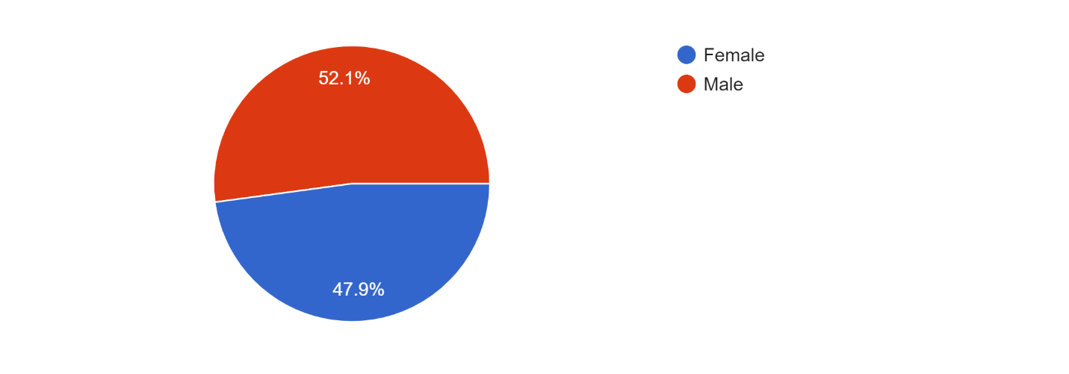

Source: elaborated by us with google forms
the figure above showed that 52.1% of the people responded to this survey are males
And the other 47.9% are females.
We can see that it’s almost the same quantity of both genders has responded to this survey, in our case gender is an important part to ask about, because it’s a part of the demographic segmentation and companies should know which of them has the most presence online so they could know how to target them and offering them the products and services they need depend on their gender. And also to study the difference between them and the perspective of each of them.
3) Occupation:
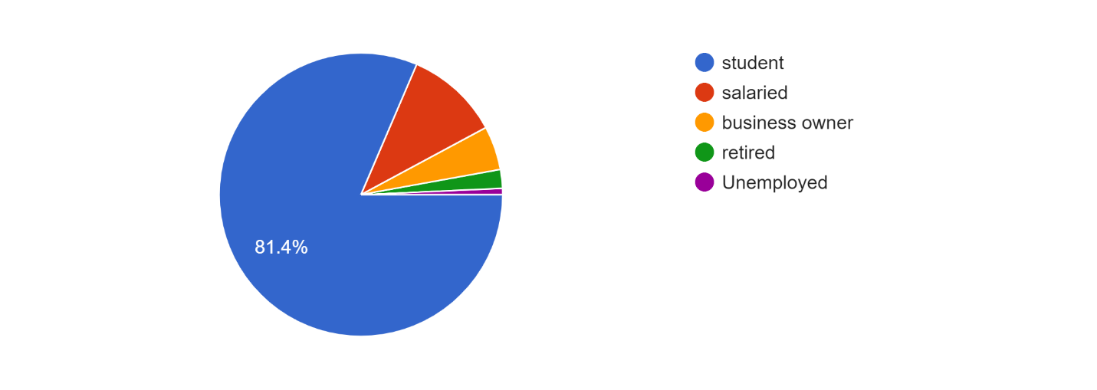
Source: elaborated by us with google forms

From the people who respond to this survey 81.4% of them are students, 10.7% are salaried, 5% are business owners, 2.1% are retired, and less than 1% are unemployed.
It’s also important to know what the occupation of the people we’re targeting because that might indicate their living standards and life style and help companies offer each one of them products they need and they can afford to buy.
We notice here that the majority of the respondents are student, that explain why most of them are between 18 and 31 years old. And about 1/10 of them are salaried, just few are business owners.

Question n°1: How many times you access the internet?

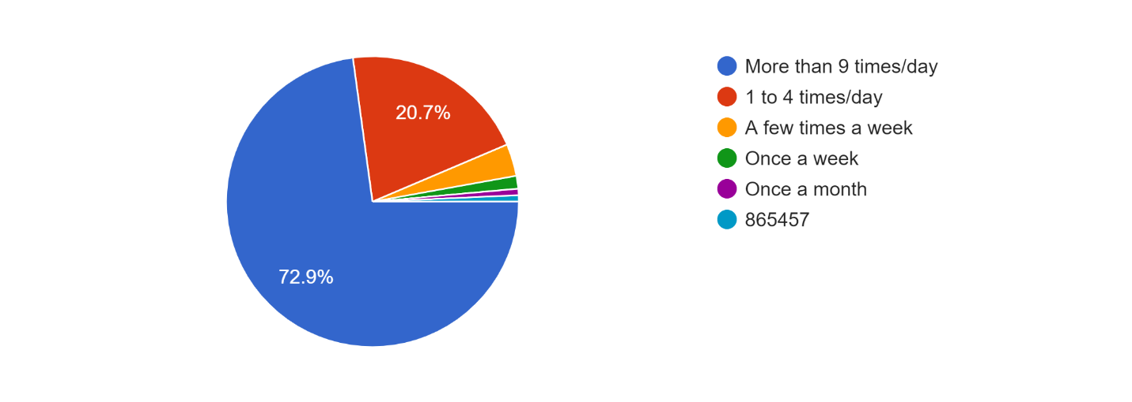

Source: elaborated by us with google forms

72.9% of the respondent to this question said that they access the internet more than 9 time a day, 20.7% said they access it little less than that. And about 3.6% said that they do access the internet a couple times a week. The rest 2.8% of them said they access they rarely access or use the internet.
It’s hard to find out how many times exactly people use the internet with just a survey, the perfect way to achieve a lot better abs a specific results is by monitoring them and keep their internet usage 24/7 under the scope, but this might be enough for us to know how much most of them spend time in the internet, the chart above indicate that the vast majority of Algerians use the internet daily and for more than 9 times a day, this also lead to a conclusion that the Algerians customers are more connected to the internet more than they were ever, this massive users inside the internet is a big opportunity for companies and organization, that they should take in consideration before other competitors do, and also this should motivate them to move their old tradition marketing and promotion to a new directions.
Question n°2: which of these tools you use the most?
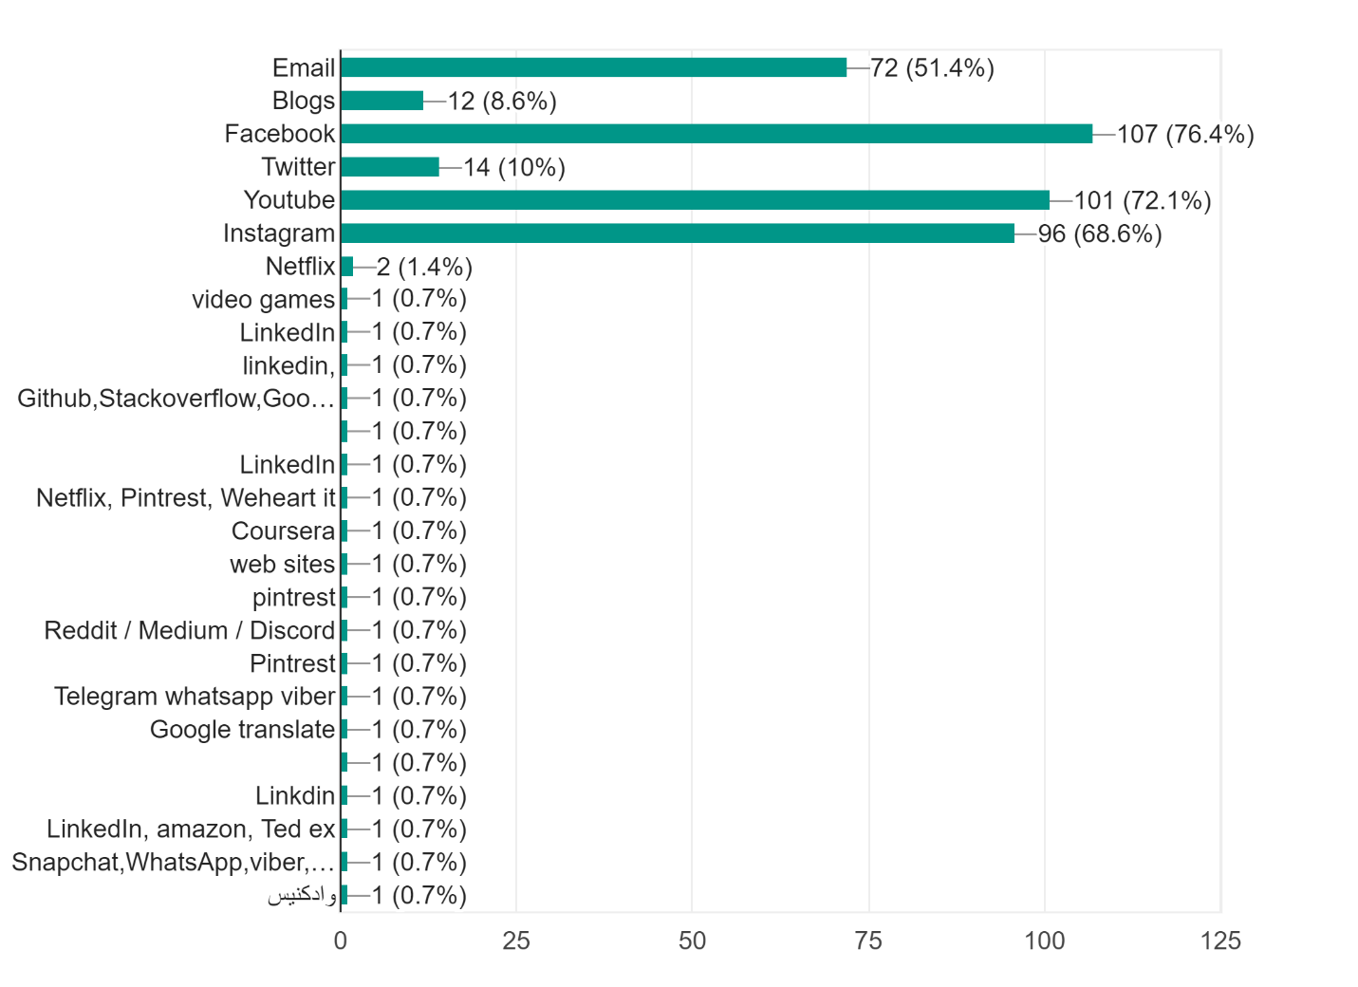
Source: elaborated by us with google forms

This study shows that 76.4 of the persons who respond to the survey use Facebook, 72.1 use YouTube, 68.6 use Instagram, 51.4% uses emails, 8.6 use blogs, and about 3% linked in. And less than 1% other websites (Netflix, Coursera, amazon, Pinterest… etc.)
We notice that the majority of the people responded to our survey use social media a lot than the other tools, Facebook and YouTube and Instagram are the most used websites or apps in Algeria duo to this study. And as we see that half of them use emails as well, for a past time just few Algerians were using emails as a tool most of them just used it to create accounts in other websites and to receive confirmation emails, this numbers above indicate a noticeable increase in the use of emails in Algeria, this digital marketing tool were abandoned by Algerian companies and marketing agencies and just a few of them were using it to promote their products and services, but after this study i think that they have to rethink about that option.

Question n°3: what’s your main purpose of using it?
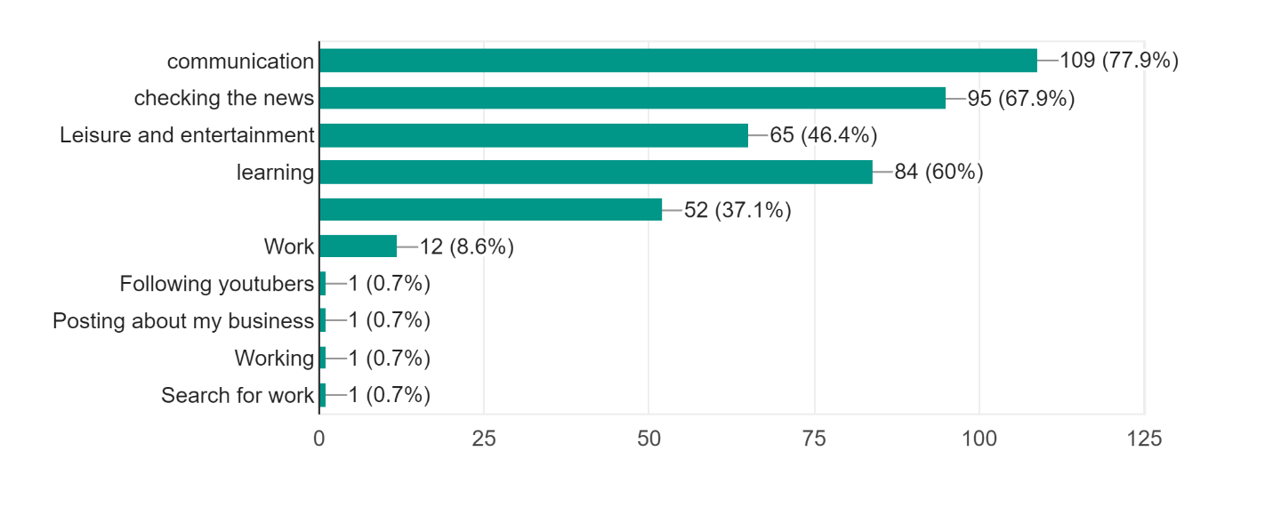
Source: elaborated by us with google forms

For this question 77.9% of the respondents uses the internet mostly for communication, 67.9% for checking the news, 60% for learning, 46.4% for entertainment, 37.1 of them want to search for products and services, About 9 % for work.
And less than 1% searching for jobs and to promote their products and services.
We notice that the majority use the internet for communication and checking the news that’s explain why in the previous question we found that social media is the most used tools from the list, because it’s provide both of this options, and there’s an amount we can’t underestimate of them that use internet for learning or entertainment this are some of the option we see websites like YouTube provide to its user and that’s why there’s a big number of them use YouTube in a daily basis.
Question n°4: type of ads that attract you the most in the internet ?
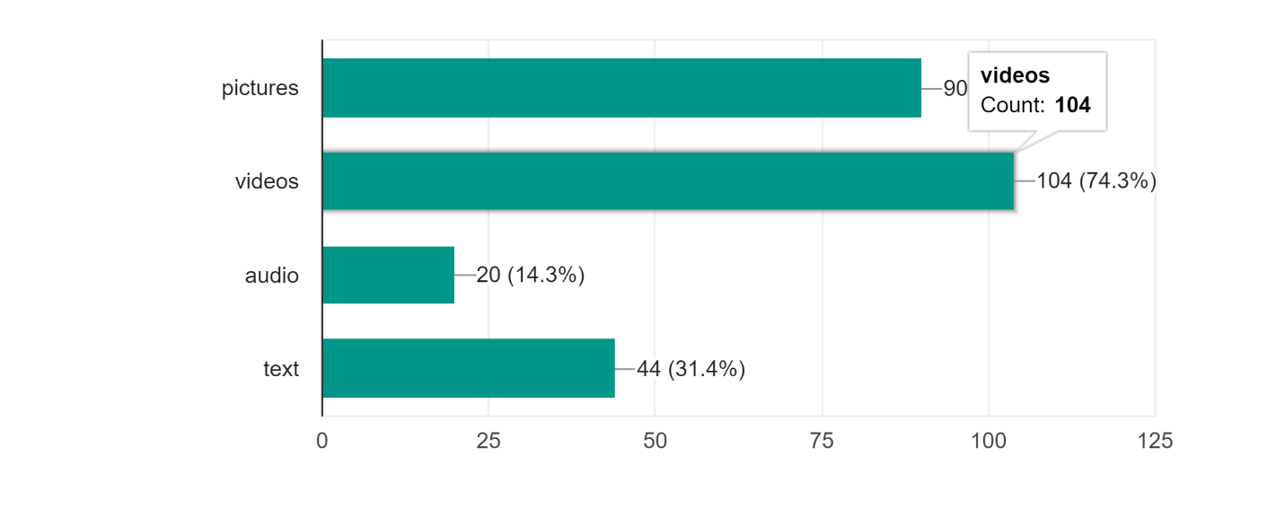

Source: elaborated by us with google forms

the responds from the fig above show that 74.3% of the people in the internet are attracted by video ads, and 64.3% of them by picture ads, 31.4% by texts ads and only 14.3% by just the audio ads or commercial.
We notice that the majority of the people get attracted by commercials that are presented in videos lot more than the other type of promotions, that mean they prefer to see a product or a service in a video because it’s more real to see and give them many other information to deal with. In the other hand many of them also prefer to see ads presented in form of a picture, only the third of this amount get attracted by text ads.
From the information above we indicate that Algerian companies should focus more in making video commercials because is the most effective way to attract many customers attention, but i think the best way to many more than that is to use the combination between all the three type of promotion content.

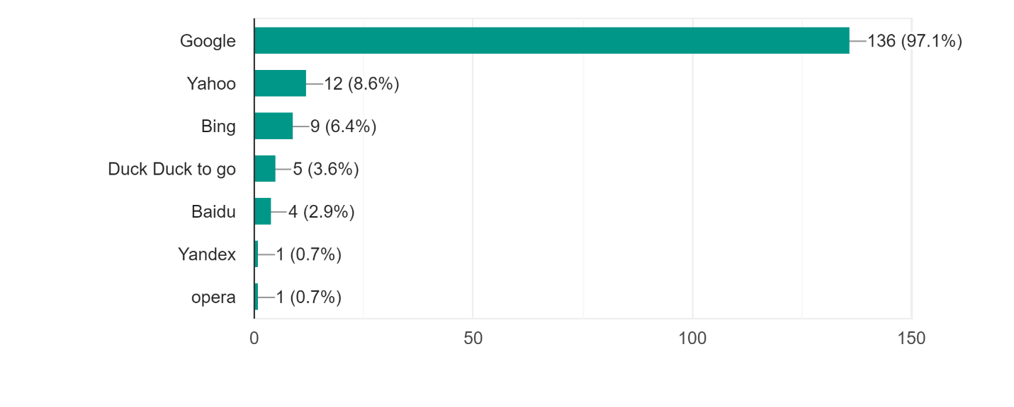
Question n°5: which of this search engines you use the most ?
Source : elaborated by us with google forms

97.1% of the respondents use google as a default search engine every day, 8.6% use yahoo, and 9% use Bing, the rest use different search engines.
We notice that the vast majority uses google and a main search engine, and that’s wasn’t a surprise because it’s considered the most Search engine used worldwide.
Question n° 6: have you had any experience buying products online?

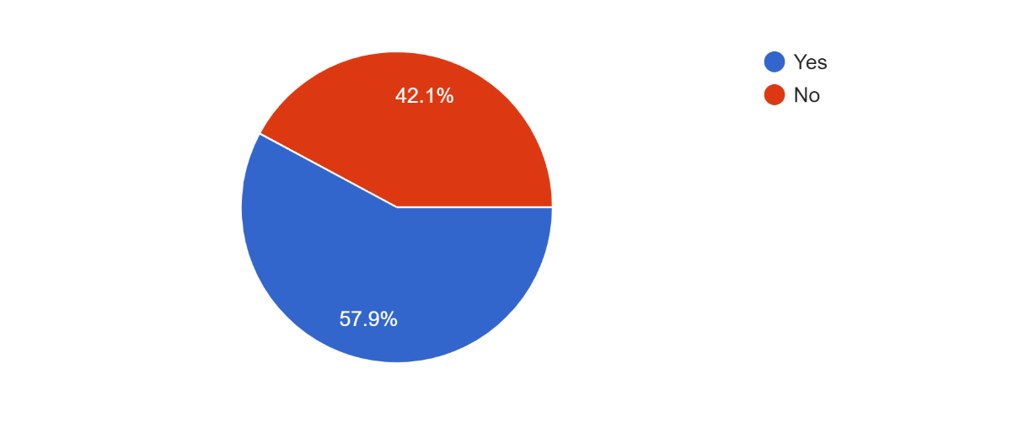
Source : made by us with google forms

Source: elaborated by us with google forms

57.9% said yes to this question and 42.1% said no.
It little more than half of the respondents has bought a product from the internet, we know that few past years this wasn’t an option in Algeria and this result show how internet change the way people on Algeria tend to buy products, and it also indicate an increase in the E-commerce application.
Question n°7: before buying a new products do you search about it online?
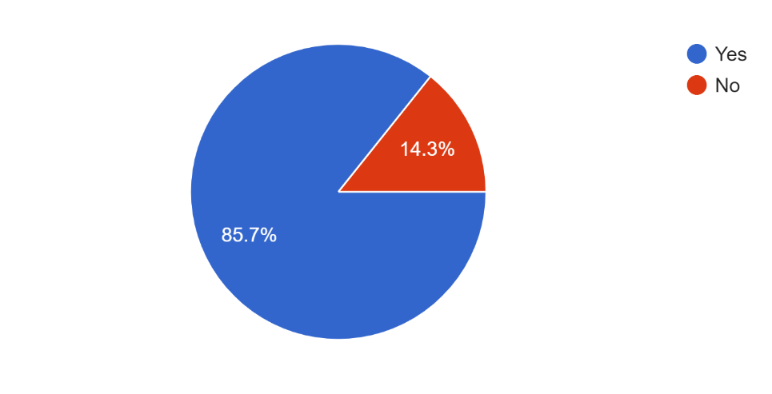

Source: elaborated by us with google forms
For this question 85.7% of the respondents by yes, and the rest 14.3 said no.
We notice that the vast majority of the people who responded tend to search online about the product before they actually buy it, mostly to know the specifics of the product, its price, and to see the reaction of the people who did purchase the product and used it, through the reviews they post online, and the comments reaction from others about the actual review. This will be another opportunity for companies to show their and why it’s different from other competitors’ products, because of its really better, people will find out that.

Question n°8: if yes, where do you search about it?
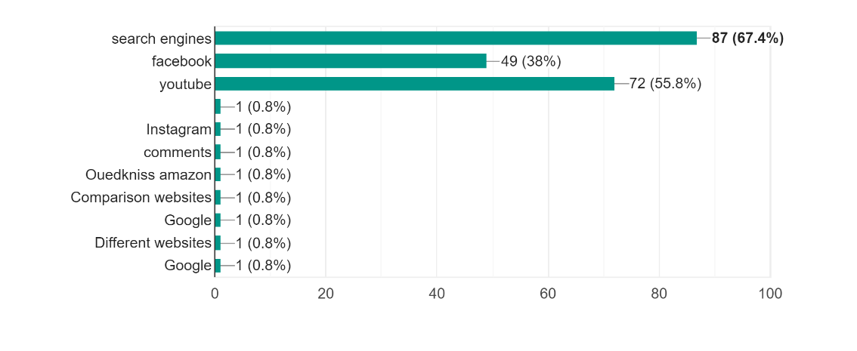

Source: elaborated by us with google forms

From the people who said yes there is 67.4% person use search engines for searching for products and services, 55.8% use YouTube, 38% use Facebook
And less than 5% uses other websites like Instagram, amazon… etc
We notice that search engines are the most used tools for searching about and for products and services online and because we found out that most of the users use Google as their default search engine we conclude that most the Algerian users prefer to use google search engine to search about products and services before actually purchasing it.
As we can see that YouTube comes in the second place as the most used platform or tools to search about products and services, and this not very surprising, mostly because of the enormous amount of reviews videos available on it, which are a lot more helpful this days and many of them give you an honest opinion about the product, these reviews are done by both of the youtubers that are considered professional reviewers, and their job is to find the most requested products in the market and review it for their audience and followers, and also from people who did purchase the product and used it for a period of time.
when we talk about the Algerian case here, there aren’t so many reviewers out there, and even the Algerian customers don’t always give their opinion about products they used, mostly because most companies don’t open the online discussion about its customers experience on their website or other platforms. This may be a thing Algerian firms and companies should really take it into consideration, because most Algerian customers find just few information about the local products when they search about it, and this leads them to try find a more known products that tend most of the time to be an imported ones, this way our local companies should find a way to gives more details and information about their products in different platforms.
Question n°9: while you're trying to purchase a new product, do you search for a product that you already saw advertised in the internet?
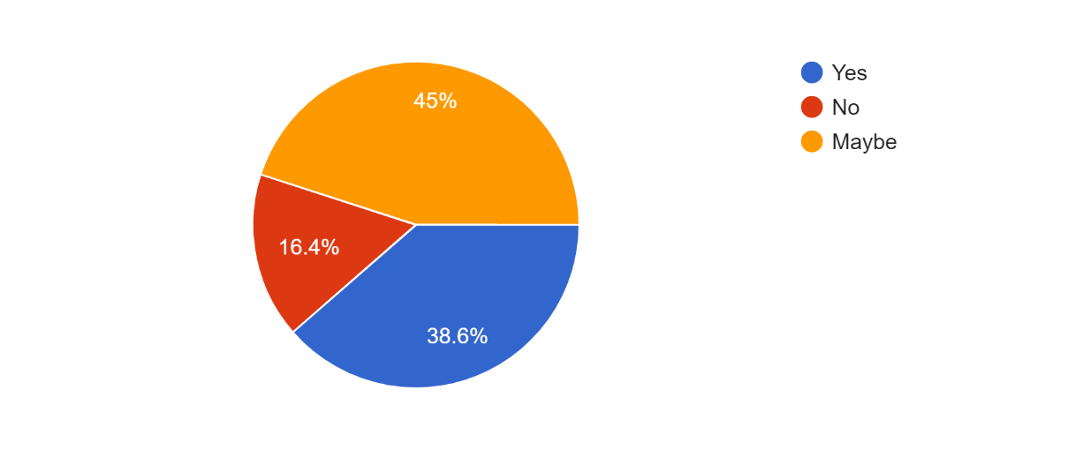

Source: elaborated by us with google forms

38.6 of the people who respond to this question said confirm that they do search for products they saw before in a commercial or an ad, 16.4% said they don’t and 45% were not sure about that.
We notice that a lot of people are most likely to search for and buy a products they already know and they have saw it advertised on the internet before, that that Algerian mostly trust advertised brand a lot more than the none advertised brands, and the reason why online marketing maybe more trusted than other type of marketing because of it allow the customers to react and give their opinion and thoughts about the products advertised on the internet.

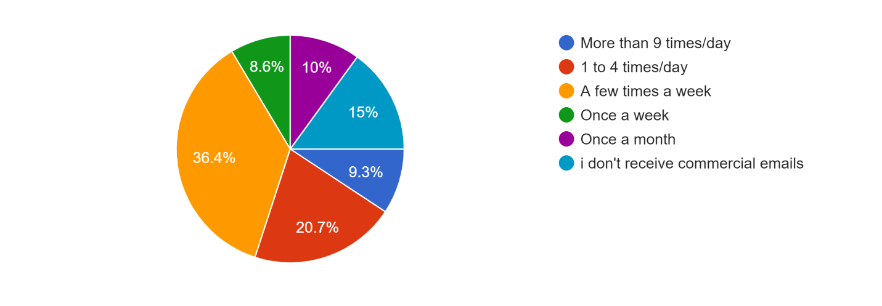
Question n° 10: how often you receive commercial emails?
Source: elaborated by us with google forms

36.4% of the respondents said they receive a commercial email a few times a week, 20.7 of them said between 1 to 4 times a day, 15% of them said that they don’t receive any emails, 9.3% said more than 9 times a day, 8% said they receive once a week, 10% receive once a month.
We notice that the third of the respondents receive just few commercial emails a week and the 1/5 of them receive 1 to 4 email a day. The half of that receive more than nine emails a day, and the rest said they receive less than 4 commercial emails a month.
The results in the chart above indicate that most Algerian companies don’t really use email marketing and most of the email received by the Algerian users are from international companies or websites.
Question n°11: how do you react to commercial emails?

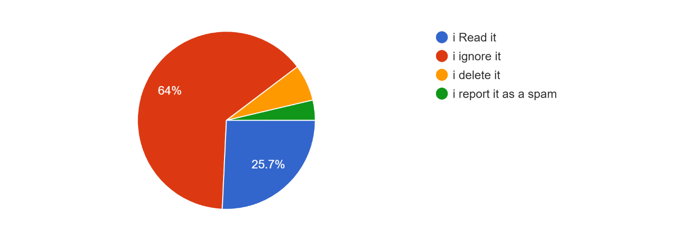
Source: elaborated by us with google forms

25.7% read the emails, 64% ignore it, 6.6% delete it, 3.7% reported as a spam
From the few people who said they receive commercial emails, most of them ignore this email, about the quarter of them do read this email, the rest of them either delete it or report it as spam.
We conclude that most of Algerian’s don’t really think that the commercial emails they receive are worthy to check or read, that’s way it’s less used as a promotion option in Algeria.
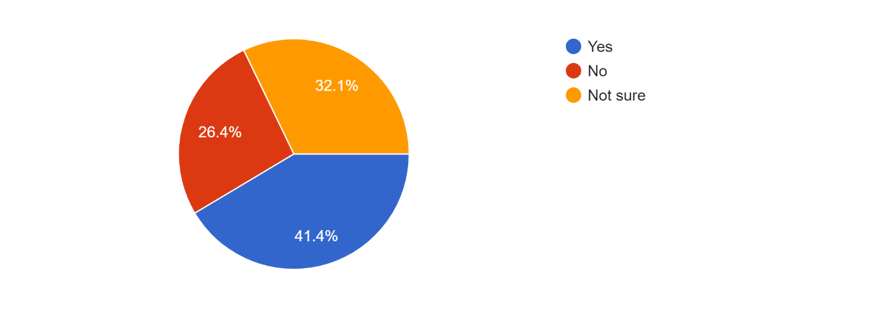
Question n°12: Do you find the sponsored ads on social media related to your interest?

Source: elaborated by us with google forms

41.4% think that sponsored ads are related to their interest, 26.4 said no, 32.1% are not sure about that
The majority of the persons in the sample choose for the survey thinks that the sponsored ads in social media are related somehow to their interest, and we know that websites like Facebook and YouTube keep developing their ads algorithm to send you the most related ads to you, as an example if you were on Facebook and you used the marketplace to search for computer or a phone, you will notice after a moment that there’s a lot of sponsored ads showing you pages or websites that sell computers and phones. That majorly indicates the effectiveness of the social media ads enhancer and the algorithms developed to help companies reach to the potential customers in social media.
From this we conclude that Algerians also use the sponsored ads to promote their products and services, and the customers use social media to search about products and services.
Question n°13: how do you find ads that appear in the following websites and mediums
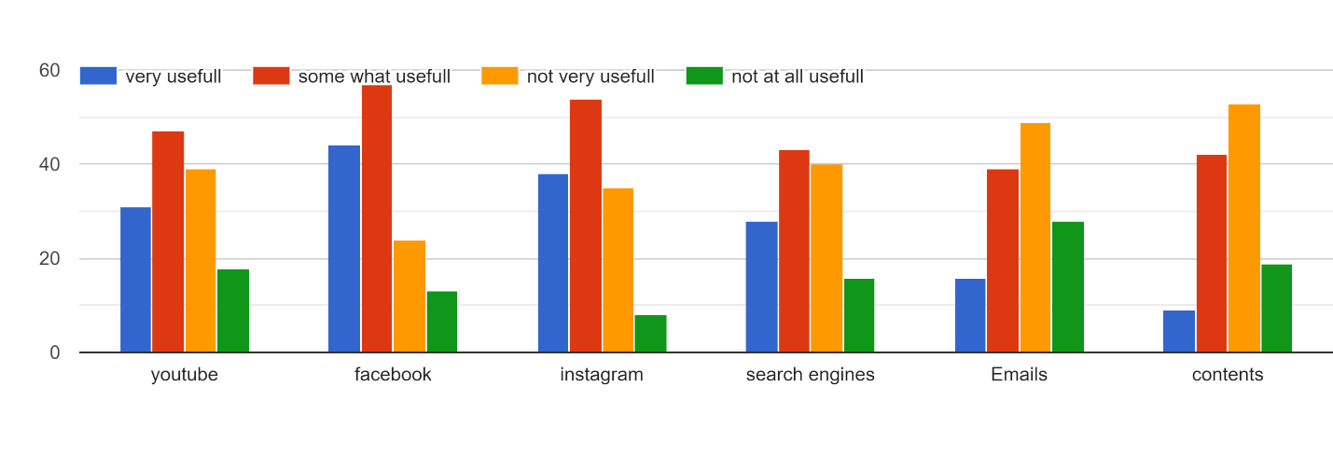
Source: elaborated by us with google forms
We notice that most of the respondents think that the ads that appear on Facebook, Instagram and YouTube -which represent social media- are more likely to be useful than any of the other internet tools. Which also explain why the majority find that the ads in social media are more related to their interests.

Question n°14: How likely you’re to check a product after seeing it in the following internet tools
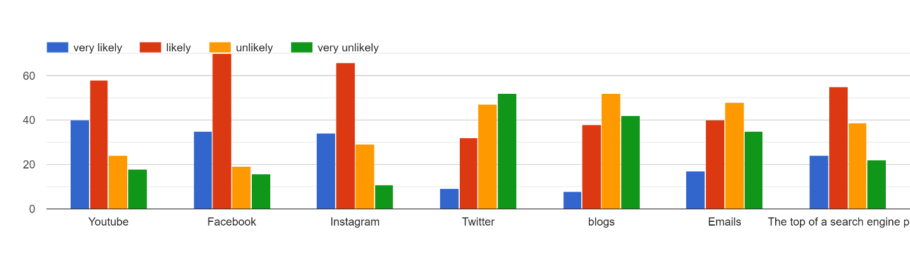
Source: elaborated by us with google forms

We notice that people responded lot more higher in Facebook, YouTube and Instagram, and a little less than that on SE than any other tools and platforms.
About 50% of them said that they are more likely to check the product after seeing it in Facebook.
People are more likely to check and search about a product after seeing it in social media more than any other website or a tool.

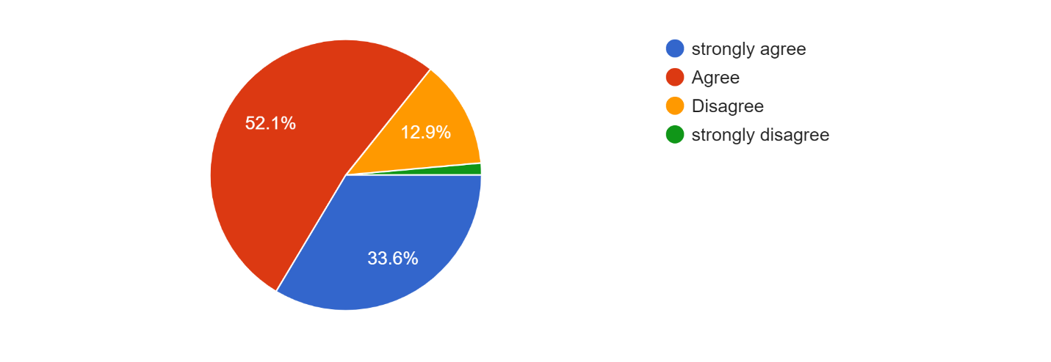
Question n°15: When using search engines, you always find what were you looking for in the first page of results.

Source: elaborated by us with google forms

52.1% of the respondents agreed with the this and more 33.6% strongly agreed about that, 12.9% disagree and the rest strongly disagree with that.
We can notice that the majority of the people find what they were looking for by searching about in the first page of results, and because google is the most used search engine we conclude that they’re doing a really good job generating the result of the search, and they’re making users satisfied with what they find. And for that we say that google has one of the most brilliant and smart algorithms for its search engine, this make it an effective tool to use in order to reach to a new customer.
Question n°16: when you use you’re using search engines to search about something, the most relevant results appear in the top of the result page and the less relevant results in the last pages of the results webpages.
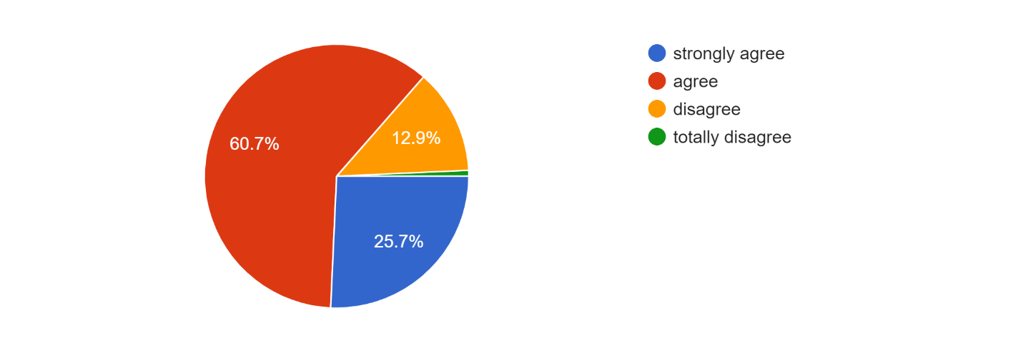
Source: elaborated by us with google forms

The vast majority either agreed or strongly agreed that the most relevant results appear in the top of the search engines, and less than13% sees the opposite.
Like we said in the previous question that google has the best algorithms to provide you with the best results but they also classify this result from the most to the less relevant to your search, and that what help users find what they’re looking for fast.

Question n°17: are you satisfied with the results that appear in the top the results webpages?
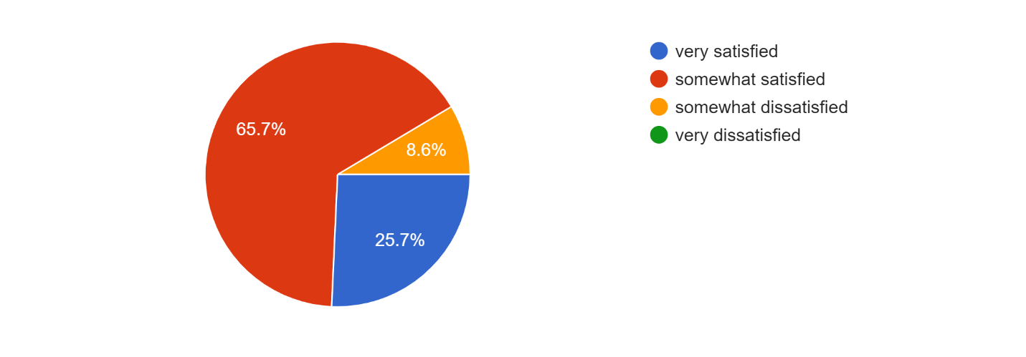
Source: elaborated by us with google forms
This was a trick question to see if the people answered the question 17 were sure about that, we can see that the results are almost the same, from that we confirm again that search engines like google are doing great job and giving the best for their users.

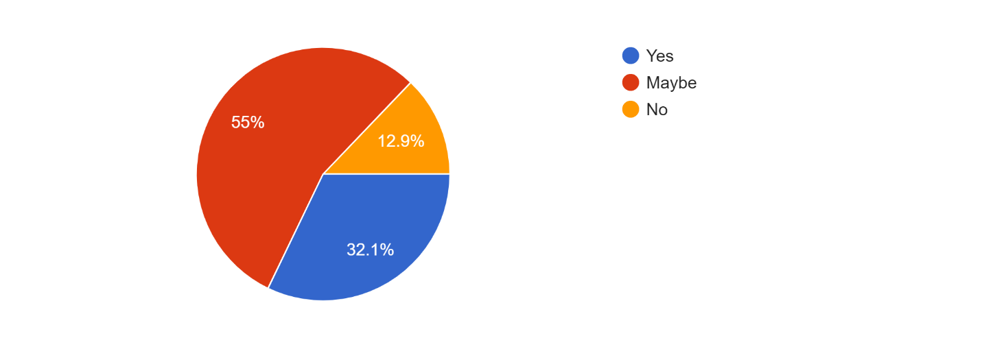
Question n°18: do you thing that your favorite vlogger or blogger opinion can influence your you choices and decisions in buying or using a specific product?
Source: elaborated by us with google forms
People tend to follow some people in the internet either they were youtubers who do videos or blogger who write articles and stories online, this people considered as influencers in the digital world because they have the ability to influence others. We asked 140 people about if they think that their favorite vlogger or a blogger opinion and recommendation can change and influence their choices in buying products and services, and we find out that there are more than 32.1% of them take the opinion of their fav influencer into consideration because they see him as a trust worth person.
This opinion doesn’t mean it will be a direct recommendation to buy or use something, maybe just if you see him use something a lot (like wearing a specific t-shirt, or traveling with the same airlines over and over) will motivate you to do the same.
The majority (55%) weren’t sure about that.

Question n°19: from your experience on the internet, what are the best digital marketing tools companies should use to win new customers?
As an Algerian i think social media is the best place to advertise any product, because most Algerians use websites like Facebook YouTube and Instagram more than any other web site , for example there's affiliate
marketing by sponsoring events
From my experience social media is most likely to work if you're willing to promote a product in Algeria, but i think that there are so many followed youtubers and bloggers out there, that can help you promote your products through their contents. And people love free stuff so organizing a giveaway might help also.
Section 5: conclusion and recommendations
5.1/ Conclusion:
Based on the theories discussed, the interview and the survey, we conclude that online marketing is a growing concept in the modern age, and if it was adopted and used in the perfect way, then companies and firms in the Algerian territory will benefit from it and direct them towards achieving their goals, Social media in the other hand founded at the most used by the Algerian customer, and this usage keep growing every day, this massive use of social media from the Algerian customers is a big opportunity for the companies that want to elevate their sales performance in the market and also elevate their relationship with the customers, to create a communication network with them, and in order to keep them close and updated.
As we saw in the study above that social media is found one of the most effective strategies in the online marketing, and it help improve and automate the number of sales and the marketing process.
Email marketing in the other found the less use tool by the Algerian companies, because most of them had the idea of that most Algerians don’t even check their emails daily, but from the survey we elaborated we found that to be wrong and at more than the half of the respondents uses their emails daily, from this point we would love to recommend for our local companies to reconsider about the use of email marketing.
For the SEO we found out that there are just few agencies in Algeria that help other companies optimize their websites, so you will find just few companies in the Algerian territory using this tool.
When we’re talking about content marketing, we can state that the number of the Algerian influencers keep increasing, and using them through sponsored contents can help companies in its marketing process, as we saw there’s so many people see the opinion of their favorite vlogger or blogger important, and it may influence their choices in buying a specific product from another, that’s way the Algerian companies have to think about the use of this tool as a marketing strategy all over again.

5.2/ Recommendations:
After the observation and the interpretation of the results from the survey and the information we collect from the interview, it’s interest us to give some of our own recommendations to the Algerian companies and organizations.
- Improve their social media pages and upload daily:
- Hire influencers to promote their products
- Help reviewers and consumers to review their products on their platform or on social media by asking them: what’s their opinion after using it, that will help them devoloping their products.
- Make a data base of each customers they deal with, using there emails, social media’s profile and more, so they can follow them and send them new ads.

General conclusion:
The current globalization market has made companies to see the internationalization of their activities as a way to remain competitive. Marketing strategy has become important tool globally for any organization to remain in competitive market environment and was stronger. The power on online marketing strategies is related directly way to the power of the internet, it’s phenomena that allows us to find new customers, expend our businesses and communicate in a better way with the customers,
The use of the online marketing communication tools might be massive, but the results are not always guaranteed to be always working, but if we dedicate the needed resources and know how to use it, we will certainly reach a new scale and develop our marketing process.
The social media helped create a chain of continuous connection between people, and it helped the 24/7 online presence of the companies and the business owner for their clients and for any potential customer.
Social media is a good a very good medium of communication between any company and it’s consumers, to create that strong band with them, and keep them close and updated to its activities and products, this may take its relationship with them to the next level.
knowing how to use social media and the internet in general to promote products and services online become essential.
Through the interviews done with the company's staff during the internship period in it and through the published survey on social media, we tried to better understand the dynamics of different e-marketing strategies and to highlight their importance along with their tools, in order to be able to define the most suitable approaches for the Algerian Market. This work is an attempt to convince the Algerian companies that in the digital century e-marketing is the key when it comes to consolidation with customers and to establish some guidelines, we judge useful and helpful to better implement a digital strategy in Algeria.
After the results obtained from the survey and the interview, we confirm the hypothesis: « Online marketing is an important strategy to use nowadays ».

References
Anthony J James [AJ]. (2019, october 9). The Coming Risk to Marketing Strategy. Retrieved from theinnovationenterprise.com/: https://channels.theinnovationenterprise.com/articles/8626-the-coming-risk-to-marketing-strategy
barman, b. (1996). Marketing channels. united state: John wiley & sons.
Bennett, P. D. (1988). dictionary of marketing terms 5. chicago: american marketing association 1988.
Borden, N. (1984). The concep pf marketing mix. journal of advertising research.
Bostanshirin, s. (2014). online marketing: challenges and opportunities, international conference on social sciences and humanities. Proceedings of SOCIOINT14- International Conference on Social Sciences and Humanities. Iran.
Burnett, J. (2008). Core Concepts of Marketing. Zurich, Switzerland: The Global Text Project.
Chaffey, D. (2007). Top 10 E-marketing strategies of today and tomorrow Site implemented by Dave Chaffey. Retrieved from http://www.davechaffey.com/E-marketing- Insights/Internet-marketing-articles/Top-10-Emarketing-strategies.
Clement, J. (2019, Mars 8). Instagram - Statistics & Facts. Retrieved from statistica.com: https://www.statista.com/topics/1882/instagram/
CMEX. (2014). Content Marketing Handbook – Simple Ways to Innovate Your Marketing Approach. Warsaw: Content Marketing Expert.
cohen-almagor, r. (2015). confronting the internet’s dark side .
content marketing institute. (2019). What Is Content Marketing? Retrieved from ontent marketing institute: https://contentmarketinginstitute.com/what-is-content-marketing/
Dr. M. Saravana Kumar, D. L. (2012).
dummies. (2019). The Difference between Organic and Paid Search Engine Results. Retrieved from dummies: https://www.dummies.com/web-design-development/search-engine-optimization/the-difference-between-organic-and-paid-search-engine-results/
Furrer, O. (2006, January). marketing strategies. Retrieved from researchgate: https://www.researchgate.net/publication/230743793_Marketing_Strategies
Garcia, T. L. (2016). YouTube as a Business. School of Business and Service Management.
Gbolagade, A., Adesola, M., & Oyewale, I. (2013). impact of marketing strategy on business performance a study of selected small and medium enterprises (smes) in Oluyole local government, ibadan, nigeria. journal of business and management .
Gilbert, B. (2018, May 4). YouTube now has over 1.8 billion users every month, within spitting distance of Facebook's 2 billion. Retrieved from http://www.businessinsider.fr/us/youtube-user-statistics-2018-5
Goi, C. L. (2009, May). A Review of Marketing Mix: 4Ps or More? International Journal of Marketing Studies, 1.
Grönroos, C. (1994, AUGUST). From marketing mix to relationship marketing: towards a paradigm shift in marketing. Retrieved from researchgate.net: https://www.researchgate.net/publication/215915788_From_Marketing_Mix_to_Relationship_Marketing_Towards_a_Paradigm_Shift_in_Marketing
gupta, r. (2015). marketing strategies of patanjali ayurved. meera bai institute of technology government of nct of Delhi.
išoraitė, m. (2016). marketing mix theoretical aspect. international journal of research – granthaalayah.
Järvelin, R. (2016 ). First Year Digital Marketing Plan Case: Arctos . Bachelor’s Thesis Degree Program in International Business .
Jayaraman , M., & Wong , C. (2008). relationship between marketing mix strategy and consumer motive: an empirical study in major Tesco stores. unitary e-journal vol. 4, no. 2.
Kasiso, M. C. (2017). The effects of marketing strategies on sales perfomance pf small and medium entreprises in kenya. School of business, university of nairobi.
Kotler, P. &. (2006). Principles of marketing-- 11th ed. new york: pearson international.
Kotler, P. (2002). Marketing managment, millenuim edition. PEARSON CUSTOM PUBLISHING.
Kotler, P. (2007). Marketing: an introduction. new jersey: Pearson education Inc.
Kotler, P., & Armstrong, G. (2012). Principles of Marketing (14th ed.). New Jersey, USA: Pearson Education.
Lokteva, D. (2015). Developing a customer-centric digital marketing communication strategy . Master’s Degree Programme in International Business Management , 23.
mailchimp. (2019). Email marketing strategy and tips for successful campaigns. Retrieved from mailchimp: https://mailchimp.com/email-marketing/
marketingmix.co.uk. (2019). marketing mix 4p’s and 7p’s explained. Retrieved from marketingmix.co.uk: marketingmix.co.uk
masterclassmanagement. (2019). BUSINESS BASICS PART III - MARKETING & SALES. Retrieved April 25, 2019, from Master class management: https://www.masterclassmanagement.com/managementcourse-peopleprocessphysical.html
Nickols, F. (2015, June 27). Strategy: Definitions and Meaning. Retrieved from nickols.us: https://nickols.us/strategy_definition.htm
optinmonster. (2019). Email Marketing Made Simple: A Step by Step Guide. Retrieved from https://optinmonster.com/beginners-guide-to-email-marketing
Paavola, T. (2017). Effective Digital Marketing Channels. LAHTI UNIVERSITY OF APPLIED SCIENCES LTD Faculty of Business and Hospitality Management Degree Programme in International Business , 20.
Professional academy. (n.d.). MARKETING THEORIES – THE MARKETING MIX – FROM 4 PS TO 7 PS. Retrieved from professionalacademy.com: https://www.professionalacademy.com/blogs-and-advice/marketing-theories---the-marketing-mix---from-4-p-s-to-7-p-s
Saravanakumar, M., & SuganthaLakshmi, T. (2012). Social Media Marketing. Life science jornal 670, 4444. Retrieved from http://www.lifesciencesite.com
Sentance, R. (2018, November 22). What is paid search (PPC) and why do you need it? Retrieved april 22, 2019, from econsultancy: https://econsultancy.com/what-paid-search-ppc/
soas.ac.uk. (n.d.). Small agribusinesses and markets. Retrieved april 13, 2019, from soas.ac.uk: https://www.soas.ac.uk/cedep-demos/000_p538_msa_k3736-demo/unit1/page_06.htm
sotnikova, a. (2016). the application of digital marketing strategies to increase profits of the organization, . international business, hame university of applied science.
Stokes , R. (2013). eMarketing: The essential guide to marketing in a digital world (5th Edition ed.). Quirk Education Pty (Ltd).
teresa piñeiro, o., & Xabier , m.-r. (2016). understanding digital marketing basics and actions. springer international publishing Switzerland.
Terrell, K. (2019, february 14). The History of Social Media: Social Networking Evolution! Retrieved from history cooperative: https://historycooperative.org/the-history-of-social-media/
Trisha Dowerah Baruah. (2012, May ). Effectiveness of Social Media as a tool of communication and its potential for technology enabled connections: A micro-level study. International Journal of Scientific and Research Publications, 2(5).
Twitter statistics. (2018). Retrieved from https://www.omnicoreagency.com/twitter-statistics/
Varadarajan, R. ( 2010). Strategic marketing and marketing strategy: domain, definition, fundamental issues and foundational premise. Journal of the Academy of Marketing Science, 128.
we’re social. (2018). global digital report. Retrieved from https://wearesocial.com/blog/2018/01/global-digital-report-2018
we're social. (2019). hootsuite. Retrieved from The Global State of Digital in 2019 Report: https://hootsuite.com/pages/digital-in-2019

