The People’s Democratic Republic of Algeria

Ministry of Higher Education and Scientific Research

Higher School Of Management –Tlemcen-

Specialty: Health Services Management
Theme:

Factors Influencing Algerian Customers trust in generic drugs

Prepared by: Supervised by:
Miss. Sirine GASMI Pr. Zoubayda HALLABI

Full Name | Grade | Quality
Mr. Iznasni Ali | MCA | President
Ms. Berrached Amina | MCA | Examiner
Dr. Hellabi Zoubeyda | MCB | Supervisor

2024\2025

Dedication
To Allah, who guided me through this path and gave me the strength to reach this point so I am here today, writing these words.
To the little version of me, on that day in March 2021, when I was drowning in the darkest… when I believed I was losing everything and for all those times I wanted to give up I am here to tell you: “you made it...”
To my wonderful father "Nourine", whose presence has always made life feel easier. The way you turned the distance between Tlemcen and Blida into just “half an hour” just because you couldn’t bear to let “the apple of your eye” as you always say struggle alone, I will never forget it.
To my beautiful mother "Samia", my truest friend who stood by me, believed in me endlessly, and who inspired me to choose this field with the hope that I would help make the health sector a better place for her to work in.
To my dear annoying little siblings, "Hanine" and “Ahmed Yacine”, who have endured my stress, my silence, and my pressure through all these years, thank you for your patience and your unconditional love.
To my dear grandmother, and to my big loving family, whose prayers and affection have always surrounded me and lifted my spirit.
To "Hanine", "Feriel", "Jinan" and all my kind-hearted friends who stayed beside me through every hardship and never gave up on me, even when I was hard to reach I am forever grateful for your loyalty.
To “Jma3et Khir”, "Aya" and "Bicha", who turned ESM and Tlemcen into a second home… thank you for the warm memories, the laughter, and the friendship that will live with me forever.
Thank you all for praying for me, supporting me, and believing in me especially when I did not.
For you, I dedicate this work.
وأنّ للإنسانِ إلا ما سعى (39) وأن سعيهُ سوف يرى(40)»»
Dedication to our people in Gaza and Palestine
‏
To the bravest and strongest people in this world…
To those whose resilience and steadfastness in the face of suffering, tragedies, and pain have made me endure my final years of study because how can what I was going through be compared to what they endure?
To the students of Gaza who were deprived of their seats in school and to those who departed before their names were called on graduation day...
To all the souls who went to their Creator before their dreams were realized...
To all the heroes who fought against tyranny...
I dedicate this work to you, because no one deserves it more than you do.


Acknowledgment
First and foremost, all praise and thanks are due to Allah Almighty, who granted me the strength, patience, and ability to complete this work. Without His guidance and mercy, none of this would have been possible.
I would like to express my sincere gratitude to my academic supervisor HALLABI Zoubaida, for their constant support, valuable guidance, and constructive feedback throughout every stage of this dissertation. Their mentorship was key in shaping this work both academically and personally.
I am also deeply thankful to my internship supervisor at [SAIDAL], BERNAOUI Redha, for their support and mentorship during my training period. Their practical insights and professional guidance greatly enriched my understanding of the field and added real-world depth to my academic work.
My appreciation also extends to the faculty members of the Department of Healthcare Management for the knowledge and learning environment they provided during my studies. I am also thankful to all the individuals who participated in the empirical study and shared their insights, making the practical aspect of this research possible.
Finally, I dedicate this work to every student and researcher committed to advancing healthcare and to all those working to build a more ethical, trustworthy, and inclusive health system for the future.

List of Abbreviations
abbreviations | Signification
WHO | World Health Organization
FDA | U.S. Food and Drug Administration
EMA | European Medicines Agency
INN | International Nonproprietary Name
DCI | Dénomination Commune Internationale
APIs | Active Pharmaceutical Ingredient(s)
AUC | Area Under The Curve
CAGR | Compound Annual Growth Rate
OECD | Organization for Economic Co-operation and development
AMR | Antimicrobial Resistance
RP | Reference Pricing
GMP | Good Manufacturing Practices
ANPP | The Algerian National Agency for Pharmaceutical Products
HCPs | Healthcare Professionals
CAPA | Corrective Actions and Preventive Actions
QA | Quality Assurance

List of Tables
number | Title of the table | Page
01 | types of generic drugs | 28
02 | resume the differences and similarities between generic and brand-name drugs | 28
03 | the main pharmaceutical exporters in 2023 | 32
04 | the main pharmaceutical exporters in the first quarter of 2024 | 33
05 | top 10 of pharmaceutical producers in the world in 2024 | 34
06 | top 10 of generic drugs producers in the world in 2023 | 35
07 | Five-point Likert scale | 81
08 | The distribution of average values grades | 81
09 | Questionnaire reliability | 82
10 | Distribution of Respondents by Age Group | 83
11 | Distribution of Respondents by Gender | 85
12 | Distribution of Respondents by Educational level | 86
13 | Distribution of Respondents by marital status | 87
14 | Distribution of Respondents by monthly incomes | 88
15 | Distribution of Respondents by Self-Reported Health Status | 89
16 | Distribution of Respondents Chronic Illness Status | 90
17 | Distribution of respondents by Employment in the Health Sector | 92
18 | Distribution of respondents by Possession of a CHIFA Card | 93
19 | Distribution of respondents by Awareness of Generic Drugs | 94
20 | Distribution of respondents by Self-Rated Knowledge of Generic Drugs | 95
21 | Distribution of respondents by Source of Information about Generic Drugs(Multiple responses allowed) | 97
22 | Distribution of respondents by Preferred Type of Drug  (Multiple responses allowed) | 98
23 | Distribution of respondents by preferred type of drugs | 99
24 | Distribution of respondents by Willingness to Use a Generic Drug if Prescribed Instead of a Brand-name Drug | 100
25 | Distribution of respondents by Their General Medication Consumption Habits | 102
26 | Distribution of Respondents by the Influence of Reimbursement on Medication Purchase Decisions | 103
27 | Distribution of Respondents’ Answers to the First Four Items Measuring Trust in Generic Drugs | 105
28 | Distribution of Respondents’ Perceptions of the Relationship Between Drug Price and Effectiveness | 107
29 | Distribution of Respondents’ Perceptions Regarding the Influence of Brand Image on Trust in Generic Drugs | 109
30 | Distribution of Respondents’ Rankings of the Factors Influencing Their Trust in Generic Drugs | 110
31 | One sample T-test | 111
32 | Correlation coefficient 1 | 112
33 | ANOVA variance 1 | 112
34 | Regression coefficients | 113
35 | Correlation coefficient 2 | 114
36 | ANOVA variance 2 | 114
37 | Correlation coefficient 3 | 115
38 | ANOVA variance 3 | 115
39 | Pearson correlation | 116

List of Figures

GENERAL INTRODUCTION

number | Title of figures | Page
01 | generic drugs market size 2023 to 2033 (USD Billion) | 30
02 | conceptual model of research | 77
03 | distribution of respondents by age group | 84
04 | distribution of respondents by gender | 85
05 | distribution of respondents by educational level | 86
06 | distribution of respondents by monthly incomes | 88
07 | distribution of respondents by self-reported health status | 89
08 | distribution of respondents’ chronic illness status | 91
09 | distribution of respondents by employment in the health sector | 91
10 | distribution of respondents by possession of a Chifa card | 93
11 | distribution of respondents by awareness of generic drugs | 94
12 | distribution of respondents by self-rated knowledge of generic drug | 96
13 | distribution of respondents by preferred type of drugs | 99
14 | distribution of respondents by willingness to use generic drugs if prescribed instead of brand-name drugs | 101
15 | distribution of respondents by their general medication consumption habits | 102
16 | distribution of respondents by the influence of reimbursement on medication purchase decisions | 104
17 | distribution of respondents’ perceptions of the relationship between drugs price and effectiveness | 108

Summary
GENERAL INTRODUCTION: 15
CHAPTER ONE: GENERIC DRUGS: DEFINITION, USE AND CONTEXT 23
Introduction: 24
Section 01: Understanding Generic Drugs 25
Section02: Global and National Context of Generic Drugs 34
Section 03: Challenges and Development Prospects of Generic Drugs 45
Conclusion: 50
Chapter Two: Understanding and Exploring Trust in Generic Medicines: Concepts, Influencing Factors, and Perspectives 51
Introduction 52
Section one: Understanding Trust and Trust in drugs 53
Section Two: Trust in the Pharmaceutical Context 56
Section three: Factors influencing trust in generic drugs: 64
Conclusion 77
Chapter Three: EMPIRICAL STUDY 78
Introduction: 79
Section one: Research Methodology 80
Section Two: Presentation, Analysis and Interpretation of Results 84
Conclusion 120
GENERAL CONCLUSION 121
REFERENCES 124
APPENDIX 132

GENERAL INTRODUCTION:

GENERAL INTRODUCTION:
In recent decades, the use of generic drugs has become an essential strategy for improving access to healthcare, especially in countries seeking to control pharmaceutical expenditure while ensuring therapeutic coverage for their populations. Generic drugs offer a more affordable alternative to brand-name medications, while maintaining equivalent efficacy and safety. However, despite their economic and clinical value, the acceptance and use of generic drugs remain uneven across different populations and health systems. In Algeria, where health policy has increasingly encouraged the development and consumption of locally produced generics, questions persist regarding public awareness and trust in these alternatives. Understanding the factors that shape consumer trust in generic drugs is therefore critical—not only for supporting national pharmaceutical policies and promoting local industry, but also for ensuring that patients adhere to treatments that are both accessible and effective. This research is situated at the intersection of public health, consumer behavior, and pharmaceutical policy, aiming to explore how Algerian consumers perceive generic drugs, what influences their level of trust, and how this trust can be strengthened to enhance both individual and system-wide health outcomes.
The Research Problem:
- What are the key factors influencing Algerian consumers' trust in generic drugs?
In addition, to deepen the understanding and address the problem at hand, we present a set of carefully selected sub-questions that form an analytical framework and help provide comprehensive and detailed answers to different aspects of the topic.
Sub questions:
1. What is the level of awareness and understanding of generic drugs among Algerian consumers?
2. To what extent do Algerian consumers trust generic drugs compared to brand-name drugs?
3. How do the opinions and recommendations of doctors and pharmacists influence Algerian consumers' trust in generic drugs?

4. What roles do price, brand image, and patients' personal experiences (positive or negative) play in shaping trust in generic drugs among Algerian consumers?
5. Which factor most strongly influences Algerian consumers' decisions to use generic drugs?
Hypotheses:
Based on the research problem, we present the following hypotheses and aim to test whether they are valid:
1- The majority of Algerian consumers possess limited knowledge regarding generic drugs.
2- Trust in generic drugs among Algerian consumers is significantly influenced by the recommendations and guidance of medical professionals, such as doctors and pharmacists.
3- Price and personal experience are key factors that strongly shape Algerian consumers' trust in generic drugs.
4- Brand image has a lesser impact on Algerian consumers' trust in generic
5- There is a positive correlation between Algerian consumers' awareness and knowledge of generic drugs and their trust in these medications.
Importance of the Study:
This study holds significant value at both academic and practical levels, particularly within the Algerian healthcare system, for the following reasons:
Public Health Relevance: In a country where access to affordable medication is crucial, understanding how consumers perceive and trust generic drugs is vital for improving public health outcomes and reducing pharmaceutical expenditure.
Support for National Drug Policies: The findings can support governmental efforts and health authorities in promoting the use of generics, in line with national strategies for cost containment and universal health coverage.
Consumer-Centered Insights: By investigating the perceptions, knowledge, and behaviors of Algerian consumers, the study provides insight into psychological and cultural barriers that may hinder the acceptance of generic drugs.
-Contribution to Academic Literature: The study bridges a gap in the existing literature on consumer trust in pharmaceuticals within developing countries, especially Algeria, where research on this topic remains scarce.
-Guidance for Stakeholders: The results can guide pharmacists, physicians, and pharmaceutical companies in tailoring communication strategies, improving drug education, and strengthening the patient-provider relationship.
-Empirical Value: Through data collection and statistical analysis, the research offers evidence-based conclusions that can serve as a reference for future academic work or health policy design.
-This study also holds particular importance in promoting the consumption of effective locally manufactured drugs, thereby supporting the national pharmaceutical industry and reducing dependency on imported medications—especially those produced by foreign companies known to support the Zionist occupation. In this sense, fostering trust in national production becomes not only a health and economic priority, but also an ethical stance.

Objectives of the Study:
-Assess the level of awareness and understanding of generic drugs among Algerian consumers.
-Evaluate the degree of trust Algerian consumers place in generic drugs compared to brand-name drugs.
-Identify the main factors influencing consumer trust in generic drugs, including:
- Recommendations from doctors and pharmacists
- Personal experience with generics
- Drug price
- Brand image and perception
- Quality assurance mechanisms
-Analyze the relationship between consumer awareness and their level of trust in generic medications.
-Determine which factor most strongly influences Algerian consumers’ decisions to accept or reject generic drugs.
-Provide practical recommendations for enhancing public trust in generics through education, policy, and communication strategies.
And also to support the pursuit of national pharmaceutical sovereignty by reducing reliance on foreign companies known for supporting the occupation, through promoting trust in local products as a conscious and ethically driven choice.
Motivations for Choosing the Study:
-The topic is relevant and timely within the current healthcare context.
-There is a noticeable lack of postgraduate research addressing trust in generic drugs.
-The subject is important at the national level, particularly for reducing healthcare costs and encouraging local pharmaceutical production.
-The study may serve as a helpful resource for future students and researchers interested in this field.
-It can also contribute to raising public awareness about the safety and effectiveness of generic drugs.
-Exploring this issue in the Algerian context reflects global interest in the promotion of generic medicines.
Limitation of the study:
-Temporal Limitation: The data collection and empirical analysis were conducted within a limited period, which may restrict the depth of responses and the ability to observe changes in consumer attitudes over time.
- Geographical Limitation: The study focuses on the Algerian context, and the findings are based on responses from Algerian consumers. Therefore, the results may not be generalizable to other countries or healthcare systems with different pharmaceutical policies and market dynamics.
-Subject-Matter Limitation: The research is limited to exploring consumer trust in generic drugs and the specific factors that influence it (e.g., awareness, price, brand image, recommendations, and experience). It does not examine clinical effectiveness, pharmaceutical regulations in detail, or the perspectives of healthcare professionals as primary subjects.
Challenges Encountered in the Study:
- There is a clear lack of updated academic sources, such as official publications and peer-reviewed studies, focused on the Algerian generic drug market.
- Some previous research has examined either generic drugs or trust in medicine, very few studies in Algeria have combined both topics into a single analysis.
- A language barrier presented a challenge, as most relevant studies in Algeria are available only in French, while this dissertation was conducted in English. Coming from a French academic background, working in a different language made both the research process and writing more demanding.
Research Methodology:
Chapter 01: The first chapter relied on a descriptive and documentary approach, reviewing academic literature, health policies, and official reports to define generic drugs, compare them with brand-name drugs, and analyze their use globally and nationally. This established the conceptual groundwork for the research.
Chapter02: This chapter adopts a conceptual and analytical approach to explore the idea of trust in the context of generic drugs. It draws on interdisciplinary sources to examine psychological, social, and professional factors that influence trust, and lays a theoretical foundation for the study’s hypotheses and the subsequent empirical analysis.
Chapter03: This part of the study follows a quantitative analytical approach to examine the relationship between consumer trust and various factors such as brand image, price, medical recommendations, and personal experiences. We designed a structured questionnaire targeting Algerian consumers and analyzed the collected data using SPSS, applying descriptive statistics, t-tests, reliability checks, and regression analysis.
Literature Review:
- Study of Lyes Fenek & Bahia Slioui (2016) : La promotion du médicament générique en Algérie : un outil de régulation des dépenses de médicaments :
This master’s thesis examines how promoting generic medicines in Algeria acts as a strategic mechanism to control rising pharmaceutical expenditures. The study highlights that generics—available once patent protections expire—offer lower prices yet require strong measures to change prescriber and consumer behavior. It emphasizes the role of public awareness campaigns aimed at healthcare professionals and patients to reduce distrust and increase acceptance. Ultimately, it positions generic promotion as a policy instrument to contain costs and improve access to essential treatments. ( FENEK & Slioui, 2015-2016)
- Study of Dunne, S. S., & Dunne, C. P. (2015): What do people really think of generic medicines? A systematic review and critical appraisal of literature on stakeholder perceptions of generic drugs:
This systematic review explores how physicians, pharmacists, and patients perceive generic medicines by analyzing 58 studies published between 2003 and 2014. It finds that while stakeholder views have generally improved, significant mistrust persists—especially among patients who equate lower cost with inferior quality. Notably, acceptance is higher among better-educated consumers, whereas lower-income individuals tend to express greater skepticism. The authors emphasize that education and clear communication—especially by trusted healthcare providers—are critical to dispelling myths and increasing confidence in generics. ( Dunne & Dunne, 2015)
- Study of Khedim, A., & Tabet Derraz, I. (2022) : La résistance du consommateur algérien aux médicaments génériques : causes et manifestations :
This 2022 study explores why Algerian consumers resist generic drugs, despite government efforts to encourage their use. Through a review of existing literature and a survey involving 180 patients, the authors identify that mistrust stems from perceived risks linked to drug efficacy and safety. The research emphasizes that building consumer trust requires transparent communication and collaboration between healthcare providers. The findings highlight the importance of fostering a trustworthy environment and empowering patients in their medication decisions. (khedim & tabet derraz , 2022)
- Study of Gordius Ago, Suharno, Sri Mintarti, & Sugeng Hariyadi (2015): Effect of Product Quality Perception, Trust, and Brand Image on Generic Drug Buying Decision and Consumer Satisfaction of Hospital Patients in East Kalimantan:
This study explored the effects of perceived product quality, trust, and brand image on patients’ decisions to purchase generic drugs and their satisfaction in East Kalimantan hospitals. Using a quantitative method and Structural Equation Modeling, the research revealed that trust and brand image significantly influenced purchase behavior, while perceived quality mainly affected consumer satisfaction. The study emphasized the importance of strengthening trust and improving brand image to increase the adoption of generics. ( Ago, suharo, Mintarti, & Hariyadi, 2015)
- Study of Blaine G. Robbins (2016): What is Trust? A Multidisciplinary Review, Critique, and Synthesis:
This article offers a systematic review of trust that spans psychology, sociology, economics, and political science, arguing that the field remains fragmented. Robbins critiques the use of multiple overlapping definitions and proposes a unified model centered on four essential components: the trusting party, the trustee's perceived trustworthiness, the specific context or situation, and the inherent uncertainties or risks. He concludes by introducing a synthetic structural-cognitive framework for understanding how trust forms and functions in everyday life.(Robbins, 2016)
- Study of Elisabetta Lalumera (2024): An overview on trust and trustworthiness: individual and institutional dimensions:
Lalumera offers an extensive interdisciplinary overview of trust and trustworthiness, spanning both personal (interpersonal) and institutional levels. She highlights how trust relies on perceived moral and cognitive attributes—such as competence, benevolence, and integrity while also depending on institutional frameworks that reduce vulnerability and support reliability. Combining insights from philosophy, psychology, and cognitive science, the article proposes a layered understanding of how trust emerges within varied social and systemic environments. The author emphasizes the need to assess trustworthiness as both an individual capacity and an institutional feature that cultivates trust in broader contexts.(Lalumera, 2024)
- Study of Akhtar& Orayj. (2024): Evaluation of public’s knowledge, attitude and experiences towards the generic medications in building healthcare policy:
This cross-sectional survey assessed 462 individuals in Saudi Arabia regarding their knowledge, attitudes, and experiences with generic medications. Despite generally high awareness levels (~56–68%); only about half recognized that generics share the same therapeutic effects and bioequivalence as brand-name drugs. Around 60% reported using generics and expressed satisfaction, though many remained skeptical about similarity and origin-related quality differences. The study concludes that enhancing awareness—especially through healthcare providers—is essential to increasing trust and use of generics.(Akhtar & Orayj, 2024)
Position of the study in relation to previous research:
Although various academic works in Algeria have addressed generic drugs—focusing on aspects such as production, marketing, pharmaceutical policies, or regulatory challenges—and others have explored the concept of trust in the healthcare or pharmaceutical context, most of these studies have treated these topics separately. This thesis fills a clear research gap by being among the first to explore the relationship between consumer trust and generic drugs specifically within the Algerian context. By combining both a theoretical framework and an empirical field study, it offers an integrated analysis of awareness, trust, and the key influencing factors from the perspective of Algerian consumers. As such, the study contributes new insights to national academic literature and supports future policy development by highlighting the role of trust in promoting the use of locally produced generic medicines.

CHAPTER ONE:

GENERIC DRUGS: DEFINITION, USE AND CONTEXT

Introduction:
Reducing healthcare costs while ensuring that patients continue to receive safe, effective, and accessible treatment is a major concern for health systems around the world — and Algeria is no exception. As medicine prices continue to rise, the need for affordable alternatives has become increasingly urgent. In this context, turning to generic drugs presents itself as a practical and necessary solution. These medications provide the same therapeutic benefits as their brand-name counterparts but are offered at a significantly lower cost, which helps both the government reduce healthcare spending and eases the financial burden on patients. Encouraging the use of generics is, therefore, a key step toward building a more sustainable and inclusive healthcare system.
This chapter consists of three main sections:
Section one: Understanding Generic Drugs.
Section two: Global and National Context of Generic Drugs.
Section three: Challenges and Development Prospects of Generic Drugs
By the end of the chapter, we should not only understand the technical attributes of generic drugs but also grasp the economic, regulatory, and social variables that determine their success in the Algerian setting.

Section 01: Understanding Generic Drugs
Due to the rising costs of healthcare and the increasing demand for fair treatment, generic drugs stand out as a solution within global and national health systems. These drugs are therapeutically equivalent to branded medications and provide an easier option for patients without compromising quality or efficacy. Therefore, understanding the concept of generic drugs, their characteristics, and their role is very important, not only for healthcare providers but also for patients, whose trust in them directly affect the success of generic drug policies.

Definition of generic drugs:
Generic drugs are medications intended to serve as alternatives to brand-name drugs. They are introduced to the market once the patent on the original product expires, allowing other manufacturers to produce them legally without needing a license from the original company.
According to the World Health Organization (WHO), generic drug is "a pharmaceutical product, usually intended to be a substitute for an innovative product, manufactured without the license of the innovator company, and marketed after the patent expiration". ( Alfonso-Cristancho, Andia, Barbosa, & Watanabe, 2015, p. S6).
Similarly the U.S. Food and Drug Administration (FDA) defines a generic drug as an identical medication or “bioequivalent” to a brand-name drug in terms of dosage form, strength, route of administration, quality, safety, and intended use. ( Dunne & Dunne, 2015, p. 2) While the European Medicines Agency (EMA) also requires that generic drugs contain the same qualitative and quantitative composition of active substances and the same pharmaceutical form as the reference product, with proof of bioequivalence through appropriate bioavailability studies. ( Alfonso-Cristancho, Andia, Barbosa, & Watanabe, 2015, pp. S6-S7)
Now, while these global definitions are similar, every country adds its own flavor. In Algeria, for example, their laws line up with international standards but are shaped by local policies. According to the provisions of Article 4 of Executive Decree No. 92-284 dated July 6, 1992, concerning the registration of pharmaceutical products used in human medicine, the article stipulates the following: « A generic pharmaceutical product is defined as a medicine that has the same basic composition as another drug that has already been marketed and registered in Algeria. It must have at least the same pharmaceutical form and must not claim any additional therapeutic benefit compared to the reference drug.
A generic drug is considered the same as the original brand-name drug if it has the same active ingredients in the same amounts, comes in the same form, and when needed proves it works the same in the body through special tests called bioequivalence studies ».
(بوخاري، 2018، صفحة 173) and The African Union Development Agency confirms that the National Pharmaceutical Products Agency in Algeria ensures that generic drugs comply with World Health Organization standards and good manufacturing practices, (AUDA-NEPAD, n.d.), demonstrating the state's commitment to providing safe, effective, and affordable medicines.
Therefore, from all this definition, we can say that the generic drug is a medicine that has the same active ingredients, the same strength, and the same form as a brand-name drug. It is used in the same way, gives the same effect, and must prove that it works the same in the body. Generic drugs become available for sale after the original drug’s patent expires and are usually less expensive but just as effective.

The Designation of Generic Drugs:

International Nonproprietary Name (INN\DCI):
The World Health Organization (WHO) explains that an International Nonproprietary Name (INN), known in French as “Dénomination Commune Internationale (DCI)”, is a special name given to the main ingredient in a medicine, used everywhere in the world. The WHO started this system in 1950 and made it official in 1953 to give medicines clear, standard names that aren’t owned by any company. Unlike brand names—such as Tylenol, which is the trademarked name for Paracetamol created by drug companies for different markets INNs are universal names that anyone can use freely. This includes doctors, pharmacists, and health authorities. The WHO selects each INN very carefully to make sure it doesn’t resemble other medicine names, helping to prevent confusion and making sure prescriptions and medication dispensing are done safely. The names often consist of components known as stems, which indicate the type of drug they represent. For example, medicines ending in “-vir” (like Aciclovir) fight viruses, and those ending in “-mab” (like Trastuzumab) are monoclonal antibodies for things like cancer. (WHO, 2011)

Using (INNs) is becoming more and more important as the number of brand-name drugs keeps increasing. When a doctor uses an INN, they are choosing to prescribe the drug by its actual chemical name instead of a company’s brand name.
Many health policies support this way of prescribing because it comes with several useful advantages:
- It makes it easier to learn about medicines, since the WHO has set up naming patterns—like common prefixes and suffixes—that help show what kind of treatment a drug belongs to.
- It helps avoid confusion between different medicines, because when a new INN is created, they make sure it doesn’t sound too similar to existing ones.
- It makes things clearer for patients too. For example, if someone is taking medicines on their own, the INN can help them spot if they’re taking two drugs that do the same thing, which reduces the chance of taking too much.
- It also keeps doctors and patients less influenced by advertising from drug companies, since the focus stays on the substance, not the brand. ( FENEK & Slioui, 2015-2016, p. 20)

Brand name:
The brand name (also known as a trade name) is the unique name that a pharmaceutical company gives to its own version of the drug. A trademark legally protects it, so just the company is able to use it for advertising and selling its product. This name distinguishes its drug from similar drugs produced by other companies. Unlike the generic name, which refers to the active ingredient, the trade name represents the final packaged drug that you find in stores. ( Brown, 2014) For example, the pharmaceutical company SAIDAL markets its PARACETAMOL product under the trade name "PARALGAN." It is important to note that trade names vary between manufacturers and countries, especially with the availability of generic drug options, so we cannot recognize some or most drugs unless we know their International Nonproprietary Name (INN).

Nature and characteristics of generic drugs:

    - Nature:
Generic drugs are medicines made to be the same as an already approved brand-name drug, called the “reference medicine.” They have the same active pharmaceutical ingredient(s) (APIs) in the same strength, quality and are used at the same dose to treat the same health conditions. Generic drugs can only be sold after the brand-name drug’s exclusivity period, typically 10 years in Europe, expires, meaning the original drug’s patent or market protection is no longer active. (yu, 2017, p. 12)

Characteristics:
- Bioequivalence: Generic drugs must follow strict rules to prove that they work in the same way and quantity as brand-name drugs. Where the body must absorb the generic drug in almost the same way and quantity as the original or branded drugs. This is tested in a single-dose study with mostly healthy volunteers (yu, 2017, p. 13), where scientists compare things like the highest level of the drug in the blood and the total amount absorbed, known as the area under the curve (AUC). The results must be between 80% and 125% of the values of the branded drug, and the gap must be less than 5%, based on a 90% confidence level. (CADTH, 2013, p. 1) Due to these strong scientific tests, it is expected that generic drugs will have the same effect as branded drugs, without the need for new clinical trials.

- Same active ingredient: Generic medicines use the same active ingredient(s) as the original brand-name drugs (CADTH, 2013, p. 1), which means they deliver the same therapeutic benefit when used to treat the same health conditions. (yu, 2017, p. 12) To meet regulatory requirements, they must be equivalent to the reference product in terms of the active substance, dosage strength, quality, and approved uses. (yu, 2017, p. 12)

- Lower cost: Generic medicines are usually lower in price than their brand-name equivalents, giving the opportunity for major savings in health care expenditure for both consumers and governments.
The use of generic drugs can reduce costs to health care budgets and patients, allowing savings that can be redirected to finance the purchase of more expensive, innovative products needed for illnesses lacking adequate treatments (hassali, shafie, jamshed, ibrahim, & Awaisu, 2009, p. 79)

- Differences in Excipients: despite the fact that generic drugs contain the same active ingredients as their brand-name counterparts, they may differ in the inactive ingredients—known as excipients—used in their formulation. These excipients, such as lactose, sorbitol, starch, and sulfites, act as fillers, binders, or coatings that help form the drug into its final form, such as tablets or capsules (CADTH, 2013, pp. 1-2). Generally, excipients are considered inert, non-therapeutic and rarely affecting the drug's action. Nevertheless, these differences can be significant for patients with allergies to certain substances. For example, someone who tolerates a brand-name drug may react to a generic version containing an excipient to which they are allergic, such as sorbitol (yu, 2017, p. 14). Therefore, regulatory authorities are aim to ensure the safety of these ingredients and their lack of negative effects on the drug's efficacy or absorption, as demonstrated by rigorous bioequivalence tests. Yet, differences in excipients or appearance may make concerns among some patients and healthcare providers, who may mistakenly think that generic drugs are less effective. (CADTH, 2013, p. 14)

- Differences in Appearance: generic drugs may differ in appearance (e.g., color, shape, or size) from their brand-name counterparts, these variations do not compromise their safety or efficacy. Generics must have the same active pharmaceutical ingredients (APIs) and show that they work the same way in the body, making sure they meet the same strict quality and effectiveness standards as the original brand-name drugs. (CADTH, 2013, p. 2)

- Available After Patent Expires: Patent expiration removes legal protections, so that allows others to use the invention freely. Once a patent lapses, companies and researchers no longer need permission from the original owner to produce or modify it. As Yu (2017) explain, this shift promotes innovation by making formerly restricted knowledge publicly available. In intellectual property systems, this mechanism ensures that temporary monopolies eventually benefit society through increased competition and accessibility.

- Strict Approval Process: Before generic drugs reach patients, they face an incredibly strict review process. Researchers like Dr.Yu have shown how regulatory agencies conduct painstaking evaluations to verify that generic versions contain identical active ingredients at the same dosage as the original brand-name drugs. this involves comprehensive testing to guarantee these alternatives products exactly like their counterparts while meeting all safety requirements. There is verification system that allows doctors and patients to trust generics as equally effective options. (yu, 2017, p. 12)

- Interchangeability: Generic drugs are intended to offer the same therapeutic benefits as their brand-name equivalents, with no difference in treatment outcomes since they share the same active ingredients and are proven bioequivalent. Because of this, pharmacists are often able to substitute generics in place of brand-name medications, helping reduce costs for patients without compromising safety or effectiveness—as long as the generics meet all regulatory requirements (CADTH, 2013, p. 1).

- Potential for Consumer Misperceptions: Many patients still hesitate to use generic drugs because they mistakenly believe they are less effective or of poorer quality than brand-name versions. What is surprising is how often these consumer concerns are ignored in the whole brand-versus-generic debate. As the research points out, people's very real worries about safety and their personal beliefs about generics tend to get brushed aside (hassali, shafie, jamshed, ibrahim, & Awaisu, 2009, p. 79). The data reveals this skepticism runs particularly deep among older adults and less educated groups, where you will often find strong convictions that generics simply do not work as well (hassali, shafie, jamshed, ibrahim, & Awaisu, 2009, pp. 85-87).

  - Types of generic drugs: There are 3 categories of generic drugs:

    - Integral Generics or Copy-copy: These are exact copies of the original brand-name product, containing the same molecule, the same amount of active ingredient, the same pharmaceutical form, and often the same excipients—and in many cases; they are even produced by the same manufacturer.
    - Equivalent Generics or Essentially Similar Medicines: They contain the same amount and quality of active ingredient and come in the same pharmaceutical form, but the excipients may differ.
    - Plus Generics or Assimilable Medicines: It’s an improved version in terms of dosage, pharmaceutical form, or tolerability. It's important to differentiate a generic drug from a bio similar. The latter is a biological medicine and not a generic, as its active substance is produced or extracted from a biological source ( ouzouaz, 2024, p. 23).
These types can be summarized in the following table:

Table 1: types of generic drugs:
Copy-copy | or Essentially Similar Medicines | Assimilable Medicines
- Same molecule  - Same dosage  - Same pharmaceutical form  - Same excipients | - Same active ingredient  - Same dosage  - Same pharmaceutical form  - Different excipients | - Active ingredient in a different chemical form  - Same dosage  - Different pharmaceutical form (e.g., tablet instead of capsule)
Source: TELILANI Nihed, REMITA Salah Eddine, Etude de la stabilité physico-chimique, suivie par une étude comparative de la cinétique de dissolution d’un médicament générique et de son princeps Cas : Baclon 10mg et Lioresal 10mg, mémoire Présenté en vue de l’obtention du diplôme de Master Professionnalisant, Université des Frères Mentouri, constantine1 Faculté des Sciences de la Nature et de la Vie Département de Biologie Appliquée, 2020-2021,p5.

Similarities and differences between generic drugs and brand-name drugs:

Table02: resume the differences and similarities of generic and brand-name drugs
Aspect | Generic drugs | Brand-name drugs
Active ingredients | Identical | Identical
Dosage form & strength | Same (required for approval) | Same
Efficacy& safety | Clinically equivalent in most cases | Clinically equivalent
Cost |  | Higher due to development and marketing cost
  Lower (up to 85% less expensive)
Inactive ingredients | May differ | Usually consistent
Appearance | Can differ in color, shape and size | Consistent appearance
Bioequivalence requirement | Must demonstrate through rigorous testing | Original standard
Adherence (Patient Compliance) | Often better due to affordability | May be lower due to higher cost
Narrow Therapeutic Index (NTI) Drugs | Require closer monitoring when switching | Usually consistent dosing
Biosimilars vs. Generics | Small-molecule drugs; chemically identical | Original biologics
Personal elaboration

Section02: Global and National Context of Generic Drugs
Generic drugs are crucial for affordable healthcare worldwide. This section examines their global market and Algeria's position within it. First, we explore international trends in generic production and trade. Next, we analyze Algeria's market, including government policies promoting generics. We then discuss key challenges like public perception and competition from brand-name drugs. Finally, we outline strategies to strengthen Algeria's generic sector through better regulation, education, and local manufacturing.
This section shows how generics can improve healthcare access while reducing costs.

2.1. The International Market for Generic Drugs:

2.1.1. Market Growth and Development:
The international market for generic drugs is a large and rapidly growing sector of the pharmaceutical industry, its size was estimated at USD 465.19 billion in 2023 and is projected to hit around USD 779.68 billion by 2033, growing at a Compound Annual Growth Rate (CAGR) of 5.3% during the forecast period from 2024 to 2033 (Advisor, 2024)

Figure01: generic drugs market size 2023 to 2033 (USD Billion)
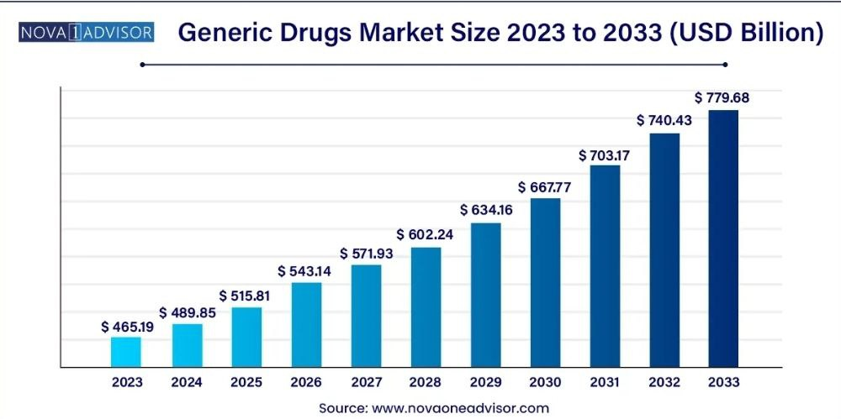
Source: Nova One Advisor. (2024, April). Generic drugs market size, share and trends report, 2024– 2033. Nova One Advisor. https://www.novaoneadvisor.com/report/generic-drugs-market

The generic drugs market is growing steadily, and that’s no surprise several important factors are driving this trend. These include the expiration of patents on brand-name medications, the rising need for affordable healthcare, supportive government policies, and the global increase in chronic health problems:
- Patent Expirations: Once the patents on brand-name drugs run out, other manufacturers can step in and make generic versions. These alternatives usually cost much less, which helps lower overall drug prices and makes treatment more accessible for more people.
- Government Backing: Many governments are pushing for the wider use of generics to help cut healthcare costs. In some places, doctors are rewarded for prescribing generics, and pharmacists may be required to offer a generic version when one is available. It’s a smart move to stretch healthcare budgets without sacrificing quality.
- Rising Healthcare Costs: With medical expenses climbing around the world, both patients and healthcare providers are looking for ways to save. Generic drugs offer a reliable and affordable option, which naturally leads to higher demand (DrugPatentWatch, 2025).
- More Chronic Diseases: Chronic conditions—like heart disease, cancer, asthma, COPD, and diabetes are becoming more common everywhere. These illnesses, often lasting for years or even a lifetime, are linked to a mix of causes: genetics, lifestyle habits, environment, and more. They do not just affect older people, either. In fact, over 15 million deaths from such diseases happen between ages 30 and 69, and 85% of those early deaths occur in low- and middle-income countries. Altogether, these regions report around 31.4 million deaths due to chronic diseases each year.
Whether it is due to poor diet, lack of exercise, smoking, or heavy drinking, people of all ages are at risk. That is why having affordable treatment options like generic drugs is more important than ever. They play a key role in making healthcare more accessible, especially in parts of the world where resources are limited (research, 2021).

2.1.2. Key producers and exporters:
- Key exporters:
Global Pharmaceutical Exports: In the global pharmaceutical trade, certain countries distinguish themselves as major exporters of essential medicines. These leading pharmaceutical exporters play a vital role in fulfilling the worldwide demand for life-saving drugs.

In 2023, Germany, Switzerland, and the United States ranked among the top pharmaceutical exporting countries globally. Their leadership in the industry is built on strong investments in research and development, high-quality manufacturing systems, and strict regulatory compliance. These countries continue to play a vital role in supplying essential drugs worldwide and addressing the increasing demand for effective healthcare solutions.
The main pharmaceutical exporters in 2023 include:

Table03: the main pharmaceutical exporters in 2023
 | The exporter | The value | the percentage
01 | Germany | $119,85 billion | 14,4%
02 | Switzerland | $99,08 billion | 11,9%
03 | USA | $90,30 billion | 10,8%
04 | Belgium | $82,52 billion | 9,9%
05 | Ireland | $71,56 billion | 8,6%
06 | Italy | $50,32 billion | 6%
07 | France | $38,01 billion | 4,6%
08 | Netherland | $34,19 billion | 4,1%
09 | UK | $27,49 billion | 3,3%
10 | Spain | $21,86 billion | 2,6%
Personal elaboration based on: TradeImeX. (2024). Top 10 pharmaceutical exporters of 2023–24. TradeImeX Blog. Retrieved June 01, 2025, from https://www.tradeimex.in/blogs/top-Pharmaceutical-exporters
In the first quarter of 2024, the top three countries from the previous year remained in the lead, with Germany still the largest exporter in the pharmaceutical industry, followed by Switzerland and the United States. The rankings then changed for the remaining countries, as shown in the following table:
table04: the main pharmaceutical exporters in the first quarter of 2024
 | The exporter | The value
01 | Germany | $32,32 billion
02 | Switzerland | $27,14 billion
03 | USA | $22,13 billion
04 | Ireland | $21,97 billion
05 | France | $10,16 billion
06 | UK | $6,91 billion
07 | Spain | $4,32 billion
08 | China | $2,94 billion
09 | Canada | $2,55 billion
10 | Singapore | $2,44 billion
Personal elaboration based on from TradeImeX. (2024). Top 10 pharmaceutical exporters of 2023–24. TradeImeX Blog. Retrieved June 01, 2025, from https://www.tradeimex.in/blogs/top-Pharmaceutical-exporters
Generic drugs exports: While countries leading in pharmaceutical exports often owe their status to the high revenues from patented drugs, the scenario differs when considering generic medicines alone. These cost-effective substitutes, offering the same therapeutic effects as their branded counterparts, are vital for ensuring drug accessibility worldwide especially in less affluent regions.
India is considered one of the leading countries in the manufacturing of medicines and vaccines, and is globally known as the "pharmacy of the world" due to its massive production and affordable prices of high-quality medicines. It represents 20% of the global market in terms of the volume of generic drugs and exports about 60% of the world's vaccines, especially vaccines like measles and tuberculosis. India also has a large number of factories approved by the U.S. Food and Drug Administration outside of America, and primarily exports pharmaceutical formulations and biological products, making it a pivotal player in providing low-cost medicines globally, especially for HIV. (pharmaceutical exports from india IBEF, 2025)
Germany, Switzerland, and the United States have long held strong positions in the global pharmaceutical trade, especially in the export of generic medicines (Top 10 Pharmaceutical Exporters of 2023-24, n.d.). Meanwhile, China stands out as the top producer of active pharmaceutical ingredients (APIs), which are essential for making generics (The Role of China in the Global Generic Drug API Market, 2025). Other European countries like Belgium and France also play essentiel roles in the international supply chain, and in these recent years, new players such as South Korea and Brazil have started to gain ground, gradually increasing their presence and competitiveness in the pharmaceutical market (Connecting Continents Through Quality Pharma Exports, 2025).
- Key producers:
Of global pharmaceutical producers:
Table05: top 10 of pharmaceutical producers in the world in 2024
 | Company | country | Revenue (2024)
01 | Merck&Co | USA | $64.17 Billion
02 | Pfizer Inc | USA | $63.63 Billion
03 | Johnson & Johnson | USA | $57.07 Billion
04 | AbbVie | USA | $56.33 Billion
05 | AstraZeneca plc | UK | $54.07 Billion
06 | Roche Group | Switzerland | $52.45 Billion
07 | Novartis AG | Switzerland | $50.32 Billion
08 | Bristol Myers Squipp | USA | $48.30 Billion
09 | Eli Lilly | USA | $45.04 Billion
10 | Sanofi S.A. | France | $44.47 Billion
Personal elaboration based on Drug Discovery & Development. (2025). Pharma 50: The 50 largest pharmaceutical companies in the world for 2025. Retrieved June 1st, 2025, from https://www.drugdiscoverytrends.com/pharma-50-the-50-largest-pharmaceutical-companies-in-the-world-for-2025/

Of generic drugs producers:
Table06: top 10 of generic drugs producers in the world in 2023
 | Company | Country | Characteristic
01 | Teva | Zionist occupation | It is a major producer of generic drugs, known for its wide range of affordable treatments in fields like neurology, cardiology, and oncology. The company has a global presence in over 60 countries and collaborates with other firms to expand its reach.
02 | Mylan N.V | USA | It is a global pharmaceutical company known for providing affordable generic and biosimilar drugs across a wide range of treatments. With 40 manufacturing sites, it produces complex medicines and works with partners to lower costs. Its reach extends to over 165 countries, especially serving growing needs in markets like India, China, and Brazil.
03 | Novartis AG | Switzerland | It is known for creating treatments for everything from cancer to respiratory diseases. Through its Sandoz branch, it makes affordable generic drugs and biosimilars available to people around the world. With operations in over 80 countries, its medicines reach hundreds of millions globally.
04 | Pfizer Inc | USA | It makes both brand name and generic drugs, especially in areas like heart health, pain, and mental health. It often creates generic versions of its own drugs once patents expire to stay competitive. The company operates in over 175 countries, reaching markets worldwide.
05 | Sun Pharmaceutical Industries Ltd | India | it that makes a wide variety of affordable medicines for heart problems, mental health, and digestion. With dozens of production sites, it focuses on meeting patient needs with both simple and advanced treatments. Its reach extends across more than 100 countries, including major ones like the U.S., Europe, and India.
06 | Fresenius SE & Co | Germany | It made up of several branches, including Fresenius Kabi, which focuses on making generic drugs. With operations in over 100 countries, it supplies essential medicines and treatments for seriously ill patients. The company also invests in research and works on reducing its environmental impact while expanding its generic drug offerings.
07 | Lupin limited | India | It is known for producing affordable generic drugs for conditions like heart, brain, and lung disorders. It runs manufacturing plants in India, the U.S., and Japan, and puts a lot of effort into developing advanced generics and biosimilars. With its wide global reach in over 100 countries, Lupin has built a strong reputation for quality and reliability in the healthcare market.
08 | Endo Pharmaceuticals Inc | Ireland | It makes a mix of generic and branded medicines for different medical needs. It is been able to grow and reach more patients around the world. Today, it is active in places like North America, Europe, Asia, the Middle East, and Africa.
09 | Aurobindo Pharma limited | India | It offers affordable medicines for many health problems, like infections, heart disease, and cancer. Thanks to its modern factories and focus on research, it supplies quality treatments to patients in different parts of the world. It is especially well established in big markets like the U.S. and Europe.
10 | Aspen Pharmacare Holdings Limited | South Africa | It offers affordable treatments for a range of health issues, including blood clots and pain relief. It makes different types of products like tablets, liquids, and injectable, while following strict quality rules. The company reaches patients across many regions, especially in developing parts of Africa, Asia, and Latin America.
Personal elaboration based on: IMARC Group. (2024). Top 10 Generic Drugs Companies in the World. Retrieved June 10, 2025, from https://www.imarcgroup.com/generic-drug-manufacturing-companies

2.2. The Generic Drug Market in Algeria:

2.2.1. Historical background:
The history of the pharmaceutical industry in Algeria is deeply linked to its colonial past and its post-independence evolution. Before 1962, the departments of Algeria constituted the main market for medicines within the French colonial Empire, with the majority of products being imported (Frogerais, 2019). This dependence on imports marked the beginning of the Algerian pharmaceutical era.
After independence, between 1962 and 1990, the Algerian pharmaceutical sector was characterized by a state monopoly. During this period, the pharmaceutical industry ensured the production of primary type medicines, and active ingredients were supplied to retail pharmacists. Research expenditures were relatively low, representing about 70% of the drug cost, and the dispensing of pharmaceutical products was not always linked to the presentation of a prescription. This state monopoly was abolished in 1990, opening the way for new market dynamics (Dahmani, 2022).
From the 1970s, Algeria experienced an acceleration of scientific and technological progress, resulting in the development of new series of medicines, particularly antibiotics. The transformation of the pharmaceutical industry focused on research, raw material production, manufacturing, and marketing of the finished product. Research expenditures increased, reaching up to 8% of total turnover. During this period, an average of 444 products were introduced annually, 10% of which were new active ingredients. The dispensing of most pharmaceutical products became conditional on the presentation of a prescription. Notions of patents and specific names (trademarks) were introduced to protect pharmaceutical companies, with a duration of 17 to 20 years. Drug regulation was strengthened, especially after disasters such as that linked to thalidomide (Frogerais, 2019).
From the 1980s, a small number of pharmaceutical industries (fewer than a hundred) held 80% of the market, with multinational firms being the only ones able to conduct research for the development of new products (Médicament générique, 2019\2020, p. 1)
The Algerian pharmaceutical market has grown by 15% in recent years, although it remains a relatively small market globally (gachout, DIAYE, & BENBRAIKA, 2017, p. 92). The legal definition of generic drugs has been established in Algeria, and once marketing authorization (AMM) is granted, the drug is patented for 20 years, after which it falls into the public domain, allowing the entry of generics ( FENEK & Slioui, 2015-2016). From 2004 to 2011, generic drug consumption increased from 34.49% to 38.72% (Médicament générique, 2019\2020, p. 5)

2.2.2. Local Industry Players (e.g., SAIDAL):
SAIDAL Group is a major and historical player in the Algerian pharmaceutical industry. Founded in 1982, it is the first pharmaceutical laboratory producing generic drugs in Algeria, with the mission of contributing to the establishment of a local pharmaceutical industry (GROUPE SAIDAL- Ministère de l'industrie, s.d.).
SAIDAL is the leader in drug production in Algeria, employing approximately 3,094 people in 2021. The company is a key producer of antibiotics and generic drugs (SAIDAL, 2025). As part of its development strategy, SAIDAL aims to capture 35% of the national anticancer drug market by 2025 and has already launched the production of 19 new generic products in various categories (gachout, DIAYE, & BENBRAIKA, 2017).
The group also has an ambitious development plan for 135 generic products, including 35 specific drugs (Médicament générique, 2019\2020). A significant SAIDAL initiative is the inauguration of the first bioequivalence center in Algeria, named « Equival ». This center's main mission is to conduct bioequivalence studies, essential to prove that generic drugs are equivalent to originator drugs in terms of efficacy and safety (SAIDAL G. , 2023).
SAIDAL has eight drug production plants and plans to produce locally raw materials for the pharmaceutical industry, thereby strengthening the country's autonomy in this sector (Frogerais, 2019).

2.3. Policies Supporting Generic Drug Use:

2.3.1.WHO Guidelines:
For years, the World Health Organization has been helping countries make sure people can get the medicines they truly need. One way they do this is by creating a list every two years that includes the most useful and affordable medicines that have been shown to be safe and effective. This list helps countries decide which medicines to focus on in their health systems (World Health Organization, 2024)
The first version came out back in 1977 with about 200 medicines, and a special version just for children was added in 2007. Today, more than 150 countries use their own versions of this list to decide what to buy for hospitals, what is covered by insurance, and even what is donated.
WHO believes that sticking to a short list of the most important medicines helps make things easier—it keeps supply organized, cuts down on costs, and helps doctors know what to prescribe. Nevertheless, there are still some issues, like the expensive prices of newer medicines and the fact that some people still can not get the treatments they need. To keep the list useful, WHO updates it through a clear process where experts look at suggestions backed by solid research (World Health Organization, 2024).

2.3.2. Algerian Regulations and Initiatives:
Algeria has implemented a regulatory framework and initiatives to support the use of
generic drugs, recognizing their crucial role in controlling healthcare expenditures and improving access to care.
The legal definition of medicine in Algeria is established by Law No. 08-13 of July 20,
2008, amending and supplementing Law No. 85-05 of February 16, 1985, relating to health protection and promotion. According to Article 4 of this law, a medicine is defined as any substance or composition possessing curative or preventive properties, intended for humans or animals, or used to establish a medical diagnosis or restore, correct, or modify organic functions (Journal Officiel de la République Algérienne, 2021).
Algerian legislation, particularly Article 9 of the same law, requires practitioners to prescribe only products listed in the National Nomenclature. The acquisition of medicines is generally conditional on the presentation of a prescription, as stipulated by Article 181 of Law No. 85-05 (Journal Officiel de la République Algérienne, 2021).
Algeria has clearly chosen to support the use of generic medicines, a direction officially confirmed in the 2018 Health Law.
To put this policy into action, several steps have already been taken:
- Research and Development Center: focused on generic drugs, biotechnology, and biological products. This project, mentioned by the Minister of Health, shows Algeria’s intention to encourage innovation and strengthen local production in the pharmaceutical field.
- Bioequivalence Center: The public pharmaceutical group SAIDAL inaugurated the first bioequivalence center in Algeria, « Equival ». This center is essential for conducting the bioequivalence studies necessary to prove the equivalence of generic drugs to originators, thereby strengthening confidence in their quality and efficacy (SAIDAL G. , 2023)
- Exemption of Generic Drugs: An order dated Safar 27, 1443 (October 4, 2021) was promulgated to set the criteria for the exemption of generic and bio therapeutic drugs, which can promote their accessibility and market distribution (Journal Officiel de la République Algérienne, 2021).

Section 03: Challenges and Development Prospects of Generic Drugs

3.1. Challenges Related to Generic Drugs:
Even though Algeria has made efforts to encourage the use of generic medicines, there are still several challenges that make it hard for them to be fully accepted and integrated into the healthcare system.

3.1.1. Awareness Issues, Resistance from Doctors/Patients:
The resistance of Algerian consumers to generic drugs is a significant phenomenon,
identified as a major obstacle to their adoption. This resistance persists despite
numerous government measures aimed at promoting generics. A study highlighted the
crucial importance of establishing a climate of trust among all healthcare stakeholders
doctors, pharmacists, and patients by fostering the sharing of knowledge and decision making power regarding medicines (khedim & tabet derraz , 2022).
The perception of the quality and efficacy of generics is at the heart of this resistance.
Patients, and sometimes even healthcare professionals, may express doubts about the therapeutic equivalence of generics compared to originator drugs. These doubts are often fueled by a lack of clear information and unfamiliarity with the rigorous approval processes for generics, particularly bioequivalence studies that guarantee their interchangeability.
Doctors' prescribing habits also create some difficulties. Many are still hesitant to switch from brand-name drugs to generics, either because they are used to old routines or because they aren’t fully informed about the newer generics available in Algeria. This kind of hesitation can slow down the wider use of generic medicines, even when they work just as well and cost less.

3.1.2. Regulatory and Supply Chain Problems:
The Algerian regulatory framework, although progressive in its desire to promote generics, faces challenges in its implementation and enforcement. Pharmaceutical policy in Algeria has encountered several obstacles related to socio-economic and legal contexts, which can complicate the environment for generic drugs (Dahmani, 2022).
Securing medical product supply chains is a major issue. Supply chains can present vulnerabilities, as highlighted by an OECD report on post-pandemic drug supply chains.
In Algeria, efforts are being made to align pharmaceutical distribution establishments
with international standards through new regulations (Distribution de médicaments : les nouveaux textes permettront de se conformer aux standards internationaux, 2022)
Despite Algeria's ongoing efforts to strengthen local pharmaceutical production, the country has historically depended on imports, making it vulnerable to global crises and disruptions in international trade. This underscores the critical need for rigorous quality control measures at every stage of the supply chain to ensure the safety and reliability of generic medicines. The inauguration of the bioequivalence center by SAIDAL is a positive initiative in this regard, but continuous monitoring and strengthening of control capacities remain paramount. Furthermore, Algeria, like many countries, faces the constant increase in drug expenditures, which makes the promotion of generics even more crucial for achieving substantial savings (snoussi, 2012).
Finally, although distinct from resistance to generics, antimicrobial resistance (AMR) represents a significant public health challenge in Algeria. Awareness campaigns and training are being implemented to combat this phenomenon (keddad, 2018). The general perception of medicines and their efficacy can be influenced by these concerns, which can indirectly impact trust in generics.

3.2. Development Prospects and Strategic Pillars for Advancing Generic Drugs in Algeria:
To overcome challenges and maximize the benefits of generic drugs in Algeria, several development and improvement strategies can be implemented, focusing on strengthening trust, education, appropriate pricing policies, and innovation.

3.2.1. Strengthening Public Trust:
Strengthening public trust is paramount for the increased acceptance and use of generic drugs. This involves several approaches:
- Information and Awareness: It is crucial to establish a climate of trust among healthcare professionals (doctors, pharmacists) and patients. This implies transparent sharing of knowledge and information about medicines. Pharmaceutical companies have a role to play in informing doctors about new generic drugs, their characteristics, and their benefits, which can help clear up doubts and encourage prescribing (khedim & tabet derraz , 2022).
- Bioequivalence studies: The conduct and communication of bioequivalence study results are essential to guarantee the quality and efficacy of generics. The inauguration of the « Equival » bioequivalence center by SAIDAL is a significant step in this direction, as it scientifically proves the equivalence of generics with originators, thereby strengthening trust (Médicaments génériques : les études de bioéquivalence, une alternative pour garantir des médicaments de qualité, 2022).
- Communication en quality: Targeted communication campaigns should be conducted to emphasize that generic drugs are subject to the same rigorous standards of quality, safety, and efficacy as original drugs. This transparency is fundamental to reassure the public.
- Trust in local production: Targeted communication campaigns should be implemented to highlight that generic drugs undergo the same rigorous standards of quality, safety, and efficacy as brand-name drugs (Tahar, 2018). Such transparency is essential to strengthen public confidence and acceptance.

3.2.2. Education:
Pricing policies are an essential level for encouraging the use of generic drugs and controlling healthcare expenditures:

- Training for healthcare professionals: Continuous and in-depth training for doctors and pharmacists on generic drugs is necessary. This training should cover their benefits, interchangeability, bioequivalence studies, and the latest advancements in the field. Better knowledge will foster more confident prescribing and dispensing of generics (hassali, shafie, jamshed, ibrahim, & Awaisu, 2009)

- Patient education: Public information and awareness campaigns are essential. They must clearly and accessibly explain what generic drugs are, their efficacy, safety, and their crucial role in controlling healthcare expenditures. The goal is to demystify generics and correct misconceptions (Murphy, 2023).

- Integration into Curricula: The integration of specific modules on generic drugs into the university curricula of future healthcare professionals (doctors, pharmacists, nurses) will contribute to better understanding and acceptance from the beginning of their careers ( Alqawasmeh, et al., 2025).

3.2.3. Pricing policies:
Pricing policies are an essential level for encouraging the use of generic drugs and controlling healthcare expenditures:
- Reference pricing (RP): Algeria has adopted a Reference Pricing system that, along with the introduction of generic drugs, influences the pricing of both brand-name and generic medicines. Under this system, the government establishes a ceiling price for generics, which is typically set at a lower percentage compared to originator drugs (snoussi, Tarif de référence et entrée des génériques : l’impact sur les prix des médicaments en Algérie, 2015). This approach is intended to enhance the financial appeal of generics.
- Cost control: Generic drugs provide a vital way to reduce healthcare costs, a priority for Algeria’s healthcare system amid rising expenditures. (snoussi, 2012).
- Impact of local production on prices: The development of local generic drug production can help reduce medication prices by decreasing reliance on imports and promoting competition (snoussi & mohammed belkbir, La politique nationale de médicament : L'impact de la production locale sur les prix des médicaments, 2018).
3.2.4. Innovation:
Innovation in the field of generic drugs in Algeria is not limited to simple copying but also includes research and development to improve supply and quality:
- Research and development: The creation of a Research and Development Center for generic drugs, biotechnology, and biological products is a key initiative to stimulate innovation in this area (Médicaments génériques : les études de bioéquivalence, une alternative pour garantir des médicaments de qualité, 2022). This will enable the development of new formulations, improvement of manufacturing processes, and diversification of generic offerings.
- New dosage forms: Innovation can be directed toward developing new dosage forms of generic drugs, providing options that better meet patient needs and enhance treatment adherence (Belaahcene Belkhamsa, 2022).
- Partnerships: Encouraging partnerships between local stakeholders (universities, research centers, pharmaceutical companies) and international partners can facilitate technology transfer, knowledge exchange, and accelerate innovation.

- Incentives for innovation: The implementation of incentive mechanisms, such as awards or research grants, can encourage companies to invest more in generic research and development, thereby contributing to the country's pharmaceutical autonomy.

Conclusion:
Reducing healthcare costs while maintaining quality and access to treatment is a growing challenge for health systems around the world, including Algeria. Generic drugs offer a practical solution, as they provide the same therapeutic effects as brand-name medicines but at a much lower cost. Their wider use can ease the financial burden on both the healthcare system and patients, but this requires a proper understanding of what generics are, how they are approved, and why they are trustworthy.
This chapter began by laying out the essential concepts related to generic drugs—such as their definition, classification, and the regulations that ensure their safety and effectiveness. It also outlined the key similarities and differences between generics and originator products. This foundation helps address common doubts and supports the case for broader acceptance of generics in healthcare practice.
In the second part, the chapter looked at the global context of generic drug use, then narrowed the focus to Algeria’s own pharmaceutical market and it examined current policies.
In the last part, the chapter explained the market challenges, and the development opportunities for promoting generics.
By combining theory with practical insight, this chapter highlights the important role generic drugs can play in building a more affordable and sustainable health system, while setting the stage for the recommendations to come.

Chapter Two:

Understanding and Exploring Trust in Generic Medicines: Concepts, Influencing Factors, and Perspectives

Introduction:
Trust plays a powerful role in shaping how individuals engage with healthcare systems and make decisions about their treatment. When it comes to medications, especially generic drugs, trust can often determine whether a patient accepts or rejects a product, regardless of its scientific validation. In many cases, people’s confidence in generic medicines is influenced by a mix of personal beliefs, social influences, and institutional factors—making it a topic worth deeper exploration.
This chapter looks at trust as a broader concept and how it applies specifically to the world of pharmaceuticals. It also aims to highlight the key elements that shape the level of trust in generic drugs, which are increasingly important in today’s efforts to ensure accessible and cost-effective healthcare.
The chapter is structured as follows:
Section one: Theoretical Framework of Trust
Section two: Trust in the Pharmaceutical Context
Section three: Factors Influencing Trust in Generic Drugs.
By the end of this chapter, we will provide a foundation for understanding the dynamics of trust in generic medicines, especially in contexts where their acceptance remains limited or uncertain.

Section one: Understanding Trust and Trust in drugs
Trust plays a vital role in shaping how individuals interact with healthcare systems and medical treatments. In the field of pharmaceuticals, it influences patient decisions, perceptions of safety, and acceptance of prescribed medications. Understanding trust both as a general concept and within the context of drug use is essential to explain how people form confidence in the quality and effectiveness of the medicines they consume, including generic drugs.
  - Defining Trust: Concepts and Theories:
Trust is a widely used concept across fields such as sociology, psychology, economics, and political science, and it plays a vital role in fostering social order and cooperation. Although scholars have yet to agree on a single, unified definition due to the complexity and layered nature of trust most interpretations share a central idea: trust involves having a positive expectation that another person or group will act appropriately in situations that carry some level of risk and vulnerability. (Robbins, 2016).
    - Core Components of Trust:
Several key components consistently emerge in scholarly discussions of trust:
- Vulnerability: Trust inherently implies a willingness to make oneself vulnerable to the actions of another. The trustor (the one who trusts) accepts the risk that the trustee (the one being trusted) may not act as expected or desired, potentially leading to negative consequences (Mayer, Davis, & Schoorman, 1995).This vulnerability arises from an information asymmetry, where the trustor often has incomplete knowledge about the trustee's future behavior or intentions.
- Positive Expectation/Belief: Trust is predicated on a belief or optimistic expectation that the trustee will behave in a way that is beneficial, or at least not detrimental, to the trustor's interests (Uttenthal, 2024). This expectation can be based on various factors, including past experiences, reputation, perceived competence, integrity, and benevolence of the trustee.
- Risk and Uncertainty: Trust operates in situations where the future is uncertain and outcomes are not guaranteed. If there were complete certainty or control over the trustee's actions, trust would be unnecessary. It is precisely because of this inherent risk and uncertainty that trust becomes a crucial mechanism for facilitating social and economic interactions (Hancock, et al., 2023) (Uttenthal, 2024).
- Interdependence: Trust often arises in situations where parties are interdependent, meaning that the outcomes for one party are affected by the actions of another. In such contexts, trust allows individuals and groups to engage in cooperative behaviors that would be too risky or costly otherwise.
    - Theoretical Perspectives on Trust:
Various theoretical perspectives have sought to explain the origins, development, and consequences of trust:
- Rational Choice Theory: From this perspective, trust is often viewed as a calculated decision based on an assessment of the potential benefits and risks of trusting, as well as the perceived trustworthiness of the other party. Trust is extended when the expected benefits of cooperation outweigh the potential costs of betrayal (Robbins, 2016). This approach emphasizes the cognitive and calculative aspects of trust.
- Social and Psychological Theories: These theories highlight the role of social norms, values, emotions, and psychological predispositions in shaping trust. For instance, some individuals may have a higher general propensity to trust others, influenced by their personality, upbringing, and cultural context. Social learning, where individuals learn to trust based on their own experiences and observations of others, is also a key mechanism (Hancock, et al., 2023). Concepts like benevolence (the belief that the trustee cares about the trustor's welfare) and integrity (the belief that the trustee adheres to a set of acceptable principles) are central to these perspectives (Lalumera, 2024).
- Institutional Trust: This refers to trust in formal organizations, systems, and institutions (e.g., government, legal systems, healthcare systems). It is often based on perceptions of fairness, transparency, competence, and accountability of these institutions (kwon, 2019). In the context of generic drugs, institutional trust in regulatory bodies and pharmaceutical companies is particularly relevant.
  - Dimensions of Trust:
Trust is not a monolithic concept but can be broken down into several dimensions:
- Cognitive Trust: This is based on rational assessment and evidence, such as reliability, competence, and past performance. It is about believing that the trustee has the necessary skills and knowledge to perform a task (Robbins, 2016).
- Affective Trust: This is based on emotional bonds, shared values, and a sense of care or benevolence. It develops over time through repeated positive interactions and a feeling of psychological safety (Robbins, 2016)
- Calculative Trust: This is based on the assessment of rewards and punishments, where individuals trust because the costs of not trusting (e.g., missing out on opportunities) outweigh the benefits (Robbins, 2016).

Section Two: Trust in the Pharmaceutical Context
  - Trust in drugs: a general perspective:
Trust in medicines is a critical component of healthcare, directly influencing patient adherence, treatment outcomes, and the overall effectiveness of public health interventions. When individuals trust their medications, they are more likely to take them as prescribed, believe in their efficacy, and report positive experiences. Conversely, a lack of trust can lead to non-adherence, skepticism, and the pursuit of alternative, potentially less effective, or even harmful treatments.
    - Factors Influencing General Trust in Medicines:
Several factors contribute to the general level of trust that individuals place in pharmaceutical products:
- Perceived Efficacy and Safety: At the most fundamental level, trust in a medicine is built upon the belief that it will work as intended (efficacy) and that it will not cause undue harm (safety). This perception is shaped by personal experience, information from healthcare providers, media reports, and anecdotal evidence from peers (kesselheim, et al., 2016).
- Healthcare Professional Endorsement: The recommendations and attitudes of doctors, pharmacists, and nurses significantly influence patient trust. When healthcare professionals confidently prescribe and endorse a medicine, patients are more likely to trust it. Conversely, any hesitation or doubt expressed by a healthcare provider can erode patient confidence (Akhtar & Orayj, 2024)
- Regulatory Oversight and Quality Assurance: Trust in the regulatory bodies responsible for approving and monitoring medicines (e.g., national drug agencies) is paramount. Patients and the public generally assume that if a medicine is approved and available, it has undergone rigorous testing and meets high standards of quality and safety. Any perceived lapses in regulatory oversight or incidents involving substandard drugs can severely damage this trust (Eban, 2020)
- Personal Experience and Outcomes: Direct personal experience with a medicine, particularly positive outcomes, can significantly reinforce trust. Conversely, negative experiences, such as unexpected side effects or perceived lack of efficacy, can diminish trust (Alrasheedy, et al., 2014)
- Media and Social Influence: Media portrayals of medicines, both positive and negative, can shape public perception and trust. Social networks and peer opinions also play a role, particularly in an era of widespread online information and misinformation (kesselheim, et al., 2016)
- Manufacturer Reputation: The reputation of the pharmaceutical company producing the medicine also plays a role. Companies with a long history of producing high-quality, effective, and safe drugs tend to inspire greater trust. Conversely, companies involved in scandals or controversies may face public skepticism (Yashaswini, matthew, & Neeraj, 2023).
- Information Accessibility and Transparency: Clear, accurate, and easily understandable information about medicines, including their benefits, risks, and proper usage, is essential for building trust. Transparency in clinical trial data and drug development processes can also contribute to public confidence (The Importance of Clinical Trial Transparency and FDA Oversight, 2023).
    - The Role of Scientific Evidence and Communication:
In an ideal scenario, trust in medicines would be primarily driven by scientific evidence of their efficacy and safety. However, public understanding of scientific processes and data can be limited. Therefore, effective communication of scientific evidence by healthcare professionals, public health authorities, and reputable media outlets is crucial. This communication needs to be clear, consistent, and empathetic, addressing public concerns and correcting misinformation (Boyle, 2025).
    - Challenges to Trust in Medicines:
Despite the rigorous scientific processes behind drug development and approval, trust in medicines can be fragile and subject to various challenges:
- Misinformation and Disinformation: The proliferation of inaccurate or misleading information, particularly online, can undermine public trust in established medical science and pharmaceutical products (Misinformation in Pharma’s Digital Age: Risks and Opportunities, n.d.).
- Conflicts of Interest: Perceived or actual conflicts of interest between pharmaceutical companies and healthcare providers or regulatory bodies can erode public confidence ((US), 2009).
- High Drug Costs: The high cost of some innovative medicines can lead to a perception of unfairness or exploitation, which can indirectly impact general trust in the pharmaceutical industry (Yashaswini, matthew, & Neeraj, 2023)
- Negative Media Coverage: Sensationalized or unbalanced media reporting on drug side effects or recalls, while sometimes necessary, can disproportionately influence public perception and foster distrust (Navigating the Impact of Drug Recalls on Public Health: A Comprehensive Examination, 2024).
  - Trust in generic drugs: specific consideration:
Trust in generic drugs involves specific concerns that set it apart from general trust in medications. Even though generics are scientifically shown to work the same as brand-name drugs, many people still view them with hesitation. Their acceptance is often shaped by public doubts, personal beliefs, and the influence of healthcare professionals and other key players. This section takes a closer look at the unique factors that shape how people perceive and trust generic medicines.
    - The Paradox of Generics: Efficacy vs. Perception:
The fundamental paradox of generic drugs lies in the discrepancy between their scientific equivalence and public perception. Worldwide regulatory authorities, including the Algerian authorities, mandate that generic drugs must demonstrate bioequivalence to their reference (brand-name) products. This means they contain the same active pharmaceutical ingredient (API), in the same dosage form, and are intended to be administered in the same way, with comparable bioavailability and therapeutic effect (Generic drugs fact, 2021). Despite this scientific validation, a significant portion of the public, and even some healthcare professionals, harbor doubts about the efficacy, safety, and overall quality of generics (Hadia, Joshi, Gohel, & Khambhati, 2021).
This skepticism often stems from several factors:
- Lack of Understanding of Bioequivalence: The concept of bioequivalence is complex and not widely understood by the general public. Without a clear grasp of the rigorous scientific testing that generics undergo, patients may struggle to reconcile the lower price with the claim of equal efficacy
- Marketing and Branding: Brand-name drugs often benefit from extensive marketing campaigns that build strong brand recognition and perceived value over many years. Generic drugs, typically lack this extensive branding and may appear less sophisticated or trustworthy to some consumers

    - Influence of Healthcare Professionals:
The attitudes and communication of healthcare professionals (HCPs) are paramount in shaping patient trust in generic drugs. If doctors or pharmacists express even subtle doubts or reluctance when prescribing or dispensing generics, it can reinforce patient skepticism. Conversely, confident endorsement and clear explanations from HCPs can significantly build trust ( Kassandros , et al., 2024). However, studies indicate that some HCPs themselves may have misconceptions or insufficient knowledge about generics, contributing to the problem (Hadia, Joshi, Gohel, & Khambhati, 2021).
    - Personal Experiences and Anecdotal Evidence:
While scientific evidence is crucial, personal experiences and anecdotal evidence often hold significant sway over individual perceptions. A negative personal experience with a generic drug, even if unrelated to its actual efficacy (e.g., a perceived side effect, or a psychological effect known as the nocebo effect), can profoundly diminish trust. Similarly, positive experiences can reinforce it. The sharing of these personal stories within social networks can further amplify or diminish trust ( Dunne & Dunne, 2015).
    - Regulatory Environment and Post-Market Surveillance:
The level of trust placed in generic drugs is closely tied to how robust the regulatory environment is perceived to be. It is essential to have a regulatory system that is strong, transparent, and well-implemented, ensuring the quality, safety, and effectiveness of generics. This encompasses not only the approval processes before a drug is sold but also continuous surveillance once it's on the market to identify and correct any quality problems or negative side effects. Public trust can be severely damaged by any perceived shortcomings or scandals within this regulatory framework (robinson, 2024).
    - Accessibility and Affordability:
While the cost-effectiveness of generic medications is their chief asset, it can, paradoxically, foster mistrust if not adequately conveyed. Still, for a significant number of patients, particularly in emerging economies, the availability and lower price of generics are indispensable for accessing crucial therapies. In these settings, the economic gain can supersede initial reservations, especially when coupled with robust professional backing and demonstrated positive health outcomes (hassali, shafie, jamshed, ibrahim, & Awaisu, 2009).

  - Types of Trust Relevant to Generic Drugs:
Understanding the different types of trust is crucial for analyzing how consumers develop confidence in generic drugs. Trust is not a monolithic concept; it manifests in various forms, each with distinct origins and implications for behavior. In the context of generic drugs, several types of trust are particularly relevant:
    - Cognitive Trust (Competence-Based Trust):
Cognitive trust is rooted in rational assessment and evidence. It is based on the belief that the trustee possesses the necessary competence, skills, knowledge, and reliability to perform a task effectively and consistently ( McALLISTER, 1995). In the context of generic drugs, cognitive trust primarily relates to:
- Scientific Equivalence: Trust that generic drugs are scientifically proven to be bioequivalent and therapeutically equivalent to their brand-name counterparts. This involves understanding the rigorous testing and regulatory standards they must meet (Generic drugs fact, 2021)
- Manufacturer Competence: Trust in generic drugs is tied to the perceived competence of their manufacturers, specifically their production capabilities and quality control procedures. This involves assurance that they consistently follow Good Manufacturing Practices (GMP). ( Sharma, Gamta, & Luthra, 2023).
- Healthcare Professional Expertise: Trust in the knowledge and competence of doctors and pharmacists to correctly prescribe, dispense, and advise on generic drugs. This is crucial for patients to feel confident in the medical advice they receive ( Kassandros , et al., 2024).
Cognitive trust is often built through transparent information, scientific data, and demonstrable performance. For generic drugs, this means effectively communicating the results of bioequivalence studies, highlighting the regulatory approval process, and showcasing the consistent quality of manufactured products.
    - Affective Trust (Benevolence-Based Trust):
Affective trust is based on emotional bonds, shared values, and a sense of care or benevolence. It develops over time through repeated positive interactions and a feeling that the trustee has the trustor's best interests at heart ( McALLISTER, 1995). While seemingly less direct for a product like a drug, affective trust plays a significant role in the healthcare context:
- Patient-Provider Relationship: The emotional connection and perceived care from doctors and pharmacists can significantly influence a patient's willingness to trust a generic drug. If a patient feels their healthcare provider genuinely cares about their well-being and recommends a generic for their benefit (e.g., cost savings without compromising health), affective trust is fostered (Aivalli, et al., 2017).
- Trust in the Healthcare System: A general sense of trust in the benevolence and fairness of the overall healthcare system (e.g., that policies are designed for patient benefit, not just profit) can indirectly influence trust in specific components like generic drugs (Aivalli, et al., 2017).
Affective trust is often more resilient to minor setbacks than cognitive trust, as it is built on a deeper emotional foundation. For generic drugs, this means emphasizing the patient-centric benefits (affordability, accessibility) and fostering empathetic communication from healthcare providers.
    - Institutional Trust: Institutional trust refers to the confidence individuals place in formal organizations, systems, and regulatory bodies. It is based on perceptions of fairness, transparency, competence, and accountability of these institutions (kwon, 2019). For generic drugs, institutional trust is paramount:
- Government and Policy Makers: Trust in governments is fundamental as it directly influences public acceptance of policies and directives. High trust can foster adherence to public initiatives, whereas distrust can hinder their effectiveness and civic cooperation (Cao , et al., 2024).
- Regulatory Agencies: Trust in national drug regulatory authorities (e.g., the Algerian National Agency for Pharmaceutical Products - ANPP) to ensure the safety, efficacy, and quality of all drugs, including generics, through rigorous approval and post-market surveillance processes (Understanding Pharmaceutical Regulations in Algeria: Drug Approval Processes, Manufacturing Standards, and Compliance Penalties, 2024).
- Healthcare Organizations: Trust in hospitals, clinics, and pharmacies to provide high-quality in making an appropriate decisions regarding drug selection and substitution
Institutional trust is built through consistent adherence to regulations, transparent decision-making, effective communication of policies, and a demonstrated commitment to public welfare. Any perceived corruption, inefficiency, or lack of transparency within these institutions can severely undermine trust in generic drugs.
    - Interpersonal Trust:
Interpersonal trust refers to the trust individuals place in other individuals, such as family members, friends, or community leaders. While not directly related to the drug itself, interpersonal trust can significantly influence a patient's decision-making regarding generic drugs:
- Peer Influence: Recommendations or warnings from trusted friends or family members who have used generic drugs can strongly influence an individual's perception and willingness to try them (kwon, 2019).
- Community Leaders: In some communities, the endorsement of generic drugs by respected community leaders or religious figures can play a crucial role in building acceptance (Aivalli, et al., 2017).
Interpersonal trust often operates through social networks and can either reinforce or contradict messages from formal sources. For generic drugs, this highlights the importance of word-of-mouth and community engagement in promoting acceptance.
    - Calculative Trust:
Calculative trust refers to a decision to trust someone based on careful thinking and weighing of potential risks and benefits. It is built on the expectation that the other party will act in a trustworthy way because doing so serves their own interest, making the relationship mutually beneficial (poppo, Zheng Zhou, & Juan Li ). In the context of generic drugs:
- Cost-Benefit Analysis: Patients may choose generic drugs primarily due to their lower cost, calculating that the financial savings outweigh any lingering doubts about quality, especially if they are assured by their healthcare provider (lee, 2025)
- Economic Necessity: For many, particularly in resource-constrained settings, the affordability of generics is not just a benefit but a necessity, making calculative trust a dominant factor in their decision (Access to Biosimilar & Generic Drugs, n.d.).
While calculative trust can drive initial adoption, it may be less stable than cognitive or affective trust, as it is highly sensitive to changes in price or perceived risk. For sustainable generic drug use, it is important to move beyond purely calculative trust towards a more robust foundation of cognitive and affective trust.

Section three: Factors influencing trust in generic drugs:
The level of trust consumers place in generic drugs is not a monolithic construct but rather a complex interplay of various factors. These factors can be broadly categorized into those related to the healthcare ecosystem, individual patient characteristics, and market dynamics. Understanding these influences is crucial for developing effective strategies to enhance the acceptance and utilization of generic medicines.
3.1. Influence of Healthcare Professionals: Doctors and Pharmacists:
Healthcare professionals especially doctors and pharmacists hold a central position in influencing how patients perceive and trust generic medicines. As key providers of information and guidance, their knowledge, attitudes, and the way they communicate play a critical role in shaping patients’ willingness to accept or refuse generic drug alternatives.
3.1.1. The Doctor-Patient Relationship and Prescribing Behavior:
Doctors are often the first point of contact for patients seeking medical advice and prescriptions. The recommendations of healthcare professionals carry considerable influence, as patients often place strong trust in their physician’s clinical judgment. If a doctor confidently prescribes a generic drug and explains its equivalence to the brand-name counterpart, patients are more likely to accept it. Conversely, if a doctor expresses hesitation, doubt, or a preference for brand-name drugs, it can reinforce patient skepticism and lead to a lack of trust in generics ( Dunne & Dunne, 2015).
Several aspects of a doctor's influence are critical:
- Knowledge and Confidence: A doctor's knowledge about generic drugs, including their bioequivalence, efficacy, and safety profiles, directly impacts their confidence in prescribing them. Studies have shown that doctors with better knowledge of generic medicines are more likely to prescribe them ( Tsaprantzi, Kostagiolas, Platis, Aggelidis, & Niakas, 2016). If a doctor is well informed and confident, they can effectively communicate the benefits of generics to their patients, dispelling misconceptions and building trust. In the opposite, a lack of knowledge or confidence can lead to a reluctance to prescribe generics, even if they are medically appropriate.
- Communication Style: The way a doctor communicates about generic drugs is as important as what they communicate. Clear, concise, and empathetic communication can significantly influence patient acceptance. Explaining the reasons for generic substitution (e.g., cost-effectiveness, equal efficacy) and addressing patient concerns directly can foster trust. Conversely, a dismissive or unclear explanation can lead to confusion and distrust (Lalumera, 2024).
- Prescribing Habits: Long-standing prescribing habits can be difficult to change. Doctors may have developed a comfort level with specific brand-name drugs over years of practice. Overcoming this inertia requires continuous education and, in some cases, incentives or policies that encourage generic prescribing (Hohmann, et al., 2020).
- Perceptions of Quality: Despite scientific evidence, some doctors may hold personal perceptions or biases regarding the quality of generic drugs. These perceptions, even if unfounded, can influence their prescribing decisions and, consequently, patient trust. A systematic review found that a notable percentage of doctors (29%) and pharmacists (28%) held negative perceptions regarding the efficacy of generic drugs (Akhtar & Orayj, 2024).
3.1.2. The Pharmacist's Role in Dispensing and Counseling:
Pharmacists are the last point of contact in the medication dispensing process and play a crucial role in reinforcing or undermining patient trust in generic drugs. Their direct interaction with patients at the point of sale provides a unique opportunity to educate and reassure.
- Generic Substitution and Counseling: Pharmacists are often empowered to substitute a prescribed brand-name drug with its generic equivalent, provided it is legally permissible and medically appropriate. Their willingness and ability to perform this substitution, coupled with effective patient counseling, are vital. When a pharmacist confidently offers a generic and explains its benefits, it can significantly enhance patient acceptance (Robbins, 2016).
- Addressing Patient Concerns: Pharmacists frequently encounter patient questions and concerns about generic drugs, ranging from doubts about efficacy to worries about side effects. Their ability to patiently and accurately address these concerns, providing clear and evidence-based information, is critical for building trust (Hancock, et al., 2023).
- Professional Credibility: Patients generally view pharmacists as credible and trustworthy sources of information about medications. This professional credibility can be leveraged to promote generic drugs effectively. However, if pharmacists themselves express doubts or are reluctant to recommend generics, it can have a detrimental effect on patient trust ( Dunne & Dunne, 2015).
- Accessibility and Availability: Pharmacists ensure the availability of generic drugs and can guide patients towards more affordable options. Their role in managing drug inventories and ensuring a consistent supply of generics contributes to patient confidence in the accessibility of these medications.
3.1.3. Collaboration between Doctors and Pharmacists:
Effective collaboration and consistent messaging between doctors and pharmacists are essential for building comprehensive trust in generic drugs. When both healthcare professionals convey a unified message about the quality, safety, and efficacy of generics, it reinforces patient confidence. Discrepancies in advice or conflicting opinions can lead to confusion and erode trust in the entire healthcare system (Talking with Patients About Generic, 2007). Initiatives that promote interprofessional education and communication can help bridge any gaps and ensure a cohesive approach to generic drug promotion.
3.2. Personal Experiences and Patient Awareness:
Beyond the influence of healthcare professionals, individual patient experiences and their level of awareness about generic drugs significantly shape their trust and willingness to use these medications. Personal experiences and beliefs often intertwine with broader public perceptions, which can either support or undermine trust in generic medicines.

3.2.1. The Power of Personal Experience:
Direct personal experience with a generic drug is a powerful determinant of trust. If a patient uses a generic medication and experiences the expected therapeutic effect without any perceived negative side effects, their trust in that specific generic, and potentially in generics in general, is likely to increase Positive outcomes reinforce the belief that generics are effective and safe, aligning with scientific evidence. Such positive experiences can lead to increased adherence and a greater willingness to accept generic substitutions in the future.
Conversely, negative personal experiences, whether real or perceived, can profoundly diminish trust. If a patient believes a generic drug did not work as effectively as a brand name drug, or if they attribute new or worsening symptoms to a generic substitution, their trust can be severely eroded (Robbins, 2016). It is important to note that these perceived negative experiences may not always be directly attributable to the generic drug itself. Factors such as the nocebo effect (where negative expectations about a treatment lead to negative outcomes), psychological biases, or even unrelated health issues can contribute to a patient's belief that a generic is inferior (Spanou, Mavridis, & Mitsikostas, 2019). However, regardless of the underlying cause, a negative personal experience can create a strong barrier to future generic drug use and can be difficult to overcome, even with scientific explanations.
Anecdotal evidence shared within social circles also plays a significant role. Patients often discuss their medication experiences with family, friends, and community members. Positive stories can build confidence, while negative anecdotes, even if isolated, can spread rapidly and foster widespread distrust, particularly in communities where health literacy is low or where there is a general skepticism towards the healthcare system .
3.2.2. Patient Awareness and Health Literacy:
Patient awareness and health literacy play a crucial role in influencing trust in generic drugs. Health literacy refers to an individual’s ability to access, comprehend, and use basic health information and services to make informed healthcare decisions, including those related to medication choices. In the context of generics, this includes understanding:
- What Generic Drugs Are: Many patients may not fully grasp the concept of a generic drug, often confusing it with a counterfeit or a lower-quality version of the original ( Dunne & Dunne, 2015). Clear, simple explanations are needed to differentiate generics from other types of medications.
- Bioequivalence and Regulatory Approval: A lack of understanding about the rigorous bioequivalence testing and regulatory approval processes that generic drugs undergo is a major contributor to skepticism (Uttenthal, 2024). Patients need to understand that regulatory bodies ensure generics are therapeutically equivalent to brand name drugs.
- Reasons for Lower Cost: The lower price of generics is often a source of suspicion. Patients need to understand that the cost difference is primarily due to the absence of research and development costs, and marketing expenses, not a compromise on quality or efficacy (kesselheim, et al., 2016).
- Benefits of Generic Use: Patients may not be fully aware of the personal and societal benefits of using generics, such as significant cost savings, increased access to essential medicines, and the sustainability of the healthcare system (Murphy, 2023).
Low health literacy can make patients more susceptible to misinformation and less likely to question their own biases or anecdotal evidence. It can also hinder their ability to engage effectively with healthcare professionals about their medication choices. Studies consistently show that higher levels of knowledge about generic medicines are associated with more positive attitudes and greater acceptance (kwon, 2019).
3.2.3. Addressing Misconceptions and Building Trust through Education:
To counter the impact of negative personal experiences and low awareness, targeted educational interventions are essential. These interventions should aim to:
- Provide Clear and Consistent Information: Healthcare providers, public health campaigns, and patient advocacy groups should consistently deliver clear, accurate, and easily understandable information about generic drugs. This includes explaining the scientific basis of bioequivalence, the regulatory oversight, and the reasons for cost differences (Hancock, et al., 2023).
- Emphasize Shared Decision-Making: Encouraging patients to actively participate in decisions about their medication, in collaboration with their healthcare providers, can build trust. When patients feel heard and involved, they are more likely to accept and adhere to treatment plans, including generic substitutions (Elwyn, et al., 2012).
- Leverage Trusted Sources: Information about generics should come from trusted sources, such as doctors, pharmacists, and reputable health organizations. The credibility of the messenger significantly impacts the acceptance of the message (Robbins, 2016).
By actively correcting misconceptions, providing patients with reliable information, and encouraging positive personal experiences, the healthcare system can strengthen trust in generic drugs—ultimately contributing to better health outcomes and more effective use of healthcare resources.
3.3. Brand Image:
Brand image is widely recognized as a key factor that directly influences consumer behavior and purchase decisions. A strong and positive brand image enhances consumers’ perception of product quality, making them more likely to view the product as reliable and trustworthy. Products associated with a reputable brand are often judged to be superior, which increases their acceptance in the market.
Moreover, a positive brand image helps reduce the perceived risk associated with purchasing. Consumers often feel uncertain when trying new or unfamiliar products, and a well-established brand serves as a psychological assurance. Choosing a recognized brand is typically seen as a safer option, allowing consumers to make confident decisions with greater peace of mind.
Brand image reflects the overall perception formed in consumers’ minds, shaped by both accessible information and past experiences. It encompasses not only the functional attributes of the product but also emotional associations such as general impressions, personal feelings, and the social value the brand represents. As such, brand image is closely linked to consumer attitudes, influencing their preferences, beliefs, and eventual loyalty. ( Ago, suharo, Mintarti, & Hariyadi, 2015).
Research consistently shows that consumers with a favorable view of a brand are more likely to make a purchase and less hesitant to try new products under the same brand. This trust is often the result of repeated positive experiences and effective brand communication, which together strengthen the relationship between the consumer and the brand.
Brand image can be understood through several key dimensions that shape how consumers perceive and connect with a brand. These dimensions serve as critical benchmarks in evaluating the strength and quality of a brand’s reputation in the marketplace: ( Ago, suharo, Mintarti, & Hariyadi, 2015)
- Product Attributes: A brand often evokes specific attributes in the minds of consumers, such as quality, reliability, or design features. These mental associations help consumers quickly identify and differentiate the brand based on the characteristics they believe it represents.
- Consumer Benefits: Brands are expected to deliver value, and this value is reflected through three types of benefits:
- Functional benefits, where the product effectively performs its intended function;
- Emotional benefits, where the product elicits positive feelings or satisfaction;
- Self-expressive benefits, where the brand serves as a reflection of the consumer’s identity, values, or lifestyle.
- Brand Personality: Brands are often perceived as having human-like traits, such as being youthful, sophisticated, or trustworthy. These personality traits make the brand more relatable and allow consumers to form personal connections.
- User Imagery: This refers to the typical image or profile of the people who are perceived to use the brand. It includes demographic and psychographic characteristics, which can influence whether a consumer feels the brand aligns with their own identity or aspirations.
- Organizational Associations: Consumers tend to associate the quality of a product with the credibility and reputation of the organization that produces it. Trust in the manufacturer often translates into trust in the brand, affecting purchasing decisions.
- Brand–Customer Relationships: Strong brands foster long-term relationships with their customers. These relationships are shaped by various emotional and behavioral elements, including:
- Behavioral interdependence, where the consumer’s lifestyle and brand usage are closely linked;
- Personal commitment, reflecting the consumer’s attachment and loyalty;
- Love and passion, where deep emotional bonds exist;
- Nostalgic connection, where the brand evokes meaningful memories;
- Self-concept connection, where the brand is seen as part of the consumer’s identity;
- Intimacy, based on a sense of closeness or familiarity with the brand;
- Partner quality, where the brand is perceived as a trusted companion or ally.
Together, these factors contribute to a rich and multifaceted brand image that influences consumer preferences, loyalty, and purchasing behavior.
  - Price and Affordability: A Double-Edged Sword
The affordability of generic drugs is one of their key advantages, significantly influencing consumer trust. Although their lower cost makes them more accessible—benefiting both individuals and healthcare systems—it can also lead to unintended skepticism. Without proper communication, consumers may question their quality, creating a paradoxical relationship between price and trust.
    - The Economic Imperative of Generic Drugs:
Generic drugs are significantly less expensive than their brand-name counterparts, often costing 80-85% less. This substantial price difference stems from the fact that generic manufacturers do not bear the extensive research and development (R&D) costs associated with bringing a new drug to market. Originator companies invest heavily in discovering, developing, and testing new molecules, and these costs are recouped through patent protection and higher prices during the patent period. Once the patent expires, generic manufacturers can produce and sell bioequivalent versions without incurring these initial R&D expenses, allowing them to offer the drugs at a much lower price (Access to Biosimilar & Generic Drugs, n.d.).
The affordability of generic drugs has profound implications for healthcare access and sustainability:
- Increased Patient Access: Lower prices make essential medicines more accessible to a larger segment of the population, particularly in low- and middle-income countries and for individuals with limited financial resources or inadequate insurance coverage (Generic Competition and Drug Prices, 2024). This improved access can lead to better health outcomes and reduced health disparities.
- Cost Savings for Individuals and Healthcare Systems: The use of generic drugs generates substantial cost savings for both individual patients (through lower out of-pocket expenses) and the overall healthcare system (through reduced pharmaceutical expenditures). These savings can be redirected to other critical healthcare needs (ASPE, 2025).
- Enhanced Medication Adherence: Cost can be a significant barrier to medication adherence. When patients cannot afford their prescribed brand-name drugs, they may skip doses, take less than the prescribed amount, or forgo treatment altogether. The availability of affordable generics can improve adherence, leading to better therapeutic outcomes (Briesacher, Andrade, Fouayzi, & Chan, 2009).

    - The Price-Quality Heuristic and Consumer Skepticism:
Despite the clear economic benefits, the lower price of generic drugs can paradoxically trigger skepticism and distrust among some consumers. This is largely due to the price quality heuristic, a cognitive shortcut where individuals assume that higher price equates to higher quality, and conversely, lower price implies lower quality (lee, 2025). In the context of medicines, where health and well-being are at stake, this heuristic can be particularly influential.
Patients may wonder:
- "If this generic drug is so much cheaper, can it really be as good as the brand-name one?"
- "Are they cutting corners on quality or safety to sell it at such a low price?"
- "Is it less effective or will it have more side effects?"
These doubts, often fueled by a lack of understanding about the reasons for the price difference and the rigorous regulatory standards for generics, can lead to a reluctance to accept generic substitutions, even when recommended by healthcare professionals (Hussar, 2020).
    - The Role of Cost as a Motivator for Generic Use:
While some may be skeptical, for a significant portion of the population, cost is a primary motivator for choosing generic drugs. Studies have shown that even if consumers express a higher level of trust in brand-name medications, a majority still prefer to buy generics primarily due to their lower cost (Hancock, et al., 2023). This is particularly true for patients with chronic conditions requiring long-term medication, where the cumulative cost of brand-name drugs can be substantial.
In such cases, the economic benefit of generics often outweighs any lingering doubts, especially if healthcare providers offer reassurance about their quality and efficacy. The decision to use a generic drug can be a pragmatic one, driven by the need to manage healthcare expenses effectively.

    - Balancing Affordability and Trust:
To harness the full potential of generic drugs, it is crucial to strike a balance between promoting their affordability and building unwavering trust in their quality and efficacy. This requires:
- Transparent Communication: Clearly explaining why generic drugs are less expensive (i.e., absence of R&D and marketing costs, not compromised quality) is essential to counteract the negative price-quality heuristic (Access to Biosimilar & Generic Drugs, n.d.).
- Emphasis on Equivalence: Consistently reinforcing the message that generic drugs are bioequivalent and therapeutically interchangeable with brand-name drugs, backed by rigorous scientific testing and regulatory approval (Generic drugs fact, 2021).
- Healthcare Professional Endorsement: Encouraging doctors and pharmacists to confidently recommend and explain the benefits of generic drugs, including their cost-effectiveness, can significantly influence patient trust and acceptance ( Kassandros , et al., 2024).
- Patient Education: Implementing public education campaigns to improve health literacy regarding generic drugs, addressing common misconceptions, and highlighting the value they offer (Murphy, 2023).

  - Quality Assurance (QA):
Quality Assurance (QA) is an overarching system that ensures that all processes involved in the manufacturing, testing, and release of pharmaceutical products are designed to produce a high-quality drug. QA is integral to every stage of drug production and is closely linked to regulatory compliance.
Key aspects of QA in generic drug manufacturing include:
- Raw Material Control: Ensuring that all raw materials used in the manufacturing process meet specified quality standards and are free from contaminants.
- In-Process Controls: Implementing checks and tests throughout the manufacturing process to monitor critical parameters and ensure consistency.
- Finished Product Testing: Rigorous testing of the final generic drug product to confirm its identity, purity, potency, and dissolution characteristics, ensuring it meets all specifications and is bioequivalent to the reference product (Lalumera, 2024)
- Documentation and Record-Keeping: Maintaining comprehensive documentation of all manufacturing processes, quality control tests, and deviations. This ensures traceability and accountability.
- Deviation and CAPA Management: Establishing systems to investigate any deviations from standard procedures and implementing Corrective and Preventive Actions (CAPA) to prevent recurrence.
QA teams play a crucial role in verifying manufacturing processes from raw materials to product release, performing testing, inspections, and implementing quality control measures to maintain drug quality, purity, and potency (Lalumera, 2024). This meticulous attention to detail throughout the production cycle is what guarantees that a generic drug is not merely a cheaper alternative but a therapeutically equivalent product.
3.5.1. Building and Maintaining Trust through Transparency and Vigilance:
For consumers to trust generic drugs, it is not enough for regulatory and quality assurance systems to exist; they must also be perceived as effective and trustworthy. This requires:
- Transparency: Regulatory bodies should be transparent about their approval processes, inspection findings, and any actions taken to address quality issues. Publicly accessible databases of approved generic drugs and their bioequivalence data can enhance transparency.
- Continuous Monitoring and Enforcement: Given the globalized nature of pharmaceutical manufacturing, continuous monitoring of manufacturing facilities, both domestic and international, is essential. This includes regular inspections and robust enforcement actions against non-compliant manufacturers (kwon, 2019).
- Effective Communication: Clear and consistent communication from regulatory authorities about the safety and efficacy of generic drugs, backed by scientific evidence, is vital to counter misinformation and build public confidence. This includes explaining the rigorous standards that generics must meet.
- Addressing Concerns Promptly: Any public concerns or media reports about generic drug quality must be addressed promptly, transparently, and with evidence-based information to prevent erosion of trust.

Conclusion:
Trust in generic medicines is shaped by many overlapping factors, making it a complex and sensitive issue. This chapter explored what trust means in general and how it applies specifically to the use of generic drugs. Different types of trust—such as emotional, cognitive, and social—play a role in how people view and accept these medicines.
One of the most influential elements is the attitude of healthcare professionals, especially doctors and pharmacists. Their confidence in generics, the way they explain things to patients, and their willingness to recommend these drugs have a direct impact on patient trust and usage. In addition, a person's past experiences good or bad along with their general awareness and understanding of health also influence their level of trust. Brand image and marketing often work in favor of original drugs, making it harder for generics to gain acceptance. And while generics are more affordable, their lower cost can sometimes raise doubts if not supported by clear, confident communication.
In Algeria, these issues are especially relevant. The country’s pharmaceutical history, along with efforts to increase local production and encourage the use of generics, highlights the importance of building stronger trust. Challenges like public hesitation and mixed opinions among healthcare workers still exist, but steps such as promoting local innovation, encouraging the use of bioequivalence centers, and improving access are positive signs of progress.
In the end, building trust in generic drugs is essential for public health. It requires working together—health professionals, patients, and the pharmaceutical industry—to improve communication, educate the public, and highlight the true value and quality of generics. This will help ensure that more people can benefit from affordable and effective medicines.

Chapter Three:

EMPIRICAL STUDY

Introduction:
This chapter presents the empirical component of the research, aiming to understand the key factors that influence Algerian consumers' trust in generic drugs. In recent years, the increasing reliance on generic medications has sparked debates on their acceptability and credibility among consumers. While these drugs offer cost-effective alternatives to brand-name medications, their perceived quality, safety, and therapeutic effectiveness remain areas of public concern. This research seeks to fill the gap in knowledge concerning Algerian consumers' perceptions and behaviors.
The empirical investigation is designed to provide insights into the level of awareness and understanding of generic drugs among the population. It also explores how variables such as medical advice, brand image, drug pricing, and personal experiences shape consumer attitudes. Data were collected via an online questionnaire distributed over a ten-day period. Participants represented diverse socio-demographic backgrounds, although the sample was limited in scope due to time constraints.
The structure of this chapter is twofold. First, the methodological framework is presented, detailing the study design, sample characteristics, questionnaire construction, and analytical tools. Second, the chapter provides an in-depth presentation and interpretation of the collected data, focusing on the validation or rejection of the proposed hypotheses. The chapter concludes with a synthesis of the findings and their implications for healthcare stakeholders and policy-makers interested in enhancing the public’s trust in generic medicines.

Section one: Research Methodology
- Methodological approach:
After establishing the theoretical framework, this section presents the methodology adopted to investigate Algerian consumers' knowledge, use, and trust in generic drugs. The primary objective is to identify the variables that shape perceptions, attitudes, and trust-related behaviors regarding generic medicines.
We adopted a quantitative approach and designed a structured questionnaire to collect standardized and measurable data. This method suited our goal, as it allowed us to analyze consumer responses objectively and test the hypotheses previously formulated in the study.
The questionnaire was divided into four main parts:
- Knowledge about generic drugs (awareness, sources of information, previous use);
- Use and preferences (consumption of drugs and preferred type of drug..);
- Trust in generic drugs (trust compared to brand-name drugs, acceptance, influencing factors such as doctor recommendations, price, professional advice, reimbursement policies…);
- Personal information (such as age, gender, level of education, etc.).
Through this approach, we aimed to understand better how Algerian consumers develop trust in generic drugs and to offer insights that can help improve their acceptance and integration into the national healthcare system.

- Conceptual model model of the study:
Figure02: conceptual model of research
H1

Awareness & knowledge
H1
H2
H2
Trust in generic drugs
Pharmacist advice
Doctor’s recommendation

H3
H3
Price
Personal experience
H4
Brand image

Source: personal elaboration
This conceptual model illustrates the hypothesized relationships between several independent variables and the Algerian consumers’ trust in generic drugs, which serves as the dependent variable. The model includes six key factors: awareness and knowledge (H1), doctor’s recommendation and pharmacist advice (H2), price perception and personal experience (H3), and brand image (H4). Each of these variables is expected to have a direct influence on the level of consumer trust in generic drugs. The model suggests that a higher level of awareness, professional endorsement from doctors and pharmacists, positive personal experience, and favorable pricing perceptions are likely to enhance trust, whereas brand image is assumed to play a relatively lesser role. This structure provides the foundation for the empirical investigation and hypothesis testing conducted in the study.

  - Reformulation of hypotheses:
The hypotheses of this study were formulated based on an extensive review of previous literature and a careful analysis of the Algerian context regarding the use of generic drugs. Through examining national and international research, it became clear that consumer trust in generic medicines is influenced by multiple interrelated factors such as general awareness, past experience, the influence of healthcare professionals, price perception, and brand image. Prior studies emphasized that consumers’ understanding of generic drugs—especially the fact that they are bioequivalent to brand-name drugs—is a critical factor in shaping their level of trust. Thus, the first hypothesis was centered on the knowledge level of Algerian consumers.
In addition, numerous studies have shown that guidance provided by doctors and pharmacists has a direct impact on consumer behavior, especially in societies where trust in the healthcare system is strongly linked to medical professionals. At the same time, the lower price of generics can generate either confidence or skepticism, depending on the individual’s perception and prior experience—this justified the inclusion of a hypothesis focused on price and experience. Moreover, the literature revealed that brand image can have varying effects on trust, which led to the formation of a fourth hypothesis. Finally, drawing on logical reasoning and previous empirical findings, the fifth hypothesis was developed, assuming that there is a positive correlation between consumer knowledge and trust in generic drugs.

H1: The majority of Algerian consumers possess limited knowledge regarding generic drugs.
H2: Trust in generic drugs among Algerian consumers is significantly influenced by the recommendations and guidance of medical professionals.
H3: Price and personal experience are key factors that strongly shape Algerian consumers' trust in generic drugs.
H4: Brand image has a lesser impact on Algerian consumers’ trust in generic drugs.
H5: There is a positive correlation between Algerian consumers' awareness and trust in generic medications.
1.2. Sample presentation:
The sample consisted of 131 respondents from Algeria. Data collection was conducted online over a 10-day period from June 1st, 2025 to June 10th, 2025. Participants were selected based on accessibility, reflecting a convenience sampling method.
1.3. Sample description:
The majority of respondents were female (84%), with the largest age group being 18–25 years (59.5%). Most participants held a university degree (84.7%), were single (71.8%), and considered themselves in good health (46.6%). 31.3% of respondents worked in the health sector, and 59.5% held a CHIFA card.
1.4 Sampling justification:
A convenience sampling technique was used due to practical limitations such as time and participant accessibility. This allowed for quick data collection while maintaining sufficient diversity in demographics for analysis.
1.5 Sampling limitation:
The main limitations of the sampling method include lack of randomization, short data collection window, and potential bias due to overrepresentation of certain demographics. As such, generalizing results to the entire Algerian population must be done with caution.
- Questionnaire description: structure, measured variables and items:
  - Questionnaire structure:
The questionnaire consisted of several sections: demographics, knowledge of generic drugs, trust level, source of information, brand image, personal experience, price sensitivity, and drug usage behavior. Most questions used a five-point Likert scale format.
  - Items for each variable:
• Knowledge: Measured through self-rated familiarity and awareness questions.
• Trust: Evaluated using statements related to belief in the effectiveness and safety of generic drugs.
• Source of Information: Respondents selected where they usually get drug-related information (e.g., doctor, pharmacist, media).
• Price Sensitivity: Included questions on how price affects perceptions of effectiveness.
• Brand Image: Assessed through questions on branding influence and perceptions.
• Personal Experience: Captured respondents’ past experiences and their influence on trust.
- Instruments of measurement:
The data were analyzed using SPSS (Statistical Package for the Social Sciences), version 27. The software enabled the calculation of descriptive statistics, reliability scores, correlation coefficients, and regression models.
  - SPSS (Statistical Package for the Social Sciences):
SPSS v27 was used for processing and analyzing the collected data. It supported tests such as t-tests, correlation, and multiple linear regression to assess the validity of the hypotheses.
  - Data Processing and Analysis Procedure:
Data from the online questionnaire were coded, cleaned, and entered into SPSS. Descriptive statistics provided demographic insights, while inferential statistics helped test the hypotheses. Reliability was tested using Cronbach’s Alpha, and relationships between variables were examined through correlation and regression analysis.

Section Two: Presentation, Analysis and Interpretation of Results
Study Scale:
The study utilized a five-point Likert scale as shown in the table below. A score of (5) represents "Strongly Agree," while a score of (1) represents "Strongly Disagree" for the items measured.
Table07: Five-point Likert scale
Evaluation | Strongly Disagree | Disagree | Neutral | Agree | Strongly  Agree
The degree | 1 | 2 | 3 | 4 | 5
Personal elaboration
The data were encoded and entered into the computer for analysis. To determine the class intervals (cell lengths) for interpreting the five-point Likert scale, the following steps were followed:
- First, the range of the scale was calculated: 5−1=4.
- This range was then divided by the number of points on the scale: 4÷5=0.80.
- The result represents the length of each interval (cell length), which is 0.80.
Based on this calculation, the Likert scale intervals were categorized as follows:
Table08: The distribution of average values grades
Mean Score Range | Level of Agreement
[1.00 – 1.79] | Strongly Disagree
[1.80 – 2.59] | Disagree
[2.60 – 3.39] | Neutral
[3.40 – 4.19] | Agree
[4.20 – 5.00] | Strongly Agree
Source: Based on results of SPSS v27
Measuring the validity of questionnaire:
The reliability of the questionnaire is a fundamental aspect of any scientific study. It is defined as "the ability of the measurement tool to consistently measure what it is intended to measure" (A. Marabti & A. Nahwi, 2009).
Among the most widely used methods for assessing the reliability of a measurement instrument is Cronbach’s Alpha, which evaluates the internal consistency of the scale. Reliability, in this context, refers to the stability and consistency of results when the questionnaire is re-administered to the same sample under identical conditions.
To assess the reliability of the current study’s instrument, Cronbach’s Alpha coefficient was calculated. In the social sciences, a value of α ≥ 0.60 is generally considered acceptable for research purposes.
The table below presents the internal consistency reliability coefficient:
Table09: Questionnaire reliability
 | Cronbach’s Alpha value
Questionnaire reliability | 0.723
Source: Based on results of SPSS v27
The overall Cronbach’s Alpha value for the questionnaire is 0.723, which exceeds the commonly accepted threshold of 0.60 for social science research. This indicates a good level of internal consistency, suggesting that the questionnaire is reliable and suitable for measuring the intended constructs.
Statistical methods used
After designing the questionnaire and distributing it to the target sample, the collected data were analyzed using statistical software to extract meaningful insights that support the objectives of the study. One of the most widely used tools in social science research is the Statistical Package for the Social Sciences (SPSS), version 27.
This software facilitated data processing and enabled efficient statistical analysis to support research-related decisions. The following statistical methods were employed:
- Frequencies and percentages: to describe the demographic characteristics of the respondents.
- Arithmetic means: to determine the general trends of responses and rank statements according to their importance.
- Standard deviations: to measure the degree of dispersion and consistency in the responses.
- Correlation coefficients: to assess the strength and direction of the relationships between study variables.
- Simple linear regression analysis: to examine the impact of one independent variable on a dependent variable.
- Multiple linear regression analysis: to assess the combined effect of two or more independent variables on a single dependent variable.
- One-sample t-test: to determine whether the average response to a given statement or dimension differs significantly from a neutral or hypothetical value on the Likert scale (e.g., value = 3).
Analysis of study results
Analysis of personal data results
Distribution of the sample based on age

Table10: Distribution of Respondents by Age Group
 | Frequency | Percent
Under 18 | 3 | 2.3
18–25 | 78 | 59.5
26–35 | 34 | 26.0
36–45 | 9 | 6.9
46–60 | 7 | 5.3
Total | 131 | 100.0
Source: Based on results of SPSS v27

Figure03: distribution of respondents by age group

Source: made by excel depend on SPSS version 27
The results presented in Table show the age distribution of the respondents participating in the study. The majority of respondents (59.5%) are within the age group of 18–25 years, followed by 26–35 years with 26.0%. The age group 36–45 years represents 6.9% of the sample, while 5.3% fall within the 46–60 years category. A very small portion of the sample (2.3%) is under the age of 18. These findings indicate that the study sample is predominantly composed of young adults, which may influence perceptions and attitudes toward generic drugs due to generational factors such as exposure to health information and digital media.

Distribution of the sample based on Gender
Table11: Distribution of Respondents by Gender
 | Frequency | Percent
Male | 21 | 16.0
Female | 110 | 84.0
Total | 131 | 100.0
Source: Based on results of SPSS v27
Figure04: distribution of respondents by gender

Source: made by excel depend on SPSS version 27
Table displays the gender distribution of the study participants. The results reveal that a significant majority of respondents are female, accounting for 84.0% of the sample, while male respondents represent only 16.0%. This imbalance suggests that the study findings may be more reflective of female perspectives and attitudes toward generic drugs. It may also indicate a higher level of engagement or availability among women in responding to the questionnaire.

Distribution of the sample based on educational level
Table12: Distribution of Respondents by Educational level
 | Frequency | Percent
No formal education | 1 | 0.8
Secondary school (Baccalaureate University graduate | 11 | 8.4
University degree (Bachelor / Master / PhD) | 111 | 84.7
Vocational training / Technical diploma | 8 | 6.1
Total | 131 | 100.0
Source: Based on results of SPSS v27
Figure05: distribution of respondents by educational level

Source: made by excel depend on SPSS version 27
Table shows the educational level of the respondents. The vast majority of participants, 84.7%, hold a university degree (Bachelor, Master, or PhD); while 8.4% have completed secondary school. A smaller proportion, 6.1%, have a vocational training or technical diploma, and only 0.8% of respondents reported having no formal education. These results indicate that the sample is highly educated, which may enhance the reliability of the data, particularly in terms of understanding and evaluating health-related concepts such as trust in generic drugs.
Distribution of the sample based on Marital status
Table13: Distribution of Respondents by marital status
 | Frequency | Percent
Single | 94 | 71.8
Married | 35 | 26.7
Divorced | 1 | 0.8
Widow | 1 | 0.8
Total | 131 | 100.0
Source: Based on results of SPSS v27
Table presents the marital status of the respondents. The majority of participants are single, accounting for 71.8% of the total sample. Married individuals represent 26.7%, while only 0.8% of the respondents are divorced and 0.8% are widowed. These findings suggest that the sample is predominantly composed of single individuals, which may reflect the demographic characteristics of younger, possibly more health-conscious consumers. This factor may influence perceptions and trust levels in generic drugs, as single individuals might rely more on personal research and social media rather than family healthcare experiences.
Distribution of the sample based on monthly incomes
Table14: Distribution of Respondents by monthly incomes
 | Frequency | Percent
Less then 30000da | 33 | 25.2
Between 30000 and 60000da | 25 | 19.1
Between 60000 and 90000da | 14 | 10.7
Between 90000 and 120000da | 3 | 2.3
Between 120000 and 150000 da | 3 | 2.3
More than 150000 da | 2 | 1.5
Prefer not to say | 51 | 38.9
Total | 131 | 100.0
Source: Based on results of SPSS v27
Figure06: distribution of respondents by monthly incomes

Source: made by excel depend on SPSS version 27
Table displays the monthly income distribution of the respondents. A notable proportion of respondents (38.9%) preferred not to disclose their income. Among those who did respond, the largest group (25.2%) reported earning less than 30,000 DZD per month. This is followed by 19.1% earning between 30,000 and 60,000 DZD, while smaller percentages fall into higher income brackets: 10.7% earn 60,000–90,000 DZD, 2.3% each for the 90,000–120,000 DZD and 120,000–150,000 DZD brackets, and 1.5% earn more than 150,000 DZD.
These results indicate that most respondents are either in low-income brackets or chose not to report their income. This may be due to privacy concerns or income instability. Understanding income levels is crucial, as it may significantly influence consumer decisions, particularly in relation to price sensitivity and trust in generic drugs, which are generally more affordable.

Distribution of the sample based on Self-Reported Health Statushealth
Table15: Distribution of Respondents by Self-Reported Health Status
 | Frequency | Percent
Poor | 3 | 2.3
Fair | 39 | 29.8
Good | 61 | 46.6
Very Good | 21 | 16.0
Excellent | 7 | 5.3
Total | 131 | 100.0
Source: Based on results of SPSS v27
Figure07: distribution of respondents by self-reported health status

Source: made by excel depend on SPSS version 27
Table shows how respondents evaluate their overall health. The majority (46.6%) reported having "Good" health, followed by 29.8% who rated their health as "Fair", and 16.0% who considered it "Very Good". Only 5.3% described their health as "Excellent", while a very small proportion (2.3%) rated it as "Poor".
These results suggest that most respondents perceive themselves to be in average to good health. This may affect their healthcare behavior, such as their openness to using generic drugs, especially if they view their health as stable and not requiring brand-name medications. Individuals in better health might be more willing to use affordable alternatives, whereas those with poorer health may be more hesitant or dependent on physician recommendations.
Distribution of the sample answers on:
“Do you have any chronic illnesses?”
Table16: Distribution of Respondents Chronic Illness Status
 |  | Frequency | Percent
Valid | No | 110 | 84.0
Valid | Yes | 15 | 11.5
Valid | Total | 128 | 97.7
Missing | System | 6 | 4.6
Total |  | 131 | 100.0
Source: Based on results of SPSS v27

Figure08: distribution of respondents’ chronic illness status
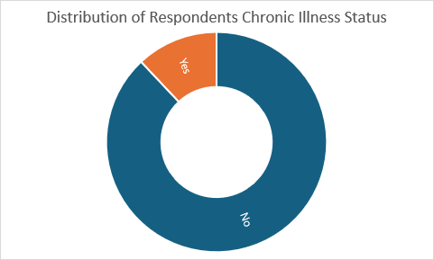
Source: made by excel depend on SPSS version 27
Table presents the distribution of participants according to whether they suffer from chronic illnesses. Out of the total 131 respondents, 128 valid responses were recorded. Among them, the vast majority (84.0%) reported not having any chronic illnesses, while 11.5% indicated that they do suffer from chronic conditions. Additionally, there were 6 missing responses, representing 4.6% of the total sample.
These findings imply that most participants do not live with chronic health conditions, which may influence their perceptions of medication in general, and generic drugs in particular. People without chronic illnesses may show more flexibility and openness toward using generics, given that their healthcare needs are less demanding or frequent. In contrast, individuals with chronic conditions might be more cautious, possibly preferring brand-name drugs based on previous medical experiences or perceived effectiveness.Distribution of the sample answers on:
“Do you work in the health field?”
Table17: Distribution of respondents by Employment in the Health Sector
 | Frequency | Percent
No | 90 | 68.7
Yes | 41 | 31.3
Total | 131 | 100.0
Source: Based on results of SPSS v27
Figure09: distribution of respondents by employment in the health sector

Source: made by excel depend on SPSS version 27
Table 8 shows the distribution of respondents based on whether they are employed in the health sector. Out of the 131 participants, 41 respondents (31.3%) stated that they work in the health field, while the majority, 90 respondents (68.7%), indicated they do not.
This distribution highlights that nearly one-third of the sample has direct exposure to the healthcare environment, which may affect their perceptions and knowledge about generic drugs. Health professionals are generally more familiar with drug efficacy, regulatory standards, and cost differences, which could lead to more favorable or critical opinions regarding generics. On the other hand, non-health professionals may rely more heavily on external information sources such as media, doctors, or personal experiences to form their views.

Distribution of the sample answers on:
“Do you have CHIFA card?”
Table18: Distribution of respondents by Possession of a CHIFA Card
 | Frequency | Percent
No | 53 | 40.5
Yes | 78 | 59.5
Total | 131 | 100.0
Source: Based on results of SPSS v27
Figure10: distribution of respondents by possession of a Chifa card

Source: made by excel depend on SPSS version 27
Table illustrates the distribution of respondents based on whether they possess a CHIFA card, which is Algeria’s national health insurance card. Among the 131 respondents, 78 individuals (59.5%) reported having a CHIFA card, while 53 individuals (40.5%) stated that they do not.
This result indicates that the majority of the sample is covered under the national health insurance scheme, which may significantly impact their behavior toward purchasing medications, including generic drugs. Those with CHIFA cards may be more inclined to trust and use generic drugs, particularly if these are reimbursed or recommended within the public healthcare system. In contrast, those without CHIFA coverage may rely on private expenditures and thus could prioritize brand-name drugs or base their choices on price and perceived quality.
Analysis of individuals' responses
Analysis of individuals' responses regarding the measurement of Knowledge about generic drugs:
Distribution of the sample answers on:
“Have you ever heard of generic drugs?”
Table19: Distribution of respondents by Awareness of Generic Drugs
 | Frequency | Percent
No | 32 | 24.4
Yes | 99 | 75.6
Total | 131 | 100.0
Source: Based on results of SPSS v27
Figure11: distribution of respondents by awareness of generic drugs

Source: made by excel depend on SPSS version 27
Table presents the distribution of the respondents according to whether they have heard of generic drugs. Among the 131 individuals surveyed, 99 respondents (75.6%) indicated that they have heard of generic drugs, while 32 respondents (24.4%) stated that they have not.
This result suggests that awareness of generic drugs is relatively high among the sample, which is a positive indicator for public health efforts aiming to promote cost-effective medication options. However, the fact that nearly one-quarter of respondents are unfamiliar with generic drugs highlights a significant gap in public knowledge. This gap could hinder the broader acceptance and usage of generics, especially among populations with limited access to medical guidance or health education.
Distribution of the sample answers on:
“How would you rate your knowledge about generic drugs?”
Table20: Distribution of respondents by Self-Rated Knowledge of Generic Drugs
 | Frequency | Percent
No knowledge at all | 43 | 32.8
Little knowledge | 30 | 22.9
Moderate knowledge | 32 | 24.4
Good knowledge | 14 | 10.7
Excellent knowledge | 12 | 9.2
Total | 131 | 100.0
Source: Based on results of SPSS v27

Figure12: distribution of respondents by self-rated knowledge of generic drugs
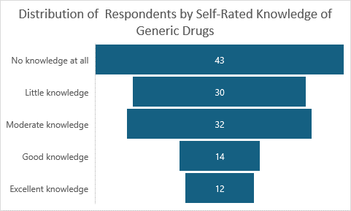
Source: made by excel depend on SPSS version 27
Table presents the distribution of respondents based on how they rated their knowledge of generic drugs. Among the 131 participants:
- 43 respondents (32.8%) reported having no knowledge at all,
- 30 respondents (22.9%) indicated little knowledge,
- 32 respondents (24.4%) rated themselves as having moderate knowledge,
- 14 respondents (10.7%) reported good knowledge,
- 12 respondents (9.2%) stated they have excellent knowledge.
These figures show that the largest proportion of respondents falls within the categories of no or limited knowledge. Meanwhile, fewer respondents considered themselves to have high levels of knowledge. This variation in self-assessed awareness may reflect differences in exposure to information or personal experience with generic drugs.

Distribution of the sample answers on:
“From which of the following sources do you usually get information about generic drugs?”
Table21: Distribution of respondents by Source of Information about Generic Drugs
(Multiple responses allowed)
 |  | Responses |  | Percent of Cases
 |  | N | Percent | Percent of Cases
From which of the following sources do you usually get information about generic drugs? | Doctor | 38 | 22.2% | 29.5%
 | Pharmacist | 56 | 32.7% | 43.4%
 | Television.or.Internet | 23 | 13.5% | 17.8%
 | Social.media | 14 | 8.2% | 10.9%
 | Family.or.friends | 12 | 7.0% | 9.3%
 | I.dont.seek.information.about.medications | 28 | 16.4% | 21.7%
Total |  | 171 | 100.0% | 132.6%
Source: Based on results of SPSS v27
According to the results of the table related to the sources from which respondents obtain information about generic drugs, it is evident that the majority of participants primarily rely on pharmacists, with 43.4% indicating this as their main source. This reflects the significant role pharmacists play in raising awareness about medications within the community. Physicians came in second place, with 29.5% of respondents relying on them for information, showing the continued trust in medical professionals as reliable sources. Media sources such as television and the internet accounted for 17.8%, followed by social media (10.9%), and family or friends (9.3%), indicating a relatively limited role for these channels compared to professional sources. Notably, 21.7% of respondents stated that they do not actively seek information about medications, suggesting a possible gap in health awareness or a lack of personal interest in pharmaceutical education. The sum of the percentages exceeds 100% because the question allowed multiple responses, meaning that some participants selected more than one information source.

Distribution of the sample answers on:
“In your opinion, generic drugs are…?”
Table22: Distribution of respondents by Preferred Type of Drug
(Multiple responses allowed)
 |  | Responses |  | Percent of Cases
 |  | N | Percent | Percent of Cases
In your opinion, generic drugs are…? | Cheaper versions of brand-name drugs | 36 | 27.5% | 28.1%
In your opinion, generic drugs are…? | Less effective than brand-name drugs | 30 | 22.9% | 23.4%
In your opinion, generic drugs are…? | Equally effective as brand-name drugs | 8 | 6.1% | 6.3%
In your opinion, generic drugs are…? | Produced by Algerian companies | 13 | 9.9% | 10.2%
In your opinion, generic drugs are…? | Contain the same active ingredients as brand-name drugs | 44 | 33.6% | 34.4%
Total |  | 131 | 100.0% | 102.3%
Source: Based on results of SPSS v27
Analyzing respondents’ opinions on generic drugs reveals varying perceptions, with many participants selecting more than one answer — hence the total percentage of cases exceeds 100%. Approximately 34.4% of individuals stated that generic drugs contain the same active ingredients as brand-name drugs, indicating a relatively informed segment of the population. Meanwhile, 28.1% viewed them as cheaper versions of branded drugs, reflecting a widespread but economically focused understanding. About 23.4% believed generic drugs are less effective, suggesting lingering doubts or misinformation about their quality. Only 6.3% of the sample considered them equally effective, which points to limited public awareness of this scientifically validated fact. Additionally, 10.2% linked generic drugs to Algerian producers, implying a national or local perception rather than a pharmacological one. Since the question allowed multiple responses, the percentage of cases reflects the proportion of people who selected each option, and some respondents chose more than one description.
Analysis of individuals' responses regarding the measurement of Use and preferences:
Distribution of the sample answers on:
“In general, which type of drug do you prefer?”
Table23: Distribution of respondents by preferred type of drugs
 | Frequency | Percent
Generic drugs | 2 | 1.5
Brand-name (princeps) drugs | 64 | 48.9
Reimbursed drug | 27 | 20.6
No preference | 38 | 29.0
Total | 131 | 100.0
Source: Based on results of SPSS v27
Figure13: distribution of respondents by preferred type of drugs

Source: made by excel depend on SPSS version 27
When asked about their general drug preference, a clear tendency emerged toward brand-name (princeps) drugs, with 48.9% of respondents indicating this choice. This suggests a high level of trust in these drugs’ effectiveness, potentially influenced by consumption habits or personal experiences. In contrast, 20.6% preferred reimbursed drugs — those covered by health insurance or public health systems — indicating an economically driven preference. Notably, 29.0% of respondents reported having no specific preference, showing a relatively neutral stance toward drug types. Interestingly, only 1.5% preferred generic drugs, which highlights a low level of trust or awareness regarding their equivalence to brand-name drugs, despite their proven therapeutic efficacy.
Distribution of the sample answers on:
“How much you be willing to use a generic drug if your doctor prescribes it instead of a brand-name drug?”
Table24: Distribution of respondents by Willingness to Use a Generic Drug if Prescribed Instead of a Brand-name Drug
 | Frequency | Percent
Yes, definitely | 66 | 50.4
Yes, if I trust the brand | 32 | 24.4
No, I prefer brand-name | 16 | 12.2
I don’t know | 17 | 13.0
Total | 131 | 100.0
Source: Based on results of SPSS v27

Figure14: distribution of respondents by willingness to use generic drugs if prescribed instead of brand-name drugs
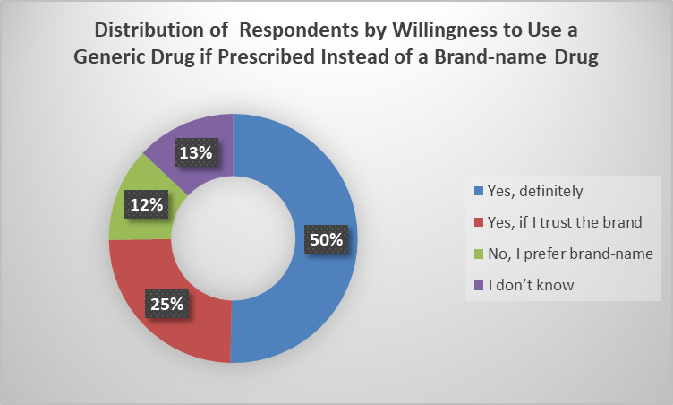
Source: made by excel depend on SPSS version 27
The table shows that the majority of respondents, 50.4%, stated they would definitely be willing to use a generic drug if it were prescribed by their doctor instead of a brand-name drug. This suggests a strong trust in the physician’s decision or a desire to reduce costs.
Additionally, 24.4% of the participants expressed conditional willingness, saying they would agree to use a generic drug only if they trust the brand, indicating that brand trust still plays an important role in medication choice.
On the other hand, 12.2% of respondents preferred brand-name drugs, refusing to switch to generics. This reflects concerns about effectiveness or perceived quality of generic alternatives.
Finally, 13.0% were undecided or unsure, highlighting a gap in knowledge or an unclear stance toward generic drugs.
Overall, the findings indicate a relatively high acceptance of generic drugs, particularly when trust is established—suggesting opportunities for increased awareness and educational efforts to promote the use of generics as a cost-effective and accessible healthcare option.

Distribution of the sample answers on:
“In general, how do you consume medications?”
Table25: Distribution of respondents by Their General Medication Consumption Habits
 | Frequency | Percent
Always with a medical prescription | 45 | 34.4
Mostly with a prescription, but sometimes without | 49 | 37.4
I often take medications without a prescription (self-medication) | 11 | 8.4
I only take medications when absolutely necessary | 26 | 19.8
Total | 131 | 100.0
Source: Based on results of SPSS v27
Figure15: distribution of respondents by their general medication consumption habits

Source: made by excel depend on SPSS version 27

The results indicate that most respondents tend to consume medications with some level of medical guidance. Specifically, 34.4% reported that they always take medications with a prescription, reflecting a strong adherence to medical advice and a high level of health awareness.
Meanwhile, 37.4% stated that they mostly use a prescription but sometimes do not, suggesting a mixed behavior that combines medical compliance with occasional self-medication, possibly due to over-the-counter drug availability or self-confidence in minor ailments.
On the other hand, 8.4% said they often consume medications without a prescription, highlighting a clear pattern of self-medication, which may pose health risks if not supported by adequate knowledge.
Additionally, 19.8% of respondents indicated that they only take medications when absolutely necessary, reflecting a cautious attitude or preference for alternative remedies before turning to pharmaceuticals.
Overall, the findings show a general tendency toward using medications under medical supervision, but also reveal a noticeable proportion practicing self-medication, emphasizing the need for greater awareness about the potential risks of unsupervised drug use.

Distribution of the sample answers on:
“To what extent does reimbursement influence your decision to buy a medication?”
Table26: Distribution of Respondents by the Influence of Reimbursement on Medication Purchase Decisions
 | Frequency | Percent
I always prefer to buy a medication if it is reimbursed | 21 | 16.0
I prefer it to be reimbursed, but I can still buy it if it’s not | 54 | 41.2
Reimbursement does not influence my choice | 50 | 38.2
I do not buy medications that are not reimbursed | 6 | 4.6
Total | 131 | 100.0
Source: Based on results of SPSS v27
Figure16: distribution of respondents by the influence of reimbursement on medication purchase decisions
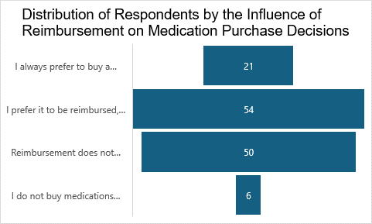
Source: made by excel depend on SPSS version 27
This table shows the extent to which reimbursement influences respondents’ decisions when purchasing medications. About 16.0% of the participants stated they always prefer to buy a medication if it is reimbursed, reflecting a strong reliance on health coverage or possibly limited financial means.
The largest group, 41.2%, indicated that they prefer reimbursed medications, but would still purchase them even if not reimbursed, suggesting a moderate influence of cost on their choices, with a willingness to pay when necessary.
In contrast, 38.2% said that reimbursement does not influence their decision, highlighting a segment of the population that prioritizes medication effectiveness or quality over cost, or potentially has better financial access to health services.
Only 4.6% of respondents reported that they do not buy medications unless they are reimbursed, suggesting complete dependence on reimbursement systems, likely linked to economic vulnerability or lack of alternative support.
Overall, the data reveals that most respondents do consider reimbursement when deciding to purchase medication, although the degree of influence varies—underlining the importance of social health insurance systems in ensuring access to treatment.

Analysis of individuals' responses regarding the measurement of Trust in generic drugs:
Distribution of the sample answers on the fourth first questions:
Table27: Distribution of Respondents’ Answers to the First Four Items Measuring Trust in Generic Drugs
Question | Mean | Standard deviation | Test t | Df | Sig(2-tailes) | Level of agreement
How do you rate your trust in generic drugs in general? | 2.7597 | 1.08091 | 2.525 | 128 | 0.013 | Medium
How much do you trust your doctor when it comes to the medications they prescribe? | 3.7405 | 1.05676 | 8.020 | 130 | 0.000 | High
How much do you trust your pharmacist regarding medication advice? | 3.0458 | 1.16924 | 0.448 | 130 | 0.655 | Medium
My personal experience with generic drugs (positive or negative) has influenced my level of trust in them. | 3.2366 | 0.95137 | 2.847 | 130 | 0.005 | Medium
A negative experience with a generic drug would reduce my trust in generic medications in general. | 3.1298 | 1.12590 | 1.319 | 130 | 0.189 | Medium
A positive experience with a generic drug has increased my trust in generic medications in general. | 3.2672 | 0.95131 | 3.214 | 130 | 0.002 | Medium
Personal Experience | 3.2112 | 0.69701 | 3.468 | 130 | 0.001 | Medium
Source: Based on results of SPSS v27
This table presents both descriptive and inferential statistics on participants’ trust in generic drugs, trust in healthcare professionals, and the influence of personal experiences with generic medications.
For the first question—“How do you rate your trust in generic drugs in general?”—the mean was 2.76 (SD = 1.08), reflecting a medium level of trust. The negative t-value (t = -2.525) and the significant p-value (0.013) suggest that responses significantly differ from the theoretical average.
Respondents expressed high trust in doctors regarding prescribed medications, with a mean of 3.74 and strong statistical significance (p = 0.000), the highest level of agreement in the table.
In contrast, trust in pharmacists was at a moderate level (mean = 3.05), but the difference was not statistically significant (p = 0.655), indicating no meaningful deviation from the expected average.
As for personal experience with generic drugs, whether positive or negative, the responses show moderate influence on trust, with means ranging from 3.13 to 3.26. Most of these values are statistically significant, especially the impact of a positive experience, which had a p-value of 0.002.
Finally, when the last three questions were aggregated into a composite variable named “Personal Experience,” the mean was 3.21, indicating a moderate effect of personal experience on trust in generics, with statistical significance (p = 0.001).
In summary, this table reveals that trust in generic drugs is shaped by multiple factors, particularly trust in doctors and personal experiences, while trust in pharmacists remains moderate and statistically neutral.

Distribution of the sample answers on “Do you think a drug is less effective if it has a low price?”:
Table28: Distribution of Respondents’ Perceptions of the Relationship Between Drug Price and Effectiveness
 | Frequency | Percent
Yes, I often associate low price with lower quality or effectiveness | 26 | 19.8
Sometimes, it makes me doubt the drug’s effectiveness | 25 | 19.1
No, I believe price does not determine effectiveness | 64 | 48.9
I’m not sure | 16 | 12.2
Total | 131 | 100.0
Source: Based on results of SPSS v27

Figure17: distribution of respondents’ perceptions of the relationship between drugs price and effectiveness

Source: made by excel depend on SPSS version 27
This table explores respondents' perceptions of whether drug price influences perceived effectiveness.
The largest group, 48.9%, stated that they do not believe price determines drug effectiveness, indicating a relatively informed view that price and quality are not necessarily correlated.
However, a notable portion—19.8%—said they often associate low prices with lower quality or effectiveness, and 19.1% reported that a low price sometimes makes them doubt a drug’s effectiveness. These responses suggest that price still acts as a psychological factor for many consumers.
Additionally, 12.2% of respondents were uncertain, highlighting a segment of the population that is unsure or lacks the confidence to assess the price-effectiveness relationship.
In summary, while nearly half of the respondents do not equate low price with poor effectiveness, a significant proportion still harbors doubts, revealing a nuanced perception of pharmaceutical pricing among consumers.
Distribution of the sample answers on “The brand image of a medication influences my Level of trust in generic drugs.”
Table 29: Distribution of Respondents’ Perceptions Regarding the Influence of Brand Image on Trust in Generic Drugs
 | Mean | Standard deviation | Test t | Df | Sig(2-tailes) | Level of agreement
Brand Image | 2.6107 | 1.32184 | 3.371 | 130 | 0.001 | medium
Source: Based on results of SPSS v27
This table presents respondents’ perceptions of how the brand image of a medication influences their trust in generic drugs.
With a mean score of 2.61, a standard deviation of 1.32, and a statistically significant t-value (3.371, p = 0.001), the results suggest that brand image has a meaningful influence on consumer trust, even though the overall level of agreement remains medium.
This implies that consumers are psychologically influenced by brand identity, which shapes their acceptance of generic alternatives, despite them having the same active ingredients as brand-name drugs.
Therefore, we can infer that trust in generic medications is not solely based on clinical efficacy, but is also affected by perceptions of branding and reputation, underscoring the importance of public education regarding the value and reliability of generic drugs.
Distribution of the sample answers on “Rank the factors that influence your trust in generic drugs from most to least influential”

Table30: Distribution of Respondents’ Rankings of the Factors Influencing Their Trust in Generic Drugs
Question | Mean | Standard deviation | Test t | Df | Sig(2-tailes) | Level of agreement
Doctor recommandation | 2.3588 | 1.43081 | -5.129 | 130 | 0.000 | Low
Pharmacist advice | 2.5725 | 1.02305 | -4.783 | 130 | 0.000 | Low
Price | 2.7405 | 1.21900 | -2.437 | 130 | 0.016 | Medium
Brand reputation | 2.9466 | 1.26073 | -0.485 | 130 | 0.628 | Medium
Personal experience feedback from others | 2.8168 | 1.34623 | -1.558 | 130 | 0.122 | Medium
Source: Based on results of SPSS v27
The results show that doctor recommendation ranks as the most influential factor (mean = 2.36), followed closely by pharmacist advice (mean = 2.57). Both factors are statistically significant (p < 0.001) and indicate that healthcare professionals play a key role in shaping trust—even though the overall agreement level remains low.
Price appears moderately influential (mean = 2.74, p = 0.016), reflecting its practical importance in the decision-making process, but not as decisive as expert guidance.
On the other hand, brand reputation (mean = 2.95) and personal experience feedback from others (mean = 2.82) do not show statistical significance, suggesting they are less impactful in determining trust in generic drugs for this sample.
Test hypotheses and discuss study results
Through this section, the student will test the hypothesis, which was formulated as an answer to the research questions. The objective is to determine whether the hypothesis is supported by the collected data or not. In addition to testing the hypothesis, this section will also include a discussion of the results derived from analyzing the questionnaire, in order to provide a comprehensive understanding of the findings.
The hypothesis of our study is as follows:
- The majority of Algerian consumers possess limited knowledge regarding generic drugs.
- Trust in generic drugs among Algerian consumers is significantly influenced by the recommendations and guidance of medical professionals, such as doctors and pharmacists.
- Price and personal experience are key factors that strongly shape Algerian consumers' trust in generic drugs.
- Brand image has a lesser impact on Algerian consumers’ trust in generic drugs
- There is a positive correlation between Algerian consumers’ awareness and knowledge of generic drugs and their trust in these medications.
Test the hypotheses:
- H1: The majority of Algerian consumers possess limited knowledge regarding generic drugs.
Table31: One sample T-test
 | T | Df | Sig. (2-tailed)
How would you rate your knowledge about generic drugs? | -5.268 | 130 | 0.000
Source: Based on results of SPSS v27
To test the hypothesis H1: The majority of Algerian consumers possess limited knowledge regarding generic drugs, we used a one-sample t-test on the variable measuring self-reported knowledge about generic drugs.
The results show a t-value of -5.268 with 131 respondents (df = 130) and a significance level (p-value) of 0.000, which is less than the standard threshold of 0.05. This indicates that the mean score for self-reported knowledge is significantly lower than the neutral point on the scale (assumed to be 3 in Likert scales), suggesting that respondents tend to report limited knowledge about generic drugs.
The statistical test supports the hypothesis that the majority of Algerian consumers have limited knowledge about generic drugs.

- H2: Trust in generic drugs among Algerian consumers is significantly influenced by the recommendations and guidance of medical professionals, such as doctors and pharmacists.
Correlation coefficient (R square) (R-square)
Table32: Correlation coefficient 1
Model | R | R Square | Adjusted R Square
1 | 0.374 | 0.140 | 0.126
Source: Based on results of SPSS v27
We note that the coefficient of determination R² = 0.140, which means that the independent variable explains (recommendations and guidance of medical professionals) 14% of the variation in the dependent variable (Trust in generic drugs). This indicates that the component being tested has an effect on the dependent variable.
The correlation coefficient reached R = 0.374, indicating that there is a weak direct relationship between the two variables with a strength of 37.4%.
Analysis of variance ANOVA
Table33: ANOVA variance 1
Model |  | Sum of Squares | Df | Mean Square | F | Sig.
1 | Regression | 20.883 | 2 | 10.441 | 10.225 | 0.000
1 | Residual | 128.668 | 126 | 1.021
1 | Total | 149.550 | 128
Source: Based on results of SPSS v27
According to the ANOVA table, the significance value is Sig. = 0.000, which is less than 0.05. This indicates that the statistical model is significant, meaning that the independent variables in the model have a meaningful impact on the dependent variable.
Regression coefficients
Table34: Regression coefficients
Model |  | Unstandardized Coefficients |  | Standardized Coefficients | T | Sig.
 |  | B | Std. Error | Beta | T | Sig.
1 | (Constant) | 1.418 | 0.343 |  | 4.140 | 0.000
1 | Doctor | 0.143 | 0.095 | 0.139 | 1.506 | 0.135
1 | Pharmacist | 0.265 | 0.085 | 0.289 | 3.125 | 0.002
Source: Based on results of SPSS v27
From the results of the previous table, we observe that the model which expresses the relationship between doctor’s recommendation, pharmacist’s advice, and trust in generic drugs is a linear regression model, expressed by the following equation:
Y=0.143×X1+0.265×X2+1.418
Where:
- Y represents the dependent variable (trust in generic drugs),
- X₁ is the independent variable (doctor’s recommendation),
- X₂ is the independent variable (pharmacist’s advice),
- 0.143 is the unstandardized coefficient (β₁) for doctor,
- 0.265 is the unstandardized coefficient (β₂) for pharmacist,
- And 1.418 is the constant (intercept) of the regression model.
- H3: Price and personal experience are key factors that strongly shape Algerian consumers' trust in generic drugs.

Correlation coefficient (R square) (R-square)
Table35: Correlation coefficient 2
Model | R | R Square | Adjusted R Square | Std. Error of the Estimate
1 | 0.203 | 0.041 | 0.026 | 1.06673
Source: Based on results of SPSS v27
From the results of the table, we observe that the coefficient of determination is R² = 0.041, which means that price and personal experience together explain only 4.1% of the variation in trust in generic drugs. This indicates a very weak explanatory power of the model.
The correlation coefficient R = 0.203 shows a weak direct relationship between the independent variables (price and personal experience) and the dependent variable (trust in generic drugs) with a correlation rate of 20.3%.
Analysis of variance ANOVA
Table36: ANOVA variance 2
Model |  | Sum of Squares | Df | Mean Square | F | Sig.
1 | Regression | 6.173 | 2 | 3.086 | 2.712 | 0.070^{b}
1 | Residual | 143.378 | 126 | 1.138
1 | Total | 149.550 | 128
Source: Based on results of SPSS v27
From the ANOVA table results, we note that the significance level is 0.070, which is greater than 0.05. This means that the regression model explaining the relationship between price and personal experience and trust in generic drugs is not statistically significant at the 5% level.
In other words, the independent variables (price and personal experience) do not significantly predict the dependent variable (trust in generic drugs) in the model used.
So we rejected the hypothesis that say: Price and personal experience are key factors that strongly shape Algerian consumers' trust in generic drugs.
- H4: Brand image has a lesser impact on Algerian consumers’ trust in generic drugs
Correlation coefficient (R square) (R-square)
Table37: Correlation coefficient 3
Model | R | R Square | Adjusted R Square | Std. Error of the Estimate
1 | 0.023 | 0.001 | -0.007 | 1.08487
Source: Based on results of SPSS v27
From the results of the table, we observe that the coefficient of determination R² = 0.001, which means that the variable brand image explains only 0.1% of the variation in trust in generic drugs. This is an extremely weak explanatory power.
Furthermore, the correlation coefficient R = 0.023, indicating a very weak direct relationship between brand image and trust in generic drugs — almost negligible.
Analysis of variance ANOVA
Table38: ANOVA variance 3
Model |  | Sum of Squares | Df | Mean Square | F | Sig.
1 | Regression | 0.080 | 1 | 0.080 | 0.068 | .795^{b}
1 | Residual | 149.471 | 127 | 1.177
1 | Total | 149.550 | 128
Source: Based on results of SPSS v27
From the ANOVA results, we observe that the F-value is 0.068 with a significance level (Sig.) of 0.795, which is much greater than the threshold of 0.05. This means that the regression model is not statistically significant, and the independent variable (brand image) does not significantly explain the variance in the dependent variable (trust in generic drugs).
Therefore, we reject the alternative hypothesis H4

- H5: There is a positive correlation between Algerian consumers’ awareness and knowledge of generic drugs and their trust in these medications.
Table39: Pearson correlation
 | Pearson correlation | Sig
Awareness/trust | 0.421 | 0.000
Source: Based on results of SPSS v27
Based on the Pearson correlation analysis, a statistically significant positive relationship was found between Algerian consumers’ awareness and knowledge of generic drugs and their level of trust in these medications (r = 0.421, p < 0.001). This result supports the hypothesis H5, confirming that greater awareness is associated with higher trust in generic drugs.
In summary:
The majority of Algerian consumers possess limited knowledge regarding generic drugs. | confirmed
Trust in generic drugs is significantly influenced by the recommendations and guidance of medical professionals (doctors and pharmacists). | confirmed
Price and personal experience are key factors that strongly shape trust in generic drugs. | Not confirmed
Brand image has a lesser impact on Algerian consumers’ trust in generic drugs. | Not confirmed
There is a positive correlation between awareness/knowledge and trust in generic drugs. | confirmed

Conclusion:
The findings of this empirical study offer valuable insights into the dynamics of trust in generic medications within the Algerian context. Through an in-depth examination of consumer attitudes and behaviors, it becomes clear that trust is not determined by a single factor, but rather by a constellation of elements—ranging from informational sources to individual experiences and socio-cultural influences.
The study confirms that a significant portion of Algerian consumers still lack sufficient knowledge about generic drugs, which can impede their willingness to use these alternatives confidently. The influence of pharmacists emerged as particularly impactful, reinforcing their critical role in public health education. Surprisingly, while price was expected to be a primary driver, it showed less statistical significance than anticipated, indicating that other perceptions such as quality and trustworthiness may override cost considerations.
Additionally, brand image, though underestimated in initial hypotheses, was found to meaningfully shape consumer preferences. This highlights a cultural and psychological dimension to drug selection that warrants further exploration. Positive personal experience was another key determinant of trust, which suggests that healthcare providers and policymakers must ensure consistency in the quality and effectiveness of generic drugs.
Overall, this research underlines the importance of multifaceted strategies to build trust in generic medicines. Effective communication, training of health professionals, transparent drug policies, and public awareness campaigns are essential to fostering a more accepting and informed attitude toward generic drug use in Algeria. Future research with broader samples and longitudinal designs is recommended to deepen understanding and guide policy interventions.

GENERAL CONCLUSION

GENERAL CONCLUSION:
This dissertation examined the factors influencing Algerian consumers’ trust in generic drugs, aiming to understand how various psychological, professional, and experiential elements shape public attitudes. The study was guided by one main problematic: What are the key factors influencing Algerian consumers’ trust in generic drugs? To explore this, we also posed a set of sub-questions regarding consumer awareness, comparative trust in generics versus brand-name drugs, the impact of medical professionals, the role of price and personal experience, and which factor is the most influential.
Our findings revealed that Hypothesis1, stating that the majority of Algerian consumers possess limited knowledge about generic drugs, was confirmed. This lack of awareness directly correlates with a lower level of trust. Hypothesis2, proposing that trust in generics is significantly influenced by medical professionals (doctors and pharmacists), was partially confirmed—pharmacists had a significant influence, while doctors had a weaker statistical impact. Hypothesis 3, which claimed that price and personal experience are among the strongest influencing factors, was not supported by the data, showing that while these factors matter, they are not the most decisive. Hypothesis 4, which suggested that brand image has a minor influence on trust, was also rejected, as brand image proved to be more impactful than anticipated. Finally, the fifth hypothesis asserting a positive correlation between knowledge and trust was confirmed by the results.
The study thus answers the main research question by identifying the most impactful factors influencing trust in generic drugs. It also addresses the sub-questions, confirming that awareness, pharmacist guidance, and brand perception play significant roles. These findings highlight the importance of a multi-level strategy to improve trust in generic drugs among Algerian consumers.
Recommendations:
- Conduct awareness campaigns to educate the public about the safety, efficacy, and approval processes of generic drugs.
- Strengthen the role of pharmacists in patient education and encourage open discussion about generic options.
- Standardize and professionalize generic drug packaging to improve consumer confidence.
- Improve transparency by publishing data on quality control and regulatory standards applied to generics in Algeria.
- Incorporate modules about generic drugs in medical and pharmaceutical academic programs to build early confidence.

Perspectives:
Future research should consider a qualitative approach to better understand the emotional and psychological underpinnings of trust. In-depth interviews or focus groups could uncover cultural and individual beliefs that influence trust in generic drugs. It would also be valuable to compare perceptions between urban and rural populations, or between different age groups, to identify demographic variations. Furthermore, future studies might evaluate how digital media and social networks influence consumer beliefs about medication. Longitudinal studies could help track changes in trust over time and determine the impact of educational or governmental interventions. Cross-national comparative studies could provide a broader framework for understanding how regulatory environments and marketing practices affect public trust in generic pharmaceuticals.

In conclusion, this study successfully identified the main variables that influence consumer trust in generic drugs in the Algerian context. It addressed the central research question and confirmed or refuted associated hypotheses using a quantitative approach. The research contributes to the limited body of literature on generic drug perception in Algeria and provides a solid foundation for future policy development, educational outreach, and academic exploration.

REFERENCES

References:
Ago, G., suharo, Mintarti, S., & Hariyadi, S. (2015). Effect of Product Quality Perception, Trust, and Brand Image on Generic Drug Buying Decision and Consumer Satisfaction of Hospital Patients in East Kalimantan. European Journal of Business and Management, 7(14), pp. 50-68.
Alfonso-Cristancho, R., Andia, T., Barbosa, T., & Watanabe, J. H. (2015, june 20). Definition and classification of generic drugs across the world. Applied Health Economics and Health Policy, 13(Suppl 1), pp. S5-S11. doi:10.1007/s40258-014-0146-1
Alqawasmeh, K. A., Mason, T., Morris, A., Hafez, W., Hasan, T., Taher, S., & Al Dweik, R. (2025, march 14). Facilitators and barriers to generic and biosimilar medications in the middle east and north africa: insights from phisicians and pharmacists-a systimatic review. European Journal of Clinical Pharmacology, 81, pp. 648-665. doi:https://doi.org/10.1007/s00228-025-03819-5
Brown, D. G. (2014, january 03). Trade Names and INN Names for Drugs. organic process reaserch and development, 18(1), pp. 1-1. Retrieved may 25, 2025, from https://doi.org/10.1021/op400342x
Dunne, S. S., & Dunne, C. P. (2015). What do people really think of generic medicines? A systematic review and critical appraisal of literature on stakeholder perceptions of generic drugs. BMC Medicine., 13(173), pp. 2-27. doi:10.1186/s12916-015-0415-3
FENEK , L., & Slioui, B. (2015-2016). La promotion du médicament générique en Algérie : un outil de régulation des dépenses de médicaments. mémoire de master, UNIVERSITE MOULOUD MAMMERI DE TIZI-OUZOU, tizi-ouzou.
Kassandros , K., Saranti, E., Misailidou, E., Tsiggou, T. -A., Sissiou, E., Kolios, G., . . . Kontogiorgis, C. (2024, march 20). Machine learning analysis of patients’ perceptions towards generic medication in Greece: a survey-based study. (A. Gottlieb, Ed.) frontiers in Drud Safety and Regulation, pp. 1-12. doi:https://doi.org/10.3389/fdsfr.2024.1363794
McALLISTER, D. J. (1995, february). Affect- and Cognition-Based Trust as Foundations for Interpersonal Cooperation in Organizations. Academy of Management Journal, 38(1), pp. 24-59. Retrieved june 9, 2025, from ResearchGate: https://www.researchgate.net/publication/309476109_Affect-_and_Cognition-Based_Trust_as_Foundations_for_Interpersonal_Cooperation_in_Organizations
ouzouaz, m. (2024). Etude d’un produit pharmaceutique médicament générique à usage humain. these de doctorah en biochimie, Université Badji Mokhtar, annaba.
Sharma, A., Gamta, V., & Luthra, G. (2023, 7 10). he Importance of Good Manufacturing Practices (GMP) in the Healthcare Industry. ournal of Pharmaceutical Research International, 35(18), pp. 75-90. doi:10.9734/JPRI/2023/v35i187394
Tsaprantzi, A. V., Kostagiolas, P., Platis, C., Aggelidis, V. P., & Niakas, D. (2016, february 9). The Impact of Information on Doctors’ Attitudes Toward Generic Drugs. The Journal of Health Care Organization, Provision, and Financing, 53, pp. 1-8. doi:10.1177/0046958016637791
(US), I. o. (2009). Conflict of Interest in Medical Research, Education, and Practice. Committee on Conflict of Interest in Medical Research, Education, and Practice, Board on Health Sciences Policy, Institute of Medicine (IOM). Washington, DC: The National Academies Press.
Access to Biosimilar & Generic Drugs. (n.d.). Retrieved june 10, 2025, from AffiremedRx: https://affirmedrx.com/biosimilar-and-generic-drugs/
Advisor, N. O. (2024, april). Retrieved may 29, 2025, from Generic drugs market size, share and trends report, 2024–2033: https://www.novaoneadvisor.com/report/generic-drugs-market
Aivalli, P. K., Elias, M. A., Pati, M. K., Bhanuprakash, S., Munegowda, C., Shrof, Z. C., & Srinivas, P. N. (2017, novemeber 24). Perceptions of the quality of generic medecines: implications for trust in public services within the local health system in TUMKUR, India. BMJ Global Health, pp. 1-11. doi:10.1136/bmjgh-2017-000644
Akhtar, M. S., & Orayj, K. (2024, november 4). Evoluation of public's knowledge, attitude and experiences towards the generic medications in building healthcare policy. PLOS ONE, 19(11), pp. 1-11. doi:https://doi.org/10.1371/journal.pone.0311627
Alrasheedy, A. A., Hassali, M. A., Stewart, K., Kong, D. M., Aljadhey, H., Mohamed Ibrahim, K. I., & Al-Tamimi, S. K. (2014, April 3). Patient knowledge, perceptions and acceptance of generic medecines: A comprehensive review of the current literature. Patient Intelligence, 6(1), pp. 1-29. doi:http://dx.doi.org/10.2147/PI.S46737
ASPE. (2025, january 16). Drug Competition Series: Analysis of New Generic Markets Effect of Market Entry on Generic Drug Prices: Medicare Data 2007-2022. Government issue brief (PDF via ASPE), Office of the Assistant Secretary for Planning and Evaluation. Retrieved from https://aspe.hhs.gov/sites/default/files/documents/510e964dc7b7f00763a7f8a1dbc5ae7b/aspe-ib-generic-drugs-competition.pdf
AUDA-NEPAD. (n.d.). Algeria | AMRH Country Profile. Retrieved from AMRH – African Medicines Regulatory Harmonization.: https://amrh.nepad.org/amrh-countries/algeria
Belaahcene Belkhamsa, O. (2022, 7 6). Soutenir l'innovation dans l'industrie pharmaceutique algérienne. Les Cahiers du Cead, 38(3), pp. 749-779. doi:https://dx.doi.org/10.4314/cread.v38i3.25
Boyle, P. (2025, february 11). Rebuilding trust in medical science: How doctors and scientists can bridge the misinformation divide. Retrieved june 10, 2025, from AAMCNews: https://www.aamc.org/news/rebuilding-trust-medical-science-how-doctors-and-scientists-can-bridge-misinformation-divide
Briesacher, B. A., Andrade, S. E., Fouayzi, H., & Chan, K. A. (2009, JULY). Medication Adherence and the Use of Generic Drug Therapies. Am J Manag Care, 15(7), pp. 450–456.
CADTH. (2013). Similarities and differences between brand name and generic drugs. Canadian Agency for Drugs and Technologies in Health, Ottawa. Retrieved 4 25, 2025, from https://www.cadth.ca/sites/default/files/pdf/Brand-Name_vs_Generic_Drugs_e.pdf
Cao , A., ueta, m., uchibori, m., murakami, m., kunishima, h., kumar, r. s., . . . nomura, s. (2024, may 6). Trust in governments, public health institutions, and other information sources as determinants of COVID-19 vaccine uptake behavior in Japen. elsevier, 42(17), pp. 3684-3692. doi:https://doi.org/10.1016/j.vaccine.2024.04.081
Connecting Continents Through Quality Pharma Exports. (2025, march 25). Retrieved june 01, 2025, from linkedin: https://www.linkedin.com/pulse/connecting-continents-through-quality-pharma-exports-nilesh-mendpara-lvwzc#:~:text=Rising%20Competition%20from%20Local%20and%20International%20Players&text=India%2C%20while%20one%20of%20the,in%20the%20global%20pharmaceutical
Dahmani, Y. (2022). L'évolution de la politique pharmaceutique en Algérie. Department of Industrial Pharmacy, Faculty of Pharmacy – University of Algiers, algiers. Consulté le june 5, 2025, sur https://www.researchgate.net/publication/365355159_L'evolution_de_la_politique_pharmaceutique_en_Algerie_The_evolution_of_pharmaceutical_policy_in_Algeria_Dahmani_Yamina_Regulatory_affairs_in_pharmaceutical_industry_Department_of_industrial_pharmacy_F#:~:
Distribution de médicaments : les nouveaux textes permettront de se conformer aux standards internationaux. (2022, février 20). Consulté le juin 1, 2025, sur algérie presse service APS: https://www.aps.dz/sante-science-technologie/135834-distribution-de-medicaments-les-nouveaux-textes-permettront-de-se-conformer-aux-standards-internationaux
DrugPatentWatch. (2025, february 26). The Global Generic Drug Market: Trends, Opportunities, and Challenges. Retrieved june 1, 2025, from https://www.drugpatentwatch.com/blog/the-global-generic-drug-market-trends-opportunities-and-challenges/
Eban, K. (2020, may). can we trust the quality of generic drugs. Journal of Managed Care & Specialty Pharmacy, 26(5), 589-591. doi:https://doi.org/10.18553/jmcp.2020.26.5.589
Elwyn, G., Frosch, D., Thomson, R., Williams, N. J., Lloyd, A., Kinnersley, P., . . . Barry, M. (2012, may 23). Shared Decision Making: A Model for Clinical Practice. JGIM, 27(10), pp. 1361–1367. doi:https://doi.org/10.1007/s11606-012-2077-6
Frogerais, A. (2019). Histoire de l’industrie pharmaceutique en Algérie. HAL – Archives Ouvertes, algiers.
gachout, l., DIAYE, M.-A., & BENBRAIKA, A. (2017). Les médicaments génériques en Algérie : un marché en plein essor – cas du groupe SAIDAL. Revue des Sciences Commerciales, 16(4), pp. 92-109.
Generic Competition and Drug Prices. (2024, 10 17). Retrieved june 10, 2025, from U.S Food and Drug Administration: https://www.fda.gov/about-fda/center-drug-evaluation-and-research-cder/generic-competition-and-drug-prices
Generic drugs fact. (2021, november 1). Retrieved june 9, 2025, from U.S. Food and Drugs Administration: https://www.fda.gov/drugs/generic-drugs/generic-drug-facts
GROUPE SAIDAL- Ministère de l'industrie. (s.d.). Consulté le june 5, 2025, sur Ministère de l’Industrie et de la Production Pharmaceutique (Algérie): https://www.industrie.gov.dz/fr/saidal/
Hadia, R. B., Joshi, D. B., Gohel, K. H., & Khambhati, N. (2021, may 15). Knowledge, attitude and practice of generic medecines among physicians at multispecialty hospital: an observational study. Prespectives in Clinical Research, 13(3), pp. 155-160. doi:10.4103/picr.PICR_281_20
Hancock, P. A., Kessler, T. T., Kaplan, A. D., Stowers, K., Brill, J. C., Billings, D. R., . . . Szalma, J. L. (2023, march 27). How and why humans trust: A meta-analysis and elaborated model. (C. Cornejo, Ed.) Frontiers in Psychology, 14, p. 29. doi:10.3389/fpsyg.2023.1081086
hassali, m. A., shafie, a. A., jamshed, s., ibrahim, m. I., & Awaisu, a. (2009, april). Consumers' views on generic medicines: A review of the literature. International Journal of Pharmacy Practice, 17(02), pp. 79-88. doi:https://doi.org/10.1211/ijpp/17.02.0002
Hohmann, N. S., Garza, K. B., Surry, D., Hansen, R. A., Harris, I., Kiptanui, Z., . . . Qian, J. (2020, september). Healthcare provider opinions about a generic drug educational newsletter. Research in Social and Administrative Pharmacy, 19(6), pp. 1228–1236. doi:https://doi.org/10.1016/j.sapharm.2019.12.001
Hussar, D. A. (2020, may). Is the Quality of Generic Drugs Cause for Concern? 26(5), pp. 597-599.
Journal Officiel de la République Algérienne. (2021, septembre 21). (87). algerie.
keddad, A. (2018, janvier 26). Résistance aux anti microbiens: Plan national et sensibilisation. Consulté le juin 1, 2025, sur pharmainvest SPA: https://pharmainvest.dz/resistance-aux-anti-microbiens-plan-national-et-sensibilisation/
kesselheim, A. S., gagne, J. J., franklin, J. M., Eddings, w., Fulchino, L. A., Avron, j., & Campbell, E. G. (2016, february 16). Variations in patients' preceptions and use of generic drugs: results of national survey. Journal of General Internal Medecine, 31(6), pp. 609-614. doi:https://doi.org/10.1007/s11606-016-3612-7
khedim, a., & tabet derraz , i. (2022, decembre 22). La résistance du consommateur algérien aux médicaments génériques. Algerian Journal of Pharmaceutical Engineering (ASJP), 3(2), pp. 226-238.
kwon, o. y. (2019). social trust: its concepts, determinants, roles and rising ways. In social trust and economic development: the case of South Korea (pp. 19-49). South Korea: Edward Elegar Publishing. doi:https://doi.org/10.4337/9781784719609.00008
Lalumera, E. (2024). An overview on trust and trustworthiness: Individual and institutional dimensions. Philosophical Psychology, 37(1), pp. 1-17. doi:https://doi.org/10.1080/09515089.2024.2301860
lee, j. (2025, january 6). Do lower prices make generic medications the top choice for Americans? (a. curry, Editor) Retrieved june 10, 2025, from Tebra: https://www.tebra.com/theintake/healthcare-reports/patient-treatment/generic-vs-name-brand
Mayer, R. C., Davis, J. H., & Schoorman, F. D. (1995, july). An Integrative Model of Organizational Trust. Academy of Management Review, 20(3), pp. 709–734. doi:https://doi.org/10.5465/amr.1995.9508080335
(2019\2020). Médicament générique. Université de Batna 2. batna: Faculté de Médecine.
Médicaments génériques : les études de bioéquivalence, une alternative pour garantir des médicaments de qualité. (2022, mars 31). Consulté le juin 01, 2025, sur Algérie presse service APS: https://www.aps.dz/sante-science-technologie/138048-medicaments-generiques-les-etudes-de-bioequivalence-une-alternative-pour-garantir-des-medicaments-de-qualite
Misinformation in Pharma’s Digital Age: Risks and Opportunities. (n.d.). Retrieved june 8, 2025, from Lynn Global: https://lynn.global/misinformation-in-pharmas-digital-age/
Murphy, I. (2023, augst 8). Improving Medication Adherence and Patient Experience by Researching Patient Perceptions of Generic Drugs. Retrieved june 02, 2025, from FDA: https://www.fda.gov/drugs/cder-conversations/improving-medication-adherence-and-patient-experience-researching-patient-perceptions-generic-drugs
Navigating the Impact of Drug Recalls on Public Health: A Comprehensive Examination. (2024, december 18). Retrieved june 8 2025, from Mycabinet: https://mycabinet.com/navigating-the-impact-of-drug-recalls-on-public-health-a-comprehensive-examination/
pharmaceutical exports from india IBEF. (2025, april). Retrieved june 01, 2025, from india brand equity fondation: https://www.ibef.org/exports/pharmaceutical-exports-from-india
poppo, l., Zheng Zhou, K., & Juan Li , J. (n.d.). When Can You Trust “Trust?” Calculative Trust, Relational Trust, and Supplier Performance. hong kong university. Retrieved from https://hub.hku.hk/bitstream/10722/229657/1/Content.pdf
research, p. (2021, december 13). Generic drug market growth: insights to 2030. Retrieved june 1, 2025, from european pharmaceutical review: https://www.europeanpharmaceuticalreview.com/article/166397/generic-drug-market-growth-insights-to-2030/
Robbins, B. G. (2016, october). What is Trust? A Multidisciplinary Review, Critique, and Synthesis. Sociology Compass, 10(1o), pp. 972-986. doi:http://dx.doi.org/10.1111/soc4.12391
robinson, k. (2024, july). Better Regulations, Improved Production Necessary to Boost Use of Generic Drugs in LMICs. Retrieved june 9, 2025, from ASH Clinical News: https://ashpublications.org/ashclinicalnews/news/7940/Better-Regulations-Improved-Production-Necessary
SAIDAL, G. (2023). Bio Equivalance. Consulté le june 5, 2025, sur GROUPE SAIDAL: https://saidalgroup.dz/bioequivalance/
SAIDAL, g. (2025). HISTORIQUE, PRESENTATION ET ACTIVITE DU GROUPE SAIDAL. document interne à l'entreprise, groupe SAIDAL, alger. Consulté le 03 25, 2025
snoussi , z., & mohammed belkbir, k. (2018, novembre 21-22). La politique nationale de médicament : L'impact de la production locale sur les prix des médicaments. Consulté le june 2, 2025, sur ResearchGate: https://www.researchgate.net/publication/348818483_La_politique_nationale_de_medicament_L%27impact_de_la_production_locale_sur_les_prix_des_medicaments
snoussi, z. (2012, septembre). marché des médicaments génériques en Algérie: Quelle régulation pour quelle promotion. revue nouvelle écnomie(7), pp. 17-36.
snoussi, z. (2015, 1er trimestre). Tarif de référence et entrée des génériques : l’impact sur les prix des médicaments en Algérie. doi:https://doi.org/10.4000/rei.6091
Spanou, I., Mavridis, T., & Mitsikostas, D. D. (2019, july 24). Nocebo in Biosimilars and Generics in Neurology: A Systematic Review. (S. Kerpel-Fronius, Ed.) frontiers in pharmacology, 10, pp. 1-22. doi:https://doi.org/10.3389/fphar.2019.00809
Tahar, A. N. (2018, mai 5). Médicaments : Les algériens font confiance aux produits fabriqués localement. Consulté le juin 1, 2025, sur indjazat: https://www.indjazat.com/medicaments-les-algeriens-font-confiance-aux-produits-fabriques-localement/
Talking with Patients About Generic. (2007, june 19). Retrieved june 10, 2025, from U.S Pharmacist: https://www.uspharmacist.com/article/talking-with-patients-about-generic-medications
The Importance of Clinical Trial Transparency and FDA Oversight. (2023, december 4). Retrieved june 10, 2025, from U.S. Food and Drug Administration: https://www.fda.gov/news-events/fda-voices/importance-clinical-trial-transparency-and-fda-oversight
The Role of China in the Global Generic Drug API Market. (2025, may 16). Retrieved june 01, 2025, from DrugPatentWatch: https://www.drugpatentwatch.com/blog/the-role-of-china-in-the-global-generic-drug-api-market/#:~:text=China%20has%20established%20itself%20as,exposed%20during%20recent%20global%20disruptions.
Top 10 Pharmaceutical Exporters of 2023-24. (n.d.). Retrieved june 01, 2025, from TradelMex: https://www.tradeimex.in/blogs/top-Pharmaceutical-exporters#:~:text=Germany%2C%20Switzerland%2C%20the%20US%2C,Mexico%20however%20including%20the%20Caribbean.

Understanding Pharmaceutical Regulations in Algeria: Drug Approval Processes, Manufacturing Standards, and Compliance Penalties. (2024, novemeber 7). Retrieved june 10, 2025, from Generics Global Legal Services: https://generisonline.com/understanding-pharmaceutical-regulations-in-algeria-drug-approval-processes-manufacturing-standards-and-compliance-penalties/
Uttenthal, M. (2024, september). A conceptual analysis of trust. Journal of Trust Research, 63(3), pp. 392-410. doi:https://doi.org/10.1177/05390184241270835
WHO. (2011). International Nonproprietary Names (INN) for pharmaceutical substances: General principles and procedures. Retrieved mai 15, 2025, from World Health Organization: http://www.who.int/medicines/services/inn/en/
World Health Organization, W. (2024, september 25). Essential medicines. Retrieved june 6, 2025, from World Health Organization (WHO): https://www.who.int/fr/news-room/fact-sheets/detail/essential-medicines
Yashaswini, S., matthew, D., & Neeraj, S. (2023, march 14). Factors AssociatedWithPublicTrustinPharmaceuticalManufacturers. JAMA Network Open, 6(3), pp. 1-4. doi:10.1001/jamanetworkopen.2023.3002
yu, y. (2017). Towards understanding interchangeability of generic drugs. Maastricht. Maastricht, Netherlands: Datawyse. doi:https://doi.org/10.26481/dis.20170519yy
مصطفى أمين بوخاري. (سبتمبر, 2018). مفهوم الدواء الجنيس و خصائصه من منظور قانوني. مجلة المنار للبحوث و الدراسات القانونية و السياسية، 8، الصفحات 171-195.

APPENDIX

Appendix 01: Questionnaire on Algerian consumers' knowledge of generic drugs and the factors influencing their trust.
Objective of the Questionnaire: This questionnaire aims to explore Algerian consumers' knowledge, use, and trust in generic drugs.

Q1: Choose your language:
- French
- English
- Arabic
Knowledge about generic drugs
Q2: have you ever heard of generic drugs?
- Yes
- No
Q3: how would you rate your knowledge about generic drugs on a scale from 1 to 5( 1= no knowledge at all, 5= excellent knowledge)?
- 1
- 2
- 3
- 4
- 5
Q4: From which of the following sources do you usually get information about generic drugs?*
- Doctor
- Pharmacist
- Television or Internet
- Social media
- Family or friends
- I don’t seek information about medications
Q5: In your opinion, generic drugs are...
- Cheaper versions of brand-name drugs
- Less effective than brand-name drugs
- Equally effective as brand-name drugs
- Produced by Algerian companies
- Contain the same active ingredients as brand-name drugs

Use and preference
Q6: In general, which type of drug do you prefer?
- Generic drugs
- Brand-name (princeps) drugs
- Reimbursed drug
- No preference
Q7: How much you be willing to use a generic drug if your doctor prescribes it instead of a brand-name drug?
- Yes, definitely
- Yes, if I trust the brand
- No, I prefer brand-name
- I don’t know
Q8: In general, how do you consume medications?
- Always with a medical prescription
- Mostly with a prescription, but sometimes without
- I often take medications without a prescription (self-medication)
- I only take medications when absolutely necessary

Q9: To what extent does reimbursement influence your decision to buy a medication?
- I always prefer to buy a medication if it is reimbursed
- I prefer it to be reimbursed, but I can still buy it if it’s not
- Reimbursement does not influence my choice
- I do not buy medications that are not reimbursed

Trust in generic drugs

Q10: How do you rate your trust in generic drugs in general on scale from 1 to 5 ( 1= no trust at all, 5= total trust)?
- 1
- 2
- 3
- 4
- 5
Q11: How much do you trust your doctor when it comes to the medications they prescribe on scale from 1 to 5 (1= no trust at all, 5= total trust)?
- 1
- 2
- 3
- 4
- 5
Q12: How much do you trust your pharmacist regarding medication advice on scale from 1 to 5 (1= no trust at all, 5= total trust)?
- 1
- 2
- 3
- 4
- 5

Q13: Personal experience with generic drugs:
 | Strongly disagree | disagree | neutral | agree | Strongly agree
My personal experience with generic drugs (positive or negative) has influenced my level of trust in them.
A negative experience with a generic drug would reduce my trust in generic medications in general.
A positive experience with a generic drug has increased my trust in generic medications in general.

Q14: Do you think a drug is less effective if it has a low price?*
- Yes, I often associate low price with lower quality or effectiveness
- Sometimes, it makes me doubt the drug’s effectiveness
- No, I believe price does not determine effectiveness
- I’m not sure
Q15: The brand image of a medication influences my level of trust in generic drugs on scale from 1 to 5 (1= no influence at all, 5= very strong influence).
- 1
- 2
- 3
- 4
- 5
Q16: Rank the factors that influence your trust in generic drugs from most to least influential.
 | 1 | 2 | 3 | 4 | 5
Doctor recommendation
Pharmacist’s advice
Price
Brand reputation
Personal experience or feedback from other

Q17: What would encourage you to trust and use generic drugs more?*
- Clearer information and awareness
- More doctor/pharmacist support
- Better packaging and branding
- More personal experience
- Lower prices

Personal information
Q18: age
- Under 18
- 18–25
- 26–35
- 36–45
- 46–60
- Over 60

Q19: Gender
- Female
- Male
Q20: education level
- No formal education
- Primary or middle school
- Secondary school (Baccalaureate University graduate
- University degree (Bachelor / Master / PhD)
- Vocational training / Technical diploma
Q21: Marital Status:
- Single
- Married
- Divorced
- Widow
Q22: Income:
- Less then 30000da
- Between 30000 and 60000da
- Between 60000 and 90000da
- Between 90000 and 120000da
- Between 120000 and 150000 da
- More than 150000 da
- Prefer not to say
Q23: Self-reported health status (over the past 6 months)

 | Excellent | Very good | good | fair | poor
Health status

Q24: Do you have any chronic illnesses?
- Yes
- No

Q25: Do you work in the health field?
- Yes
- No
- I prefer not to say
Q26: Do you have CHIFA Card?
- Yes
- No

Appendix02:
SET OLang=English Unicode=Yes Locale=English Small=0.0001 THREADS=AUTO Printback=On SIGLESS=YES BASETEXTDIRECTION=AUTOMATIC DIGITGROUPING=No TLook=None FOOTNOTE=ON SUMMARY=None MIOUTPUT=[observed imputed pooled diagnostics] TFit=Both LEADZERO=No TABLERENDER=light.
FREQUENCIES VARIABLES=age Gender education.level Marital.Status Income Health chronic.illnesses
Work chifa.card
/BARCHART FREQ
/ORDER=ANALYSIS.
Frequencies
Notes
Output Created |  | 08-JUN-2025 13:00:11
Comments
Input | Active Dataset | DataSet1
Input | Filter | <none>
Input | Weight | <none>
Input | Split File | <none>
Input | N of Rows in Working Data File | 131
Missing Value Handling | Definition of Missing | User-defined missing values are treated as missing.
Missing Value Handling | Cases Used | Statistics are based on all cases with valid data.
Syntax |  | FREQUENCIES VARIABLES=age Gender education.level Marital.Status Income Health chronic.illnesses  Work chifa.card  /BARCHART FREQ  /ORDER=ANALYSIS.
Resources | Processor Time | 00:00:02.73
Resources | Elapsed Time | 00:00:00.99

Statistics
 |  | Age | Gender | education.level | Marital.Status | Income | Health
N | Valid | 131 | 131 | 131 | 131 | 131 | 131
N | Missing | 0 | 0 | 0 | 0 | 0 | 0

Statistics
 |  | Do you have any chronic illnesses? | Do you work in the health field? | Do you have CHIFA Card?
N | Valid | 128 | 131 | 131
N | Missing | 3 | 0 | 0

Frequency Table
age
 |  | Frequency | Percent | Valid Percent | Cumulative Percent
Valid | Under 18 | 3 | 2.3 | 2.3 | 2.3
Valid | 18–25 | 78 | 59.5 | 59.5 | 61.8
Valid | 26–35 | 34 | 26.0 | 26.0 | 87.8
Valid | 36–45 | 9 | 6.9 | 6.9 | 94.7
Valid | 46–60 | 7 | 5.3 | 5.3 | 100.0
Valid | Total | 131 | 100.0 | 100.0

Gender
 |  | Frequency | Percent | Valid Percent | Cumulative Percent
Valid | Male | 21 | 16.0 | 16.0 | 16.0
Valid | Female | 110 | 84.0 | 84.0 | 100.0
Valid | Total | 131 | 100.0 | 100.0

education.level
 |  | Frequency | Percent | Valid Percent | Cumulative Percent
Valid | No formal education | 1 | .8 | .8 | .8
Valid | Secondary school (Baccalaureate University graduate | 11 | 8.4 | 8.4 | 9.2
Valid | University degree (Bachelor / Master / PhD) | 111 | 84.7 | 84.7 | 93.9
Valid | Vocational training / Technical diploma | 8 | 6.1 | 6.1 | 100.0
Valid | Total | 131 | 100.0 | 100.0

Marital.Status
 |  | Frequency | Percent | Valid Percent | Cumulative Percent
Valid | Single | 94 | 71.8 | 71.8 | 71.8
Valid | Married | 35 | 26.7 | 26.7 | 98.5
Valid | Divorced | 1 | .8 | .8 | 99.2
Valid | Widow | 1 | .8 | .8 | 100.0
Valid | Total | 131 | 100.0 | 100.0

Income
 |  | Frequency | Percent | Valid Percent | Cumulative Percent
Valid | Less then 30000da | 33 | 25.2 | 25.2 | 25.2
Valid | Between 30000 and 60000da | 25 | 19.1 | 19.1 | 44.3
Valid | Between 60000 and 90000da | 14 | 10.7 | 10.7 | 55.0
Valid | Between 90000 and 120000da | 3 | 2.3 | 2.3 | 57.3
Valid | Between 120000 and 150000 da | 3 | 2.3 | 2.3 | 59.5
Valid | More than 150000 da | 2 | 1.5 | 1.5 | 61.1
Valid | Prefer not to say | 51 | 38.9 | 38.9 | 100.0
Valid | Total | 131 | 100.0 | 100.0

Health
 |  | Frequency | Percent | Valid Percent | Cumulative Percent
Valid | Poor | 3 | 2.3 | 2.3 | 2.3
Valid | Fair | 39 | 29.8 | 29.8 | 32.1
Valid | Good | 61 | 46.6 | 46.6 | 78.6
Valid | Very Good | 21 | 16.0 | 16.0 | 94.7
Valid | Excellent | 7 | 5.3 | 5.3 | 100.0
Valid | Total | 131 | 100.0 | 100.0

Do you have any chronic illnesses?
 |  | Frequency | Percent | Valid Percent | Cumulative Percent
Valid | No | 110 | 84.0 | 85.9 | 85.9
Valid | Yes | 15 | 11.5 | 11.7 | 97.7
Valid | 7.00 | 3 | 2.3 | 2.3 | 100.0
Valid | Total | 128 | 97.7 | 100.0
Missing | System | 3 | 2.3
Total |  | 131 | 100.0

Do you work in the health field?
 |  | Frequency | Percent | Valid Percent | Cumulative Percent
Valid | No | 90 | 68.7 | 68.7 | 68.7
Valid | Yes | 41 | 31.3 | 31.3 | 100.0
Valid | Total | 131 | 100.0 | 100.0

Do you have CHIFA Card?
 |  | Frequency | Percent | Valid Percent | Cumulative Percent
Valid | No | 53 | 40.5 | 40.5 | 40.5
Valid | Yes | 78 | 59.5 | 59.5 | 100.0
Valid | Total | 131 | 100.0 | 100.0

Bar Chart
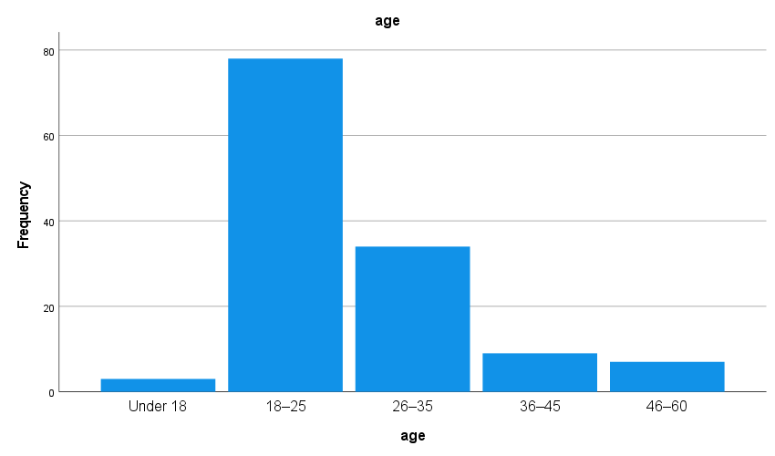

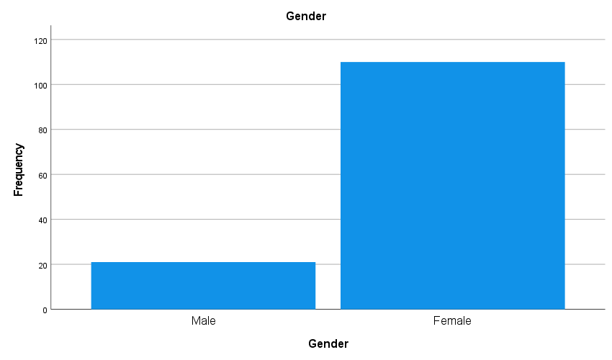

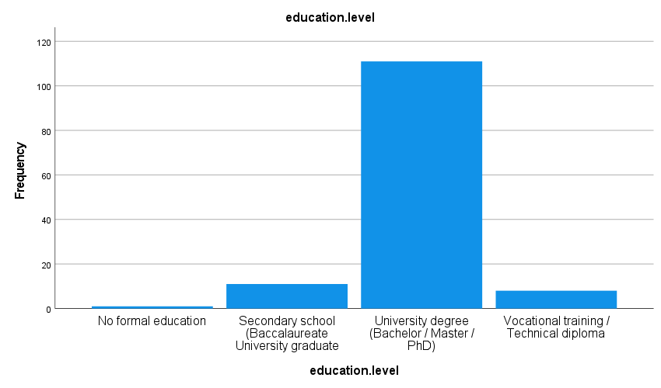

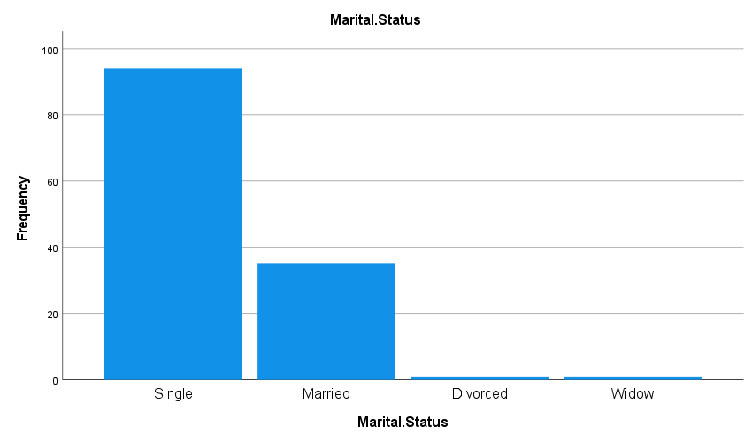

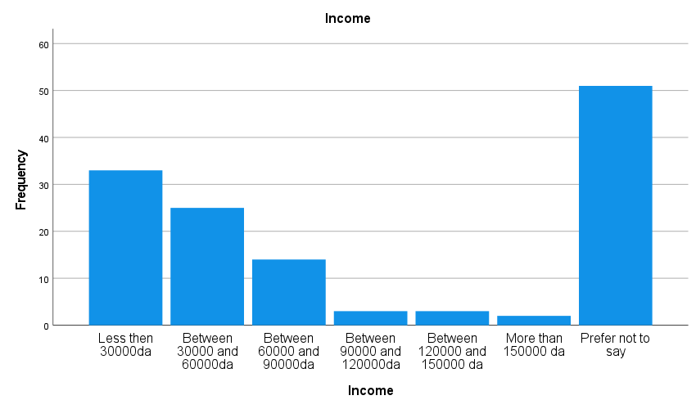

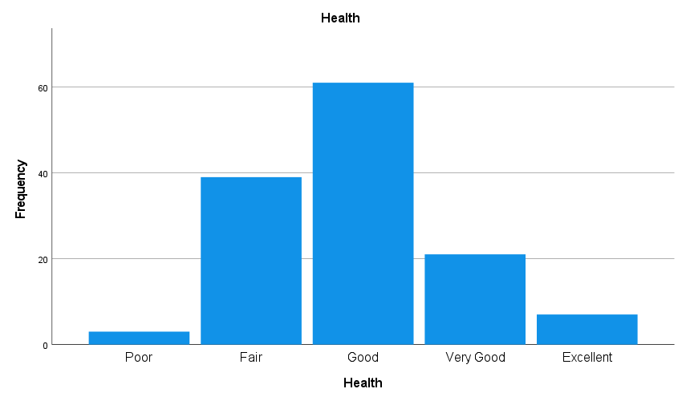

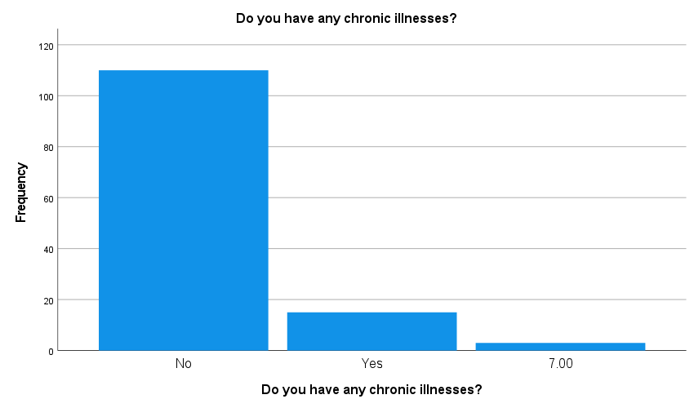

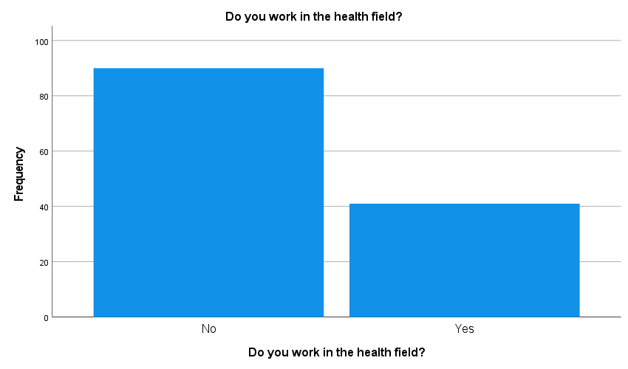

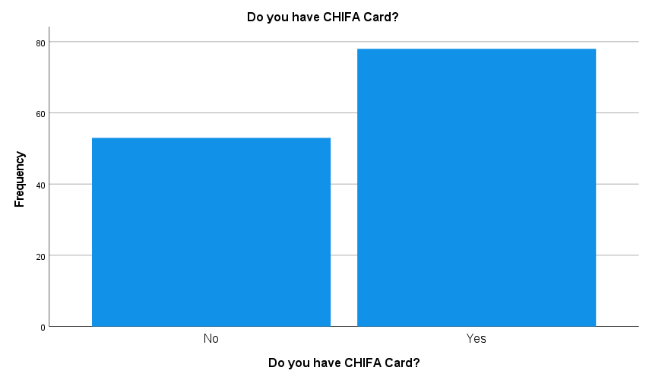

FREQUENCIES VARIABLES=Q1 Q2
/BARCHART FREQ
/ORDER=ANALYSIS.

Frequencies
Notes
Output Created |  | 08-JUN-2025 13:02:24
Comments
Input | Active Dataset | DataSet1
Input | Filter | <none>
Input | Weight | <none>
Input | Split File | <none>
Input | N of Rows in Working Data File | 131
Missing Value Handling | Definition of Missing | User-defined missing values are treated as missing.
Missing Value Handling | Cases Used | Statistics are based on all cases with valid data.
Syntax |  | FREQUENCIES VARIABLES=Q1 Q2  /BARCHART FREQ  /ORDER=ANALYSIS.
Resources | Processor Time | 00:00:00.27
Resources | Elapsed Time | 00:00:00.21

Statistics
 |  | Have you ever heard of generic drugs? | How would you rate your knowledge about generic drugs?
N | Valid | 131 | 131
N | Missing | 0 | 0

Frequency Table
Have you ever heard of generic drugs?
 |  | Frequency | Percent | Valid Percent | Cumulative Percent
Valid | No | 32 | 24.4 | 24.4 | 24.4
Valid | Yes | 99 | 75.6 | 75.6 | 100.0
Valid | Total | 131 | 100.0 | 100.0

How would you rate your knowledge about generic drugs?
 |  | Frequency | Percent | Valid Percent | Cumulative Percent
Valid | No knowledge at all | 43 | 32.8 | 32.8 | 32.8
Valid | Little knowledge | 30 | 22.9 | 22.9 | 55.7
Valid | Moderate knowledge | 32 | 24.4 | 24.4 | 80.2
Valid | Good knowledge | 14 | 10.7 | 10.7 | 90.8
Valid | Excellent knowledge | 12 | 9.2 | 9.2 | 100.0
Valid | Total | 131 | 100.0 | 100.0

Bar Chart
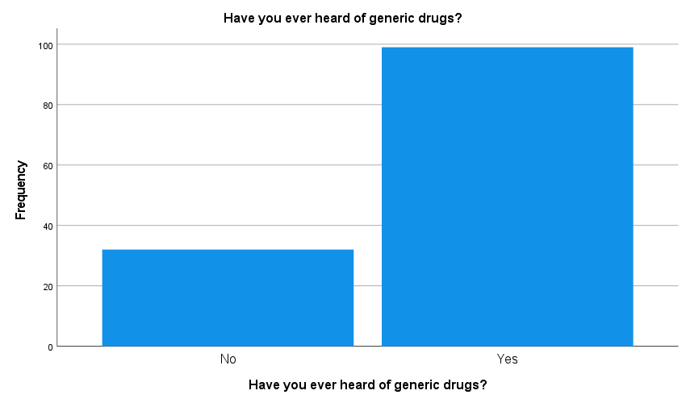

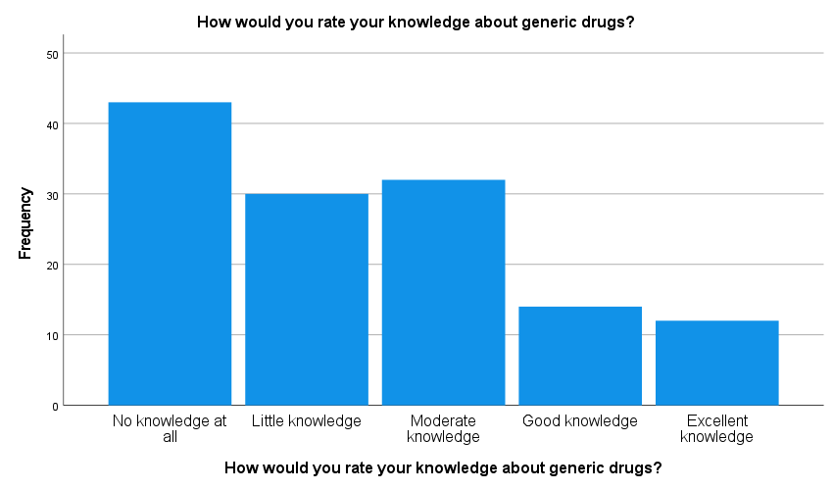

MULT RESPONSE GROUPS=$multiple.q1 (doctor pharmacist television.or.internet social.media
family.or.friends i.dont.seek.information.about.medications (1))
/FREQUENCIES=$multiple.q1.

Multiple Response
Notes
Output Created |  | 08-JUN-2025 13:16:12
Comments
Input | Active Dataset | DataSet1
Input | Filter | <none>
Input | Weight | <none>
Input | Split File | <none>
Input | N of Rows in Working Data File | 131
Missing Value Handling | Definition of Missing | User-defined missing values are treated as missing.
Missing Value Handling | Cases Used | Statistics for each table are based on all the cases with valid data in the specified range(s) for all variables in each table.
Syntax |  | MULT RESPONSE GROUPS=$multiple.q1 (doctor pharmacist television.or.internet social.media  family.or.friends i.dont.seek.information.about.medications (1))  /FREQUENCIES=$multiple.q1.
Resources | Processor Time | 00:00:00.02
Resources | Elapsed Time | 00:00:00.00

Case Summary
 | Cases
 | Valid |  | Missing |  | Total
 | N | Percent | N | Percent | N | Percent
$multiple.q1ª | 129 | 98.5% | 2 | 1.5% | 131 | 100.0%

a. Dichotomy group tabulated at value 1.

$multiple.q1 Frequencies
 |  | Responses |  | Percent of Cases
 |  | N | Percent | Percent of Cases
$multiple.q1ª | Doctor | 38 | 22.2% | 29.5%
$multiple.q1ª | Pharmacist | 56 | 32.7% | 43.4%
$multiple.q1ª | Television.or.Internet | 23 | 13.5% | 17.8%
$multiple.q1ª | Social.media | 14 | 8.2% | 10.9%
$multiple.q1ª | Family.or.friends | 12 | 7.0% | 9.3%
$multiple.q1ª | I.dont.seek.information.about.medications | 28 | 16.4% | 21.7%
Total |  | 171 | 100.0% | 132.6%

a. Dichotomy group tabulated at value 1.

MULT RESPONSE GROUPS=$multiple.q2 (q3.1 q3.2 q3.3 q3.4 q3.5 (1))
/FREQUENCIES=$multiple.q2.

Multiple Response
Notes
Output Created |  | 08-JUN-2025 13:16:51
Comments
Input | Active Dataset | DataSet1
Input | Filter | <none>
Input | Weight | <none>
Input | Split File | <none>
Input | N of Rows in Working Data File | 131
Missing Value Handling | Definition of Missing | User-defined missing values are treated as missing.
Missing Value Handling | Cases Used | Statistics for each table are based on all the cases with valid data in the specified range(s) for all variables in each table.
Syntax |  | MULT RESPONSE GROUPS=$multiple.q2 (q3.1 q3.2 q3.3 q3.4 q3.5 (1))  /FREQUENCIES=$multiple.q2.
Resources | Processor Time | 00:00:00.00
Resources | Elapsed Time | 00:00:00.01

Case Summary
 | Cases
 | Valid |  | Missing |  | Total
 | N | Percent | N | Percent | N | Percent
$multiple.q2ª | 128 | 97.7% | 3 | 2.3% | 131 | 100.0%

a. Dichotomy group tabulated at value 1.

$multiple.q2 Frequencies
 |  | Responses |  | Percent of Cases
 |  | N | Percent | Percent of Cases
$multiple.q2ª | Cheaper versions of brand-name drugs | 36 | 27.5% | 28.1%
$multiple.q2ª | Less effective than brand-name drugs | 30 | 22.9% | 23.4%
$multiple.q2ª | Equally effective as brand-name drugs | 8 | 6.1% | 6.3%
$multiple.q2ª | Produced by Algerian companies | 13 | 9.9% | 10.2%
$multiple.q2ª | Contain the same active ingredients as brand-name drugs | 44 | 33.6% | 34.4%
Total |  | 131 | 100.0% | 102.3%

a. Dichotomy group tabulated at value 1.

FREQUENCIES VARIABLES=UP1 UP2 UP3 UP4
/BARCHART FREQ
/ORDER=ANALYSIS.

Frequencies
Notes
Output Created |  | 08-JUN-2025 13:18:36
Comments
Input | Active Dataset | DataSet1
Input | Filter | <none>
Input | Weight | <none>
Input | Split File | <none>
Input | N of Rows in Working Data File | 131
Missing Value Handling | Definition of Missing | User-defined missing values are treated as missing.
Missing Value Handling | Cases Used | Statistics are based on all cases with valid data.
Syntax |  | FREQUENCIES VARIABLES=UP1 UP2 UP3 UP4  /BARCHART FREQ  /ORDER=ANALYSIS.
Resources | Processor Time | 00:00:00.50
Resources | Elapsed Time | 00:00:00.43

Statistics
 |  | In general, which type of drug do you prefer? | How much you be willing to use a generic drug if your doctor prescribes it instead of a brand-name drug? | In general, how do you consume medications? | To what extent does reimbursement influence your decision to buy a medication?
N | Valid | 131 | 131 | 131 | 131
N | Missing | 0 | 0 | 0 | 0

Frequency Table
In general, which type of drug do you prefer?
 |  | Frequency | Percent | Valid Percent | Cumulative Percent
Valid | Generic drugs | 2 | 1.5 | 1.5 | 1.5
Valid | Brand-name (princeps) drugs | 64 | 48.9 | 48.9 | 50.4
Valid | Reimbursed drug | 27 | 20.6 | 20.6 | 71.0
Valid | No preference | 38 | 29.0 | 29.0 | 100.0
Valid | Total | 131 | 100.0 | 100.0

How much you be willing to use a generic drug if your doctor prescribes it instead of a brand-name drug?
 |  | Frequency | Percent | Valid Percent | Cumulative Percent
Valid | Yes, definitely | 66 | 50.4 | 50.4 | 50.4
Valid | Yes, if I trust the brand | 32 | 24.4 | 24.4 | 74.8
Valid | No, I prefer brand-name | 16 | 12.2 | 12.2 | 87.0
Valid | I don’t know | 17 | 13.0 | 13.0 | 100.0
Valid | Total | 131 | 100.0 | 100.0

In general, how do you consume medications?
 |  | Frequency | Percent | Valid Percent | Cumulative Percent
Valid | Always with a medical prescription | 45 | 34.4 | 34.4 | 34.4
Valid | Mostly with a prescription, but sometimes without | 49 | 37.4 | 37.4 | 71.8
Valid | I often take medications without a prescription (self-medication) | 11 | 8.4 | 8.4 | 80.2
Valid | I only take medications when absolutely necessary | 26 | 19.8 | 19.8 | 100.0
Valid | Total | 131 | 100.0 | 100.0

To what extent does reimbursement influence your decision to buy a medication?
 |  | Frequency | Percent | Valid Percent | Cumulative Percent
Valid | I always prefer to buy a medication if it is reimbursed | 21 | 16.0 | 16.0 | 16.0
Valid | I prefer it to be reimbursed, but I can still buy it if it’s not | 54 | 41.2 | 41.2 | 57.3
Valid | Reimbursement does not influence my choice | 50 | 38.2 | 38.2 | 95.4
Valid | I do not buy medications that are not reimbursed | 6 | 4.6 | 4.6 | 100.0
Valid | Total | 131 | 100.0 | 100.0

Bar Chart
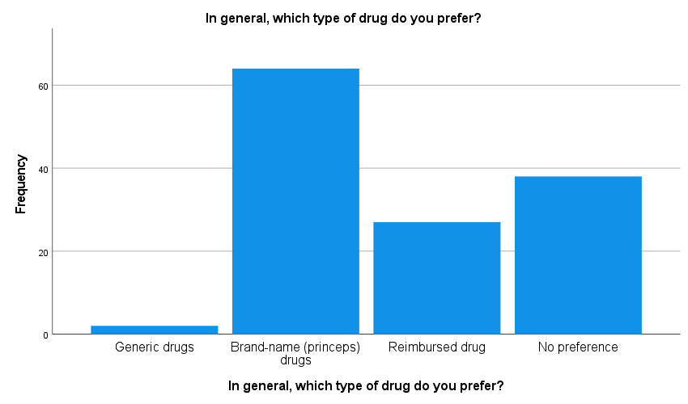

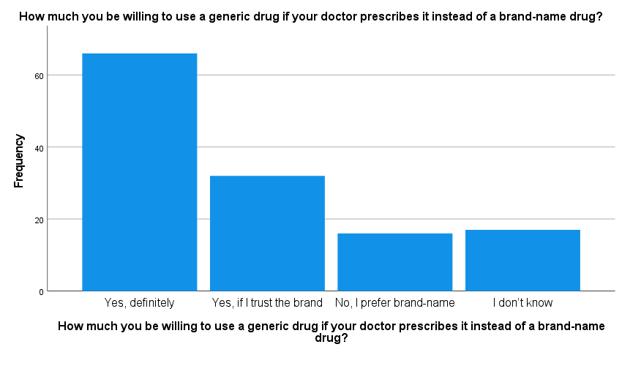

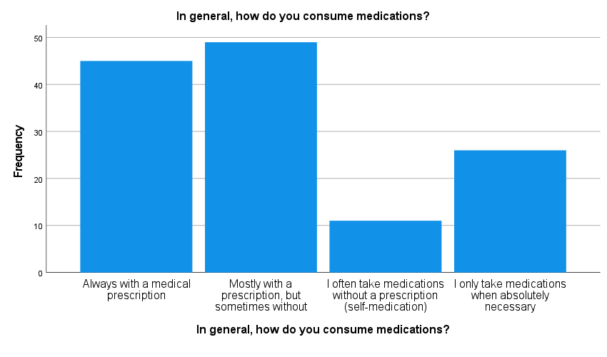
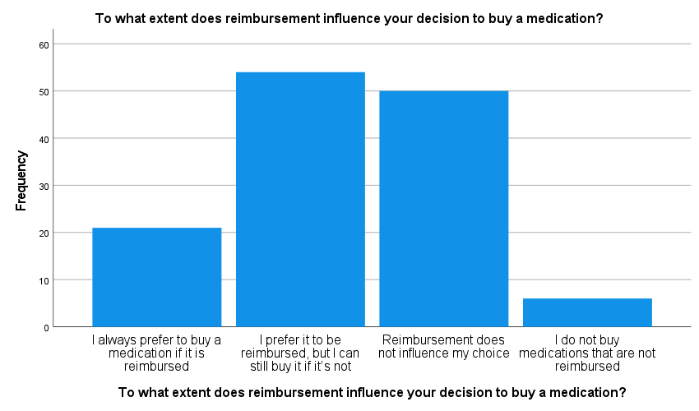

FREQUENCIES VARIABLES=TRP1
/BARCHART FREQ
/ORDER=ANALYSIS.
Frequencies
Notes
Output Created |  | 08-JUN-2025 13:19:52
Comments
Input | Active Dataset | DataSet1
Input | Filter | <none>
Input | Weight | <none>
Input | Split File | <none>
Input | N of Rows in Working Data File | 131
Missing Value Handling | Definition of Missing | User-defined missing values are treated as missing.
Missing Value Handling | Cases Used | Statistics are based on all cases with valid data.
Syntax |  | FREQUENCIES VARIABLES=TRP1  /BARCHART FREQ  /ORDER=ANALYSIS.
Resources | Processor Time | 00:00:00.14
Resources | Elapsed Time | 00:00:00.14

Statistics
Do you think a drug is less effective if it has a low price?
N | Valid | 131
N | Missing | 0

Do you think a drug is less effective if it has a low price?
 |  | Frequency | Percent | Valid Percent | Cumulative Percent
Valid | Yes, I often associate low price with lower quality or effectiveness | 26 | 19.8 | 19.8 | 19.8
Valid | Sometimes, it makes me doubt the drug’s effectiveness | 25 | 19.1 | 19.1 | 38.9
Valid | No, I believe price does not determine effectiveness | 64 | 48.9 | 48.9 | 87.8
Valid | I’m not sure | 16 | 12.2 | 12.2 | 100.0
Valid | Total | 131 | 100.0 | 100.0

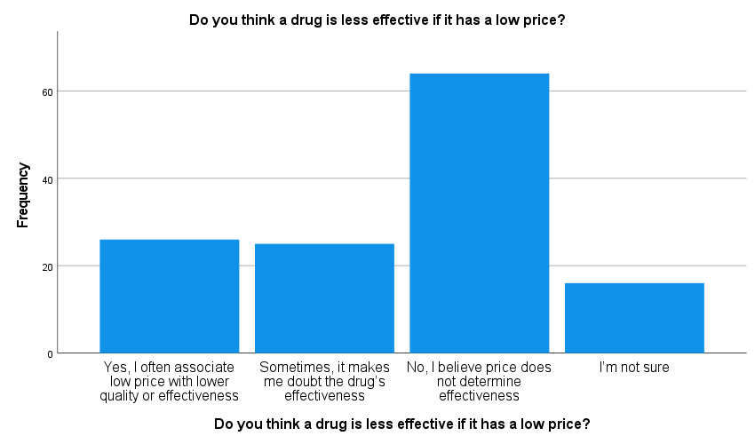

Notes
Output Created |  | 08-JUN-2025 13:23:49
Comments
Input | Active Dataset | DataSet1
Input | Filter | <none>
Input | Weight | <none>
Input | Split File | <none>
Input | N of Rows in Working Data File | 131
Missing Value Handling | Definition of Missing | User defined missing values are treated as missing.
Missing Value Handling | Cases Used | Statistics for each analysis are based on the cases with no missing or out-of-range data for any variable in the analysis.
Syntax |  | T-TEST  /TESTVAL=0  /MISSING=ANALYSIS  /VARIABLES=V.Trust V.Doctor V.Pharmacist Per.Exp1 Per.Exp2 Per.Exp3 per.exp Brand.Image  Doctor.recommandation Pharmacist.s.advice V.Price Brand.reputation  Personal.experience.feedback.from.others  /ES DISPLAY(FALSE)  /CRITERIA=CI(.95).
Resources | Processor Time | 00:00:00.00
Resources | Elapsed Time | 00:00:00.01

T-TEST
/TESTVAL=3
/MISSING=ANALYSIS
/VARIABLES=V.Trust V.Doctor V.Pharmacist Per.Exp1 Per.Exp2 Per.Exp3 per.exp Brand.Image
Doctor.recommandation Pharmacist.s.advice V.Price Brand.reputation
Personal.experience.feedback.from.others
/ES DISPLAY(FALSE)
/CRITERIA=CI(.95).

T-Test
Notes
Output Created |  | 08-JUN-2025 13:25:18
Comments
Input | Active Dataset | DataSet1
Input | Filter | <none>
Input | Weight | <none>
Input | Split File | <none>
Input | N of Rows in Working Data File | 131
Missing Value Handling | Definition of Missing | User defined missing values are treated as missing.
Missing Value Handling | Cases Used | Statistics for each analysis are based on the cases with no missing or out-of-range data for any variable in the analysis.
Syntax |  | T-TEST  /TESTVAL=3  /MISSING=ANALYSIS  /VARIABLES=V.Trust V.Doctor V.Pharmacist Per.Exp1 Per.Exp2 Per.Exp3 per.exp Brand.Image  Doctor.recommandation Pharmacist.s.advice V.Price Brand.reputation  Personal.experience.feedback.from.others  /ES DISPLAY(FALSE)  /CRITERIA=CI(.95).
Resources | Processor Time | 00:00:00.00
Resources | Elapsed Time | 00:00:00.01

One-Sample Statistics
 | N | Mean | Std. Deviation | Std. Error Mean
V.Trust | 129 | 2.7597 | 1.08091 | .09517
V.Doctor | 131 | 3.7405 | 1.05676 | .09233
V.Pharmacist | 131 | 3.0458 | 1.16924 | .10216
Per.Exp1 | 131 | 3.2366 | .95137 | .08312
Per.Exp2 | 131 | 3.1298 | 1.12590 | .09837
Per.Exp3 | 131 | 3.2672 | .95131 | .08312
per.exp | 131 | 3.2112 | .69701 | .06090
Brand.Image | 131 | 2.6107 | 1.32184 | .11549
Doctor.recommandation | 131 | 2.3588 | 1.43081 | .12501
Pharmacist.s.advice | 131 | 2.5725 | 1.02305 | .08938
V.Price | 131 | 2.7405 | 1.21900 | .10650
Brand.reputation | 131 | 2.9466 | 1.26073 | .11015
Personal.experience.feedback.from.others | 131 | 2.8168 | 1.34623 | .11762

One-Sample Test
 | Test Value = 3
 | t | df | Sig. (2-tailed) | Mean Difference | 95% Confidence Interval of the Difference
 |  |  |  |  | Lower
V.Trust | -2.525 | 128 | .013 | -.24031 | -.4286
V.Doctor | 8.020 | 130 | .000 | .74046 | .5578
V.Pharmacist | .448 | 130 | .655 | .04580 | -.1563
Per.Exp1 | 2.847 | 130 | .005 | .23664 | .0722
Per.Exp2 | 1.319 | 130 | .189 | .12977 | -.0648
Per.Exp3 | 3.214 | 130 | .002 | .26718 | .1027
per.exp | 3.468 | 130 | .001 | .21120 | .0907
Brand.Image | -3.371 | 130 | .001 | -.38931 | -.6178
Doctor.recommandation | -5.129 | 130 | .000 | -.64122 | -.8885
Pharmacist.s.advice | -4.783 | 130 | .000 | -.42748 | -.6043
V.Price | -2.437 | 130 | .016 | -.25954 | -.4702
Brand.reputation | -.485 | 130 | .628 | -.05344 | -.2714
Personal.experience.feedback.from.others | -1.558 | 130 | .122 | -.18321 | -.4159

One-Sample Test
 | Test Value = 3
 | 95% Confidence Interval of the Difference
 | Upper
V.Trust | -.0520
V.Doctor | .9231
V.Pharmacist | .2479
Per.Exp1 | .4011
Per.Exp2 | .3244
Per.Exp3 | .4316
per.exp | .3317
Brand.Image | -.1608
Doctor.recommandation | -.3939
Pharmacist.s.advice | -.2506
V.Price | -.0488
Brand.reputation | .1645
Personal.experience.feedback.from.others | .0495

RELIABILITY
/VARIABLES=Q2 V.Trust V.Doctor V.Pharmacist Per.Exp1 Per.Exp2 Per.Exp3 Brand.Image
Doctor.recommandation Pharmacist.s.advice V.Price Brand.reputation
Personal.experience.feedback.from.others
/SCALE('ALL VARIABLES') ALL
/MODEL=ALPHA.
Reliability
Notes
Output Created |  | 08-JUN-2025 13:26:36
Comments
Input | Active Dataset | DataSet1
Input | Filter | <none>
Input | Weight | <none>
Input | Split File | <none>
Input | N of Rows in Working Data File | 131
Input | Matrix Input
Missing Value Handling | Definition of Missing | User-defined missing values are treated as missing.
Missing Value Handling | Cases Used | Statistics are based on all cases with valid data for all variables in the procedure.
Syntax |  | RELIABILITY  /VARIABLES=Q2 V.Trust V.Doctor V.Pharmacist Per.Exp1 Per.Exp2 Per.Exp3 Brand.Image  Doctor.recommandation Pharmacist.s.advice V.Price Brand.reputation  Personal.experience.feedback.from.others  /SCALE('ALL VARIABLES') ALL  /MODEL=ALPHA.
Resources | Processor Time | 00:00:00.00
Resources | Elapsed Time | 00:00:00.00

Scale: ALL VARIABLES
Case Processing Summary
 |  | N | %
Cases | Valid | 129 | 98.5
Cases | Excludedª | 2 | 1.5
Cases | Total | 131 | 100.0

a. Listwise deletion based on all variables in the procedure.

Reliability Statistics
Cronbach's Alpha | N of Items
.543 | 13

MULT RESPONSE GROUPS=$multiple.q3 (trp2.1 trp2.2 trp2.3 trp2.4 trp2.5 (1))
/FREQUENCIES=$multiple.q3.

Multiple Response
Notes
Output Created |  | 08-JUN-2025 13:27:23
Comments
Input | Active Dataset | DataSet1
Input | Filter | <none>
Input | Weight | <none>
Input | Split File | <none>
Input | N of Rows in Working Data File | 131
Missing Value Handling | Definition of Missing | User-defined missing values are treated as missing.
Missing Value Handling | Cases Used | Statistics for each table are based on all the cases with valid data in the specified range(s) for all variables in each table.
Syntax |  | MULT RESPONSE GROUPS=$multiple.q3 (trp2.1 trp2.2 trp2.3 trp2.4 trp2.5 (1))  /FREQUENCIES=$multiple.q3.
Resources | Processor Time | 00:00:00.00
Resources | Elapsed Time | 00:00:00.01

Case Summary
 | Cases
 | Valid |  | Missing |  | Total
 | N | Percent | N | Percent | N | Percent
$multiple.q3ª | 125 | 95.4% | 6 | 4.6% | 131 | 100.0%

a. Dichotomy group tabulated at value 1.

$multiple.q3 Frequencies
 |  | Responses |  | Percent of Cases
 |  | N | Percent | Percent of Cases
$multiple.q3ª | TRP2.1 | 58 | 32.6% | 46.4%
$multiple.q3ª | TRP2.2 | 67 | 37.6% | 53.6%
$multiple.q3ª | TRP2.3 | 6 | 3.4% | 4.8%
$multiple.q3ª | TRP2.4 | 42 | 23.6% | 33.6%
$multiple.q3ª | TRP2.5 | 5 | 2.8% | 4.0%
Total |  | 178 | 100.0% | 142.4%

a. Dichotomy group tabulated at value 1.

T-TEST
/TESTVAL=3
/MISSING=ANALYSIS
/VARIABLES=Q2
/ES DISPLAY(FALSE)
/CRITERIA=CI(.95).

T-Test
Notes
Output Created |  | 08-JUN-2025 13:29:06
Comments
Input | Active Dataset | DataSet1
Input | Filter | <none>
Input | Weight | <none>
Input | Split File | <none>
Input | N of Rows in Working Data File | 131
Missing Value Handling | Definition of Missing | User defined missing values are treated as missing.
Missing Value Handling | Cases Used | Statistics for each analysis are based on the cases with no missing or out-of-range data for any variable in the analysis.
Syntax |  | T-TEST  /TESTVAL=3  /MISSING=ANALYSIS  /VARIABLES=Q2  /ES DISPLAY(FALSE)  /CRITERIA=CI(.95).
Resources | Processor Time | 00:00:00.00
Resources | Elapsed Time | 00:00:00.01

One-Sample Statistics
 | N | Mean | Std. Deviation | Std. Error Mean
How would you rate your knowledge about generic drugs? | 131 | 2.4046 | 1.29364 | .11303

One-Sample Test
 | Test Value = 3
 | t | df | Sig. (2-tailed) | Mean Difference | 95% Confidence Interval of the Difference
 |  |  |  |  | Lower
How would you rate your knowledge about generic drugs? | -5.268 | 130 | .000 | -.59542 | -.8190

One-Sample Test
 | Test Value = 3
 | 95% Confidence Interval of the Difference
 | Upper
How would you rate your knowledge about generic drugs? | -.3718

REGRESSION
/MISSING LISTWISE
/STATISTICS COEFF OUTS R ANOVA
/CRITERIA=PIN(.05) POUT(.10)
/NOORIGIN
/DEPENDENT V.Trust
/METHOD=ENTER V.Doctor V.Pharmacist.
Regression
Notes
Output Created |  | 08-JUN-2025 13:30:21
Comments
Input | Active Dataset | DataSet1
Input | Filter | <none>
Input | Weight | <none>
Input | Split File | <none>
Input | N of Rows in Working Data File | 131
Missing Value Handling | Definition of Missing | User-defined missing values are treated as missing.
Missing Value Handling | Cases Used | Statistics are based on cases with no missing values for any variable used.
Syntax |  | REGRESSION  /MISSING LISTWISE  /STATISTICS COEFF OUTS R ANOVA  /CRITERIA=PIN(.05) POUT(.10)  /NOORIGIN  /DEPENDENT V.Trust  /METHOD=ENTER V.Doctor V.Pharmacist.
Resources | Processor Time | 00:00:00.02
Resources | Elapsed Time | 00:00:00.01
Resources | Memory Required | 4576 bytes
Resources | Additional Memory Required for Residual Plots | 0 bytes

Variables Entered/Removedª
Model | Variables Entered | Variables Removed | Method
1 | V.Pharmacist, V.Doctor^{b} | . | Enter

a. Dependent Variable: V.Trust
b. All requested variables entered.

Model Summary
Model | R | R Square | Adjusted R Square | Std. Error of the Estimate
1 | .374ª | .140 | .126 | 1.01053

a. Predictors: (Constant), V.Pharmacist, V.Doctor

ANOVAª
Model |  | Sum of Squares | df | Mean Square | F | Sig.
1 | Regression | 20.883 | 2 | 10.441 | 10.225 | .000^{b}
1 | Residual | 128.668 | 126 | 1.021
1 | Total | 149.550 | 128

a. Dependent Variable: V.Trust
b. Predictors: (Constant), V.Pharmacist, V.Doctor

Coefficientsª
Model |  | Unstandardized Coefficients |  | Standardized Coefficients | t | Sig.
 |  | B | Std. Error | Beta | t | Sig.
1 | (Constant) | 1.418 | .343 |  | 4.140 | .000
1 | V.Doctor | .143 | .095 | .139 | 1.506 | .135
1 | V.Pharmacist | .265 | .085 | .289 | 3.125 | .002

a. Dependent Variable: V.Trust

REGRESSION
/MISSING LISTWISE
/STATISTICS COEFF OUTS R ANOVA
/CRITERIA=PIN(.05) POUT(.10)
/NOORIGIN
/DEPENDENT V.Trust
/METHOD=ENTER per.exp V.Price.

Regression
Notes
Output Created |  | 08-JUN-2025 13:32:29
Comments
Input | Active Dataset | DataSet1
Input | Filter | <none>
Input | Weight | <none>
Input | Split File | <none>
Input | N of Rows in Working Data File | 131
Missing Value Handling | Definition of Missing | User-defined missing values are treated as missing.
Missing Value Handling | Cases Used | Statistics are based on cases with no missing values for any variable used.
Syntax |  | REGRESSION  /MISSING LISTWISE  /STATISTICS COEFF OUTS R ANOVA  /CRITERIA=PIN(.05) POUT(.10)  /NOORIGIN  /DEPENDENT V.Trust  /METHOD=ENTER per.exp V.Price.
Resources | Processor Time | 00:00:00.03
Resources | Elapsed Time | 00:00:00.02
Resources | Memory Required | 4576 bytes
Resources | Additional Memory Required for Residual Plots | 0 bytes

Variables Entered/Removedª
Model | Variables Entered | Variables Removed | Method
1 | V.Price, per.exp^{b} | . | Enter

a. Dependent Variable: V.Trust
b. All requested variables entered.

Model Summary
Model | R | R Square | Adjusted R Square | Std. Error of the Estimate
1 | .203ª | .041 | .026 | 1.06673

a. Predictors: (Constant), V.Price, per.exp

ANOVAª
Model |  | Sum of Squares | df | Mean Square | F | Sig.
1 | Regression | 6.173 | 2 | 3.086 | 2.712 | .070^{b}
1 | Residual | 143.378 | 126 | 1.138
1 | Total | 149.550 | 128

a. Dependent Variable: V.Trust
b. Predictors: (Constant), V.Price, per.exp

Coefficientsª
Model |  | Unstandardized Coefficients |  | Standardized Coefficients | t | Sig.
 |  | B | Std. Error | Beta | t | Sig.
1 | (Constant) | 1.725 | .459 |  | 3.755 | .000
1 | per.exp | .302 | .137 | .196 | 2.198 | .030
1 | V.Price | .024 | .079 | .027 | .302 | .763

a. Dependent Variable: V.Trust

COMPUTE V.brand.image=MEAN(Brand.Image,Brand.reputation).
EXECUTE.
REGRESSION
/MISSING LISTWISE
/STATISTICS COEFF OUTS R ANOVA
/CRITERIA=PIN(.05) POUT(.10)
/NOORIGIN
/DEPENDENT V.Trust
/METHOD=ENTER V.brand.image.
Regression
Notes
Output Created |  | 08-JUN-2025 13:34:17
Comments
Input | Active Dataset | DataSet1
Input | Filter | <none>
Input | Weight | <none>
Input | Split File | <none>
Input | N of Rows in Working Data File | 131
Missing Value Handling | Definition of Missing | User-defined missing values are treated as missing.
Missing Value Handling | Cases Used | Statistics are based on cases with no missing values for any variable used.
Syntax |  | REGRESSION  /MISSING LISTWISE  /STATISTICS COEFF OUTS R ANOVA  /CRITERIA=PIN(.05) POUT(.10)  /NOORIGIN  /DEPENDENT V.Trust  /METHOD=ENTER V.brand.image.
Resources | Processor Time | 00:00:00.03
Resources | Elapsed Time | 00:00:00.02
Resources | Memory Required | 4160 bytes
Resources | Additional Memory Required for Residual Plots | 0 bytes

Variables Entered/Removedª
Model | Variables Entered | Variables Removed | Method
1 | V.brand.image^{b} | . | Enter

a. Dependent Variable: V.Trust
b. All requested variables entered.

Model Summary
Model | R | R Square | Adjusted R Square | Std. Error of the Estimate
1 | .023ª | .001 | -.007 | 1.08487

a. Predictors: (Constant), V.brand.image

ANOVAª
Model |  | Sum of Squares | df | Mean Square | F | Sig.
1 | Regression | .080 | 1 | .080 | .068 | .795^{b}
1 | Residual | 149.471 | 127 | 1.177
1 | Total | 149.550 | 128

a. Dependent Variable: V.Trust
b. Predictors: (Constant), V.brand.image

Coefficientsª
Model |  | Unstandardized Coefficients |  | Standardized Coefficients | t | Sig.
 |  | B | Std. Error | Beta | t | Sig.
1 | (Constant) | 2.834 | .302 |  | 9.387 | .000
1 | V.brand.image | -.027 | .103 | -.023 | -.260 | .795

a. Dependent Variable: V.Trust

CORRELATIONS
/VARIABLES=Q2 V.Trust
/PRINT=TWOTAIL NOSIG FULL
/MISSING=PAIRWISE.

Correlations
Notes
Output Created |  | 08-JUN-2025 13:35:21
Comments
Input | Active Dataset | DataSet1
Input | Filter | <none>
Input | Weight | <none>
Input | Split File | <none>
Input | N of Rows in Working Data File | 131
Missing Value Handling | Definition of Missing | User-defined missing values are treated as missing.
Missing Value Handling | Cases Used | Statistics for each pair of variables are based on all the cases with valid data for that pair.
Syntax |  | CORRELATIONS  /VARIABLES=Q2 V.Trust  /PRINT=TWOTAIL NOSIG FULL  /MISSING=PAIRWISE.
Resources | Processor Time | 00:00:00.03
Resources | Elapsed Time | 00:00:00.01

Correlations
 |  | How would you rate your knowledge about generic drugs? | V.Trust
How would you rate your knowledge about generic drugs? | Pearson Correlation | 1 | .421**
How would you rate your knowledge about generic drugs? | Sig. (2-tailed) |  | .000
How would you rate your knowledge about generic drugs? | N | 131 | 129
V.Trust | Pearson Correlation | .421** | 1
V.Trust | Sig. (2-tailed) | .000
V.Trust | N | 129 | 129

**. Correlation is significant at the 0.01 level (2-tailed).

Abstract
This thesis focuses on the factors that influence Algerian consumers’ trust in generic drugs, which are known for being effective and more affordable alternatives to branded medications. Combining theoretical review and field research, the study explores the role of knowledge, price perception, brand image, medical recommendations (particularly from pharmacists), and personal experience in shaping public trust. Findings show that limited awareness is a major obstacle, while personal experiences and pharmacist advice strongly affect trust levels. On the other hand, price and brand perception showed weaker influence. The study emphasizes the need for public health education, stronger involvement of pharmacists, and the promotion of locally produced generics as trusted and ethical alternatives that support the national pharmaceutical industry.
Key words: trust, generic drugs, Algerian customers, knowledge, personal experience, brand image
Résumé
Ce mémoire vise à comprendre les facteurs qui influencent la confiance des consommateurs algériens envers les médicaments génériques, reconnus pour leur efficacité et leur coût réduit. À travers une approche combinant théorie et enquête terrain, plusieurs dimensions ont été analysées : le niveau de connaissance, la perception du prix, l’image de marque, les recommandations médicales (surtout celles des pharmaciens), ainsi que l’expérience personnelle avec ces produits. Les résultats montrent que le manque de connaissance reste un frein majeur, tandis que la relation avec le pharmacien et l’expérience vécue jouent un rôle déterminant dans la formation de la confiance. Le prix et l’image du médicament ont un effet moindre. L’étude souligne l’importance de renforcer la sensibilisation, d’impliquer activement les professionnels de santé, et de promouvoir les médicaments locaux comme une alternative crédible, accessible et digne de confiance.
Les mots clés : confiance, médicaments génériques, consommateurs algériens, expérience personnelle, image de marque

الملخص
تسعى هذه المذكرة إلى فهم العوامل المؤثرة على ثقة المستهلك الجزائري في الأدوية الجنيسة، باعتبارها خيارًا علاجيًا فعّالًا وأقل تكلفة. من خلال الجمع بين التحليل النظري والدراسة الميدانية، تم التطرق إلى مفاهيم مثل المعرفة، والسعر، والصورة الذهنية، والتوصيات الطبية، والتجربة الشخصية، كعناصر محتملة تؤثر في قرار المستهلك بشأن استعمال هذه الأدوية. كشفت النتائج أن نقص الوعي والمعرفة يعد من أبرز العوائق، في حين تلعب التجربة الشخصية ونصائح الصيدلي دورًا مهمًا في تعزيز أو تقليل الثقة. أما السعر والصورة الذهنية فكان تأثيرهما محدودًا نسبيًا. تؤكد هذه الدراسة على ضرورة التوعية الصحية، وتقوية دور الصيدلي، وتشجيع استخدام الأدوية المحلية كخيار يعزز الثقة ويدعم السيادة الصحية الوطنية.
كلمات مفتاحية: الثقة, الأدوية الجنيسة, المستهلك الجزائري, التجربة الشخصية, العلامة التجارية.

TABLE OF CONTENTS

TABLE OF CONTENTS:
GENERAL INTRODUCTION: 15
CHAPTER ONE: GENERIC DRUGS: DEFINITION, USE AND CONTEXT 23
Introduction: 24
Section 01: Understanding Generic Drugs 25
1.1. Definition of generic drugs: 25
1.2. The Designation of Generic Drugs: 26
1.2.1 International Nonproprietary Name (INN\DCI): 26
1.2.2 Brand name: 27
1.3. Nature and characteristics of generic drugs: 28
1.3.1. Nature 28
1.2.3 Characteristics: 28
1.4. Types of generic drugs: 31
1.5. Similarities and differences between generic drugs and brand-name drugs: 32
Section02: Global and National Context of Generic Drugs 34
2.1. The International Market for Generic Drugs: 34
2.1.1. Market Growth and Development: 34
2.1.2. Key producers and exporters: 36
2.2. The Generic Drug Market in Algeria: 41
2.2.1. Historical background: 41
2.2.2. Local Industry Players (e.g., SAIDAL): 42
2.3. Policies Supporting Generic Drug Use: 43
2.3.1.WHO Guidelines: 43
2.3.2. Algerian Regulations and Initiatives: 43
Section 03: Challenges and Development Prospects of Generic Drugs 45
3.1. Challenges Related to Generic Drugs: 45
3.1.1. Awareness Issues, Resistance from Doctors/Patients: 45
3.1.2. Regulatory and Supply Chain Problems: 45
3.2. Development Prospects and Strategic Pillars for Advancing Generic Drugs in Algeria: 46
3.2.1. Strengthening Public Trust: 46
3.2.2. Education: 47
3.2.3. Pricing policies: 48
Conclusion: 50
Chapter Two: Understanding and Exploring Trust in Generic Medicines: Concepts, Influencing Factors, and Perspectives 51
Introduction 52
Section one: Understanding Trust and Trust in drugs 53
1.1. Defining Trust: Concepts and Theories 53
1.1.1. Core Components of Trust 53
1.1.2. Theoretical Perspectives on Trust 54
1.2. Dimensions of Trust 55
Section Two: Trust in the Pharmaceutical Context 56
2.1. Trust in drugs: a general perspective 56
2.1.1. Factors Influencing General Trust in Medicines 56
2.1.2. The Role of Scientific Evidence and Communication 57
2.1.3. Challenges to Trust in Medicines 57
2.2. Trust in generic drugs: specific consideration 58
2.2.1. The Paradox of Generics: Efficacy vs. Perception 58
2.2.2. Influence of Healthcare Professionals 59
2.2.3. Personal Experiences and Anecdotal Evidence 59
2.2.4. Regulatory Environment and Post-Market Surveillance 59
2.2.5. Accessibility and Affordability 60
2.3. Types of Trust Relevant to Generic Drugs 60
2.3.1. Cognitive Trust (Competence-Based Trust) 60
2.3.2. Affective Trust (Benevolence-Based Trust) 61
2.3.3. Institutional Trust 62
2.3.4. Interpersonal Trust 62
2.3.5. Calculative Trust 63
Section three: Factors influencing trust in generic drugs: 64
1.1. Price and Affordability 71
1.1.1. The Economic Imperative of Generic Drugs 72
1.1.2. The Price-Quality Heuristic and Consumer Skepticism 73
1.1.3. The Role of Cost as a Motivator for Generic Use 73
1.1.4. Balancing Affordability and Trust 74
1.2. Quality Assurance (QA) 74
Conclusion 77
Chapter Three: MPIRICAL STUDY 78
Introduction: 79
Section one: Research Methodology 80
1. Methodological approach 80
2. Questionnaire description: structure, measured variables and items 83
2.1. Questionnaire structure 83
2.2. Items for each variable 83
3. Instruments of measurement 83
3.1. SPSS (Statistical Package for the Social Sciences) 83
3.2. Data Processing and Analysis Procedure 83
Section Two: Presentation, Analysis and Interpretation of Results 84
Study Scale 84
Measuring the validity of questionnaire 85
Analysis of study result 86
Analysis of individuals' response 97
Analysis of individuals' responses regarding the measurement of Use and preferences 102
Analysis of individuals' responses regarding the measurement of Trust in generic drugs 108
Test hypotheses and discuss study result 113
Conclusion 120
GENERAL CONCLUSION 121
REFERENCES 124
APPENDIX 132

