
PEOPLE’S DEMOCRATIC AND REPUBLIC OF ALGERIA

MINISTRY OF HIGH EDUCATION

AND SCIENTIFIC RESEARCH

HIGH SCHOOL OF MANAGEMENT

Department of: Management

Dissertation Submitted as a Partial Fulfillment of the Requirement for the Master

Degree in Management

Option: Marketing
A Study of factors influencing the purchase decision of a decision-making member within the Algerian family: the Local electrical appliance as a case.

Presented by: supervised by:
Ms. Mostefaoui Oumeima Dr.Benbouziane Mohammed
Members of jury
Dr. Metaiche Mohamed MCA President Higher School of Management Tlemcen
Elamine
Dr..Benbouziane MCA Supervisior Higher School of Management Tlemcen
Mohammed
Dr. Chib Djazia MCB Examiner University of Tlemcen

Academic Year : 2019-2020

Aknowledgments

My first thanks to my advisor, Mr Mohammed Benbouziane, for his confidence and patience, better advice and guidance.

My thanks go to the members of the Jury for agreeing to evaluate this work.
I would like to express my gratitude to the friends and colleagues who have given me their moral and intellectual support.

Dedication

First of all, I would thank Allah for giving me the strength to finish this work.
Foremost, I would like to express my sincere gratitude to my beloved parents, for all their sacrifices, love, tenderness, support and prayers throughout my studies,
To my darling sister Bouchra for her constant encouragement and moral underpinning,
To my dear brother for his aid and faith,
To Madame Bessouh for her efforts, for being such a gleaming example...
To Mr. Omar for his confidence and motivation
To my sincere friends
May this work be the fulfillment of your much-vaunted wishes, and the flight from your infallible support,

Thank you for always being there for me.

Liste of tables :

Table3. 1: evolution of consumer prices in Algiers from 2010 to 2019 59
Table 3.1: Distribution of the sample according to gender. 66
Table 2.2: The distribution of our sample according to age. 67
Table 3.3: Distribution of our sample according to marital status. 68
Table3.3: Distribution of our sample according to family members. 69
Table 3.4: Distribution according to educational attainment. 70
Table3.5: Distribution of our sample according to income. 72
Table 6: Decision maker representation. 75
Table 3.9: Descriptive statestics. 76
Table 3.8: Variables Entered/Removed 77
Table3.9: Model Summary 77
Table 3.10: ANOVA 78
Table 3.11: Coefficients 79

List of figures:
Figure 1: The model of customer behaviour according to NICOSIA 8
Figure 1.2 Haward and Steth model 9
Figure 1.3 the model of Engel, Kollat and Blackwell 10
Figure 1.4 Maslow pyramid of needs 13
Figure 1.5 Factors influencing customer behavior 21
Figure 1.6 Costumer decision- making process 27
Figure 2.1: The FLC model proposed by Murphy and Staples 36
Figure2.2: The Zaichkowsky (1985) scale 52
Figure2.4: The resident population in Algeria 57
Figure 1.5: Algerian Population structure 58
Figure 2.6: Mortality rate in Algeria 59
Figure2.7: Evolution by category of goods and services 60
Figure2.9: Evolution of home furnishings consummation 62
Figure 3.1: Distribution of the sample according to gender. 67
Figure3.2: The distribution of our sample according to age. 68*
Figure 3.4: Distribution of our sample according to marital status. 69
Figure 3.5: Distribution of our sample according to marital status. 70
Figure 3.6:Distribution of our sample according to marital status. 71
Figure 3.7: Representation of our sample according to the socio-professional situation 73
Figure3. 8: Distribution of our sample according to income 74
Figure3.9: Marriage duration representation 75
Figure3. 10: Representation of Children’s number 76
Figure 3.11: Product distribution 77
Figure 3.12 : Decision maker representation 78
Figure3. 13: Standardized Residual regression 80
Figure3.14 : Prob Cum observed 81

تلخيص :
في دراستنا سنتطرق الى فهم و تحديد العوامل المؤثرة على قرار الشراء بالنسبة لصانع القرار، اخذنا كدراسة حالة العائلة الجزائرية، اما بالنسبة للمنتج فكان الأجهزة الكهرومنزلية المحلية.
لتحصيل هذه الدراسة قمنا باعداد استبيان و نشره على مواقع التواصل الاجتماعي، اما بالنسبة للعينة فقد شملت 172 فرد و باستعمال دالة الانحدار الخطي استطعنا تحديد اهم العوامل، تمثلت في ان العائلة و الجماعات التي ينتمي اليها المستهلك تؤثر في قرار شرائه، بالإضافة الى وضيفته و مستواه التعليمي و حالته المدنية.
بالإضافة الى عوامل أخرى في مرحلة الشراء نذكر: خدمات ما بعد البيع، الضمان و العاملين.
كلمات مفتاحية :
السلوك الشرائي، مستهلك، العوامل المؤثرة على صنع القرار.

Abstract :
In our study, we will deal with understanding and identifying the factors affecting the purchase decision for the decision maker, we took as a case study of the Algerian family, as for the product, it was the local electrical appliances. To obtain this study, we prepared a questionnaire and published it on social media. As for the sample, it included 172 individuals, and by using the linear regression function, we were able to determine the most important factors.
Those factors are consumer’s family and groups influence his buying decision, in addition to his job, his educational level, and his civil status. In addition to other factors in the purchasing phase, we mention: after-sales services, warranty and workers.
Keywords : Customer behaviour, Customer, Factors influencing decision making.

Contents

GENERAL INTRODUCTION 1
CHAPITRE ONE : CUSTOMER BEHAVIOUR 4
Introduction 5
Section 01: Consumer Behaviour Research Area Distinguishes6
Section 02: Definition of consumer behaviour 7
Section 03: Global models of consumer purchasing behaviour8
Section 04: Factors influencing consumer behaviour12
Section 05: Consumer purchase decision making22
Conclusion 30
CHAPITRE TWO : FAMILY BUYING BEHAVIOUR
Introduction 31
Section 01: Definitions and conceptualization of family behaviour32
Section 02: The purchasing process in the family 39
Section 03: The distribution of roles in decision making45
Section 04: The distribution of roles in decision making55
Section 05: Socio-demographic characteristics in Algeria56
Conclusion 57
CHAPITRE THREE: RESEARCH AND ANLYSIS
Section 01: Methodological approach to the survey 64
Section 02: Describing the personal variables of the survey66
Section 03: Analysis of survey results 75
Conclusion 83
GENERAL CONCLUSION84

GENERAL INTRODUCTION

General Introduction:
Several brands operating in the electronics and household appliances sector in Algeria and which are facing stiff competition on the national market.
Each of these brands is trying to do its best to gain more market share and thus sell its products.
In order to win the battle and achieve large market shares, manufacturers in the field of electronics and household appliances try to introduce the latest technologies and invest in innovation. Partnerships with foreign companies are established, allowing also the training of their engineers and technicians, both in Algeria and abroad.
In efforts to be competitive and to convince their customers, manufacturers stay in touch with the market and some even provide them with questionnaires to get an idea of their perception of the product.
However, these efforts cannot have impressive results if these companies are not in listening to customers' requirements and understanding their behaviour.
Consumer behaviour is those interconnected processes for an individual or group of individuals to choose, buy, and use a product, service, idea, or even experience with the purpose of satisfying needs and desires.
Consumer knowledge, expectations and the logic with which they implement the decision-making process helps to devise appropriate strategies to attract and win consumer confidence. The purchasing decision process can be defined as the psychological journey that the consumer follows from his awareness of an unmet need until solving the problem of selection and use of the commodity and evaluate the performance of the latter .Therefore; this behaviour needs to be understood across all decision-making stages.
Throughout the decision-making stages, consumers are exposed to several factors that affect decision-making, some factors favor the act of buying, others will slow it down.
There are three levels of factors that explain the buying behaviour of a consumer; and each level includes a number of factors that will influence the consumer when faced with an act of purchase. The individual level linked to the psychological factors of the consumer (needs, perception, and attitudes), the second level is centred on the interpersonal factors that influence the purchasing process and in which the consumer will look for the symbols necessary for his social recognition, these are reference groups, membership groups and opinion leaders, and the last level includes socio-cultural factors such as the culture of the consumer, his social class affiliation and his lifestyle.
Context and theoretical bases of the research:
The family is the basic nucleus for the formation of the individual and the cornerstone in building society. Family members have a great influence on consumer behaviour, as parents gain their children many religious, social and political trends ... etc. that direct their behaviour and affect it, and consumer behaviour varies according to the number of members The family and stage that she is going through in the various stages of her life.
The study of the family from the point of view of marketing is important for several considerations, the most important of which are:
- That the institution’s current and potential market is a group of households or a group of members Families.
- The family members are in constant contact with each other and therefore the information provided on the different brands from Goods and services are traded between these members. The consumer behaviour and attitudes among family members, hence the wording strategies depend on the size and nature of households, their consumption patterns, the volume and the nature of the information that has a mutual influence on household consumption. They use it in making their purchasing decisions, the sources of this information and the effort spent searching for it ... etc.
Problematic:
Our study is in the field of research on family purchasing decisions. The research focuses on the factors that influence the purchase decision. The main objective of this work is to make an Intersection between these factors and family purchasing behaviour, and trying to understand how consumers are reacting to this fierce competition between local and international products. Therefore we discover and understand the factors that determine and influence the purchasing behaviour of Algerian consumers' local household appliances.
Our central questioning then revolves around the following problematic: what are factors that influence the purchase decision of a decision-maker member in the Algerian family to buy local household appliances?
Hypothesis:
- H1: Family is always a determining factor in the purchasing decision.
- H2: Situational factors influence the decision to purchase local electrical appliances.
Importance of the study:
The study derives its importance from the role played by the purchasing decision-making process and the influence of groups Bookmark it especially the family, Since reference groups are one of the most important social factors affecting in a clear and clear way, the behaviors of individuals and their attitudes and thus on their purchasing decisions, the importance of the study is shown through Clarify the impact of consumer decision by reference groups when purchasing.
Objectives of the study:
The aim of this study is to:
1 - Find out the truth about the factors and variables that control consumer behavior and know how to use these factors and variables to influence this consumption behavior.
2- Knowing the nature of cultural and social factor influence on purchasing decisions for the Algerian consumer.
3 - Trying to find answers to a number of questions posed, namely how to buy, what are the circumstances in which this purchase is made, and what are the reasons and factors affecting purchasing decisions ... etc. for the Algerian consumer

Research methodology:
In order to validate our research hypotheses, we propose to conduct an exploratory study with 173 people representing his families. In this study, the personal questionnaire survey is chosen as method of collecting information and the questionnaire is launched on social networks.
Literature review:
- The Bearden Wetzel study, 1990:
This study presented a distinction to the role played by the reference group in influencing consumer behavior with respect to specific products. This study differentiated between essential products and luxury products as well as between the general use of the product and its private use. The study showed whether the impact of the reference group responds to the entire commodity product category or is focused on specific marks within this category. This effect varies according to the cell to which the product is organized. With regard to public welfare: the influence of the reference group is great on choosing the product and then its brand, since not all people have these luxuries, and the product and its trademark can be observed because it is limited to a category that owns these luxuries such as cars and cigarettes .... As for private luxuries: The influence of reference groups is great in choosing a product without its brand because few people own air conditioners. As for the general necessities: the reference group does not have an influence on the product itself as much as it does on its commercial relationship, because almost everyone understands their need for this product, and here the brand stands out significantly like most basic household electrical appliances (refrigerator ...).
- Scott et al. 1973 study:
This study attempted to clarify the relationship between consumer behavior and consumer values ​​with regard to the characteristics of cars such as the model (type), the need for services, environmental pollution, operating costs and warranty, relying on that on the SRK scale. The results of this study showed the existence of a relationship between some consumer values ​​and specific characteristics in cars, as it was found that the model (type) could be associated with some values ​​such as "comfortable life and enjoyable life" and pleasure, especially environmental pollution, which were found to be ranked by world peace and with assistance.

The Work Plan:
To carry out our research, we used different information gathering methods based on a documentary approach using numerous bibliographical references, as well as data collected through a quantitative approach through a field survey.
In order to provide some answers to the questions raised in our modest work, it has been divided into three chapters:
- The first chapter will deal with the basic notions of consumer behaviour, the process of making a purchase decision and the factors influencing consumer behaviour.
- The second chapter will focus on consumer behaviour within the family.
- Finally, the last chapter will be devoted to the field survey, with the presentation of theme theological approach to the survey as well as the analysis and interpretation of the results.

Introduction:
Consumer behaviour is a field of study in which many researchers are interested. It's a field that is both compelling and fascinating.
Unavoidable because it is one of the pillars of marketing, helping managers to make decisions that enable organizations to achieve their objectives. Fascinating because it concerns human behaviour in consumption situations.
Behavioural analysis has evolved profoundly. Understanding the factors that govern purchasing behaviour has always been a major concern of the marketing function companies. This understanding was not only used to develop the action plans commercial (segmentation and positioning strategy, communication, the promotion...) but still to identify the characteristics to be given to the product and service on the basis of the expectations of potential buyers.
The content of this chapter focuses on a good understanding of consumer behaviour, addressing first of all multidisciplinary approaches to consumer behaviour, then we will focus on examining the various influencing factors that help us to better understand consumer behaviour, on the one hand a from an internal point of view, on the other hand from an external point of view, finally we will study the analysis of the decision-making process by which each individual is led to the purchase decision or not buying.

Section 1: Consumer Behaviour Research Area Distinguishes
Over the years, consumer behaviour has become a discipline in its own right, on a par with mathematics, literature or nuclear physics. More than just a subject of study, consumer behaviour must now be considered as a speciality of the social sciences and humanities in which knowledge is produced (through research), transmitted (through teaching) and applied (through practice).
However, knowledge about consumer behaviour is not produced in a vacuum; it benefits from input from other disciplines. The most important are psychology (the study of mental processes), social psychology (the study of how people function in society), sociology (the study of group behaviour), anthropology (the study of people in the context of their culture) and economics (the study of the supply and demand of goods and services). In this sense, it can be said that the study of consumer behaviour is truly an interdisciplinary endeavour (Alain D, Naoufel D , Pierre B , Christèle B ,2009).
In terms of the methods used to study consumers, research is polarized. On the one hand, there are very formal approaches based on microeconomic models and complex statistical methods (such as structural equations). On the other hand, there are more literary approaches.
Whether quantitative or qualitative in nature, these approaches lead to a better understanding of consumers in order to guide the decisions of businesses (innovation, communication, etc.) and public authorities (regulation, regulation, etc.). This discipline has focused on the process of brand evaluation and selection, the effects of advertising (memorization, persuasion, etc.), the influence of the environment on the individual (family, culture, etc.) and the characteristics that differentiate consumers (social class, values, personality, etc.). Currently, the themes are broadening towards understanding the act of consuming (rather than the act of buying), the influence of price and promotions, taking time and emotions into account, loyalty and relational marketing. The study of consumers is therefore quite largely linked to marketing. That said, this discipline is not only intended to help business leaders make better decisions (Denis D, Pierre V, 2007).

Section 2: Definition of consumer behaviour

The study of consumer and buyer behaviour has become an essential part of marketing analysis and practice. Its contributions are essential to both strategic thinking and operational marketing. Consumption has also become a societal debate. The way in which the study of consumer and buyer behaviour is addressed here does not pretend to take a position, but it does offer some indicators that allow the reader to situate himself among the many approaches that can be mobilized to study the consumer or buyer (RICHAD LADWEIN, 2003).

Definition of consumer behaviour:
Consumer behaviour is a special case of the study of human behaviour. The study of human behaviour concerns the whole process by which an individual reacts in his environment. It therefore concerns the thoughts, feelings, actions and reasons for the actions of individuals.
The study of consumer behaviour, on the other hand, concerns the specific actions of humans directly related to the purchase of goods and services (DALI-YOUCEF S, 2012).
Consumer behaviour can be defined in the following way: "The set of acts of individuals directly linked by the purchase and use of economic goods or services, including the decision-making processes that precede and determine the act"( Mémoire online. Com).
This definition includes four concepts:
- The totality of the acts of individuals: This notion implies that the analysis of consumer behaviour is not only about the purchase itself, but also about the set of acts related to it.
- The purchase of economic goods and services: To understand consumer behaviour, we need to know what is occurring.
- Before, during and after the purchase. The decision-making processes that predispose and condition these acts:
Each act of consumption is the culmination of a decision-making process. So we are talking about store selection by involving the decision criteria that led a consumer to choose one store over another, but we are also talking about the information-seeking process by describing the information about a given product (BOUFALA C , BRIKI D, 2016).
Section 3: Global models of consumer purchasing behaviour
The fundamental models of consumer and buyer behaviour have been formed from the deficiencies of economic psychology and the creation of an independent discipline. However, the models that have been developed have continued to be strongly influenced by the contributions of psychology and especially by the behaviourist movement. The latter suggests considering the buyer or consumer as an organism producing responses to market demand. However, the authors who developed such models also sought to understand the decision-making processes. In this framework, the notion of attitude has played a key role (Richard Ladwein, 2003).
A model is an abstract, simplified and hypothetical representation constructed in order to schematize as accurately as possible the concrete and complex mechanisms that exist in society (Martin S; Védrine J. P, 1996).

The model of consumer behaviour according to NICOSIA (1966):

According to marketers, the Nicosian model is the first modalization initiative in the context of consumer behaviour. Historically, this model is the oldest and dates back to the 1960s.
Nicosia presented a model for processing advertising information. The main objective of this model is to highlight the effects of advertising messages on the behaviour and choices of consumers in general. This model is divided into four parts or areas: processing of advertising messages, product research and evaluation, and the act of buying and consuming and storing.
- 1 set fields, Advertising message processing consists first of receiving a message from a source that is the sender. This message is of an advertising nature, so the receiver adopts an attitude about the product.
- 2nd field, (Research for the evaluation of instrumental relationships) In this step, the consumer first searches for the product or service, i.e. he analyses the advertising message, then he searches for and analyses all the information about the product. This helps to motivate the buyer, i.e. to create a need in the consumer.
- 3rd field: (act of purchase) after analyzing the product and service information, the consumer expresses the desire to be able to improve his present situation in an ideal situation. That is to say, this consumer will proceed to the act of purchase.
- 4th field: in this step, the consumer, after having bought the product, will be satisfied or not. In the negative case, he will no longer look for the product, it is up to the company to find solutions after having detected the problem of course. This generates a negative attitude; in the positive case, the consumer moves on the stage of storage and communication (Khalifa M, 2016).

Figure 1: The model of customer behaviour according to NICOSIA

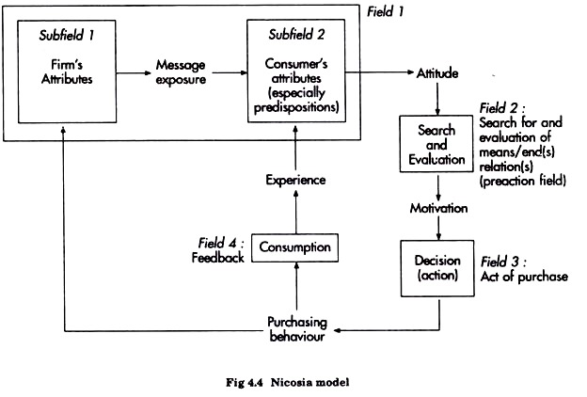
Source: business management ideas.com

The Howard and Sheath model (1969):

Incoming information is analysed by perceptual processes before being finally stored in memory. They are then likely to give rise to response behaviour from the attitude towards the offer to the purchase. The model is mainly determined since the decision is a result of the perception of the characteristics of the offer, their appreciation and their ability to respond to the motivations. The storage of information in memory is supposed to trigger purchasing behaviour if the attitude towards the product is positive. Using the different exogenous variables, the model aims to describe a systemic decision process (DALI-YOUCEF S, 2012).
Figure 1.2 Howard and Steth model
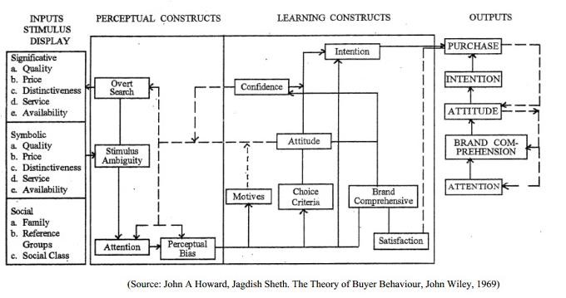

The model of Engel, Kollat and Blackwell (1968):

Engel, Kollat and Blackwell's model focuses on the decision-making process during a purchase to understand how and why consumers act towards such a category of products. It is one of the most important models in the field of consumer behaviour.
According to Engel et al, the decision process is influenced by three main types of factors. These are individual characteristics, social factors and other situational factors.
These factors influence purchasing behaviour, including the purchase decision and the product purchased, and they also trigger processes that link the various internal variables to arrive at an answer.
According to Engel et al, there is also an external information search that goes through five essential steps (exposure, attention, understanding, acceptance and retention). The two stages of research help the consumer make good decisions regarding the choice of a product or service finally; this model presents the five essential steps of the purchasing process. All consumer transactions go through these five steps:
1. Acknowledgement of the problem.
2. Searching for information
3. Evaluation of alternatives.
4. The purchase decision
5. Post-purchase evaluation
The individual finds himself in a situation that is accepted because he needs such a product to satisfy his needs; in this case he has recognized his problem. He then tries to solve it by researching and analyzing information about the product that can meet his needs. Of course, he has a choice, so he evaluates all the products that can satisfy his consumption, either he is satisfied and therefore he will buy the product, or he is not satisfied and that means he will change product or brand (Khalifa M, 2016).
Figure 1.3 the model of Engel, Kollat and Blackwell
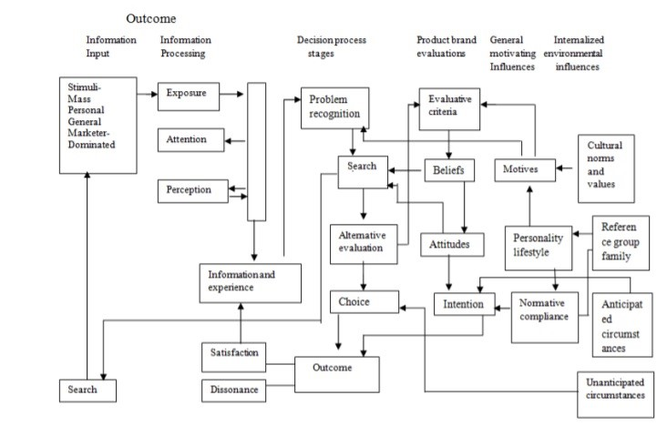
Source: research gate.net (2008)

Section 4: Factors influencing consumer behaviour
A consumer's decisions are influenced by multiple psychological, cultural, personal and caring criteria:

Psychological explanatory factors:
A set of psychological factors, combined with the individual characteristics of the consumer, leads to a decision process applicable to different purchasing decisions. Marketing must understand what is going on in the consumer's mind; four key mechanisms come into play:
Motivation, Perception, Learning and Memory (Kotlerp,Keller K, Bubois B, Manceau D, 2006) ...

Motivation:
"Motivation refers to the processes that lead individuals to act. When a need is felt, a tension is created which leads the person to act in order to satisfy it » (Michael S, Tissier-Desbordes E, Heilbrunn B, 2009)
Many psychologists have suggested theories of motivation. The three most famous are due to Sigmund Freud, Abraham Maslow and Frederick Herzberg (Kotlerp,Keller K, Bubois B, Manceau D, 2006).

The Freudian theory of motivation:
The Freudian theory states that human needs are largely unconscious. According to Freud, the individual stifles many desires in the course of his journey and his increasing acceptance of life in society. These desires are not totally excluded or perfectly controlled, and reappear in dreams, lapses and obsessions.

Maslow's motivation:
Abraham Maslow looked at why individuals are oriented by certain needs at certain times. He then proposed a hierarchy of needs:
The levels of need established by Maslow:
- Physiological needs: Eating, breathing, sleeping, etc., everything that makes it possible to live and be healthy. These are the needs that must be met first.
- Safety needs: Stability, knowledge of the environment, ability to anticipate events, etc. These are the needs that ensure we function in society.
- Love and Belonging needs: Affection and affiliation. Unions with other people, family, friends and groups are ways of meeting these needs.
- Esteem needs: the need for a positive self-image, the search for prestige, recognition and appreciation, and self-confidence.
- Self actualization needs: the realization of one's abilities in a full realization of one's potential.
This theory is based on the fundamental idea that each person has a hierarchy of needs. According to Maslow, needs are arranged hierarchically, like a pyramid. When a need becomes active, the person seeks to satisfy it.
The specificity of Maslow's theory lies in the specification of criteria for satisfying needs: according to this notion, a need at a given hierarchical level can only be triggered and satisfied if needs at a lower level have already been satisfied.
Maslow's theory is refined and above all very audacious, as it aims to explain all human behaviour by the effect of a small number of needs, but this theory can nevertheless face several criticisms. Is it really necessary to fully satisfy one level of need in order to move on to the next? How can this theory be confirmed? What is the timeframe envisaged in Maslow's theory?
To complete this reflection on needs, it should be pointed out that for some authors, it is futile to try to list needs because they are too numerous. Some consider that, at bottom, there are simply too many needs to be satisfied. Consequently, the approach of identifying needs and the means of meeting them would be superfluous. Criticisms of the explanation of needs-based motivation are somewhat justified. It is futile to attempt to interpret the variety of human behaviour in general, and consumption behaviour in particular, solely on the basis of needs. We may not be able to explain everything on the basis of needs, but needs play an important role in many consumption situations (Alain D, Naoufel D , Pierre B , Christèle B, 2015).

Figure 1.4 Maslow pyramid of needs
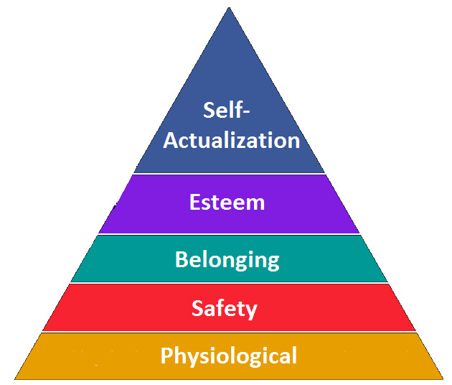
Source: ericsson.com(2015)

Herzberg's theory:
Frederick Herzberg developed the "two-factor theory", which distinguishes between the factors of satisfaction and dissatisfaction (Herzberg F, Work and of man, 1996).
The absence of a reason for dissatisfaction is not enough. The elements of satisfaction must be considerable in order to induce purchase.
Herzberg's theory proposes that the company should always act in two directions: (1) prevent dissatisfaction on the part of the potential buyer; (2) carefully determine the causes of satisfaction in order to incorporate them into its offer with a differential advantage if possible (Bernard B, Gary A .Steinerr, 1964).

Perception:
“Perception is the process by which an individual chooses, organizes and interprets external information to construct a coherent image of the world around him” (Kotlerp,Keller K, Bubois B, Manceau D, 2006).

In marketing, customer perceptions are more marked than reality. Three mechanisms act on how a stimulus is perceived: selective attention, selective distortion and selective retention.
Selective attention: The concept of selectivity explains why it is very difficult to retain consumers' attention. Even the most eager among them may not receive a signal that does not stand out clearly.
Selective Distortion: Just because a stimulus has been noted does not mean it will be interpreted correctly. Selective distortion is the mechanism that causes an individual to distort the information received to make it more consistent with his or her beliefs.
Selective Retention: The individual ignores most of what he or she discovers. He has usually memorized information that reinforces his beliefs.
Subliminal perception: The idea is that marketers consciously assimilate hidden and insensitive messages and change their behaviour accordingly. Although it is indisputable that unconscious phenomena influence consumers' processing of information, (Chris J, 1993), no evidence of the influence of subnatural images has ever been proven (Tomothy M , 1982).

Learning:
"We call learning the changes in a person's behaviour resulting from past experiences." (Kotlerp,Keller K, Bubois B, Manceau, 2006)
Marketing has made it clear that the acquired and permanent links between products and souvenirs are a means of building and maintaining customer loyalty and retention. Our understanding of the world is constantly evolving as we receive stimuli: they allow us to change our behaviour when we find ourselves in a situation we have already experienced (Kotlerp,Keller K, Bubois B, Manceau, 2006).

Memory :
Trademark knowledge stored in the memory of consumers can be considered as a core trademark linked to numerous links. The strength and organization of these links condition the information stored on the trademark. Brand associations correspond to all the thoughts, feelings, perceptions, images, experiences, beliefs and attitudes that are linked to this core ((Kotlerp,Keller K, Bubois B, Manceau, 2006).

Social factors:
The consumer is influenced by the membership and reference groups, each of which depends on the cultural environment in which he or she finds himself or herself.

Culture:
Culture is presented as a set of genetically transmitted solutions to existing and future concerns, specific to a given group and shared by the other members of that group. Thus, from birth, the consumer constructs his or her behaviour from the culture of the society in which he or she finds himself or herself. Each exchange with the different groups that make up the consumer enables him to familiarise himself with the value system characteristic of his society and to socialise, i.e. to be able to adapt to changes in his environment (Vandercammen M,Bouton B, Gaulon P, Gauthy Sinechal M, Jospin-Pernet N ,Toye A ,2002).
The company must be extremely aware of cultural particularities in order to implement a strategy and products and services that respond to the particularities of the culture. Neglecting this point may lead to bankruptcy (Vandercammen M,Bouton B, Gaulon P, Gauthy Sinechal M, Jospin-Pernet N ,Toye A ,2002) .

Sub-culture:
"Speaking of subculture implicitly implies the recognition of a global, general or generic culture in relation to which it is situated. The appearance of sub-cultures generally reveals an opposition or a questioning of the dominant culture".
They are in fact the expression, for their supporters, of a gradual or massive detachment or detachment from the central values of the culture perceived and experienced as cumbersome, even oppressive, because it is not appropriate for all the individuals it is deemed to federate. As a result, the subculture initially presents itself as a counterculture that is detached from existing values and beliefs.
Individuals who belong to a subculture adopt similar consumption behaviours (Abdelmajid A, 2002).

Social class:
"Social classes are relatively homogeneous and permanent groups, ordered in relation to each other, whose members share the same value system, the same way of life, the same interests and behaviours” (Kotler P, Keller K, BUbois B, Manceau D, 2003).
Social class is not determined by a single characteristic, but by several indicators: occupation, income, wealth, area of residence, or level of education.
People who belong to the same social class generally behave more homogeneously than those from different social classes. They express their own preferences for food, clothing, furniture, cars or leisure activities (Kotler P, Keller K, BUbois B, Manceau D, 2003).

The family:
While the social factors analysed above generally influence consumer behaviour indirectly, the members of my family play a major role in purchasing decisions behaviours (Abdelmajid A, 2002).

A buyer's behaviour is largely influenced by the different members of his or her family. It is useful to distinguish between two types of family units: the guidance family, which consists of parents, and the procreative family, which consists of spouse and children. In the guidance family, an individual may acquire certain attitudes towards religion, politics or economics, but also towards himself, his hopes and ambitions. Even after leaving the family home, he is still subject to the more or less conscious influence of his parents in certain purchasing decisions (Kotler P, Keller K, BUbois B, Manceau D, 2003).

Personal factors:

Age and gender:
A consumer's needs differ according to his age. A consumer eats throughout his life but does not consume the same products. Similarly, the needs and expenditures in terms of clothing, housing or leisure vary according to age (Bouton B, Gaulon P, Gauthy-Sinechal M, Josphin-Pernet N, Toye A, 2002).
The consumer's age is particular to him or her, but he or she shares it with fellow consumers of the same generation, thus having memories and values in common. This characteristic has found its usefulness with the development of the communication society. Indeed, retired people had little purchasing power and young people had no purchasing power at all (Michon C, 2006).
Gender also has an influence on purchasing behaviour. Indeed, some products are bought by men or women for their personal use. For other products purchased by both sexes, purchasing behaviour remains distinct (Bouton B, Gaulon P, Gauthy-Sinechal M, Josphin-Pernet N, Toye A, 2002).

Occupation:
An individual's profession determines many purchases, both professionally and personally. The company must determine the various socio-professional components that show a certain interest in its products and services (Kotler P, Keller K, BUbois B, Manceau D,2003).

Economic position:
The economic position defines an individual's purchasing capacity. It is reflected in income, repayment capacity, assets, attitude towards savings and credit, and spending by the individual (Bouton B, Gaulon P, Gauthy-Sinechal M, Josphin-Pernet N, Toye A, 2002).

Personality and self-concept:

Personality:
"Personality is a set of distinctive psychological characteristic that generate coherent and sustainable responses to the environment" (Kotler P, Keller K, BUbois B, Manceau D,2003).
Personality is an interesting dimension for studying purchasing behaviour, provided that it is measurable and linked to products and brands.
Personality is a useful variable for analysing purchasing behaviour, provided it can be measured and linked to products and brands. Personality is the set of human characteristics or traits that make up the uniqueness of each individual. It is defined as the configuration of individual characteristics and behavioural patterns that determine an individual's unique adaptation to his or her environment. Thus, an individual who displays a nationalist attitude will also be a supporter of the social order of authority in the family, etc. It can be said that he or she has a conservative type of personality.
Personality is expressed by different character traits such as impulsive or reflective, introverted or extroverted, active or passive, creative or conservative. They influence buying behaviour.
However, studies conducted on the impact of personality have produced disappointing results, measuring only insignificant or not very operational differences for marketing purposes (Bouton B, Gaulon P, Gauthy-Sinechal M, Josphin-Pernet N, Toye A, 2002).

The concept of self:
"The concept of self and the subjective representative of personality. It corresponds to the image that the individual has of himself and the way he thinks others see him"(Kotler P, Keller K, BUbois B, Manceau D,2003).
There is a strong concordance between a consumer's self-image and the image of his or her favourite products. However, the concept of self is threefold since it refers to the perception of oneself, but also to the desired image of what one would like to be and how one thinks one is perceived by others, which makes things more complicated. The power of this concept is certainly stronger for products that are consumed publicly.
The value of self-image in marketing is based, among other things, on the principle that a person generally seeks to protect and enhance their self-image. Consequently, they will be inclined to adopt behaviours that are consistent with this concept. They should therefore buy products and brands that are congruent with their image.
Several studies conducted in this area show that consumers are inclined to prefer, buy and use products and brands that they perceive to be consistent with their own image (Bouton B, Gaulon P, Gauthy-Sinechal M, Josphin-Pernet N, Toye A, 2002).
.

Lifestyle:
"An individual's lifestyle is his or her life pattern expressed in terms of activities, interests and options. It portrays the individual in his overall approach to his environment" (Kotler P, Keller K, BUbois B, Manceau D,2003).
Among the most controversial notions in marketing, the concept of lifestyle is one of the most important. Its complexity and the vagueness that surrounds its application have made it a difficult concept to grasp despite the scope of its commercial application by specialized companies.
The lifestyle approach therefore seeks, thanks to the evolution of a multiplicity of sociological, psychological and economic criteria, to create complete and homogeneous consumer profiles according to their expectations and needs. The expected marketing use of this concept concerns the identification of communication themes specific to each profile, the adaptation of the offer to these segments by organizing the points of sale by product universe responding to the main socio-styles for example (D’Astous Alain; Daghfous Naoufel; Balloffet Pierre et Boulaire Christèle, 2015).

Figure 1.5 Factors influencing customer behavior
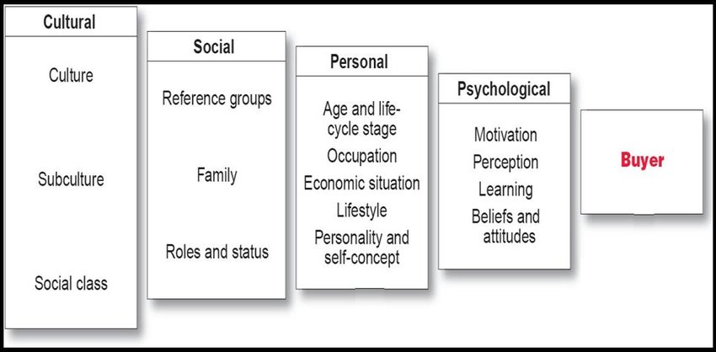 Source: Kotler and Armstrong, 2012

Section 5: Consumer purchase decision making

Studies of consumer behaviour generally analyse decision making in a rational approach. In this rational approach, individuals carefully and calmly combine as much information as possible with their previous knowledge of the product, carefully weigh the advantages and disadvantages of each choice, and arrive at a satisfactory decision (Kotler P, Keller K, BUbois B, Manceau D,2003).

Need Recognition:
Recognition of the problem occurs when the consumer feels that there is a significant difference between his condition at that time and a desired or perceived ideal condition. He recognizes that there is a problem to be solved.
Awareness of a need can occur in a number of ways: absence of a product, purchase of a product that does not satisfy, creation of new needs. This awareness can occur naturally, but is often stimulated by marketing efforts. In some cases, marketers try to create a primary demand, in which consumers are pushed to use a product or service, regardless of the brand. These needs are usually encouraged during the first phase of the life cycle of a new product. Secondary demand, in which consumers are stimulated to favour a specific brand, can only occur if primary demand already exists. At this stage, marketers are required to persuade consumers that their brand solves the problem better than competing brands.

Information search:
Once a problem has been detected, the consumer needs information to solve it. When he seeks information, he examines his entourage to collect the data necessary for a reasonable decision.

The different sources of information research:
It is, of course, very important for marketers to know the different sources of information the consumer uses and their respective influence on the final decision.
- Personal sources (family, friends, neighbours, acquaintances) ;
- Commercial sources (advertisements, websites, salespeople...) ;
- Public sources (press articles, comparative tests in consumer magazines);
- Experimental sources (examinations, handling, consumption of the product) (Lendrevie J; Lévy J; Lindon D, 2003)
Consumers rely on two types of information, internal and external information:
An internal search for information, the potential buyer uses his memory and knowledge of the product or service.
An external search for information: the consumer goes beyond his personal knowledge to make a purchase decision (Levy G , Lichti P,2011).

Factors influencing the consumer's search process:
It is important for marketers to understand the many factors that affect the consumer research process, including the following:
- The relationship between perceived benefits and costs: Is it worth spending time and effort to research information about the product or service?
- The locus of control, People with an internal locus of control feel they have some control over what happens to them. Individuals who feel this way will generally do more research than others. Those whose locus of control is external consider what happens to them to be the effect of fate or other factors beyond their control. From this perspective, it does not matter how much information they gather; if they make a good choice, they have no merit, but if they make a bad choice, it is not their fault either.
- Real or perceived risk :
Three risks inherent in the purchasing decision can delay and even interrupt the purchasing process: functional risk, economic risk, psychological risk. The higher the risk, the more likely the consumer is to conduct a thorough search for information.
- Functional risk is a perceived risk associated with a product or service that does not function properly.
- Economic risk is a risk associated with an expense that includes the initial cost of purchase and the cost of using the product or service.
- Psychological risk is the risk related to the feeling a consumer experiences when a product or service does not project the right image.
The type of product or service Another factor that influences a consumer's search for information is the type of product or service, particularly if it is a specialty product or service, a thoughtful purchase or a consumer product or service that is commonly used.
- Specialty products and services are products and services for which the customer demonstrates a strong preference and for which he is willing to make considerable effort to find the retailers who offer them.
- Thoughtful Shopping products and services are products and services for which the customer takes a great deal of time to compare the choices available to him or her.
- Thoughtful shopping products and services are products and services for which the customer does not want to have to ask questions before buying them. They are items that are frequently purchased without giving them much thought.
Consumers may spend a lot of time searching for a specialty product or service or making a thoughtful purchase. The only difference is the type of research the consumer does. In some cases, the customer's impressions and needs help to refine their search and the type of product they want to buy (Levy G , Lichti P,2011).

Evaluation of alternatives:
As information is received, the individual uses it to reduce uncertainty about alternatives and their relative attractiveness.
When consumers begin to evaluate available choices, their evaluation is often based on a series of important factors called evaluation criteria (evaluation factors are a set of significant elements about a given product), and consumers sometimes use shortcuts, such as determining attributes and decision rules.
Determining attributes are those elements of a product or service that are important to the buyer and that differ from brand to brand or store to store. Since many choices come face to face regarding certain evaluation criteria, consumers are looking for a distinctive element, a determining attribute, which they use to differentiate two brands or two stores.
As for consumer decision rules, these are a set of criteria that consumers take into account, consciously or unconsciously, in order to make a quick and informed choice among what is offered to them. There are several types of decision rules: the compensatory model, the non-compensatory model and the heuristic decision.
The compensatory model is a representation of the process by which the consumer evaluates the choices available to him or her and compares the characteristics of a product or service in order to determine which strong points compensate for the weak points(www.Sawtoothsoftware.com/productforms/ssolution/ss12.shtml).
The non-compensatory model Sometimes consumers use a non-compensatory model, in which they choose a product or service based on a subset of characteristics without paying attention to its other attributes (Jim Oliver,).

The heuristic decision, which consists of a mental process during which the potential buyer sorts out the choices available to him or her using various elements such as: price, brand, product presentation, etc....
Once the consumer has assessed the choices, he or she can move forward in the decision-making process and take the next step (Kotler P, Keller K, BUbois B, Manceau D,2006).

The purchase decision:
At the end of the evaluation phase, the consumer is given an order of preference which allows the different products to be ranked. When carrying out his purchase intention, he makes a series of decisions corresponding to the different dimensions of the purchase: brand, point of sale, quantity, method of payment and time of purchase.

Post-Purchase Behaviour
The fifth and final step in the decision-making process is post-purchase behaviour. Marketers are particularly interested in this type of behaviour because it no longer targets potential customers, but actual customers. They want customers to be unfaithful, to buy their company's products again and to have positive word-of-mouth. This is why customer loyalty is so important. Indeed, in general, post-purchase behaviour can have three positive effects on the company: greater customer satisfaction, less cognitive dissonance and greater customer loyalty.
- Customer satisfaction : Creating high customer expectations through advertising, personal selling or other promotional means can boost sales of a product for a period of time, but ultimately, when customers find that the product in question does not meet their expectations, they will remember their dissatisfaction and may experience negative word-of-mouth.
Marketers can ensure customer satisfaction by following these steps:
- Create realistic expectations for customers
- show the customer how to use the product or service
- Have confidence in your product or service
- Communicating regularly with the customer for him shows that the company cares about him and that it is committed to his total satisfaction.

- Cognitive dissonance: If the company is unable to meet the customer's expectations and the customer is not satisfied with the product or service he or she has purchased, cognitive dissonance can occur. This inconsistency is also known as "buyer's remorse" and a state of psychological discomfort caused by a dissonance between beliefs. Cognitive dissonance usually occurs when a person questions the appropriateness of a purchase decision after making it.
The chances of the buyer regretting the purchase are greater if it is an expensive product, an infrequent purchase, or if the level of risk is high.
Recognizing the drawbacks of cognitive dissonance, some product managers go so far as to direct promotional efforts towards the customer who has just made a purchase to avoid this situation.
- Customer Loyalty: In the post-purchase phase of the decision-making process, marketers try to establish a strong bond with the customer. They want customers to be satisfied with their purchase and return to their business.
Loyal customers always buy the same brands, they do not consider other brands or companies.

Figure 1.6 Costumer decision- making process
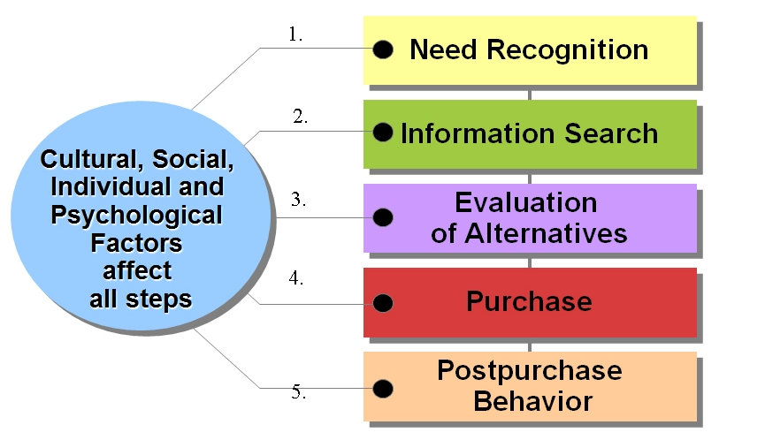
Source: marketinghuddle.com(2015)
Depending on the product, its price, the involvement of the buyer, the importance of the need, the buying habit... this process can be modified, in general, if the buying context change, the process is directly affected. The following cases can be mentioned (Levy G, Lichti P,2011):

Complex buying behaviour:
This type of purchase requires an intense search for information to justify opinions on each of the attributes, involvement is generally strong and the act of purchase follows an extensive resolution i.e. it integrates all phases of the process, it is used in the case of a completely new purchase, or a very large purchase.

Dissonance-reducing buying behaviour:
This is the case for low-risk products, for which the consumer is satisfied with little information. The process applied is limited and the consumer can do without one or two steps at the time of purchase.

Habitual buying behaviour:
The possibility of resolving this type of purchase is also limited. This is related to the fact that the product is becoming more and more familiar to the consumer; it is also known as the routine purchase, characterized by a poor search for information and a lack of comparison between products.

Variety-seeking buying behaviour:
In this case, the search for information is very important, the consumer examines the alternatives (evaluation, re-evaluation) after a stability phase. Possible causes of this purchase may be the search for new experiences, weariness or dissatisfaction after use.

Procrastination, postponed purchase:
When all phases of the process are respected, the buyer has not yet made a decision or is postponing the purchase due to lack of time or money.

Purchase thwarted:
At the time of use, the buyer feels reluctance due to feelings of guilt, shame or lack of boldness. The desire to possess or the desire not to damage can also be two other valid causes.

Impulse buying:
Impulse buying can be considered as an unplanned purchase, the consumer has an immediate feeling of need to buy which is sudden, often powerful and persistent, the impulse process manifests itself in three possible aspects :
The occasional impulse It is the act of noticing something interesting, again the buyer suddenly becomes motivated to buy it - this usually involves cheap products.
The typical impulse purchase: in this purchase, this feeling of urgency is stronger than in the impulse taken. These purchases are more emotional than rational.
The unavoidable impulse purchase: it is characterized by a feeling of urgency accompanied by a decrease in self-control.

Compulsive buying:
Compulsive buying is a psychological disorder that aims to buy in itself and not a particular product; compulsive buying is characterized by a strong propensity to spend. Clothing, cosmetics and gifts are the products most affected by this type of buying behaviour. However, Figure 1 illustrates the three types of purchasing, ranging from purely rational purchasing to the psychological disorder manifested by compulsive buying and impulse buying (Maria-Cristiana MUNTHIU, 2009).

Conclusion:
Consumer behaviour describes the way or manner in which a person acts to satisfy his or her needs and desires. Consumer behaviour is influenced by a number of factors: personal, psychological and socio-cultural.
It is important to understand these factors to try to determine what drives the consumer to buy and how potential buyers behave towards products.
It is therefore a question of knowing this behaviour and examining to what extent it is possible to adapt to it or influence it. On the basis of this knowledge, the company will be able to establish its promotional, advertising, pricing and distribution strategy.
This knowledge also extends to analysing purchasing behaviour in a family context, because the family is the centre of many decisions, especially in the case of products with family consumption.
In the next chapter we will focus on the family buying decision process, what factors influence families, the respective roles assumed by members.

CHAPTER TWO : FAMILY BUYING BEHAVIOUR

Introduction:
Individual consumer behaviour is strongly influenced by the family. His family educates him, and it is through them that he shapes his attitudes and acquires a set of notions regarding the world around it (political, economic, social, religious).
The study of the family as an environment of consumption and influence in purchasing represents a current of research which, over the years, has been able to build a foundation solid. Marketing researchers are interested in understanding the consumption behaviour of the family because it is considered the most important unit of consumption, and of decision making, so it is an agent of socialization. However, research on family buying behaviour has focused on the smaller unit (father, mother and child).
The literature review we propose to present in this chapter will be divided into several parts, starting with a definition of the main concepts: the unity of our analysis of the family, its different types and the family life cycle (FLC), then we will look at the different conceptual frameworks that have served as a reference for research on family purchasing decisions, and finally we will present family communication and socialization.

Section 1: Definitions and conceptualization of family behaviour
The individual does not live in a closed world. His actions are framed in a social environment that helps to influence them. In his youngest age, the consumer is influenced by his family in the first place, and later, friends or work colleagues take over (Lendrevie J.; Lévy J.; Lindon D, 2003).

The family, an original primary group:
The family is a group of human beings which admits different acceptations according to the cultures and the values ​​in place, in a given time, therefore it seems to specify what the concept of " group ”, and its different types (Dali youced S, 2012).

The notion of group:
According to Maisonneuve (1993) in psycho-sociology and marketing, by group is meant: "A set of individuals who share one or more objectives in common". Dubois (1990), for his part clarified that the group constitutes the basic cell of social life and ensures a double function with regard to the individual:
- A function of identification which translates that the human being affirms their identity through their social affiliation.
- The second normative function which leads individuals to adapt their behaviour, certain opinions, attitudes and values ​​to those of the group under the pressure of the latter in favour of conformity (Hammou-Poline Judith,1993).

_ The influence of the group on the individual manifests itself in particular through two types of groups:
- The group to which you belong is a group such as the family or the sports club; it is a group with which the individual interacts and whose prescriptions he will adopt (or move away from it by adopting a deviant attitude).
- The reference group is a "real or imaginary individual or group considered to have a significant interest in relation to an individual's assessments, aspirations or behaviour".

The influence of the group on the individual:
The group acts on the individual by encouraging him to develop social behaviour, helping him to become aware of himself, offering references of behaviour that he will tend to adopt to maintain membership in the group. Belonging to a group also allows an individual to become aware of himself in relation to the reference group. According to Hewitt (1970), this self-awareness has five components:
- An organized set of motivations;
- A series of social roles;
- A set of standards and their underlying values;
- Knowledge and understanding of group interactions;
- An assessment of one's own activities, qualities and motivations (Dubois B,1990).

The definition of the family:
The family has evolved considerably over the last century. Reproduction is under control, more and more women are working, providing a second salary and gaining independence. In addition, marriage is no longer for life: divorce is possible and widely practiced. Each member of the family claims his autonomy, the father having lost his authority. Faced with these developments, some have spoken of the death of the family. Bearing it, strong family ties continue to exist with the pairing of new solidarities: the grandparents become one of the pivots of the new model family (Dubois B,1990).
The family can be defined as: "Any association of two or more persons linked together by bonds of mutual behaviour, birth, adoption or placement, and who together assume responsibility for various combinations of some of the elements following: material maintenance and care of group members; adding new members through procreation or adoption; socialization of children; consumption and distribution, satisfaction of needs ... "The Vanier Institute of the Family

The typology of the family:
The term family covers a whole of very different realities, thus several classifications exist:

A classification of the types of the family:
Three types of families dominate , as in most Western societies: the married couple, the nuclear family and the extended family.
- The extended family was once the most common family unit, made up of three generations living under the same roof and including grandparents, uncles, aunts and cousins.
- The nuclear family, a mother and a father with one or more children, has become, over time, the traditional model. But the increase in divorces has allowed the emergence of the blended family.
- The blended family, comprising a couple of adults, whether married or not, living with at least one child.
- Single-parent families, including a single parent and one or more unmarried children (D’Astous Alain; Daghfous Naoufel; Balloffet Pierre et Boulaire Christèle, 2015).

Changing family boundaries:

It is important to remember that the family is not just a conglomerate or a group of individuals. The family is a complex system which links, to various degrees of kinship or proximity (members by alliance, godparents, friends, neighbors, etc.;).
We find in the first circle, the nucleus of the family proper. This nucleus is made up of parents and children, if there are any. This first circle constitutes what is often called the nuclear family.
If we add to this circle the people who are very closely related (grandparent, brothers and sisters, uncles and aunts), we define a larger family environment, the so-called extended family.
Other family circles can be drawn beyond these first two nuclei. The farther away from the first circle, the more the closeness of family ties tends to diminish, and finally includes all the people who are intimately associated with the family group, sometimes apart from all family ties, even by alliance. Less focused on religious values ​​and concerns, the current fault tends more and more to redefine itself around sharing or emotional expression, and to accommodate a certain independence of its members. It thus seems that we are gradually moving from a family subjected to a chosen family, the occasion for various meetings and reunions, but free from strict obligations, even if it is true that, within certain cultural communities, the definition and the traditional roles of the family are more marked (D’Astous Alain; Daghfous Naoufel; Balloffet Pierre et Boulaire Christèle, 2015)

The concept of household:
A distinction must be made between family and household. A household, in the statistical sense, is defined as "all the occupants of a main residence, whether or not they are related. A household can understand only one person ", In marketing this concept is often used, because a household constitutes a unit of consumption. A family is "the part of a household comprising at least two people and consisting either of a married or unmarried couple with or without children" (Denis Darpy, Valérie Guillard, 2003).

The family life cycle:
The concept of family life cycle makes it possible to account for the dynamics of family life, this life cycle is above all a metaphor. It is a convenient and useful presentation of the construction of the family unit through a number of stages (Schiffman Leon G; Kanuk Leslie Lasar, 1987).
The family life cycle can be defined as: "A process breaking down the different stages of an individual's life according to their age, marital status and the presence of children" (Pettigrew Denis et al, 2002)

The FLC model proposed by Murphy and Staples (1979):
The revised family life cycle consists of 5 major stages (young single people, young couples without children, other “young people”, middle-aged people, elderly people) subdivided into 13 subcategories. Figure 2.1 shows the different stages of this model:

Figure 2.1: The FLC model proposed by Murphy and Staples
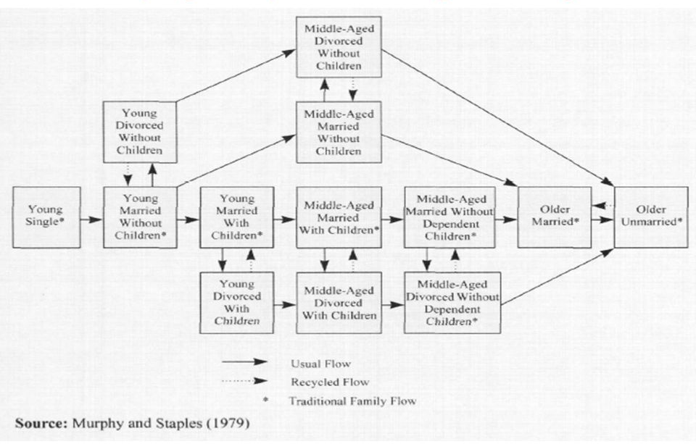

- The characteristics of this model:
1- The young stages: "The young single person" delays marriage and takes advantage of financial independence to increase consumer experiences. The second stage in the family life cycle is: "newlyweds without children", this stage is traditionally short (2 years) before the first child is born; however it lengthens for several years; due to the widespread use of contraception, the new vision of parenting as well as the increase in the number of women who want a career or who work for financial reasons. This allows the couple to rely on healthier financial foundations. Two developments are possible after this stage in the family life cycle: either "the young divorced couple" (the highest rates occur in the first years of marriage), this situation brings them back to the previous stage and then into a new life cycle in in the event of remarriage, the second possibility that may arise is that of "newlyweds with children". On the other hand, a divorce after the birth of the children requires the maintenance of two separate homes, which has serious financial consequences.
2- The stages corresponding to intermediate ages (35-64 years): During this period of life, six possible possibilities:
- "Married without children"; This group, although a minority, has a high purchasing power and consumption.
- "Divorced without children", Consumption varies according to socio-economic profile and occupation, some are financially well off, others experience financial difficulties.
- “Couples with young children and adolescents”, this group is the most numerous, is the most identical to that presented in the traditional life cycle.
- “Divorced with children”, this situation may be new or have started more quickly; in the first case, individuals bear the brunt of the difficulties associated with this change of situation, while in the second case, this adaptation has already taken place.
- The last two cases "married without dependent children" and "divorced without dependent children" correspond to the "empty nest" of Wells and Gubar.
3- The oldest stages:
These stages concern people who are married or alone (widowed or divorced). The theory accepted here shows that a widowed or divorced person of this age group can remarry (Dali Youcef S, 2012).
The concept of family life cycle interests marketers because it serves as a criterion for segmentation in many cases. In fact, depending on the number and age of household members, different needs and therefore very specific products appear.
A marketer would find many more sources of political innovation by examining deviations from the family life cycle model (e.g. targeting divorced people, single parents, elderly singles, etc.)
    - In this context, two family structures that should be the subject of increased attention from business leaders are highlighted: divorced people and couples without children (Van Vracan Paul; Janssens-Umflat Maritine, 1997).
    - Divorced people behave very differently from single people or married couples, especially when they have children. Women, who generally have custody of their children, often find themselves in a critical financial situation that support payments (sometimes very uncertain) do not necessarily balance. This often results in lifestyle changes for these families.
    - Divorced people also represent a real business opportunity for certain sectors, for example, they are not frowned upon by furniture manufacturers and real estate agents. Where it was enough to have an apartment large enough to accommodate a family with two children, you need, after separation, two apartments of more modest dimensions, both equipped to accommodate children (television, small tables, small dressers .. .) which makes certain say: "Ikéa succeeds because it makes removable furniture for removable households"( Meyer E,1992) .
    - On the other hand, without expressly wishing to do so, many couples who postpone the idea of ​​motherhood from year to year may have to remain childless. These couples, nicknamed DINKS (Dual Income No Kids), generally have two incomes and therefore live much more comfortably than their counterparts with children. In addition, they are distinguished by a different way of life. For example, they represent an attractive market segment for quality furniture, travel and luxury goods.

The Gilly and Enis model (1982) :
This model consists of dividing the family life cycle into three main stages corresponding to major changes in an individual's life. Thus, in a The first group is people under 35 years of age who represent young people. Right after that, are the median age (between 35 and 64 years of age). Finally, there is the middle age (persons over 65 years of age). After this age distribution, each of these groups can to in turn be divided according to the marital status of the people who make up the group and the presence or absence of a spouse. no children (Schiffman Leon G; Kanuk Leslie Lasar,).

Section 2: The purchasing process in the family

The home as a place of decision:
As for the study of decision processes within the family, there are two types of approach: functionalist perspectives and interactive perspectives.

Functionalist perspectives:
From a functional perspective, the dynamic structure of the purchasing decision in a family context can be defined as a problem-solving process comprising several stages in a structural and linear framework. The main emphasis is placed on the distribution of roles within the family, generally reduced to a couple, in terms of purchases. This decision-making process is then organized around well-defined roles (trigger, prescriber, informant, decision-maker, buyer, etc.
The essential element of the decision-making dynamic lies in the way in which these roles are distinguished. Within the family, the Functional theories frequently take gender as the main criterion for differentiation. Among the various theoretical currents, economists seem to be the only ones to base this differentiation of roles on the basis of inequality of income or resources. Supporters of other functionalist approaches often content to note this differentiation and to describe it as a product and cultural or social norms, without providing any real justification for the emergence of such norms.
The double perspective, which introduces a dichotomy between instrumental / objective roles (masculine ) and expressive / emotional (feminine), has been very successful. While such a differentiation seems unclear, the fact remains that, in the study of decision-making processes within the family in general, and of conflicts and decision-making within the couple in particular, many researches take as a starting point this differentiation of roles between the sexes.

The interactive perspective:

Interactive option: According to the interactive option, the purchase decision is rather considered as a construction between the different members of the family. Considering this interaction context, and its dynamics, often represents a real challenge or the course of market research. Nevertheless, a certain number of researchers are interested in taking into account the different objectives of family members in relation to a purchasing situation. Depending on how these objectives are taken into account, three categories of decision can be distinguished: Consensus; the definition of a common point; the whole family talks about a few models that caught everyone's attention and, without difficulty, a choice is made that pleases everyone enough.
- Accommodation; the acceptance of certain compromises;
- Decision making de facto the presentation of the decision as a fait accompli (Dali Youcef Souhaila,2012) .

Conflicts and the dynamics of decision-making:
The first objective of studies concerning decision-making in a couple has often been to establish the relative influence of each partner. The questions then are: who dominates? For what types of decisions? At what stages of the process? Under what conditions is a collegial decision likely to appear? The significant effect of the type of purchase envisaged as well as the stage of the decision process on the relationship of influence in the couple has thus been repeatedly demonstrated (Pettigrew Denis et al, 2002).

Types of conflicts:
Four types of conflicts are traditionally highlighted: conflicts of intra-class, inter-class preference, disagreements in principle and those relating to the definition of respective roles.
- Intraclass preference conflicts; appear when the two partners of the couple, while agreeing on the very principle of generic purchasing, have a different appreciation of the choices available to them.
- Preference conflicts between classes; reflect the existence of a disagreement on the generic purchasing project itself, this being often the subject, alongside other projects, all conceivable, but not simultaneously, of a certain prioritization or prioritization. So, to resume the first illustration.
- Principe The principle disagreement; corresponds to an unconditional opposition on the part of one of the spouses regarding a given purchase.
- Finally, it may happen that the couple, while agreeing on a specific purchase project, cannot reach agreement on the distribution of roles relating to the different stages of the decision-making process.

The main conflict factors:
In the context of the analysis of the couple's decision-making dynamics, the study of the emergence of conflicts is a subject of great importance.
The first set of factors for the emergence of conflicts corresponds to the very characteristics of the couple, mainly with regard to the stability and quality of family relationships. Within this first set, it is possible to cite the following factors:
- The degree of homogamy, that is to say the socio-cultural pairing of the spouses.
- Position in the life cycle.
- The degree of satisfaction with the union.
- Attitudes and beliefs regarding the definition of the roles of spouses.
- The employment status of women.
In addition to these characteristics of the couple, circumstantial factors can also have a profound effect on the nature of conflicts in purchasing decisions. For example, with regard to factors related to the family life cycle, the arrival of a first child, the transition from the groin to adolescence, the departure of the last child or retirement.
The loss or change of employment status as well as the change of domicile form another set of factors which do not depend strictly on the evolution over time of the family unit. The specific characteristics of the decision are also likely to explain the appearance of certain conflicts. Among these characteristics, we note the differences in risk perception and level of involvement of the spouses relative to the decision, the cost of the product, the routine or not of the purchase, as well as the relative convergence of the sources of information.
. The appearance of decisional conflicts in the couple should be seen as the "manifest" expression of certain disagreements between spouses around a purchase decision (Pettigrew Denis et al, 2002).
The existence of such disagreements may remain latent; it therefore does not always translate into the emergence of conflicts. The decision-making situation often acts as a catalyst, transforming latent disagreement into manifest conflict. When a purchase decision is made, each spouse, willy-nilly, is forced to take a stand. It is under these circumstances that they also develop different strategies for resolving or reducing the conflict.

Conflict resolution strategies:
Two main types of strategy can be identified: avoidance and resolution.
3.1 In the first case, that of avoidance, it is a question of escaping the manifest expression of disagreement.
Three categories or mode of avoidance are to be considered:
- The first mode is that of instrumentalized avoidance, in this case, thanks to the structuring of roles and the definition of spheres of action exclusive in the couple , to manage to avoid the emergence of overly acute conflicts:
- The sharing of spheres of influence can be based as much on the knowledge or relative skills of one and the other spouse as on the adherence to a certain socio-cultural norm .
- The management of specific discretionary budgets also participates and this form of avoidance.
- The second mode is that of deliberate avoidance, in which case one of the spouses simply decides not to get involved in the decision-making process.
As for unconscious avoidance, it is the result of a process in which spouses tend to implicitly assume the relative convergence of their points of view ((D’Astous Alain; Daghfous Naoufel; Balloffet Pierre et Boulaire Christèle, 2015).

Conflict resolution:
Once again, three main categories can be mentioned:
- As for the first category, the decision to be taken is considered above all as a problem to be solved, the couple then strives to develop strategies allowing him to come up with the best solution for the home.
Persuasion strategies correspond to the desire of one spouse to obtain the consent of the other by applying pressure that can take different forms (based on real or presumed skills, emotional blackmail, guilt, situation of non-choice). Unlike previous strategies, haggling methods involve the search for solutions through compromise, one seeking the consent of the other through various concessions or compensations (D’Astous Alain; Daghfous Naoufel; Balloffet Pierre et Boulaire Christèle, 2015).

Roles related to the family buying process:
Family members play a number of roles; when they make a collective decision. Depending on the decision, some or all members of the family concerned are involved, and the same person can play several roles, generally five basic roles are distinguished in the family(Amine Abdelmadjid,1999) :
- The initiator: is the one who breathes the wind of change , it refers to and informs of the existence of a new product or an innovative service. The initiator does so because he has been contaminated with a promotional item or hearsay. He is the first to suggest this new product or service.
- The influencer: an individual exercising influence at any level of the purchasing act and particularly during the final decision.
- The decision maker: he must answer a certain number of questions to consider the act of purchase. Thus, before taking on the role of the buyer - or convincing the one who will fill it - he must respond to a certain number of factors, such as the usefulness of acquiring the product, the place where it must be sold. how to do it. Once he has answered each of these questions, and has determined the real need to be filled. It’s the buyer's turn to come in.
- The buyer: the person carrying out the monetary transaction to receive the product in exchange for a sum of money. It is important for marketers to know who makes purchasing decisions in order to determine the target to be influenced.
- The user: is the one who enjoys this product or service. The user uses the product to obtain the performance corresponding to its functions. Sometimes the product is destroyed when it is first used (this is generally the case with food products), sometimes it is reused many times (household appliances) (Pettigrew Denis et al, 2002).
In certain cases, these roles can be fulfilled by the same person (for example the purchase of baby products is a function of the choice of the mother given the impossibility of the consumer to choose himself, in another field it is the woman who, according to common tastes, purchases hygiene products for men). Conversely, many complex products or services (such as a car, computer, apartment, vacation spot) involve several family members, which suggests a distribution of roles within the family. Because of the multiplicity of stakeholders and the roles they take on, the purchasing process within the family is complex. In this case, the marketing manager must identify the roles and the relative influence of the different family members, so as to better define the characteristics of his product and the target of his communication action.

Section3: The distribution of roles in decision making

Identify the decision maker:
It is important for marketers to know who makes the purchasing decisions in order to determine the target to influence. Many decisions involve several family members.
Researchers have shown that even for purchases often considered male, not only women, but also children and adolescents, have a say. Identifying the decision maker is particularly important, but difficult. On the one hand, each interviewee considers that they have an influence: it is therefore necessary to interview the various family members to get a more precise idea of ​​the perception of each member. However, the bias linked to modesty seems greater than that due to a dominating attitude. On the other hand, the weight of individuals varies according to the phase of the decision-making process. Finally, even if everyone chooses at first according to their own expectations, the needs of others are often taken into account in the subsequent phases, which leads to a collective preference.
Four factors seem to influence the distribution of roles:
1. The stereotypes of the roles of each sex. Couples attached to traditional stereotypes tend to respect them for the symbolic products of this distribution (products deemed typically male or female).
2. The resources of the spouses. The one of the two spouses who contributes the most to household income has the strongest influence.
3. Experience. Couples who have previous experience with independent decision-making more often make individual decisions.
4. Socio-economic status. Middle class families make more joint decisions than higher or lower class families ((Kotler P, Keller K, BUbois B, Manceau D,2004).

The heuristic in joint decision-making
The synoptic ideal would be for the spouses to adopt a common point of view and decide together. Evaluate the various options very conscientiously, they would divide up well-defined roles and calmly take decisions bringing mutual benefits. The couple would act rationally, analytically, using all available information to maximize joint utility. In reality, decision-making is often conflicting: a couple "comes to" a decision rather than "makes" it. Certain decision-making models frequently observed during the purchase phase demonstrate the use of heuristics:
- The couple's points of agreement relate to objective and obvious elements.
- The couple agree on a task sharing system, each responsible for certain tasks or areas of decision and does not intervene in the prerogatives of the other. For many couples, this distribution is often influenced by stereotypes of the role of each sex.
The concessions depend on the intensity of individual preferences. One spouse gives in to the other in some cases, simply because their preference for the attribute in question is not particularly intense, which will not prevent them, in other situations, from trying all means to get widely from his spouse when the stake is more important for him. If there are preferences marked within the couple for different attributes, rather than trying to influence each other, the spouses will swap a less intense preference for a stronger preference ((Kotler P, Keller K, BUbois B, Manceau D,2004).

Prescribing children:
Many authors agree on the importance of the influence of the child on family purchasing decisions. However, this convergence of views does not exist when we tackle the question of the various ways of exercising this influence. Despite the contradictory nature of the studies carried out, a certain number of salient points appear, which make it possible to describe the broad outlines of these forms of influence. It thus seems that, depending on the communication styles favored in the family, the characteristics of the family, the type of product and the stage of the decision-making process, the child's modes of influence will be different. The determination of a certain weight of influence in various fields of decision-making has long guided research carried out on this subject. Now, it is undoubtedly less important to understand this relative weight that dynamics obliges, of course, to integrate a new temporal or chronological dimension into the study scheme. Putting the emphasis on the process in this way has major methodological implications, particularly highlighting the qualitative study approaches. With regard to the products concerned, children seem to have all the more influence as their involvement in a product is strong. On this point, the analyzes hardly differ from those carried out with adolescents. However, it should be noted that, with the exception of leisure, when the products or activities are not intended for them a priori, and whatever their degree of real involvement, the influence of children tends to decrease a lot. With regard to the decision stages, the influence of the child is defined by means of certain roles (instigator, prescriber, influencer). If the child is rarely the ultimate decision maker, its potential influence on instigation and pressure seems obvious. The type of family in which the child evolves has of course a certain impact on the importance and the nature of its mode of influence. Thus, the blended nature or not of the family, the absence of a parent, economic well-being. Finally, some parents are more easily influenced than others or prefer more open forms of communication for children (Kotler P, Keller K, BUbois B, Manceau D,2004)
.

The case of adolescents:
The definitions of adolescence, unlike those of the child, are multiple. This multiplicity reflects the great diversity of visions of this period of transition between childhood and adulthood. If adolescence, as a biological fact, seems well inscribed in the very reality of the physical cycle of life, the cultural and psychosocial expression of this phenomenon differs greatly according to the societies and historical periods considered.
Sociologists thus favor a definition of adolescence as a "culture", born historically from the postponement of entry into the salaried labor market.
The sociological approach to adolescence is also very marked by theories relating to the definition of social roles. This period of life is in fact characterized by a transition from the roles and status assumed by the person. While these roles were defined by adults in the childhood period, adolescence is the time when the repertoire of individual social roles is developed. This development, not devoid of paradox, corresponds to a certain discontinuity which can sometimes be difficult to live with. Definitions of adolescence in psychology also refer to adolescence as a period of transition, accompanied by turmoil and radical behavioral changes. While there are many concrete definitions of the period of adolescence, they generally refer to the same chronological structure. There is general agreement that adolescence is the period of life between 11 and 18 years of age. Moment between transition from childhood to adulthood in Western societies, adolescence is therefore a period during which the person is gradually defined by the acquisition of various behaviours, skills, knowledge and attitudes, in relation with the plurality of its social roles, including those related to consumption. Adolescence is also a period when the individual gradually asserts his autonomy and seeks a certain form of social recognition. This conquest of autonomy is also reflected in the acquisition, if not of financial independence, at least of the ability to dispose of a certain amount of money at its discretion. The link between allocating pocket money and acquiring child and adolescent skills in consumption has been highlighted by numerous studies. The first form of influence that adolescents exercise in terms of family consumption is primarily due to their presence alone. Indeed, the arrival of a child in the family and its evolution until the end of adolescence is necessarily accompanied by a certain number of fundamental changes in the modes of economic decision-making of the family.
These changes affect the nature of the various purchases made - and the distribution of budgets - as much as the structures and forms of decision-making relationships within the couple or the family as a whole. Beyond this influence remains the question of the actual impact of the adolescent within the decision-making process, regardless of the stage of the decision-making process in question. Can the adolescent be considered in this perception as a full actor in the decision? While it tends to exert a certain influence on the choice of various products, the adolescent's place in decision-making often appears marginal. The financial aspects of the decision are, in particular, those for which the adolescent is least concerned. It is interesting to note that these observations are consistent with those obtained in the study of the influence of children on economic decision-making in the family. As in the case of children, this influence seems in fact to be confined to the area of ​​purchasing products for which it is used only. Adolescent also has greater influence over the choice of brand, style or aesthetic aspects of different products or services. Finally, the importance of commercial brands in asserting their own identity and belonging to different groups is considerable ((Kotler P, Keller K, BUbois B, Manceau D,2004).

Women business and marketing:
The growth of women's business is one of the major events of this century.
The weight of the family on female activity is becoming less and less obvious, but the relationship between education and activity level is extremely clear, the more educated women are, the more active they are. The level of education does not only weigh on the volume of female activity, it also imprints the cycles of activity. Women who have a high level of education more often pursue a continuous career, a career that does not end with the birth of children (Van Vracan Paul; Janssens-Umflat Maritine,1994).
As a result, women's work is undoubtedly a stimulating factor for the consumption of certain goods such as clothing or cosmetics (Dubois Bernard,) .
A direct link can therefore be established between women's activity and the household's supply of goods and services. Such as microwaves or mail order products time savings have undergone an extraordinary development in recent years.
Danielle Roy (2003) RESIS (Strategic Information Network for Enterprises) considers the women's segment as a privileged target of marketing strategies and an object of all the attention from the distributors because:
- Women are the majority of the household budget.
- The total income of the millions of women who have entered the labour market has been increasing.
- Measured in millions of euros. Even though women still earn less than men, they are still the most vulnerable. men in general, their economic power is colossal, and all the more so because they are
- Interesting that their relationship to consumption is very recurrent.
- Women buy or influence the purchase of 70-80% of all products. Whereas that the man buys for himself, the woman buys for herself and the whole family.
- The woman mother of the family remains a classic target.
- The number of women living alone is increasing sharply. The single woman The decision-maker therefore represents a substantial market for car salesmen, computers or mobile phones... etc.
- In a couple, the woman often spends her own salary but also a good part of her husband's salary. In addition to daily domestic purchases, she buys for her own needs as any woman does alone, but she is also increasingly involved in the big family expenses.
- Generally speaking, it is most often the woman who initiates an expense and who, moreover, prepares the investment by seeking prior information and making the first selections. At the extreme, one could almost say that the woman prefers to have nothing rather than not to choose.
- Women practice and have learned to love change to the point of making it a way of life. In a single day, their lives are full of activities and they wear several hats. They are in control of all the movements in the household. (work, stewardship, practical and economic management, intra and inter...) and This protean aspect of women's lives translates into a multiplication of needs.

Factors influencing the family purchasing decision process:
A variety of factors that come into play in the family purchasing decision process: there are the degree of involvement of family members and the types of purchase.

The degree of involvement:
The implication indicates to what extent the consumer feels concerned by the purchase. Several studies that have been carried out in the field of purchasing decisions within families have given rise to two theories: the ideological theory, according to which social and cultural norms determine the roles played by each spouse in the family, and the theory of implication, which stipulates that the influence of a spouse on a purchasing decision depends on his interest and his knowledge of the product (Qualls, 1987) .
And depending on the level of involvement, the contribution and relative influence of each family member will be determined within a family purchasing decision. Originally, involvement was a concept stemming from work carried out in social psychology. Sherif and Cantril (1947) are considered to be the fathers, since they give the first true definition, according to them: "Implication is a state of tension that arises in the individual from the link between his values fundamentals and a situation ”. The way he reacts to a given problem is therefore the consequence of his involvement in the situation, which itself derives from the values ​​involved, the importance they have for him, and the strength of their relationship to the context (Brée joël,)
- In marketing Zaichkowsky (1985) defined involvement as: "The importance given to an object by a person according to his own needs, values ​​and interests". The term object is used in a generic sense and refers to a product (or brand), an advertisement or a purchasing situation. Consumers may feel involved with all of these items (Solmon Michael R, 2005).
- Mitchelle (1979) on her part gave the following definition of implication: "It can be defined as the motivation to process information". The consumer will be attentive to any information on the product. If he perceives a link between his needs, his objectives and his values ​​and the knowledge of the product. As engagement in a product increases, consumers pay more attention to product-related ads, and develop an effort to recognize it (Solmon Michael R, 2005).

Types of involvement:
Researchers in consumer behaviour distinguish three types of involvement: in relation to advertising, in relation to the product and in relation to the purchase decision. Each type of involvement is caused by specific antecedent variables and gives rise to distinct consequences (D’Astous Alain; Daghestan Naoufel; Balloffet Pierre et Boulaire Christèle, 2006).
- Involvement in relation to advertising: this type of implication refers to the conceptualization of Krugman. Consumers strongly involved in advertising will be more inclined to listen carefully to the advertisement, to advance objections (against argumentation) later and to make associations, unlike consumers less involved. Television is seen as a medium of low involvement because viewers are often passive and exercise little control over the content. On the other hand, magazine advertisements constitute a medium with strong implication.
- Involvement in relation to the product: in marketing, he often comes to speak of products with low or with high implication.
The involvement in relation to the product depends on each person. Each consumer has a level of interest in a given product. Purchases can be involving even if they do not generate large sums of money.
- Involvement in relation to the purchase decision: Means the possible differences in implication for the purchase of the same object depending on the contexts. Depending on the case, the stake, the social risk is more or less important (for example: when we want to offer a gift to a loved one), a consumer who is weakly involved will tend to seek less information, not too much reflect and make few comparisons between brands. It is quite obvious that a weak implication is associated with a limited purchasing process, with in particular, a reduced search for information, whereas a high implication will require the consumer to engage in a purchasing process extended.

Measuring involvement:
Measuring involvement is important in many marketing situations.

The Zaichkowsky (1985) scale:
Judith Zaichkowsky (1985) is interested in the concept of personal involvement, which she describes being the importance, the relevance of an object in the context of needs, values ​​and interests of a consumer. It proposed (and validated) a scale allowing to measure the personal implication towards a product, a brand. The measurement of involvement consists in asking consumers to answer ten scales from 1 to 7 concerning their attitude towards the object studied (product, brand, advertising, etc.), under two dimensions: affective involvement (by example, exciting / not exciting) and cognitive implication (example: useful / not useful). The items on the left are noted "1" (which corresponds to a weak implication) and the items on the right "7" (strong implication) except for the reverse statements, where it is the opposite, the ten statements cumulate a score ranging from 10 to 70 (D’Astous Alain et al, 2006).
Figure2.2: The Zaichkowsky (1985) scale
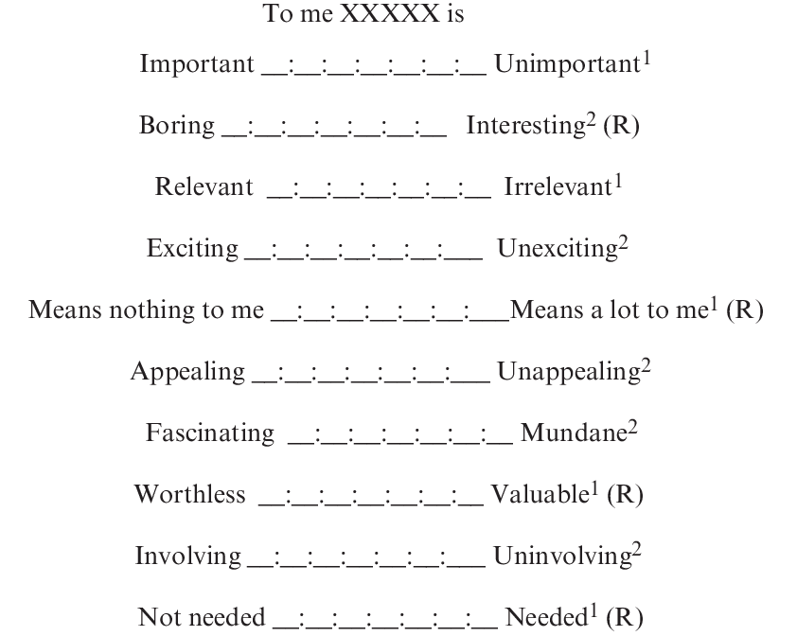
Source: ZaichkowskyJ.L, (1994)« The personnel Involvement Inventory:
Rduction, Revision, and Application to Advertising », Journal of Advertising, vol. 23,
n°4, December, pp 59-70

Jean-Noel Kapfer and Gilles Laurent's (1986) involvement profile scale:
These researchers consider that involvement in a category of products can result from personal factors (the consumer's personal interest, enjoyment and the image it projects) and the perceived risk of it, have developed a scale of involvement.
It is a global multidimensional scale that makes it possible to determine profiles involvement with a product category.
Five dimensions are retained: (interest, pleasure, sign, proberr, import)
- The consumer's personal interest in the product category. (interest)
- The pleasure associated with the product category. (pleasure)
- The sign value of the product category. (sign)
- The importance of the negative consequences of a wrong choice (risk importance).
- The probability of making a bad choice. (proberr) (Bree Joël, 2003).
Using their scale, Kapferer and Laurent were able to determine ten involvement profiles specific180 (Bree Joël, 2003):
Minimal involvement: corresponds to the lowest experience on all components (disinterest in the product and lack of perceived risk). The consumer buys first of all a product and a price; it is very sensitive to brands.
Functional differentiation: reflects the perception that an error in choice can be pretty serious. At similar price levels, the consumer is attentive to respective performances of the brands.
The risk of being overdramatized: is a profile for which pleasure, sign and interest are low, but for which an error of choice would have functional consequences, or financial. The consumer does not judge brands as a guarantee of quality; for him, the most important thing is to choose the right products based on a quality assessment. attribute performance (the price should remain reasonable).
Small pleasure: is characterized by a high hedonic value in the category of products, although interest is low. Consumers know what they like and do not want to buy. don't be afraid to make a mistake. It's a configuration where promotional benefits facilitate unpremeditated purchases.
The conformist purchase: and the consequence of an over-valuation of the significance of the choice and the risk associated with the decision, even if the product is not of interest to the individual, who is not very competent in the field.
Safe involvement: this is the consequence of high levels of both the sign, on interest and pleasure, but where both components of the perceived risk remain weak. So we're dealing with a consumer who considers himself to be competent, and who will sacrifice the price to acquire the mark considered to be the best.
Functional implication: is a scheme where the values of sign and pleasure are modest, but where the other three facets reach high levels. What is to make sure that the consumer is not mistaken about the performance of the product. This generally leads to strong brand loyalty and a mistrust of new products.
Pleasure involvement: is an involvement where only the sign value is not strongly present. The consumer is simultaneously looking for performance and pleasure. He is insensitive to price variations, on the other hand, the brand is decisive for him.
The need for care: exists when the consumer does not perceive a real difference between the brands and is unfamiliar with the class of goods. This profile is common in the purchase of goods such as household appliances, where the meaning of the product is not clear. The social impact is small, but the consequences of making the wrong choice are serious. It is therefore not very sensitive to brands, but very attentive to decision support advice.
Maximum involvement: Finally, this involvement reflects a high level of involvement in the five facets. Consumers are looking for brands that allow them to differentiate themselves and to convey the image he wants to give of himself (Bree Joël, 2003).

The type of purchase:
Family purchasing behaviour also depends on the decision under consideration. The process can take place more or less exhaustively depending on the type of purchase. Purchases fall into three categories:
1. Current purchase: includes everyday consumer goods (cleaning products, food, etc.);
2. Thoughtful purchase (furniture);
3. Specialized purchasing (hi-fi equipment).
The passage from one category to another, the importance of the purchase increases, thus its degree of complexity. For everyday purchases, the consumer follows a simplified process, bringing him directly from the awareness of the need to the decision for the other categories, a more complex process will be used.
Likewise, a distinction must be made between new purchases and re-purchases. In the first case, the consumer's reference system is not yet structured, it is not familiar with the competing products or the criteria to choose from.
A complete problem-solving process must be developed, going through all the stages. In the other case, the process is practically automatic to the extent that the product purchased has given satisfaction (Dali Youcef S, 2012).
Section 4: Family communication
The family, by its nature, is one of the privileged places of the intersection of intra and intergenerational communications having a determining influence on family consumption behaviour (Wilkie, 1990) Moschis (1985) defined family communication as representative all the verbal or non-verbal communication processes, between parents and children, and interaction structures without reference to specific content. Through this definition, the author emphasizes the structural and dynamic dimensions of family communication, rather than its content or intensity aspects.
Two essential dimensions are distinguished to describe the structures of communication:
- The social dimension (or orientation): which corresponds to the search for harmonious and socially positive relationships within the home? In this context, great importance is given to parent-child relationships. The expressive role often associated with the mother is also privileged, even if this results in systematic conflict avoidance strategies.
- Conceptual orientation: this dimension corresponds to the efforts undertaken to encourage the child's learning of autonomous and effective knowledge about the outside world. The figure illustrates the four basic family communication modes that have been identified by Mcleod and O’keefe (1972) . These authors were able to note the presence of significant differences with regard to the knowledge acquired in the field of consumption by children according to the preferred mode of communication in their family (Balloffet Pierre, 2000).

This model allowed Carlson et al. (1988) to identify the four types of family communication modes by combining the two dimensions (social orientation and conceptual orientation):
- laissez-faire: parents belonging to this category have neither a social orientation nor an orientation conceptual. There is therefore very little communication within the family. For these families, communication is therefore very weak or even absent.
- Protectors: Protective families encourage respect from parents and control socialization. Protecting families emphasize social orientation in communication and avoid conflict. Communication aims to develop social harmony based on obedience.
- Pluralists: these families want to encourage discussion without insisting on obedience. The child is encouraged to explore and express new ideas without fear of controversy. However, in this type of family, respect and mutual interest are also demanded.
- Consensuals: the latter encourage both social and conceptual orientations, the child is encouraged to take an interest in any type of discussion. The child is encouraged to take interest in the ideas around him without disturbing respect for family hierarchy and internal harmony (Gouta Nadia, 2007).

Section 5: Socio-demographic characteristics in Algeria

The resident population:
During the year 2018, the resident population in Algeria is estimated at 42,578,000 people as of 1 July. The natural increase recorded during the year reached 845,000 people, with a natural growth rate of 1.99%, registering a decline of 0.1 point compared to the year 2017. It should be noted that this is the first time since 2009 that this rate reaches a level below 2%. Two factors may explain this decline; the decline in the volume of births compared to 2017 and the increase in the volume of deaths.
The population density (people per km2 ) in Algeria was 17.73 km2 in 2018, according to the World Bank's Development Indicators Collection, compiled from officially recognized sources. Algeria - Population Density (persons per km2 ) - Actual values, historical data, forecasts and projections were provided by the World Bank in July 2020 (www.Insee.com).

Figure2.4: The resident population in Algeria
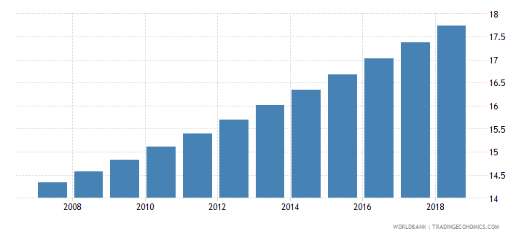
Source:Insee.com

Population structure:
A summary reading of the structure of the population by age and sex, as of July 1, 2020,
As a result of the rising birth rate, the share of the population aged under five years increased from 11.9% to 11.8% between 2017 and 2018, while the share of the population aged under 15 years continues to grow from 29.7% to 30.1% during the same period.
The share of the population of working age (15 to 59 years) continues to register a decline, from 61.1% to 60.6%, between 2017 and 2018.
The share of people aged 60 and over increased from 9.1% to 9.3% during the same period. In volume terms, the number of persons aged 60 and over reached 3,969,000 (166,000 more than in 2017).
The volume of the female population of childbearing age (15-49 years) has reached 11.0 million women compared to 10.9 million in 2017.
The change in the age structure significantly affects the level of the demographic dependency ratio, which is defined as the ratio of the number of persons under 15 years of age and those aged 60 and over in relation to the population of economic activity age (15-59 years).
This ratio continues to increase to 65.2 per 100 people of working age, compared to 63.5 in 2017 and 55 in 2010.
This increase is a result of the upturn in the birth rate that has been underway since 2003, combined with the increase in life expectancy at birth. Declined by age group, it is 49.8 persons under 15 years of age and 15.4 persons over 60 years of age per 100 persons of working age (www.Insee.com).

Figure 1.5: Algerian Population structure
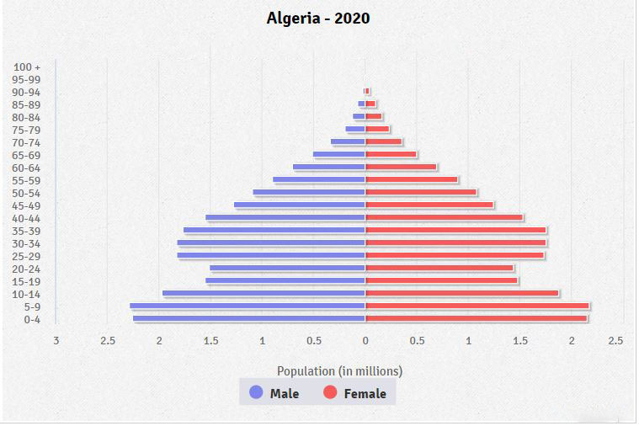
Source: Insee.com

Mortality rate:
The infant mortality rate (per 1,000 live births) in Algeria was 20.1 in 2018, according to the World Bank's Development Indicators Collection, compiled from officially recognized sources. Algeria - Infant mortality rate (per 1,000 live births) - Actual values, historical data, forecasts and projections were provided by the World Bank as of July 2020 (www.Insee.com).

Figure 2.6: Mortality rate in Algeria
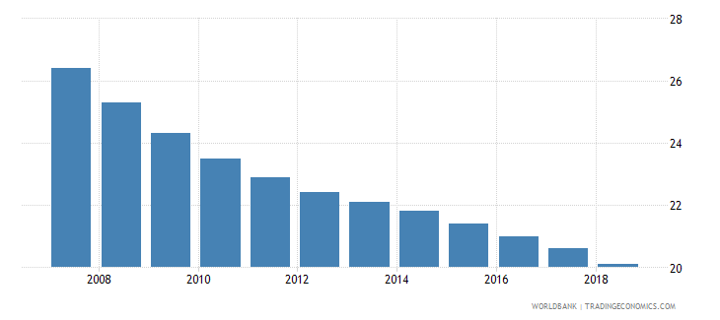
source : Insee.com

Evolution of consumer prices of the city of Algiers from 2010 to 2019:

Table3. 1: evolution of consumer prices in Algiers from 2010 to 2019
 | 2010 | 2011 | 2012 | 2013 | 2014 | 2015 | 2016 | 2017 | 2018 | 2019
Overall Index | 136,23 | 142,39 | 155,05 | 160,1 | 164,77 | 172,65 | 183,7 | 193,97 | 202,25 | 206,2
Variation (%) | 3,91 |  | 8,89 | 3,25 | 2,92 | 4,78 | 6,4 | 5,59 | 4,27 | 1,95
Source: Ons.dz
A downward trend in the rate of increase has characterized the last three years .
Consumer Price Index. In fact, after a variation of +6.4% in 2016, this rate is expected to rise to +6.4% in 2017. rises to +5.6% in 2017 to reach +4.3% in 2018 and close to +2.0% in 2019.
This deceleration affects several goods and services, including food and non-alcoholic beverages, the Body Health and Hygiene group and the Transport and Communication group.
Food goods stand out with a negative variation, i.e. -0.6% in 2019 compared with the previous year, which saw an increase of 3.4%. After growth of 4.1% in 2018, the Body Health and Hygiene group marks a new milestone in the slowdown by recording a change of +3.1%. The same was true for Transport and Communication, which rose by 5.5% in 2018 to 1.2% in 2019.
In terms of level, the general consumer price index of Greater Algiers stands at 206.2% in 2018 and 1.2% in 2019. points in 2019.
From 2001 (the index's base year) to 2019, the general price level was multiplied by 2,1 (ONS.Dz).

Evolution by category of goods and services:

Figure2.7: Evolution by category of goods and services
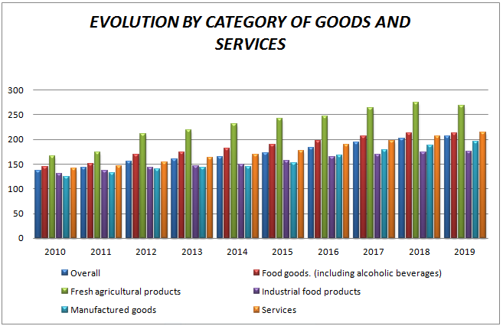
Source: Made by us based on ONS.dz

Food goods show a marked slowdown in the rate, from +3.4% to +3.4%. in 2018 to -0.6% in 2019.
This trend particularly affects fresh agricultural products, whose prices are on the rise, respectively, from +4.1% to -2.2%.
Industrial food prices follow the same trend, however with a slower pace. Indeed, the growth of the latter increases from 2.6% in 2018 to 1.1% in 2017.
in 2019 The change in prices of manufactured goods rose from +5.1% in 2018 to +4.2% in 2019. This deceleration of the rate of increase is observable from 2017 onwards, after a remarkable growth recorded in 2016 (+10.0%).
The consumer price index for services is expected to rise by 3.7% in 2019, a rate that is expected to remain at the same level as in the previous year (+10.0%). similar to that observed in 2017.
Compared to 2001, the average level of prices of food and services has been multiplied by 2.1 (ONS.DZ).

Evolution of home furnishings consummation:

Figure2.9: Evolution of home furnishings consummation
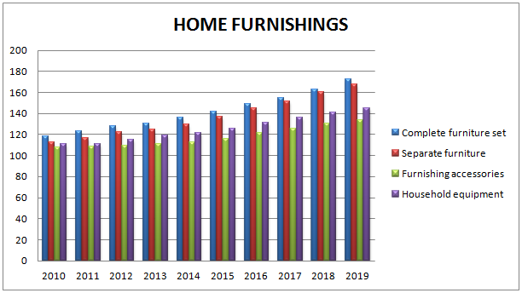
Source: Made by us based on ONS.dz
Furniture and furnishings are up 5.0% in 2019 compared to the previous year. The previous year was characterised by a relatively similar rate (+5.4%).
The complete set of furniture shows a variation of +5.6%, a rate similar to that recorded in 2018 (+5,6%).
Same observation for upholstery fabrics and carpets and kitchen utensils others metal, whose price growth, at 8.4% and 6.6% respectively in 2019, will remain at the same level as that of similar to that of 2018 (+8.5% and +6.6% respectively).
On the other hand, separate housing shows a deceleration in the rate of increase, although the rate of increase is still very high. growth remains relatively high. The latter increases from +5.9% in 2018 to +4.3% in 2019.
Household equipment and furnishing accessories show respective variations of +5.9% and +4.3% in 2019. +2.9% and +2.5% in 2019 compared to 2018, which was characterised by slightly higher rates in 2019 and 2018. (+3.6% and +3.7% respectively).
Metal cookware registered an increase of 9.2% in 2019 compared with the previous year. This was a smaller but still significant increase (+8.6%) (ONS.DZ).

Conclusion:
The family as a social group is an important field for studying consumer behaviour, since the number of intersections between its members creates an influence on a decision-maker, especially in the case of products for family consumption.
The study of the influence of different family members on purchasing decisions is an important field of research. Another point of interest in the area of marketing research that focuses on the family buying behaviour.

CHAPTER THREE : RESEARCH AND ANALYSIS

Section 01: Methodological Approach to the Survey
Empirical study is a critical step in the development of research work. It is an inquiry based on experience and observation rather than theory, and this with pragmatic methods.
We will describe below in detail the steps of the methodology followed

The Objective of the Survey:
The objective of our survey is to determine first of all whether the Algerian family consumes local household appliances, and the factors that influence a decision-maker member to buy them.

The choice of survey tool:
In order to be able to provide answers to our questions, we launched the questionnaire on Google and social networks.
This type of tool, which is the questionnaire, seems the most appropriate, given the quantitative nature of the questions that have been raised. Also the fact that the number of users of the internet and social networks which represents our field of investigation is consequent, it is more judicious to use the questionnaire for the collection of data.

Structure of the questionnaire:
In order to answer the question of what factors influence the decision-maker, we raised 18 questions.
- 10 questions out of 18 will allow us to profile this customer.
- 1 question out of 18 to find out which product the consumer got the product from.
- 3 questions out of 18 will allow us to know the role played by this consumer during the purchase process.
- 1 question out of 18 will allow us to know why they buy a local product.
- 3 questions
The nature of the questions asked is closed and open-ended questions. is justified in terms of the number of questions to be asked, the sample to be interviewed, and the mode of administration of the questionnaire which will be done by internet and this in relation to our research based on social networks.
That said, we opted for both closed and open-ended questions in order to identify the answers and lead to more relevant results.

The temporal and spatial dimensions of the survey and the way the questionnaire is administered
Given the impossibility of opting for a random sampling mode that requires a database, we opted for a non-random mode during which we administered our questionnaire to a sample of a population of 172 people of Algerian origin.
The administration of the questionnaire was carried out using various tools and media, in particular face-to-face and internet (social networks and email in particular).
Our investigation took place over a period of during which we noticed that the majority of respondents on the internet among others facebook are young people, so we targeted facebook groups for older people and used face-to-face to target this category.
At the end of the information collection phase, we proceeded to analyze the data using Microsoft Excel, google sheets and spss, and this according to two sorting:
- The low sort: This consists in reorganizing all the values into a single variable
- Cross-sorting: where we analyzed two relationships in a single variable.

Statistical tools used in the study:
In order to carry out the study, the student used the Statistical Package for Social Sciences (SPSS), in order to perform the necessary statistical analyzes of all data collected from the field study, relying on Standard Multiple Regression.
Standard Multiple Regression between two variables which measures the non-causal relation between them in order to know its degree and its direction. Suppose we have an independent variable and a dependent variable, which aims Regression to get a mathematical picture of the relationship that binds the variable (Variables) independent of the dependent variable. We call it the regression equation Y.
In Multiple Regression we assume that we have a dependent variable that we denote by the symbol X is a variable that we denote by the symbol, 1 m and a group of independent variables whose number is. X2, ..., Xm
Section2: describing the personal variables of the sample
- The gender distribution of our sample:
Table 3.1: Distribution of the sample according to gender.
Designation | Headcount | Percentage
Men | 85 | 49,4%
Women | 87 | 50,6%
Total | 172 | 100%
Source: Based on survey data.
Figure 3.1: Distribution of the sample according to gender.
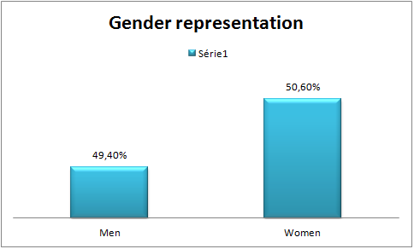
Source: elaborated by us using excel

Our survey sample is predominantly female 50.6 % of the population is male and 49. 4% is male.

- The distribution of our sample according to age:
Table 2.2: The distribution of our sample according to age.
Designation | Response Frequency | Pourcentage
Under 20 y o | 17 | 10%
20 y o- 30 y o | 122 | 71%
31 y o- 40 y o | 22 | 12,8%
41 y o- 50 y o | 5 | 2,90%
More than 50 y o | 6 | 3,50%
Total | 172 | 100%
Source: Based on survey data.
Figure3.2: The distribution of our sample according to age.
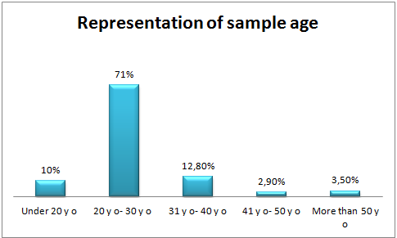
Source: elaborated by us using excel

Here we wanted to target all age categories, so our population is mostly made up of young people, the 20-30 year-old category makes up 71% of the sample, while the [31-40] year-old category they represent 12.8%.
3.5% are over 50 years old. 2.9% between 40 and 50 years old, 10% less than 20 years old.

- Distribution of our sample according to marital status
Table 3.3: Distribution of our sample according to marital status.
Designation | Response Frequency | Pourcentage
Single | 64 | 36,2%
Married | 106 | 61,6%
Divorced | 2 | 1,2%
Total | 172 | 100%
Total | 172 | 100%
Source: Based on survey data.
Figure 3.4: Distribution of our sample according to marital status.
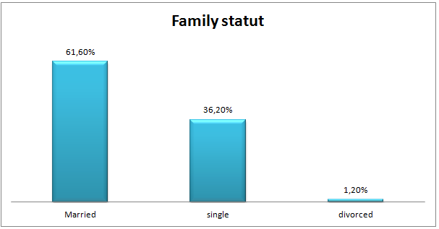
Source: elaborated by us using excel

Our survey sample is predominantly Married 61.6% ; 36.2 % of our survey are single and just 1.2% are divorced.

- Distribution of our sample according to family members
Table3.3: Distribution of our sample according to family members.
Designation | Response Frequency | Percentage
Father and mother | 28 | 16,3%
Father and mother and children | 117 | 68%
Grandfather and/or grandmother, father; mother, children | 16 | 9,3%
Father or mother and children | 13 | 6,4%
Total | 172 | 100%
Source: Based on survey data.
Figure 3.5: Distribution of our sample according to marital status.

Source: elaborated by us using excel

Our sample is largely dominated by the "father, mother, children" family type which represents 68%, 16.30% represents the "father and mother" family type, while the extended family type represents 9.3% of our sample, and only 6.4% represents the "father or mother and children" type.

- Distribution according to educational attainment
Table 3.4: Distribution according to educational attainment.
designation | Response frequency | Percentage
Primary | 0 | 0%
Middle | 3 | 2%
Secondary | 17 | 10%
University | 152 | 88%
Total | 172 | 100%
Source: Based on survey data.
Figure 3.6:Distribution of our sample according to marital status.

Source: elaborated by us using excel

The majority of our student sample is represented by academics at 88%, only 10% with secondary education attainment, 2% with middle education attainment.

- Distribution of our sample according to socio-professional situation
Figure 3.7: Representation of our sample according to the socio-professional situation

Source: elaborated by us using excel

We observe that 11% of our sample are not working (inactive), housewife, 22% student, just 2.3% are “skilled worker, carpenter, electrician, plumber, sales assistant, chef, waiter” …
35% are “clerical worker, bank clerk, civil servant” and they represent the majority of our sample, 12.8% are “Middle manager, officer, middle civil servant, small business owner, teacher”. Then “senior executive, professional, senior civil servant, liberal profession, owner of SMEs” represent 8.7 % of our sample, 5.2% are “Director, head of department, owner of a large company, senior state official …”, only 2.9 % are retired.

- Distribution by income
Table3.5: Distribution of our sample according to income.
Designation | Response Frequency | Pourcentage
[10000 -20000] DA | 47 | 27,5%
]20000-30000] DA | 4 | 2,3%
]30000-40000] DA | 12 | 7%
]40000-50000] DA | 26 | 15,2%
More than 50000 DA | 83 | 48%
TOTAL | 172 | 100%
Source: Based on survey data.
Figure3. 8: Distribution of our sample according to income

Source: elaborated by us using excel
According to the above results, we noticed that our sample is composed of 48% of people with a salary of more than 50000Da, People with salary between 40000DA and 50,000DA representing 15.2% of the respondents, 7% represent people with a salary ranging from 30000 DA and 40000 DA, and for people with a salary less than 10000 DA up to 20000 DA represents 27.5%.

Figure3.9: Marriage duration representation

Source: elaborated by us using excel
It can be seen that the group of married people differs in terms of marriage duration, 43 of them the duration of their marriage ranges between one and ten years, and 22 of them their marriage range between 21 year and 30 years, for the duration that range between 11 years and 20 years, we notice 8 individual, for more than 3o years we have 5 individuals, and 5 person didn’t mention their marriage duration.
Figure3. 10: Representation of Children’s number

Source: elaborated by us using excel
We can see the discrepancy in the number of children in families, 23 of them have 2 children, 15 have only one child, for those who have 3 and 4 children we have 12 responders, only one with 6 and 8 children.
Figure 3.11: Product distribution

Source: elaborated by us using excel
Through the graph, we can say that international brands are more popular than local brands, many do not buy devices with limited or little consumption like: Hifi system, cooler, playstation games.

Section 03: Analysis of Survey Results
Have you decided buying a local product?
Table 6: Decision maker representation.
Designation | Response Frequency | Percentage
Yes | 125 | 21%
No | 47 | 79%
Total | 172 | 100%
Source: Based on survey data.
Figure 3.12 : Decision maker representation

Source: elaborated by us using excel

1 Presentation of our study using The Standard Multiple Regression:

Through this title, we will try to present the study model using Standard Multiple Regression in order to find the most influential variables in the decision-making process, or in other words, to determine the most influential variables in the process of buying a local product.

Table 3.9: Descriptive statestics.

Descriptive statestics
 | Mean | Std.  deviation | N
buying_decision | 2,82 | ,403 | 172
Marital_situation | 2,81 | ,988 | 172
Marriage_duration | 1,93 | 1,465 | 172
children_num | 1,93 | 1,385 | 172
Children_age | 4,28 | 4,789 | 172
family_members | 4,33 | 1,077 | 172
education_level | 4,83 | ,538 | 172
Occupation | 5,18 | 1,819 | 172
Age_impact | 3,87 | 1,517 | 172
Gender_impact | 3,96 | 1,480 | 172
Incomes_impact | 3,89 | 1,404 | 172
Groups_impact | 3,84 | 1,323 | 172
Advertasing | 3,41 | 1,163 | 172
Odor_impact | 6,20 | 2,464 | 172
Light_colors_impact | 4,13 | 1,277 | 172
Music_impact | 3,72 | 1,503 | 172
Articles_arragement | 4,39 | 1,772 | 172
Space | 5,25 | 2,121 | 172
Staff | 6,06 | 2,455 | 172
Impact_caractheristic | 6,90 | 3,056 | 172
garantie_impact | 4,64 | 1,304 | 172
Serviceav | 4,80 | 1,343 | 172
Agesample | 3,11 | 2,185 | 172
Source : Based on spss outcomes

The first table gives us the mean and standard deviation for each variable separately

Table 3.8: Variables Entered/Removed

Variables Entered/Removedª
Model | Variable Entred | Variables removed | Method
1 | Agesample, Groups_impact, education_level, garantie_impact, Light_colors_impact, Gender_impact, professionalaccuoation, Marital_situation, family_members, Advertasing, Incomes_impact, Music_impact, Articles_arragement, Odor_impact, Age_impact, Impact_caractheristic, Staff, Space, Serviceav, Marriage_duration, Children_age, children_num^{b} | . | Enter
a. dependant Variable : buying_decision
b. All requested variables have been entered.
Source : Based on spss outcomes

This table contains the names of the variables that entered the regression function, which are all the variables so that no variable is excluded.

Table3.9: Model Summary

Model Summary
Model | R | R square | Ajusted R square | Standard Error of Estimation
1 | ,640ª | ,470 | ,450 | ,369
a. Predictors : (Constante), Agesample, Groups_impact, education_level, garantie_impact, Light_colors_impact, Gender_impact, professionalaccuoation, Marital_situation, family_members, Advertasing, Incomes_impact, Music_impact, Articles_arragement, Odor_impact, Age_impact, Impact_caractheristic, Staff, Space, Serviceav, Marriage_duration, Children_age, children_num
b. Dependent variable: buying_decision
Source : Based on spss outcomes

It contains some measures that have been calculated for the estimated model, namely:
- Regression coefficient value = 64%
- The square of the correlation coefficient is used to define the range of data used from the independent variables in the estimation of the dependent variable, and note that the estimated model expresses 47% from the data and increasing the value of this scale explains that the proposed model is appropriate.
- Setting the square of the modified correlation coefficient is used for the same purpose as the previous one, but is more accurate.
- Set an error estimate, which is 0.369,the less, the more appropriate the model.
Table 3.10: ANOVA

ANOVAª
Model |  | Somme of squares | ddl | Mean square | F | Sig.
1 | Regression | 7,603 | 22 | ,346 | 2,544 | ,000^{b}
1 | Residual | 20,512 | 151 | ,136
1 | Total | 28,115 | 173
a.Independt variable: buying_decision
b. Predictors : (Constante), Agesample, Groups_impact, education_level, garantie_impact, Light_colors_impact, Gender_impact, professionalaccuoation, Marital_situation, family_members, Advertasing, Incomes_impact, Music_impact, Articles_arragement, Odor_impact, Age_impact, Impact_caractheristic, Staff, Space, Serviceav, Marriage_duration, Children_age, children_num
Source : Based on spss outcomes

We notice from the table that sig =0.00, It is less than 0.05.
Therefore, we say that the regression is significant, and therefore there is some relationship between the independent variables and the dependent variable.
Table 3.11: Coefficients
Coefficientsª
Model |  | Non-standardized coefficients |  |  | Coefficients standardisés |  | t |  | Sig. |  | Standardized coefficients
 |  | B | Erreur standard | Bêta |  |  |  |  |  | simple  Corrélation |  | Partielle | Partielle
1 | (Constante) | ,911 | ,341 |  |  | 2,675 |  | ,008
1 | Marital_situation | ,141 | ,057 | ,346 |  | 2,473 |  | ,014 |  | ,115 |  | ,197 | ,172
1 | Marriage_duration | ,007 | ,037 | ,025 |  | ,180 |  | ,857 |  | ,018 |  | ,015 | ,013
1 | children_num | -,023 | ,042 | -,079 |  | -,542 |  | ,588 |  | ,027 |  | -,044 | -,038
1 | Children_age | -,013 | ,012 | -,159 |  | -1,128 |  | ,261 |  | -,003 |  | -,091 | -,078
1 | family_members | -,015 | ,029 | -,039 |  | -,497 |  | ,620 |  | -,004 |  | -,040 | -,035
1 | education_level | ,179 | ,057 | ,239 |  | 3,151 |  | ,002 |  | ,257 |  | ,248 | ,219
1 | professionalaccuoation | ,048 | ,017 | ,218 |  | 2,767 |  | ,004 |  | ,117 |  | ,220 | ,192
1 | Age_impact | -,004 | ,023 | -,017 |  | -,196 |  | ,845 |  | ,036 |  | -,016 | -,014
1 | Gender_impact | -,021 | ,024 | -,078 |  | -,877 |  | ,382 |  | ,007 |  | -,071 | -,061
1 | Incomes_impact | ,010 | ,022 | ,036 |  | ,473 |  | ,637 |  | ,077 |  | ,038 | ,033
1 | Groups_impact | ,058 | ,023 | ,192 |  | 2,568 |  | ,011 |  | ,174 |  | ,205 | ,179
1 | Advertasing | ,010 | ,027 | ,029 |  | ,369 |  | ,713 |  | ,099 |  | ,030 | ,026
1 | Odor_impact | ,008 | ,013 | ,051 |  | ,624 |  | ,534 |  | ,119 |  | ,051 | ,043
1 | Light_colors_impact | ,003 | ,027 | ,010 |  | ,120 |  | ,905 |  | ,137 |  | ,010 | ,008
1 | Music_impact | ,025 | ,022 | ,093 |  | 1,131 |  | ,260 |  | ,164 |  | ,092 | ,079
1 | Articles_arragement | ,032 | ,020 | ,143 |  | 1,625 |  | ,106 |  | ,181 |  | ,131 | ,113
1 | Space | -,018 | ,018 | -,096 |  | -1,019 |  | ,310 |  | ,074 |  | -,083 | -,071
1 | Staff | -,029 | ,015 | -,176 |  | -1,959 |  | ,032 |  | ,006 |  | -,157 | -,136
1 | Impact_caractheristic | ,005 | ,011 | ,041 |  | ,479 |  | ,633 |  | ,103 |  | ,039 | ,033
1 | garantie_impact | -,050 | ,029 | -,162 |  | -1,703 |  | ,041 |  | ,093 |  | -,137 | -,118
1 | Serviceav | ,110 | ,029 | ,366 |  | 3,765 |  | ,000 |  | ,209 |  | ,293 | ,262
1 | Agesample | -,005 | ,014 | -,025 |  | -,314 |  | ,754 |  | -,035 |  | -,026 | -,022
a. Dependent Variable : buying_decision

Source : Based on spss outcomes
This table helps to determine which of the parameters are significant and cause of the significance of the regression analysis of variance.
To test the significance of each parameter separately, the variable is significant in a case sig is less than 0.05.
From the table we get:
Marital situation (sig) =0.014
Education level (sig) =0.002
Occupation (sig)= 0.004
Group impact (sig) =0.011
Staff (sig) =0.032
After sales sevice (sig) = 0.00
Guarantee (sig) = 0.041
So our function is represented by:
Y= 0.911+ 0.011X₁ + 0.179X₂ + 0.048X₃+ 0,058X₄ +0.141X₅- 0.029X₆- 0.05X₇

Figure3. 13: Standardized Residual regression
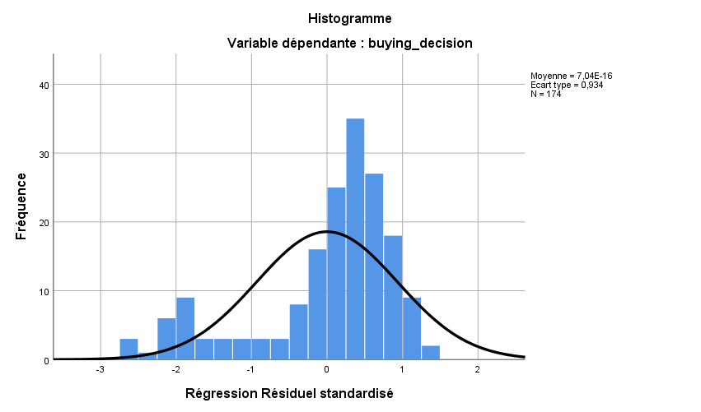
Source: Based on spss outputs.

Moreover, we can see by looking at the histogram of the distribution of residual values that we do not respect the premise of normality of error distribution. We want the distribution to follow a normal curve, but we observe a pronounced peak as well as values far from the curve. Therefore, this distribution is probably not normal. This further confirms that it may be wise to remove these extreme values from the analysis.

Figure 14 : Prob Cum observed

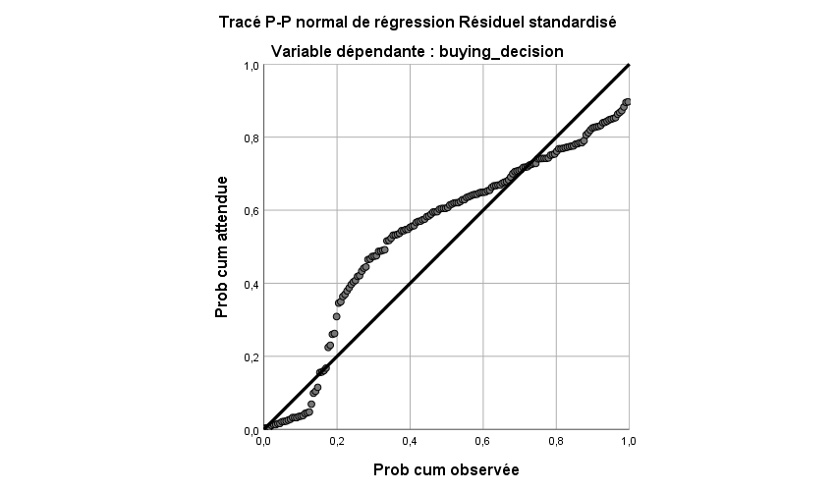
Source : Based on spss outputs.

From the figure, we find that the points are clustered around the line and thus the data (trumpets) are distributed according to a normal distribution.

2 Verification of hypotheses:

According to our survey we mean by Group impact, we mean by group family members, colleagues, friends ... who can change and influence buying decision.
Through our result, we accept the first hypothesis; Family is always one of the most influential elements for an individual. It forms an environment of socialization within which an individual will evolve, form his personality, and acquire values. But it also develops opinions and attitudes and consumer habits.
But, it can never be the only factor; it’s always matched with other personal factors as we see her, the marital situation, with cultural factors, as education level and occupation, those factors determines the social class the consumer belongs to.
Secondly we have:
Staff, after sales service and guarantee, those variables is factors that influence the buying decision in the store, which means are factors from the physical environment,
So we accept the second hypothesis that says the situational factors influence the buying decision.

Conclusion:
In this conclusion and on the basis of the analysis of the data obtained from a sample of 172 individuals representing 172 families, we will present the main results of this research on family purchasing behaviour in Algeria in order to determine the factors influencing the decision to buy local electrical household products.
Family is a major factor in influencing buying decision of local electrical appliance, it can be explained attitude acquired by customer, and it can be explained by responsibilities exist in families which make the consummation limited.
In the other hand we have occupation and education level, both determine an individual's membership groups are the social groups to which he or she belongs and which will have an influence on him, in addition costumer with high education level, can be much more informed by choices exist in the market, he followed a complicated making decision process.
Factors in the store can exercise such influence too, according to our analyze a costumer is influenced by the stuff, after sales service and guarantee.

GENERAL CONCLUSION

Consumer behaviour is not independent in most cases, as it is always affected by the family, as it is an environment to which the consumer belongs and the smallest unit of consumption. Current purchasing decisions are influenced by this, particularly with regard to household consumption products.
The effect also varies according to the size of the family, the age and culture of its members, their age and level of education and financial...
Family buying behaviour is one area that is studied in order to develop marketing strategies based on the results of this field.
Our study focused on the elements that affect the family decision maker when it comes to buying local appliances.
The main results of our study can be summarized as follows:
- The Algerian family is no longer a traditional family, Decision-making is no longer a question of age or gender but rather of experience and knowledge of the good, in terms of age, all mature family members are capable of making a good purchasing decision, It simply depends on their knowledge of the product, regarding gender, it is more the traditional distribution of roles between the spouses, the woman is capable of knowing what type, brand and characteristics of the product she wants.
- Buying a local product is linked, according to our study, with the marital situation, this factor can be expressed in two points:
- Married and single people differ in terms of responsibility to their families, and income management.
- Concerning the level of education, this factor plays a role especially in the search for information, a decision-maker with a good level of knowledge or research has what he is looking for.
On the other hand, it can be seen that the decision-maker member is influenced by a number of situational factors, such as contact personnel, the fit of items, product characteristics and music.
In the light of the results obtained, it was noted that the Algerian family does not have a local consumer culture, because it demands quality more than price.
The interest of this area of research can be summarized as follows:
- Developing local products in terms of quality.
- Developing advertising messages.
- Adapting product design to the needs of those who have the greatest influence on the purchase decision.
However, these results seem limited to us and only give us an approximate view of the factors that influence the purchase of a decision-maker member; this can be explained by the fact that we used the questionnaire method on a limited sample.
Finally, it can be said that buying behaviour is always dependent on the family, and that the factors that influence the purchase of local and international products are not different enough, but the decision is different, the question that arises here is What strategies will local brands follow to improve the quality of their products and gain the trust of their customers?

References :
Book :
Abdelmajid A, « Le comportement du consommateur face aux variables d’action Marketing »,Management et societe.
B, Gaulon P, Gauthy-Sinechal M, Josphin-Pernet N, Toye A, « Marketing l’essentiel pour comprendre, decider, agir », de boeck, Belgique, 2002.
Bernard B, Gary A .Steinerr, Human Behavior: An Inventory of scientific finding (new york :Harcourt,Brace &world,1964).
Bouton B, Gaulon P, Gauthy-Sinechal M, Josphin-Pernet N, Toye A, « Marketing l’essentiel pour comprendre, decider, agir », de boeck, Belgique.
Bouton B, Gaulon P, Gauthy-Sinechal M, Josphin-Pernet N, Toye A, « Marketing l’essentiel pour comprendre, decider, agir », de boeck, Belgique, 2002.
Chris J, « Prettentive mere Expsure Effects »,Jornal of consumer research, 20, 1993,P.376-392.
consommateurs camerounais», Cahier du CETA Juillet, 1998.
Denis D, Pierre V , « Comportements du consommateur concepts et outils »,2e édition ,edition Dunod,Paris,2007 .
Denis Darpy, Valérie Guillard « Comportement de consommateur »,4eme edition,2003.
Dubois B, «Le comportement du consommateur», édition Dalloz, 1990 édition, 2003.
Hammou-Poline Judith, « psychologie de la famille » 1993 .
Herzberg F, Work and of man (Cleveland: Collins Publishers, 1996)
Jim Oliver, « Finding Decision Rules with Genetic Algorithms”,www.umsanet.edu.bo/docentes/gchoque/MAT420l07.htm
Kotler P, Keller K, BUbois B, Manceau D, “Marketing Management”, Pearson Education, 12 eme edition , France, 2006.
Lendrevie J; Lévy J; Lindon D, «MERCATOR: théorie et pratique du marketing», édition Dalloz, 7ème,Canada.
Martin Sylvie; Védrine Jean Pierre, «Marketing les concepts clés», édition Chihab eyrolles, 1996.
Meyer E., « Portrait robot du nouveau consommateur », in l’Express, Paris, 10 novembre 1992, p 98
Michael S, Tissier-Desbordes E, Heilbrunn B, « Comportement du consommateur », 6e edition,Pearson Education,2005.
Michon C, « le marketeur »,2e edition, Pearson Education,France,2006. p 398 paris.
RICHAD LADWEIN, « le comportement de consommateur et de l’acheteur »,2e édition, édition ECONOMICA,
Schiffman Leon G; Kanuk Leslie Lasar, « Consumer behaviour», Prentice-Hall edition, third edition, 1987.
Sigué S.P; Duhaime C.P, «Perceptions des rôles familiaux dans les processus décisionnels des
Tomothy M , «Subliminal Advertasing : What you see is what you get»,Journal of marketing,46,1982
Vandercammen M,Bouton B, Gaulon P, Gauthy Sinechal M, Jospin-Pernet N ,Toye A , « Marketing l’essentiel pour comprendre décider,agir »,de boeck,Belgique,2002.

Thesis :
BOUFALA C , BRIKI D . , Etude de comportement du consommateur par rapport à la marque , diplôme de Master , Sciences Commerciales option marketing , UNIVERSITE ABDERRAHMANE MIRA DE BEJAIA , Bejaia , 2015 /2016 .
DALI-YOUCEF S . , Les rôles de la femme dans le processus de décision familiale d’achat , Mémoire de MAGISTER , Science de gestion option marketing , UNIVERSITE ABOU-BEKR BELKAID TLEMCEN , Tlemcen , 2011 /2012.
Khalifa M, « l’impact des attraibuts dy pays d’oridine sur la decision d’achat des consommateurs algeriens »,these de doctorat, Science commercial, option marketing , Université Abou bekr belkaid, Tlemcen,2015/2016.

Websites :

WWW. Mémoire online.com
www.Sawtoothsoftware.com/productforms/ssolution/ss12.shtml,173
WWW.Insee.com
WWW.ONS.com

Annex:
- Age:
Moins de 20 ans.
20 ans - 30 ans.
31 ans - 40 ans.
41 ans - 50 ans.
Plus de 50 ans.
- Genre
Homme.
Femme.
- Situation matrimoniale
Célibataire.
Marié(e).
Divorcé(e).
- Si vous êtes marié(e) indiquez la durée de mariage
1 ans – 10 ans
11 ans – 20 ans
21 ans – 30 ans
Plus de 30 ans
- Si vous êtes marié(e) ou divorcé(e) indiquez le nombre d'enfants
- 5
- 6
- 7
- 8
- si vous avez des enfants :Classe d'age des enfants
moins de 10 ans 14-16 ans
10 ans - 12 ans 16-18 ans
12-14 ans Plus de 18 ans
- Membre de la famille
Père et mère. Grand père et/ou Grande mère, Père et mère,enfants
Père et mère et enfants. Père ou mère et enfants.
- Votre niveau d’instruction
Primaire. Secondaire.
Moyen. Universitaire.

- Votre occupation socio-professionnelle
Ne travaille pas (inactif), femme au foyer.
Etudiant.
Ouvrier non qualifié, femme de ménage, gardien.
Ouvrier qualifié, menuisier,électricien, plombier, assistant commercial, cuisinier, serveur…
Employé de bureau, employé de banque, fonctionnaire.
Cadre moyen, officier, fonctionnaire moyen, propriétaire de petit commerce, technicien, enseignant.
Cadre supérieur, professionnel,haut fonctionnaire, profession libérale, propriétaire de PME.
Directeur, chef de département,propriétaire d'une grande entreprise, haut fonctionnaire d'état.
retraité(e).
- Le revenu mensuel
Moins de 10000 à 19999 DA 40000 à 49999 DA
20000 à 29999 DA Plus que 50000DA
30000 à 39999 DA
- Avez-vous déjà fait le choix d'un produit local à acheter ?
OUI NON

- êtes-vous déjà allé acheter un produit Electroménager local ?
OUI NON
- Avant l'achat :

 | pas du tout d'accord | plutôt pas d'accord |  | Neutre | plutôt d'accord | tout à fait d'accord
Votre age vous permet de faire une bonne decision d'achat des produits électroménagers locaux
Votre genre (homme/femme) vous permet de faire une
bonne décision d'achat des produits électroménagers locaux
Votre salaire vous permet d'acheter des produits électroménagers locaux

Les membres de votre famille vos collègues, amis ...peuvent changer votre décision d'achat des produits électroménagers locaux ou bien votre choix

Ces marques locaux et ces publicités, réussir à capter et retenir votre attention

- Pendant l’achat :
 | pas du tout d'accord | plutôt pas d'accord | neutre | plutôt d'accord | tout à fait d'accord
Pensez-vous que les odeurs dans un magasin des produits électroménagers peuvent impacter votre décision d’achat ?
- Pensez-vous que les lumières, les couleurs et les décorations dans un magasin des produits électroménagers peuvent impacter votre décision d’achat ?
Pensez-vous que la musique d’ambiance dans un magasin des produits électroménagers peut impacter votre décision d’achat ?
Pensez-vous que l’agencement des articles et leurs dispositions dans un magasin des produits électroménagers peuvent impacter votre décision d’achat ?
Pensez-vous que les espaces disponibles pour le déplacement dans un magasin des produits électroménagers peuvent impacter votre décision d’achat ?
Pensez-vous que le personnel de contact dans un magasin des produits électroménagers peut influencer votre décision d’achat ?
Pensez vous que ces caractéristiques peuvent impacter votre décision d'achat

- Apres l’achat :

 | Pas du tout d'accord | plutot pas d'accord | neutre | plutot d'accord | tout a fait d'accord
La garantie peut renforcer votre décision d'achat
le service aprés vente peut renforcer votre decision d'achat

Contents

GENERAL INTRODUCTION 8
Section 1: Consumer Behaviour Research Area Distinguishes 6
Section 2: Definition of consumer behaviour 7
1 Definition of consumer behaviour: 7
Section 3: Global models of consumer purchasing behaviour 8
1 The model of consumer behaviour according to NICOSIA (1966): 8
2 The Howard and Sheath model (1969): 10
3 The model of Engel, Kollat and Blackwell (1968): 11
Section 4: Factors influencing consumer behaviour 12
1 Psychological explanatory factors: 13
1.1 Motivation: 13
1.1.1 The Freudian theory of motivation: 13
1.1.2 Maslow's motivation: 13
1.1.3 Herzberg's theory: 15
1.2 Perception: 15
1.3 Learning: 16
1.4 Memory : 16
2 Social factors: 17
2.1 Culture: 17
2.2 Sub-culture: 17
2.3 Social class: 18
2.4 The family: 18
3 Personal factors: 19
3.1 Age and gender: 19
3.2 Occupation: 19
3.3 Economic position: 19
3.4 Personality and self-concept: 19
3.4.1 Personality: 19
3.4.2 The concept of self: 20
3.5 Lifestyle: 21
Section 5: Consumer purchase decision making 22
1 Need Recognition: 22
2 Information search: 23
2.1 The different sources of information research: 23
2.1.1 Factors influencing the consumer's search process: 23
3 Evaluation of alternatives: 25
4 The purchase decision: 26
4.1 Post-Purchase Behaviour 26
4.1.1 Complex buying behaviour: 28
4.1.2 Dissonance-reducing buying behaviour: 29
4.1.3 Habitual buying behaviour: 29
4.1.4 Variety-seeking buying behaviour: 29
4.1.5 Procrastination, postponed purchase: 29
4.1.6 Purchase thwarted: 29
4.1.7 Impulse buying: 29
4.1.8 Compulsive buying: 30
CHAPTER TWO : FAMILY BUYING BEHAVIOUR 1
Section 1: Definitions and conceptualization of family behaviour 32
1 The family, an original primary group: 32
1.1 The notion of group: 32
1.2 The influence of the group on the individual: 33
1.2.1 The definition of the family: 33
1.2.2 The typology of the family: 34
1.2.2.1 A classification of the types of the family: 34
1.2.2.2 Changing family boundaries: 34
1.2.2.3 The concept of household: 35
2 The family life cycle: 35
2.1 The FLC model proposed by Murphy and Staples (1979): 35
2.2 The Gilly and Enis model (1982) : 38
Section 2: The purchasing process in the family 39
1 The home as a place of decision: 39
1.1 Functionalist perspectives: 39
1.2 The interactive perspective: 40
2 Conflicts and the dynamics of decision-making: 40
2.1 Types of conflicts: 40
2.2 The main conflict factors: 41
3 Conflict resolution strategies: 42
3.1 Conflict resolution: 43
4 Roles related to the family buying process: 43
Section3: The distribution of roles in decision making 45
1 Identify the decision maker: 45
2 The heuristic in joint decision-making 45
2.1 Prescribing children: 46
2.2 The case of adolescents: 47
3 Women business and marketing: 48
4 Factors influencing the family purchasing decision process: 50
4.1 The degree of involvement: 50
4.2 Types of involvement: 51
4.3 Measuring involvement: 51
4.3.1 The Zaichkowsky (1985) scale: 51
4.3.2 Jean-Noel Kapfer and Gilles Laurent's (1986) involvement profile scale: 52
5 The type of purchase: 54
Section 4: Family communication 55
Section 5: Socio-demographic characteristics in Algeria 56
1 The resident population: 56
2 Population structure: 57
3 Mortality rate: 58
4 Evolution of consumer prices of the city of Algiers from 2010 to 2019: 59
5 Evolution by category of goods and services: 60
6 Evolution of home furnishings consummation: 62
CHAPTER THREE : RESEARCH AND ANALYSIS 31
Section 01: Methodological Approach to the Survey 64
1 The Objective of the Survey: 64
2 The choice of survey tool: 64
3 Structure of the questionnaire: 64
4 The temporal and spatial dimensions of the survey and the way the questionnaire is administered 65
5 Statistical tools used in the study: 65
Section2: describing the personal variables of the sample 66
Section 03: Analysis of Survey Results 75
1 Presentation of our study using The Standard Multiple Regression: 75
2 Verification of hypotheses: 82
GENERAL CONCLUSION 84
References ……………………………………………………………………………………….86
Annex ………………………………………………………………………………………..….88

*

